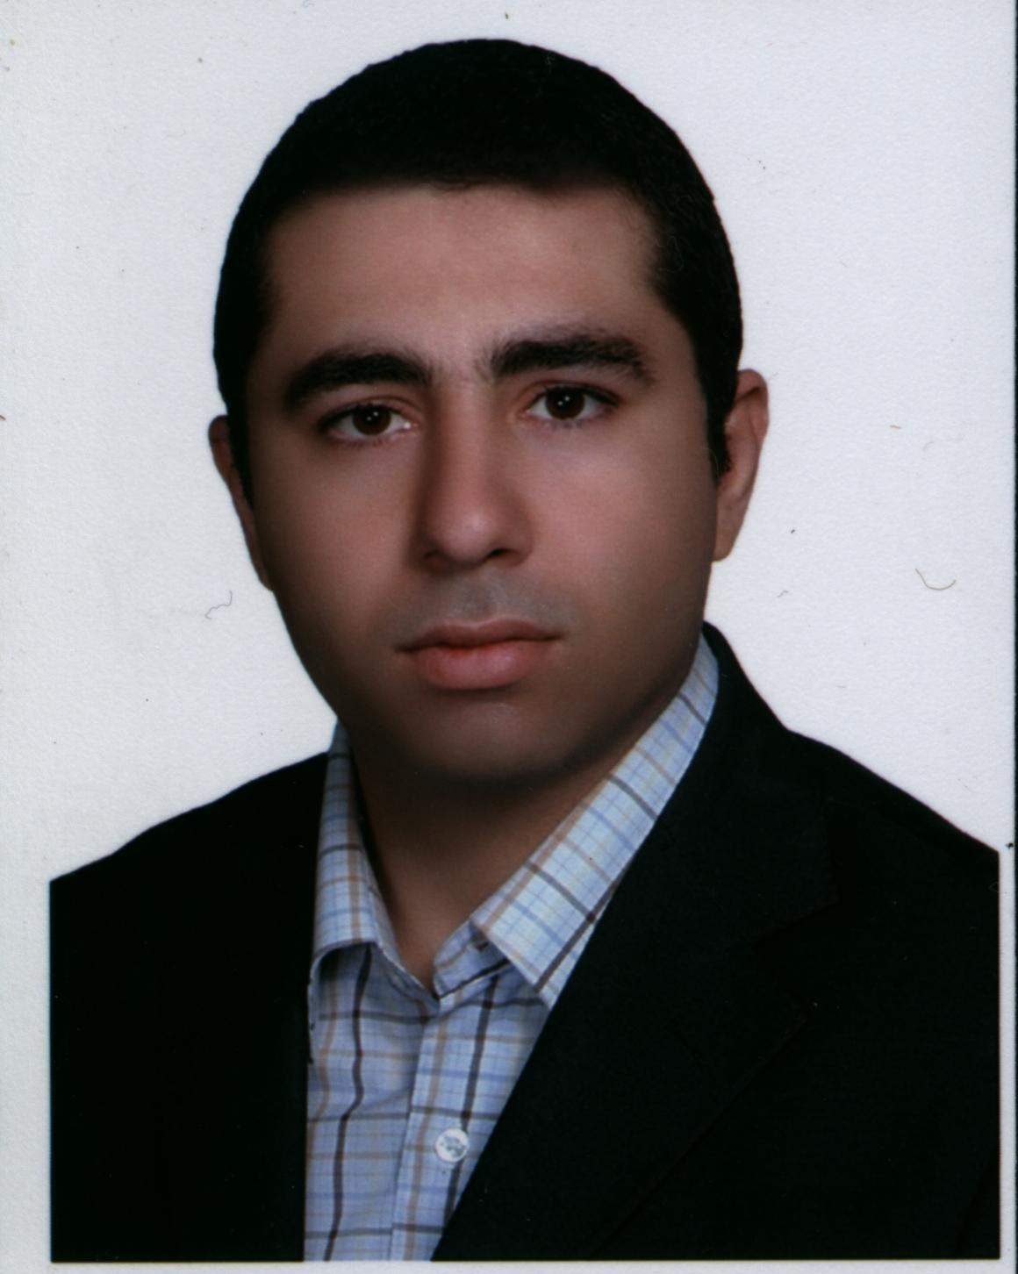
Name: Ali Nejate Date of birth: August 1983 Marriage status: Married

Education:
- Msc, Electric Engineering, Control branch Tarbiat Modares University, Iran 2005-2008 Ave:16.16
- BSc, Electric Engineering, Power branch, Islamic Azad University, Iran 2001-2005 Ave:17.31

Computer Knowledge
- Specialist in C# programming language
- Familiar with Object Oriented Design Principals
- Familiar with Xamarin Android development
- Familiar with Android XML Layout design
- Familiar with ASP.net MVC Core web development
- Familiar in designing data driven web applications
- Familiar with Microsoft SQL Server and Entity Framework
- Familiar with JavaScript and jQuery
- Familiar with CSS and Bootstrap
- Familiar with AJAX
- Familiar with web services
- Familiar with C and C++ programming languages

English Language Knowledge
- Fluent in Reading and Listening Skills
- Good at writing and speaking
- May provide 6.5 or above in IELTS if required

Experience
- 2 years in programming 8501 and AVR micro-controllers for various power electronics and control projects
- 1 year in designing and building of small multi-page websites for business companies
- 2 years in designing and building an advertisement application for selling second-hand products. This application will have a website for web browser users and also an android application being developed by Xamarin in visual studio

Contact:
Phone
(+98)(912)(2012908)
E-mail: ali62n62@yahoo.com
Address:
Number 13,Block 6,Baharan Building Complex, Akbar Hosseini Street, Alghadir Boulevard, Tehran, Iran. Postal Code: 1376839683

