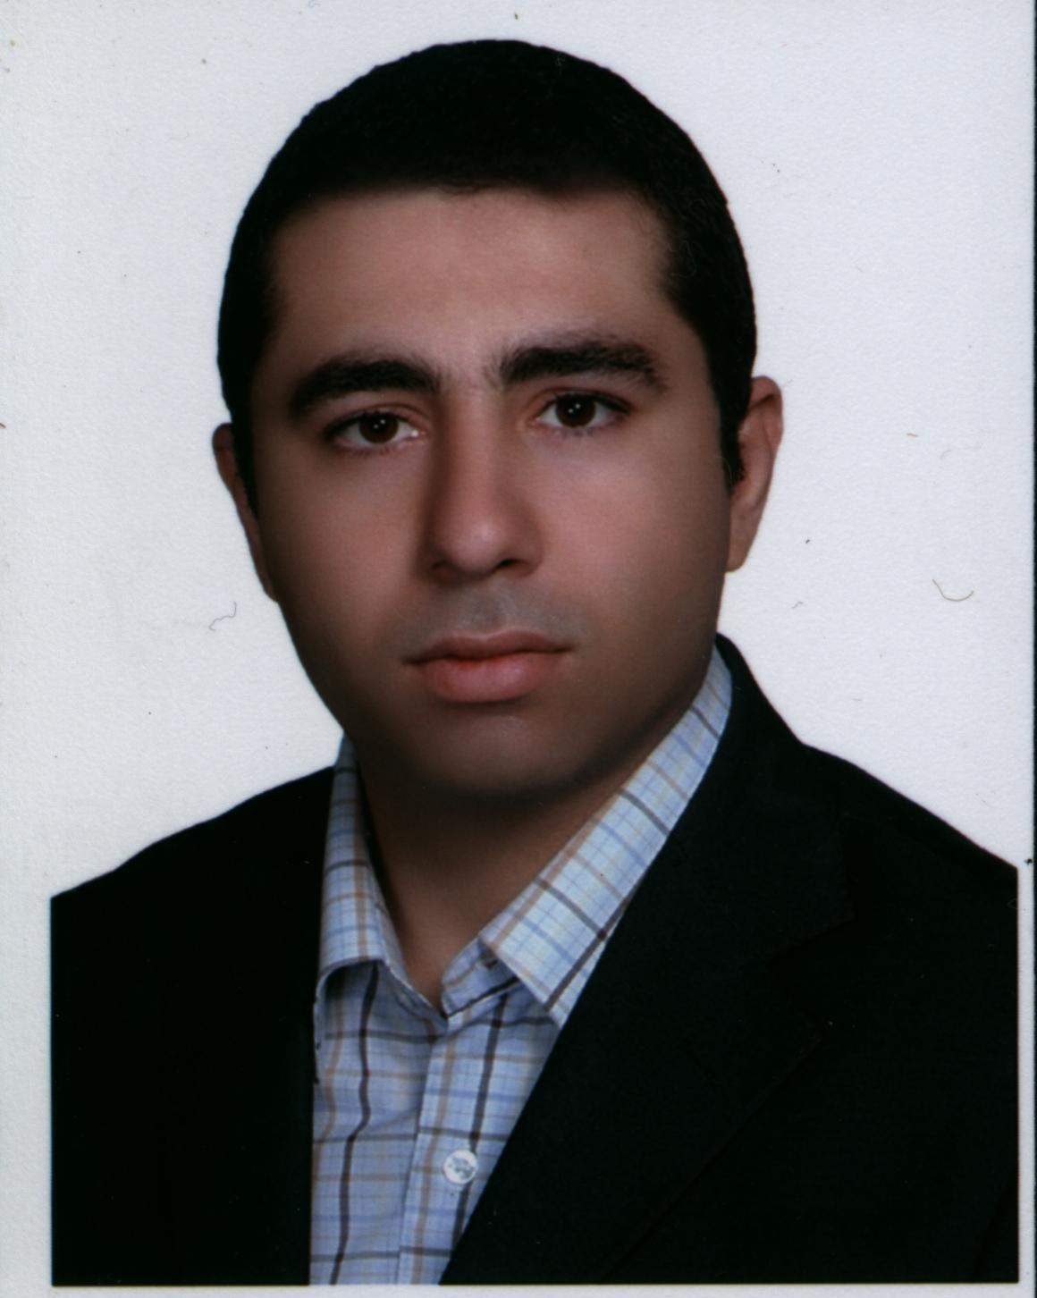
Name: Ali Nejate Birth August 1983, Tehran, Iran
Contact:
Phone: +989122012908
E-mail: alinejati1983@gmail.com
LinkedIn: https://www.linkedin.com/in/ali-nejati-24590012a

TECHNICAL SKILLS

- Familiar with scalable application development
- Object Oriented Design and Programming
- Familiar with and using Test Driven Development method
- Familiar with Domain Driven Design
- Familiar with SOLID design principles and Design Patterns
- Familiar with ASP.net MVC web development
- Familiar with Restful web services, AJAX, XML and Json
- Years of experience in C# programming language
- Familiar in designing data driven web applications
- Familiar with Relational Database Modeling and Design using SQL Server
- Familiar with T-SQL
- Familiar with Entity Framework
- Few study in Html, Java script, jQuery, CSS, Bootstrap but prefer the server side
- Familiar with Network and Socket Programming, TCP/IP, HTTP

WORK EXPERIENCE

- A Windows-form application for analyzing stock market using C#, Microsoft SQL Server, Entity framework in a multi-layer design (data layer, business layer, service layer, presentation layer)
- Server side programming in an IOT project collecting temperature of a room
- A Windows application connecting the computer to control a programmable DC power supply
- A Windows application connecting the computer to a TI DSP Board to configure DSP controller parameters via computer
- Simulating charged particles movement in magnetic field with C# and java
- Creating some small android application with Xamarin in Visual Studio
- Design and construction of a 12-volt dc to 220-volt ac push-pull convertor with 8051 micro controller
- Design and construction of a controllable DC motor drive ( 8051 micro controller for drive part and data acquisition card to bring data into computer to be used in MATLAB)

Education:
- MSc, Electric Engineering, Control branch Tarbiat Modares University, Iran 2005-2008 Ave:16.16
- BSc, Electric Engineering, Power branch, Islamic Azad University, Iran 2001-2005 Ave:17.31

Thesis Titles
- BSc: Design and construction of a soft start 3-phase Asynchronous motor drive
- MSc: Economic-Environmental Power System Utilization

English Language Knowledge
- Fluent in Reading and Listening Skills
- Good at writing and speaking
- May provide 6.5 or above in IELTS if required

Certifications
- Efficient implementation of DSP algorithm on FPGA, Iran Science and Technology University, April, 2014.

References
- Mohammad Eghbali Ghahyazi, Manager Digital Radio Functions at Ericsson

https://www.linkedin.com/in/meghbali/
Phone: 0722532132 (Mobile)
Email: mammad_egh@yahoo.com

