China–Pakistan Economic Corridor (CPEC):
A Strategic Lifeline

Historical Background

1.1 Origins: From Ancient Silk Roads to Modern Corridors
The idea of linking China to Pakistan through overland routes has deep historical roots. The ancient Silk Road trade networks, which flourished between the 2nd century BCE and 15th century CE, connected China with Central Asia, South Asia, and the Middle East - the very same regions that CPEC now seeks to reconnect through modern infrastructure.

- The Karakoram Highway (KKH), jointly built by Pakistan and China between 1959 and 1979, was the first physical expression of this vision. Often called the 'Eighth Wonder of the World,' KKH remains a cornerstone of CPEC's transport network.
- China and Pakistan established diplomatic relations in 1951. The 1963 Sino-Pakistani Boundary Agreement and the 1972 China–Pakistan Treaty of Friendship further solidified bilateral ties.
- The 1990s and 2000s saw increasing economic cooperation. The China-Pakistan Free Trade Agreement (CPFTA) was signed in 2006, laying the groundwork for deeper commercial integration.
- China's 'Going Out' (Zou Chuqu) policy of 1999 encouraged Chinese enterprises to invest abroad, and Pakistan was identified as a strategic partner given its geographic location and deep political alignment.

1.2 Belt and Road Initiative (BRI): The Grand Framework
In September–October 2013, Chinese President Xi Jinping announced the Belt and Road Initiative (BRI), previously called 'One Belt One Road' (OBOR). The initiative revives the spirit of the ancient Silk Road with a modern infrastructure investment framework:
- The Silk Road Economic Belt: Overland corridors linking China to Central Asia, the Middle East, and Europe.
- The 21st-Century Maritime Silk Road: Sea-based routes connecting China to Southeast Asia, South Asia, Africa, and Europe.

BRI encompasses six major economic corridors, of which CPEC is the flagship and most advanced. Former Pakistani Prime Minister Nawaz Sharif described BRI as 'an inter-continental mega-project ushering in a geo-economic revolution.'

1.3 CPEC: From Vision to Reality (2013–2015)
- In May 2013, then-Chinese Premier Li Keqiang visited Pakistan and the two sides agreed to build an 'Economic Corridor' - the conceptual genesis of CPEC.
- In April 2015, President Xi Jinping visited Islamabad. He and PM Nawaz Sharif signed a package of agreements worth approximately US $46 billion - equivalent to roughly 20% of Pakistan's GDP at the time - formally launching CPEC.
- CPEC was designed to span approximately 3,000 km, connecting Gwadar Port in Balochistan to Kashgar in China's Xinjiang province through roads, railways, pipelines, and fiber-optic cables.
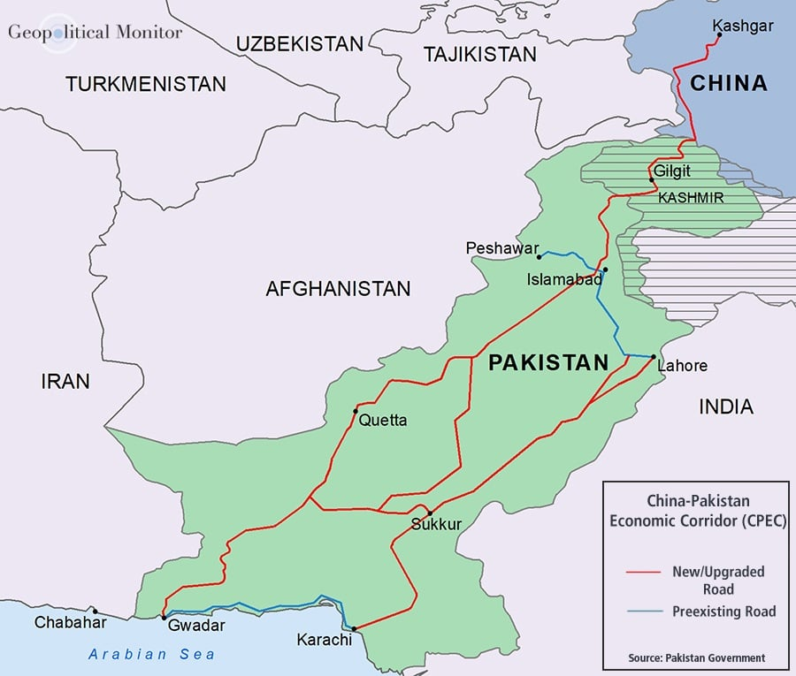
Map: China-Pakistan Economic Corridor route from Gwadar to Kashgar
Source: Geopolitical Monitor (map credited to Pakistan Government) - https://www.geopoliticalmonitor.com/background-pakistans-gwadar-port/

2. Current Overview

2.1 Investment Scale and Framework
- CPEC's original 2015 framework of US $46 billion has expanded. As of 2025, Pakistan's Ministry of Planning estimates total planned investment at over US $65 billion, spanning the three-phase framework from 2015 to 2030.
- The corridor encompasses roads, railways, ports, energy installations, fiber-optic cables, industrial zones, and urban development projects.
- Gwadar Port, managed by China Overseas Ports Holding Company (COPHC) since 2013, serves as the maritime anchor of CPEC, offering China access to the Arabian Sea.
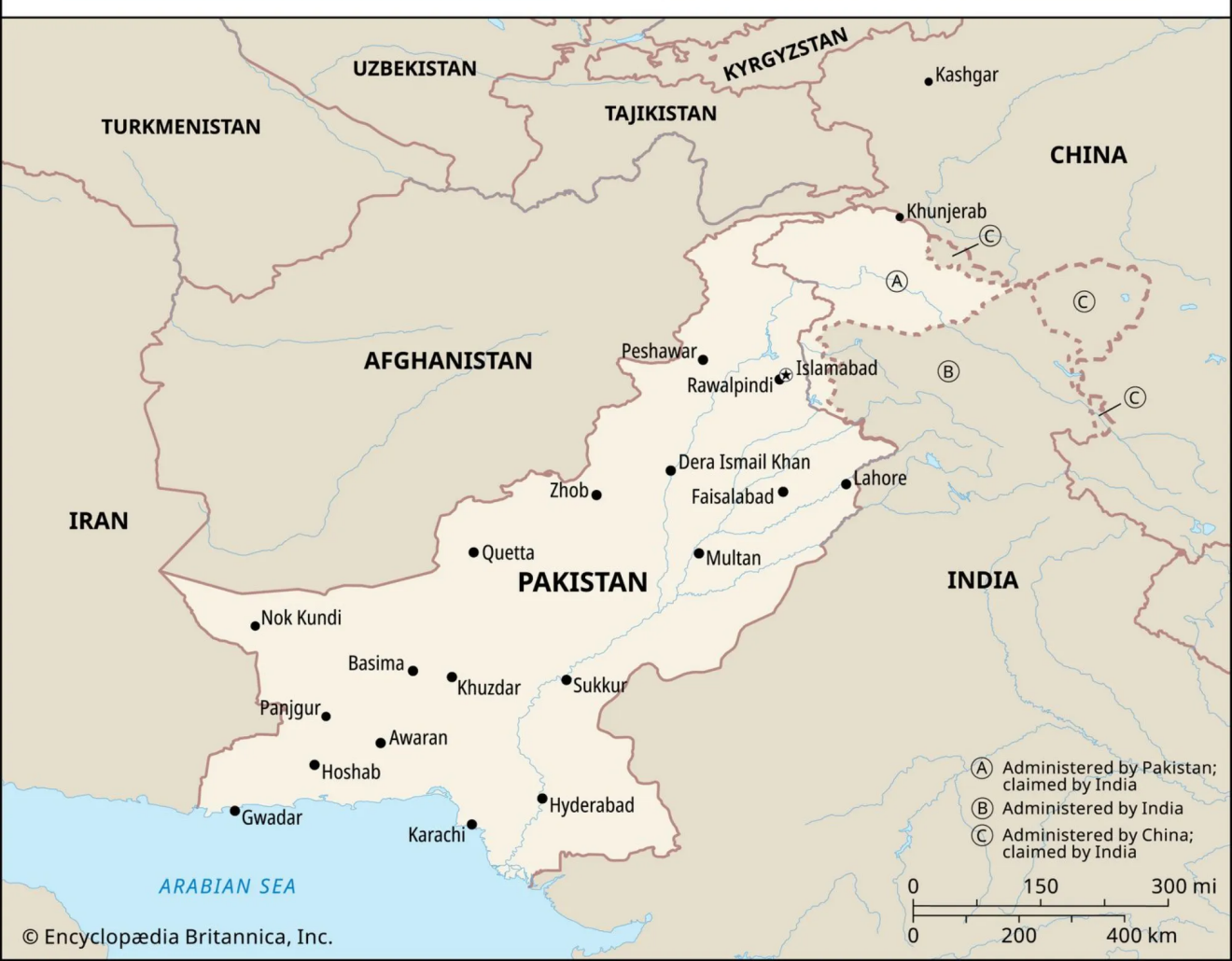
Map: CPEC project locations and regional context
Source: Encyclopaedia Britannica - https://www.britannica.com/topic/China-Pakistan-Economic-Corridor

2.2 Latest Developments (2024–2025)
- Pakistan's Planning Commission reported in May 2025 that 19 of 33 flagged CPEC projects have been completed, including the US $2.9 billion Gwadar port expansion.
- The New Gwadar International Airport, built at a cost of US $246 million, became operational in October 2024.
- The 14th Joint Coordination Committee (JCC) meeting was held in July 2025 to align bilateral CPEC implementation timelines.
- CPEC 2.0, launched in 2025, emphasizes agriculture, digital economy, industrial cooperation, and clean energy - marking a strategic expansion beyond infrastructure.
- Saudi Arabia signed a US $10 billion MoU in 2024 to establish an oil refinery in Gwadar, deepening the port's strategic importance.
- In May 2025, Pakistan, China, and Afghanistan agreed in principle to extend CPEC to Kabul, marking a significant regional diplomatic development.
- Pakistan and Chinese power entities prepared MoUs in October 2024 to reprofile over US $16 billion in foreign-currency CPEC energy loans, extending tenures by five years.

FACT BOX - CPEC at a Glance (2025)
Total Planned Investment: Over US $65 billion (Pakistan Ministry of Planning, 2025)
Corridor Length: Approximately 3,000 km (Gwadar to Kashgar)
Phase I Energy Added: Over 11,000 MW (coal, hydro, solar, wind)
Projects Completed (of flagged): 19 of 33 (Planning Commission, May 2025)
Jobs Created (estimated): 800,000–1,200,000 (AP News / Pakistan Economic Survey)
SEZs Planned: 9 | SEZs Partially Operational: 4
Digital Network: 9,600 km fiber-optic from Khunjerab to Gwadar
New Gwadar Airport: Operational since October 2024 (cost: US $246 million)

3. One Belt One Road (BRI): The Six Corridors

China's BRI comprises six strategic overland and maritime corridors:
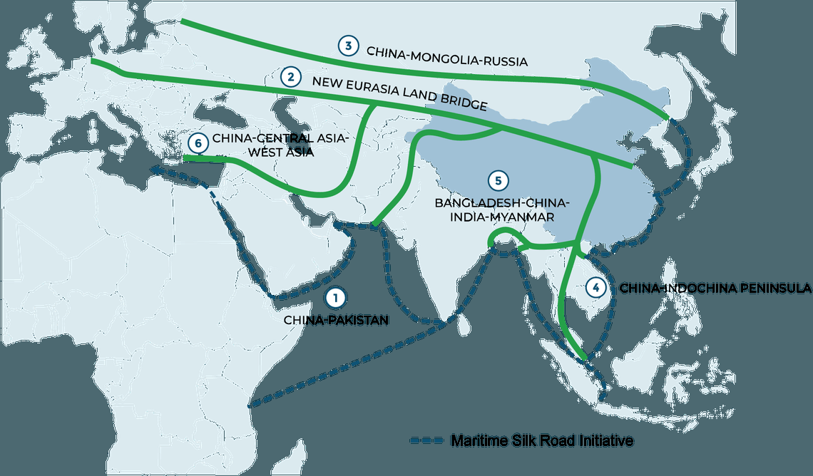
Map: Six economic corridors of the Belt and Road Initiative
Source: Standard Chartered - https://www.sc.com/en/news/corporate-investment-banking/one-masterplan-six-corridors/

3.1 China–Mongolia–Russia Corridor
- Links northeast China with Mongolia and Russia via rail and road, facilitating trade in natural resources and manufactured goods.
- According to the China Railway Corporation, bilateral trade on this corridor increased by approximately 15% between 2023 and 2024, driven by coal and machinery exports.
- Rail link upgrades have reduced the Beijing–Ulaanbaatar transit time by nearly 20 hours.

3.2 New Eurasian Land Bridge
- Also called the Second Eurasian Continental Bridge; links China's east coast (Lianyungang port) directly with Europe (Duisburg, Germany).
- Approximately 470,000 TEUs (twenty-foot equivalent units) were shipped between China and the EU through this corridor in 2025 - a 12% year-on-year increase (Roland Berger, 2025).

3.3 China–Central Asia–West Asia Corridor
- Runs west through Xinjiang into Central Asia and onward to Turkey and the Persian Gulf.
- In September 2024, Kazakhstan confirmed that sections of the China–Kazakhstan rail network now support trains at 120 km/h, reducing transit time by 36%.

3.4 China–Indochina Peninsula Corridor
- Connects Yunnan province with Vietnam, Laos, Thailand, and Malaysia.
- The China-Laos Railway (completed December 2021) supports speeds up to 200 km/h. Freight tonnage grew by 80% from 2022 to 2024 (Asian Development Bank).

3.5 Bangladesh–China–India–Myanmar (BCIM) Corridor
- Agreed in principle since 2013 but stalled due to India's withdrawal citing sovereignty and environmental concerns.
- India stated in 2022 it would 'not join corridors that do not fully ensure environmental protection and strategic autonomy' (Raisina Dialogue, 2022).

3.6 China–Pakistan Economic Corridor (CPEC) - The Flagship
- Approximately 3,000 km of road, rail, pipelines, and fiber optics connecting Kashgar (Xinjiang) to Gwadar Port.
- The International Crisis Group states: 'CPEC is China's most geopolitically significant BRI project, given its access routes and the capacity to reshape regional connectivity.'
- A 2024 Oxford Economics study estimated CPEC has contributed approximately US $12 billion to Pakistan's GDP and created approximately 80,000 direct jobs to that point.

4. Phased Development of CPEC (2015–2030)

4.1 Phase I (2015–2020): Energy and Infrastructure - Completed

Energy Projects
- Sahiwal Coal Power Plant: 1,320 MW capacity; one of Pakistan's largest coal plants.
- Port Qasim Coal Power Plant: 1,320 MW capacity.
- Karot Hydropower Project: 720 MW; completed by China Three Gorges Corp; operational since June 2022.
- Quaid-e-Azam Solar Park (Bahawalpur): Approximately 300 MW; one of the world's largest solar parks at time of construction.
- Suki Kinari Hydropower: 884 MW; registered over 3.2 billion kWh generating capacity.
- HVDC Matiari–Lahore Transmission Line: 4,000 MW capacity; became operational in September 2021.

Infrastructure Projects
- M-5 Motorway (Multan–Sukkur): 392 km; inaugurated November 2019; built by China State Construction Engineering Corp.
- Karakoram Highway (KKH) Phase II: Upgraded key segments; connects Pakistan's north to Khunjerab Pass border crossing.
- Gwadar East Bay Expressway: 19 km; significantly improved port connectivity.
- New Gwadar International Airport: Completed at cost of US $246 million; became operational October 2024.
- Gwadar Port and Free Trade Zone: Deep-sea container facilities expanded; Free Trade Zone operational; seawater desalination plant (1.2 MGD) operational.

Outcomes of Phase I:
- Addition of over 11,000 MW significantly reduced load shedding and stabilized power supply across Pakistan.
- Enhanced internal transport efficiency; motorways cut travel times and reduced fuel costs.
- Early industrial interest catalyzed by improved infrastructure.

4.2 Phase II (2021–2025): Industrialization and SEZs - Ongoing
This phase represents a strategic pivot from infrastructure to economic restructuring through Special Economic Zones (SEZs), value chains, export facilitation, and job creation.
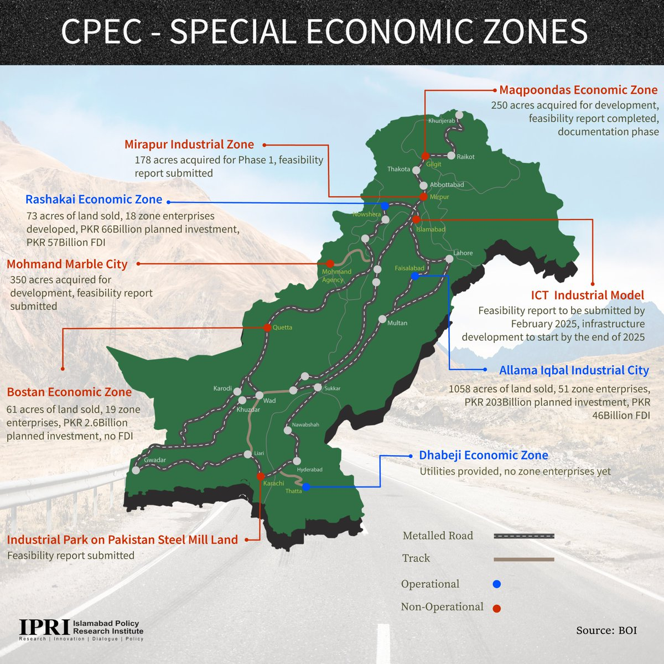
https://x.com/IPRI_Pak/status/1833128222860435634

Special Economic Zones (SEZs)
- Rashakai SEZ (Khyber Pakhtunkhwa): 1,000 acres; Phase 1 operational since July 2023; hosting manufacturing in auto parts, pharmaceuticals, and home appliances.
- Dhabeji SEZ (Sindh): Approved January 2025; projected investment of approximately US $3 billion and over 100,000 jobs.
- Allama Iqbal Industrial City (Punjab / Faisalabad): Progress includes MoUs in textiles, pharmaceuticals, and engineering sectors.
- Bostan SEZ (Balochistan): Under development with provincial coordination.

Other Phase II Developments
- Agriculture: Chinese-donated machinery and training programs began in May 2025; protocols for Pakistani agricultural exports (meat, cherries, chilies) to China have been formalized.
- Textile digitization initiative covering 200 factories approved in October 2024.
- CPEC 2.0 (launched 2025) adds agriculture, clean energy, digital economy, and cognitive cooperation.

Phase II Challenges
- Delays in utility connections and bureaucratic approvals, especially in Gwadar and Rashakai SEZs.
- Security risks in Balochistan continue to deter Chinese personnel participation.
- Local dissatisfaction in Gwadar: residents report lack of reliable power and water despite large-scale infrastructure investment.

4.3 Phase III (2026–2030): Tourism and Human Development - Planned
Phase III aims to build soft infrastructure - skills, health, tourism, culture, and human capital - on the material foundation laid in earlier phases.

Planned Initiatives
- Development of tourism corridors in Northern Pakistan (Gilgit-Baltistan, Hunza) and coastal Balochistan.
- Cultural exchanges and joint tourism promotion with Chinese provinces.
- Projects in public health: clinics, telemedicine networks.
- Education partnerships: universities, vocational training centers, scholarships.
- Livelihood improvements through rural agro-industrial integration.

4.4 Summary: Phases at a Glance
Phase | Years | Focus Areas | Status
Phase I | 2015–2020 | Energy (coal, hydro, solar), roads, Gwadar port | Completed: +11,000 MW, M-5 motorway, Gwadar airport
Phase II | 2021–2025 | SEZs, industrialization, agriculture, digital | Ongoing: Several SEZs active; CPEC 2.0 launched
Phase III | 2026–2030 | Tourism, health, education, culture, human capital | Planning Phase: To build soft infrastructure

5. Strategic Advantages of CPEC for China

5.1 Energy Security: Resolving the 'Malacca Dilemma'
China imports roughly 70–80% of its oil from the Middle East and Africa, with approximately 80% transiting through the Strait of Malacca - a narrow maritime chokepoint vulnerable to blockade by rival navies. This vulnerability was first officially termed the 'Malacca Dilemma' by President Hu Jintao in 2003.

- CPEC offers a critical overland alternative: oil and goods land at Gwadar, then travel approximately 3,000 km by road and rail to Xinjiang, reducing the sea route distance from roughly 12,000 km to 3,000 km overland - a 75% reduction.
- Gwadar lies approximately 250 km from the Strait of Hormuz, through which approximately 21 million barrels of crude oil flow daily.
- According to China's Ministry of Transport (2024), the Gwadar–Kashgar route reduces shipping distance by over 9,500 km and delivery time by 12–15 days compared to traditional routes.
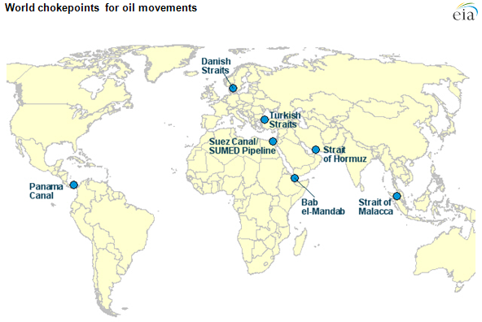
Map: World oil transit chokepoints relevant to Malacca and Hormuz
Source: U.S. Energy Information Administration (EIA) - https://www.eia.gov/todayinenergy/detail.php?id=7830

5.2 Market Access: Gateway to South Asia, Middle East, and Beyond
- CPEC's logistics network allows China to trade directly with the Middle East, Africa, and Europe, bypassing crowded maritime lanes.
- Integrating port-to-rail-to-road logistics facilitates efficient export of Chinese goods westward and import of resources eastward.
- CPEC provides access to burgeoning consumer markets in South and Central Asia, including Afghanistan and the Central Asian Republics.

5.3 Western China Development: Boosting Xinjiang
- CPEC strengthens Xinjiang's transport, logistics, and trade networks, supporting economic growth and political stability in a region challenged by underdevelopment and unrest.
- The Xinjiang Free Trade Zone, created in November 2023, spans Urumqi, Kashgar, and Khorgos, stimulating cross-border trade, manufacturing, and logistics.
- Xinjiang's FY 2023 GDP reached approximately CNY 854 billion (approximately US $120 billion), growing at 5.1% year-on-year, demonstrating improved performance linked to such infrastructure.

5.4 Geopolitical Reach: String of Pearls and Indian Ocean Presence
- CPEC is integral to China's 'String of Pearls' strategy - a network of commercial and strategic assets across the Indian Ocean to bolster sea lane security.
- Gwadar's location offers China potential naval logistics capabilities and the ability to project maritime power into the Western Indian Ocean.
- Joint security exercises, potential submarine cooperation, and logistical arrangements at Gwadar offer China a strategic foothold far from its mainland.

6. Strategic Advantages of CPEC for Pakistan

6.1 Defense Cooperation
- Since 2015, China and Pakistan have deepened military cooperation under the CPEC umbrella.
- China is supplying Pakistan with eight Hangor-class diesel-electric submarines (export variant of Type 039/039A) - described as 'the largest defence deal China has agreed to with any country' at approximately US $4–5 billion.
- The second submarine was completed in March 2025.
- Pakistan is constructing four additional submarines domestically with Chinese technology transfer at Karachi shipyards.
- Both nations conduct joint naval and air exercises, share military intelligence, and coordinate regionally to counter common security threats.

6.2 Energy Sector Uplift
- More than 17,000 MW of generating capacity from coal, hydro, solar, and wind sources has been added by 2025.
- Key projects: Sahiwal Coal-Fired (1,320 MW), Karot Hydropower (720 MW), Quaid-e-Azam Solar Park (approximately 1,000 MW), Suki Kinari Hydropower (884 MW).
- The HVDC Matiari–Lahore Transmission Line (4,000 MW capacity) became operational in September 2021, linking energy-rich zones to demand centers.
- This energy expansion has significantly lessened load shedding, reduced circular debt, and diversified energy sources away from expensive imported fossil fuels.

6.3 Infrastructure Development
- Gwadar Port has evolved into a deep-sea shipping hub, now connected to the national electricity grid.
- Karakoram Highway Phase II (Thakot–Raikot): feasibility approved in 2023–24.
- Over 5,000 km of roads and motorways have been built or upgraded, including Multan–Sukkur (M-5) and Peshawar–D.I. Khan.
- Three major transport corridors now link Gwadar with Pakistan's heartland: Western (Gwadar–Quetta–D.I. Khan–Peshawar), Central (Gwadar–Sukkur–Multan–Lahore), and Eastern (Gwadar–Karachi–Lahore–Islamabad).
- Reduced transport costs estimated at 30–50% on upgraded corridors.

6.4 Economic Integration and Employment
- An estimated 800,000–1,200,000 jobs have been generated during CPEC's first decade.
- Trade along the corridor rose from US $4.8 billion in 2015 to US $16 billion by 2023.
- SEZs such as Rashakai, Allama Iqbal, Bostan, and Dhabeji are attracting domestic and foreign investment, expected to generate up to 500,000 jobs and US $10 billion in additional exports.
- The World Bank (2023) noted CPEC could raise Pakistan's GDP growth rate by 2.0–2.5% per annum if fully implemented by 2030.
- Pakistan's trade volume with China rose 37% between 2015 and 2024 (IMF, 2024 Regional Economic Outlook).

6.5 Agricultural Reforms (CPEC 2.0)
- Chinese-donated agricultural machinery and training programs began in May 2025.
- Modern irrigation projects integrated with energy and infrastructure schemes, enhancing productivity in Sindh and Punjab.
- Protocols for Pakistani agricultural exports - including meat, cherries, and chilies - to China have been formalized.

6.6 Social Sector and Digital Expansion
- A seawater desalination plant (1.2 million gallons per day) in Gwadar is now operational.
- Pak–China Friendship Hospital completed in Gwadar.
- A 9,600 km fiber-optic network from Khunjerab to Gwadar is being deployed; by 2024, digital penetration rose from 11% to 54%.
- 50,000 Pakistanis have received vocational training in China; a vocational institute funded by China operates in Gwadar.

6.7 Nuclear Cooperation
- Civil nuclear collaboration includes Chashma Units 1–4 and Karachi K-2 and K-3, producing approximately 3,530 MW.
- Chashma Nuclear Power Project Unit 5 (C-5), with 1,200 MW capacity, began construction under CPEC 2.0 and is projected to create approximately 40,000 jobs at peak construction.

QUOTATION BOX
"CPEC has created such deep stakes in each other's stability that any conflict in the region is seen as harmful to both Islamabad and Beijing."
— Dr. Maleeha Lodhi, former Pakistani Ambassador to the UN (Geo News, 2023)

7. CPEC as a Regional Game Changer

7.1 Peace and Stability: Economic Interdependence
Liberal international relations theory posits that countries with strong economic ties are less likely to go to war. CPEC's deep economic interdependence between China and Pakistan has contributed to bilateral stability and reduced incentives for regional conflict.

- A 2024 study by the Institute of Strategic Studies Islamabad (ISSI) concluded that CPEC has 'reduced volatility' in Pak–China relations and 'acted as a dampener' in regional conflict scenarios.
- The Pakistan Special Security Division (SSD), comprising over 12,000 personnel, was established specifically to protect CPEC projects and Chinese nationals - an institutional commitment to security.

7.2 Central Asian Connectivity
CPEC provides the landlocked Central Asian Republics (CARs) - Uzbekistan, Tajikistan, Kazakhstan, Turkmenistan, Kyrgyzstan - with a shorter and politically neutral outlet to deep-sea trade via Pakistan's ports.

- In 2023, Uzbekistan signed a transit agreement with Pakistan under the CPEC framework, using Karachi and Gwadar ports, supported by the China–Pakistan–Afghanistan–Uzbekistan (CPAU) quadrilateral mechanism.
- A 2024 feasibility study by the Economic Cooperation Organization (ECO) projected that trade between CARs and South Asia could increase by over 65% if CPEC transport corridors are fully utilized.

QUOTATION BOX
"For landlocked Central Asia, Pakistan is the gateway to oceans, and CPEC is the highway."
— Dr. Rustam Azizi, Central Asia Caucasus Institute (2023)

7.3 Middle East Trade Gateway
- Gwadar lies approximately 250 km from the Strait of Hormuz, through which one-third of global oil supply passes.
- The International Maritime Organization (IMO) reported in 2024 that Gwadar's cargo handling capacity had reached 600,000 containers annually, with plans to expand to 2 million TEUs by 2028.
- Saudi Arabia, under Vision 2030, signed a US $10 billion MoU in 2024 to establish an oil refinery in Gwadar, deepening the port's importance in Gulf energy logistics.

QUOTATION BOX
"Gwadar could become the Persian Gulf's trade valve with Asia's rising markets, and Pakistan is positioning itself as the gatekeeper."
— Dr. Arif Rafiq, geopolitical analyst (Atlantic Council, 2023)
10. Major Obstacles to CPEC

10.1 Indian Hostility
India's opposition to CPEC is rooted in its territorial dispute over Gilgit-Baltistan, which India claims as part of its sovereign territory. India has consistently called CPEC activities in the region 'inherently illegal, illegitimate, and unacceptable' and this diplomatic pushback serves to delegitimize CPEC internationally.

QUOTATION BOX
"CPEC violates Indian sovereignty because it runs through Pakistan-administered Kashmir."
— S. Jaishankar, former Foreign Secretary of India (2018)

10.2 US and Western Pressure
- Western governments and analysts have raised concerns about opaque debt structures, lack of transparency, and the risk of debt-trap diplomacy.
- Sri Lanka's Hambantota Port - leased to China for 99 years after debt repayment failure - is frequently cited as a cautionary parallel.
- The US has encouraged Pakistan to pursue more transparent, multilateral financing and has expressed concern about China's growing strategic presence in South Asia.

10.3 Domestic Political Disputes
- Balochistan: Provincial parties assert the province captures few economic benefits despite hosting Gwadar - fueling separatist tensions and public resentment.
- Gilgit-Baltistan: Local political groups resist CPEC developments, alleging exclusion, land seizures, mineral exploitation, and militarization. Activists have been arrested under sedition laws.
- Route Disputes: KP and Balochistan provinces have repeatedly contested route alignments and resource allocation decisions made by the federal government.

10.4 Debt Sustainability
- Pakistan continuously seeks restructuring of CPEC-related loans. In 2024, over US $16 billion in energy sector debt was being reprofiled.
- IMF programs have highlighted CPEC-linked debt as a structural fiscal challenge for Pakistan.
- If project revenues do not meet projections, debt servicing obligations could significantly strain Pakistan's external accounts.

10.5 Terrorism and Security Threats
- 2021 BLA attack in Gwadar: Two laborers killed.
- 2018 Raid on Chinese Consulate in Karachi: Several police officers killed.
- 2021 Dasu Bus Bombing: Killed nine Chinese engineers and four Pakistanis.
- 2025 Jaffar Express Hijacking by BLA: 64 deaths, one of the deadliest terrorist incidents targeting CPEC-associated areas.
- Such insecurity has led to project delays, withdrawal of Chinese personnel, and periodic scaling back of investment commitments.

QUOTATION BOX
"There is hatred against the Chinese in Gwadar and Balochistan. Some evil forces are against the CPEC, and they want to sabotage it."
— Wang Shengjie, China's Political Secretary in Pakistan (as reported by The Guardian)

11. Criticisms and Concerns

11.1 Debt Trap Allegation
- Critics warn of a Sri Lanka-style scenario, where inability to repay loans results in loss of sovereign assets (Hambantota Port leased to China for 99 years).
- Pakistan's CPEC loans, particularly in the energy sector, carry significant repayment obligations that strain foreign exchange reserves.
- No verified instance yet of Pakistan losing a CPEC asset to China, but the structural risk remains a legitimate policy concern.

11.2 Threat to Local Industry
- Local manufacturers face competition from subsidized Chinese imports facilitated by preferential CPEC trade terms.
- Concerns about market flooding and deindustrialization of Pakistan's domestic manufacturing sector have been raised by local business associations.

11.3 Chinese Labour Dominance
- A significant portion of the workforce on Gwadar, port, and SEZ projects consists of Chinese nationals, limiting local employment generation.
- This contradicts CPEC's stated goal of creating jobs for Pakistanis and has fueled social resentment in Balochistan.

11.4 Environmental Concerns
- Marine biodiversity disruption in and around Gwadar Port.
- Land degradation along highway corridors and coal power plant sites.
- Absence of comprehensive Environmental Impact Assessments (EIAs) in early Phase I projects. Phase II has begun requiring EIAs.
- CPEC's coal-heavy energy portfolio contradicts global climate commitments - Pakistan ratified the Paris Agreement in 2016.

14. Way Forward

14.1 Transparent Financing and Debt Restructuring
- Pakistan should publish full details of CPEC loan agreements and renegotiations to build public trust and investor confidence.
- Engage multilateral development banks (World Bank, ADB, AIIB) alongside Chinese lenders to diversify CPEC's financing mix and reduce bilateral dependency.
- Institutionalize debt sustainability analyses for all future CPEC projects, with IMF-aligned fiscal risk assessments.
- Negotiate concessional financing (approximately 2% interest) for future phases, with equity and grant components where possible.

14.2 Local Inclusion and Provincial Equity
- Mandate provincial consultation and community participation in CPEC project planning through formal legislative frameworks.
- Establish transparent compensation and resettlement protocols for communities displaced by CPEC infrastructure.
- Develop a benefit-sharing mechanism for Balochistan and Gilgit-Baltistan: e.g., dedicated CPEC royalty funds for local development.
- Ensure SEZ employment quotas prioritizing local labor to counter Chinese workforce dominance.

14.3 Skilled Labour Development
- Expand vocational training institutions in CPEC zones, particularly in Gwadar and Rashakai.
- Develop formal apprenticeship programs between Pakistani and Chinese firms in SEZs, with skill certification recognized by both countries.
- Increase Pakistani scholarships in Chinese technical universities for fields relevant to CPEC: engineering, logistics, energy, ICT.

14.4 Environmental Safeguards
- Make Environmental Impact Assessments (EIAs) mandatory for all CPEC projects, with public disclosure before approval.
- Phase out coal plants on accelerated timelines and redirect future energy investments toward wind, solar, and hydropower.
- Adopt green construction standards: low-emission materials, biodiversity protection plans, and watershed conservation.
- Align CPEC environmental commitments with Pakistan's Nationally Determined Contributions (NDCs) under the Paris Agreement.

14.5 Regional Diplomacy
- Use CPEC extension to Afghanistan as an opportunity for regional peacebuilding and economic reintegration.
- Promote CPEC's benefits through multilateral platforms - SCO, ECO, OIC - to build regional consensus and dilute Indian opposition.
- Initiate Track II diplomacy with India on CPEC-adjacent issues, particularly trade in Gilgit-Baltistan, to gradually reduce bilateral tensions.

14.6 Independent Monitoring and Audit
- Establish an independent CPEC Monitoring and Audit Office, with representation from Pakistani, Chinese, and international experts.
- Conduct quarterly public audits covering cost overruns, timeline adherence, debt servicing, environmental compliance, and employment statistics.
- Commission third-party evaluations by international bodies (ADB, World Bank) for major completed projects to assess impact and compliance.

