



­­­

E-Books

# Hamza Ahmed Rabia Sheikh Abdul Rafay Muhammad Ali Khan Supervised by Miss Nusrat

E-Project

Batch Code: PR-201910B2

Certificate of Completion



# This is to certify that

# **Hamza Ahmed Rabia Sheikh Abdul Rafay Muhammad Ali Khan**

# Have successfully designed and developed

## **E-Books**

## **Supervised by Miss Nusrat**

## **E-Project PR-201910B2**

Index

#### Acknowledgement 3

#### Project Analysis 4

#### Requirement Analysis 4

#### Requirement Gathering 4

#### Requirement Specification 4

#### Technologies Used 5

#### HTML5 5

#### CSS3 5

#### JavaScript 6

#### PHP 6

#### MySQL 6

#### Solutions to Functional Requirements 7

#### Database 7

#### Details for Customers Only 8

#### Uploading Book Details 9

#### Receipt of an Order 10

#### PDF after Payment 11

#### Dealer’s Contact Info 12

#### Developer’s Guide 13

#### Source Code & Flowcharts 13

#### Checkout Process 13

#### Random String Generation 15

#### Book’s Sales Calculation 16

ACKNOWLEDGMENT

Acknowledgment is not a mere formality but a genuine opportunity to thank all those people, whose active support made this project possible. We are thankful to Almighty Allah with his grace. The project that we are successfully presenting on “E-Books”. This project has been developed with the help of HTML5 / CSS3 / JS / PHP / MySQL. I would like to acknowledge all those who have given moral support and helped me to make this project a success. I wish to express my gratitude to Miss Nusrat for her valued guidance and support for the completion of this project.

And finally, I would like to offer many thanks to all my colleagues for their valuable suggestions and constructive feedback.

Project Analysis

# Requirement Analysis

Requirements analysis process is an important stage in the system development. It determines the functions of the whole system integrity and stability. Software Requirements analysis is an ongoing process of understanding and progressive refinement. Through requirements analysis Marina Fleet will be designed as below.

# Requirement Gathering

The purpose of this project is to create a website where the client can, with satisfaction, buy books either physical or an e-book version (pdf).

# Requirement Specification

**The website is to be created based on the following requirements.**

1. A database should be created that holds details of the books, orders and that of the customer
2. The customers who are registered with the site will alone be able to fetch and see the details of the website.
3. The Admin solely should have the rights of uploading the details of the books and as well uploading the books in the PDF document form.
4. As soon as the receipt of an order, the customer should be acknowledged with the details of the order, like address (if ordered for the Hard copy) and then ask for the confirmation of the order.
5. The customer who has requested for the book online in the form of the PDF Document, can only access that document only after the payment is received by the publisher.
6. The contact information is also needed to be provided, which includes the details of the dealers of that location, so that the customer can even purchase that book from the dealer.

Technologies Used

# HTML5

Hypertext Markup Language revision 5 (HTML5) is a markup language for the structure and presentation of World Wide Web contents. HTML5 supports the traditional HTML and XHTML style syntax and other new features in its markup, New APIs, XHTML and Error handling.

# CSS3

Cascading Style Sheets Level 3 (CSS3) is an iteration of the CSS standard used in styling and formatting Web pages. CSS3 incorporates the CSS2 standard with some changes.  
CSS3 makes changes to how some visual elements are implemented and rendered by the browser. However, it is not a single unwieldy specification, unlike CSS2. CSS3 Is separated into separate modules to facilitate development. This means that the specification comes out in   
chunks, with more stable modules than others. Some would be ready for recommendation, while others would be marked as under development drafts, the most recent of which were published as early as June 1999. Some of the major modules of CSS3 are:

* Image values and replaced content
* Text effects
* Selectors
* Backgrounds and borders
* Animations
* User interface (UI)
* Multiple column layout
* 2D/3D transformations

# JavaScript

HTML pages are fine for displaying static content, e.g. a simple image or text. However, most pages nowadays are rarely static. Many of today’s pages have menus, forms, slideshows and even images that provide user interaction. JavaScript is the language employed by web developers to provide such interaction. Since JavaScript works with HTML pages, a developer needs to know HTML to harness this scripting language’s full potential. While there are other languages that can be used for scripting on the Web, in practice it is essentially all JavaScript.

# PHP

PHP is a [general-purpose](https://en.wikipedia.org/wiki/General-purpose_programming_language) [scripting language](https://en.wikipedia.org/wiki/Scripting_language) especially suited to [web development](https://en.wikipedia.org/wiki/Web_development). It was originally created by Danish-Canadian [programmer](https://en.wikipedia.org/wiki/Programmer) [Rasmus Lerdorf](https://en.wikipedia.org/wiki/Rasmus_Lerdorf" \o "Rasmus Lerdorf) in 1994. The PHP [reference implementation](https://en.wikipedia.org/wiki/Reference_implementation) is now produced by The PHP Group. PHP originally stood for Personal Home Page, but it now stands for the [recursive initialism](https://en.wikipedia.org/wiki/Recursive_initialism) PHP: Hypertext Preprocessor.

# MySQL

MySQL is an [open-source](https://en.wikipedia.org/wiki/Open-source_software) [relational database management system](https://en.wikipedia.org/wiki/Relational_database_management_system) (RDBMS). Its name is a combination of "My", the name of co-founder [Michael Widenius](https://en.wikipedia.org/wiki/Michael_Widenius)'s daughter, and "[SQL](https://en.wikipedia.org/wiki/SQL)", the abbreviation for [Structured Query Language](https://en.wikipedia.org/wiki/Structured_Query_Language). A [relational database](https://en.wikipedia.org/wiki/Relational_database) organizes data into one or more data tables in which data types may be related to each other; these relations help structure the data. SQL is a language programmers use to create, modify and extract data from the relational database, as well as control user access to the database. In addition to relational databases and SQL, an RDBMS like MySQL works with an [operating system](https://en.wikipedia.org/wiki/Operating_system) to implement a relational database in a computer's storage system, manages users, allows for network access and facilitates testing database integrity and creation of backups.

Solutions to Functional Requirements

# Our Solutions

Below are our solutions to the requirements specified above in functional requirements (pg. 4).

1. Database.

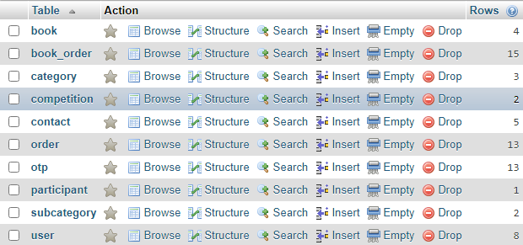

# Solution

A database was created to store book and user details, as well as keep track of orders. Entities and bridge-entities were created to normalize the database and keep data independent.

1. Details for Customers Only.

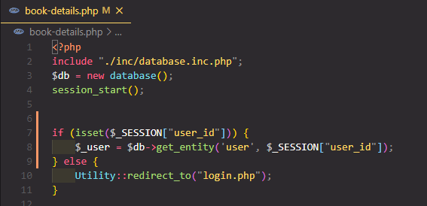  
Fig. 1

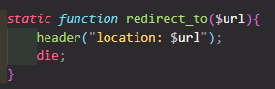  
Fig. 2

# Solution

A user can only fetch book details if he/she has logged in. Otherwise, the guest user will be redirected to the login page (Fig. 1). The *redirect_to()* function(Fig. 2) is a static function which is part of the *Utility* class. The function redirects the page to a URL *$url* and exits the current PHP script.

1. Uploading Book Details.

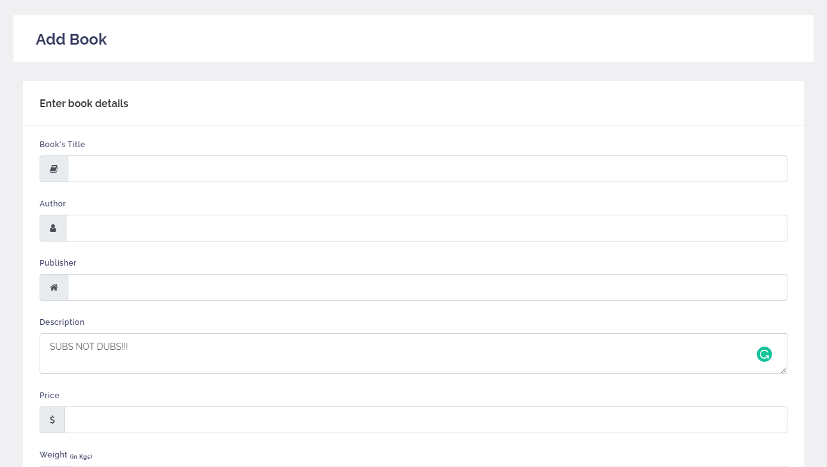

Solution  
  
The admin solely has the rights to uploading the book details, such as title, author, description, the stock, weight and price of the book.

Receipt of an Order.



# Solution

An email is sent to the user after the checkout procedure. He/she is sent an email acknowledging that the order has been received along with the order details, such as name of the user, address, and contact info. An OTP is also generated and sent through email along the confirm order page’s link, where the user can enter the provided OTP to confirm the order.

PDF after payment

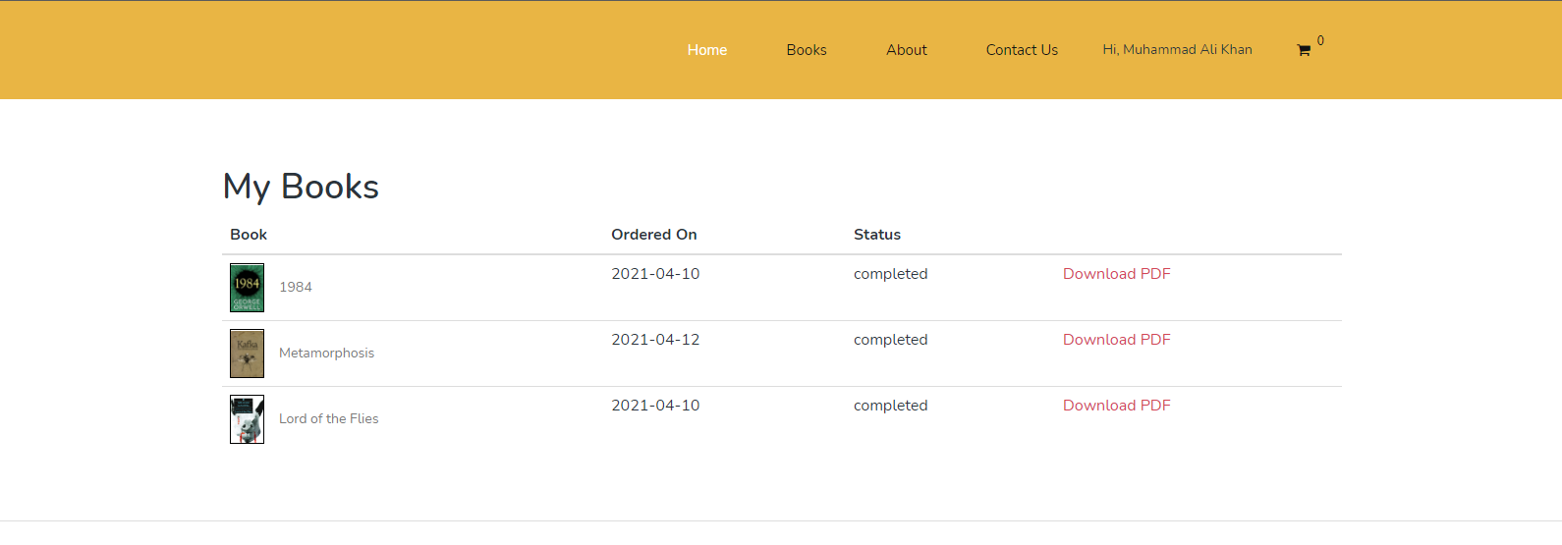  
Fig. 1

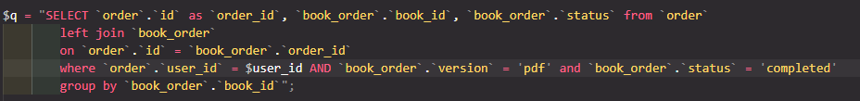  
Fig. 2

# Solution

The pdf is only shown after an order is completed and the payment is received (Fig. 1). This is done through a join query as shown in Fig. 2.

Dealer’s Contact Info



# Solution

The dealer’s contact info. is add on the book-details.php page so the user can directly contact the dealer, if he/she wants to buy the book from the shop in person.

Developer’s guide

# ERD (Entity Relationship Diagram)

This is an ERD generated by phpmyadmin’s designer tool. This shows the different entities and the relation b/w them. As shown below the database is normalized so as to reduce redundancies. For example, the `*book_order*` bridge entity, who’s purpose is to keep track of all the books in an order.

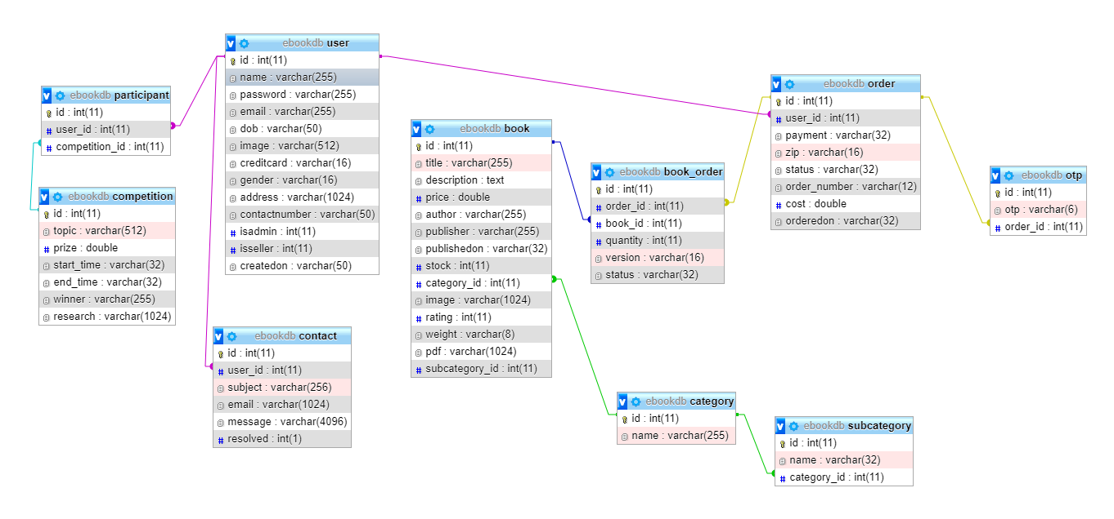

# Source Code & Flowcharts

The flowcharts below are a visual representation of the algorithms we wrote for this project.  
Screen shots of the source code is provided as well. The code maybe subject to change.

Checkout Process

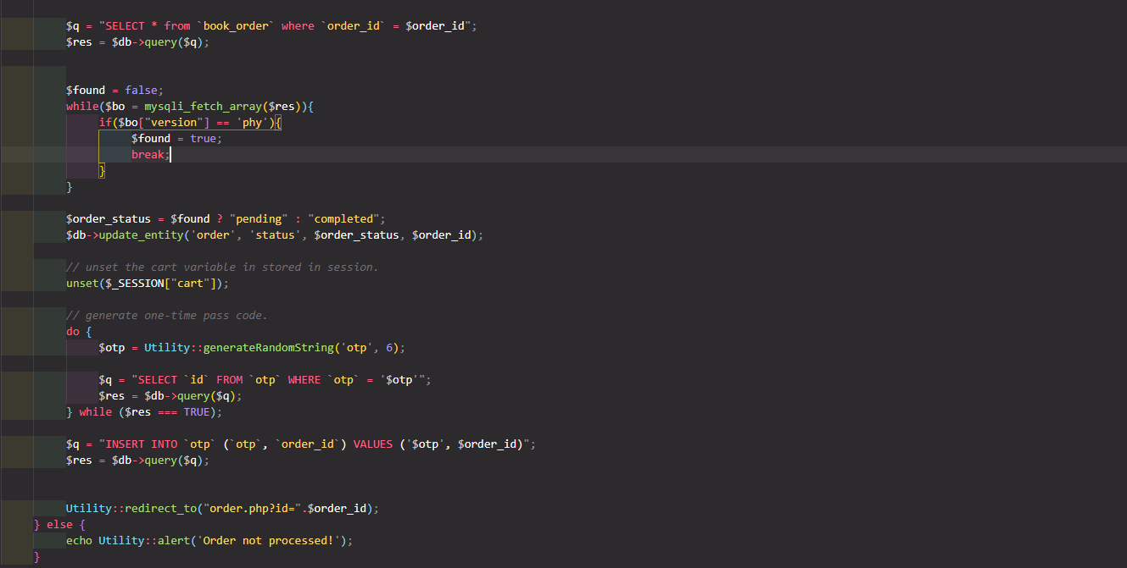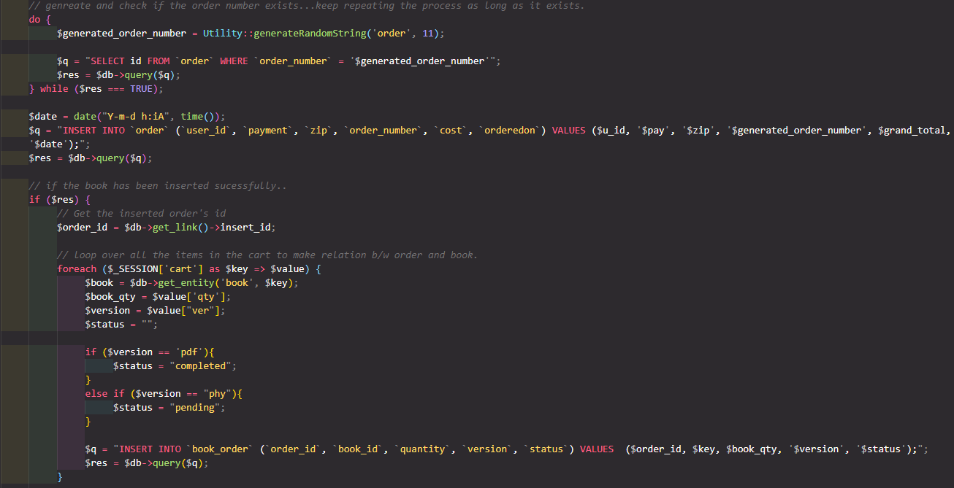

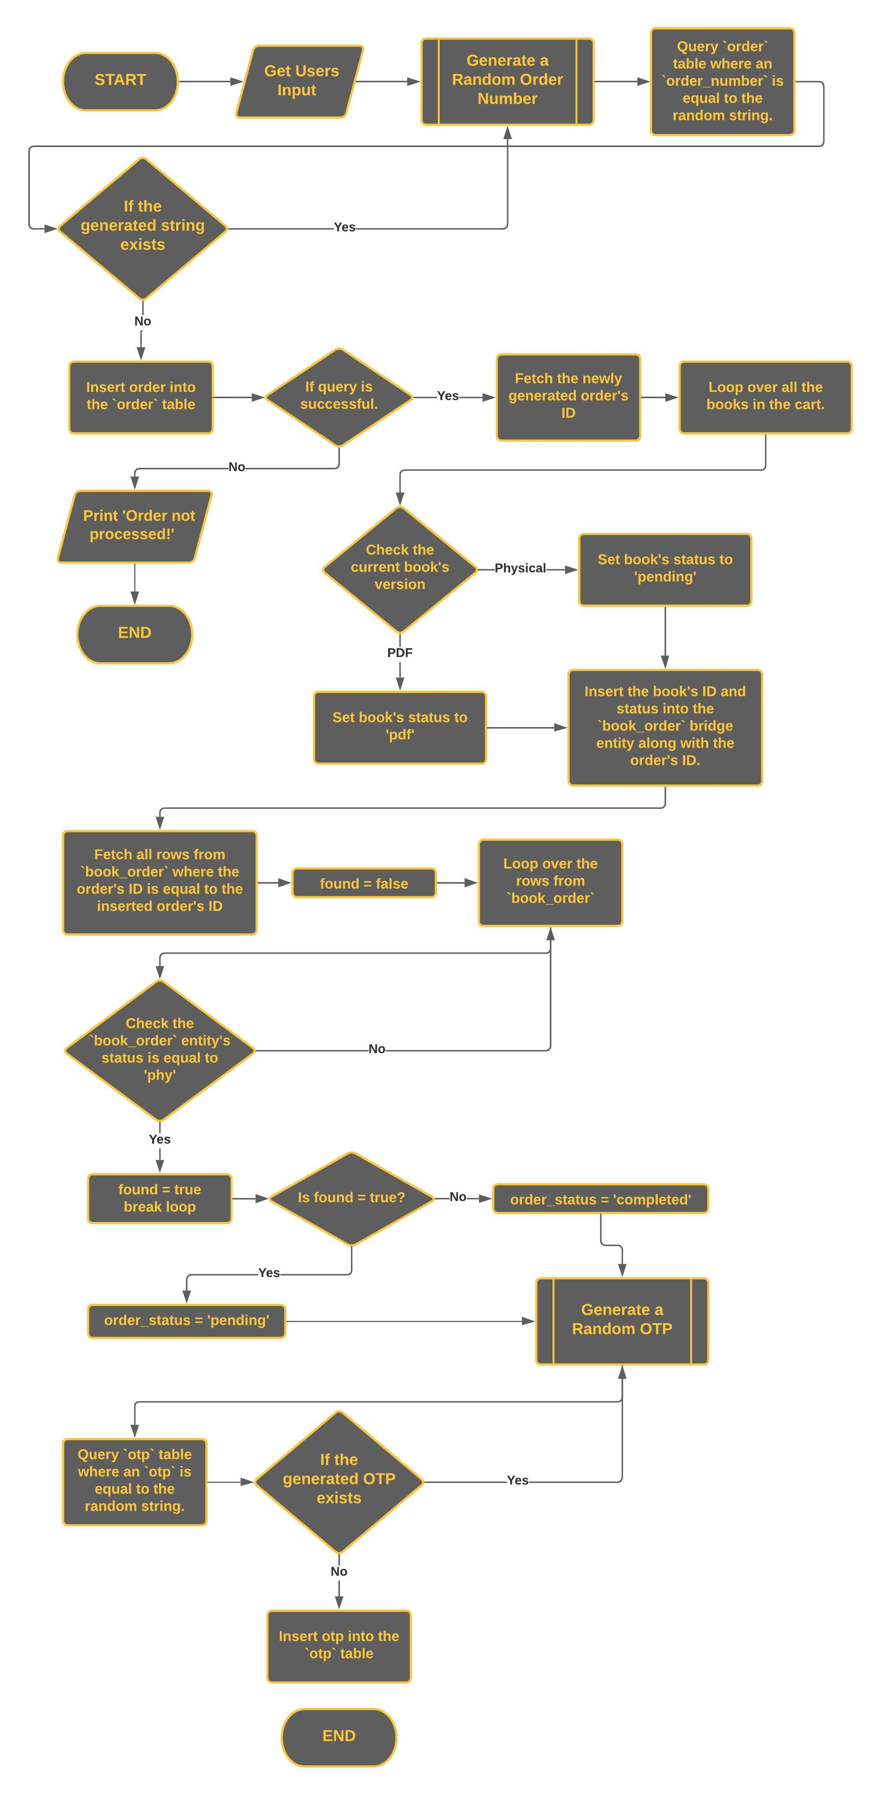

Random String Generation

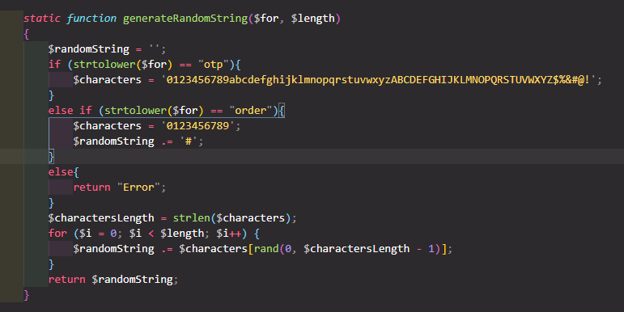

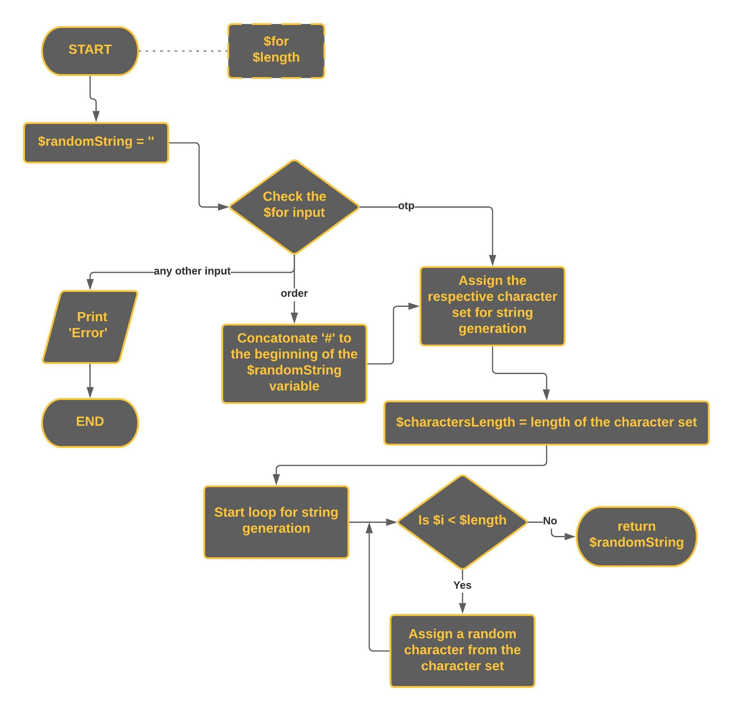

Book’s Sales Calculation

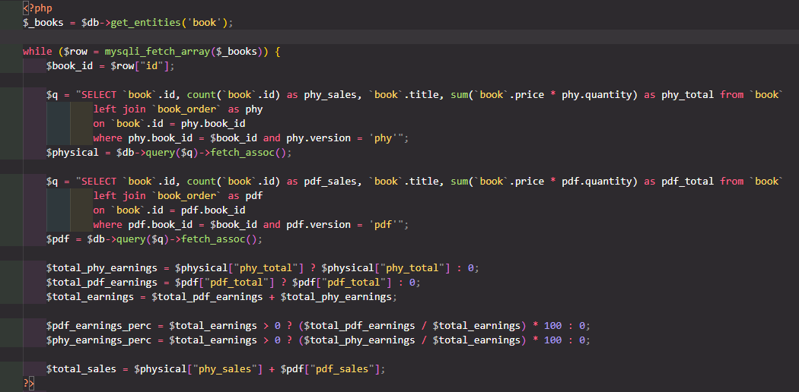

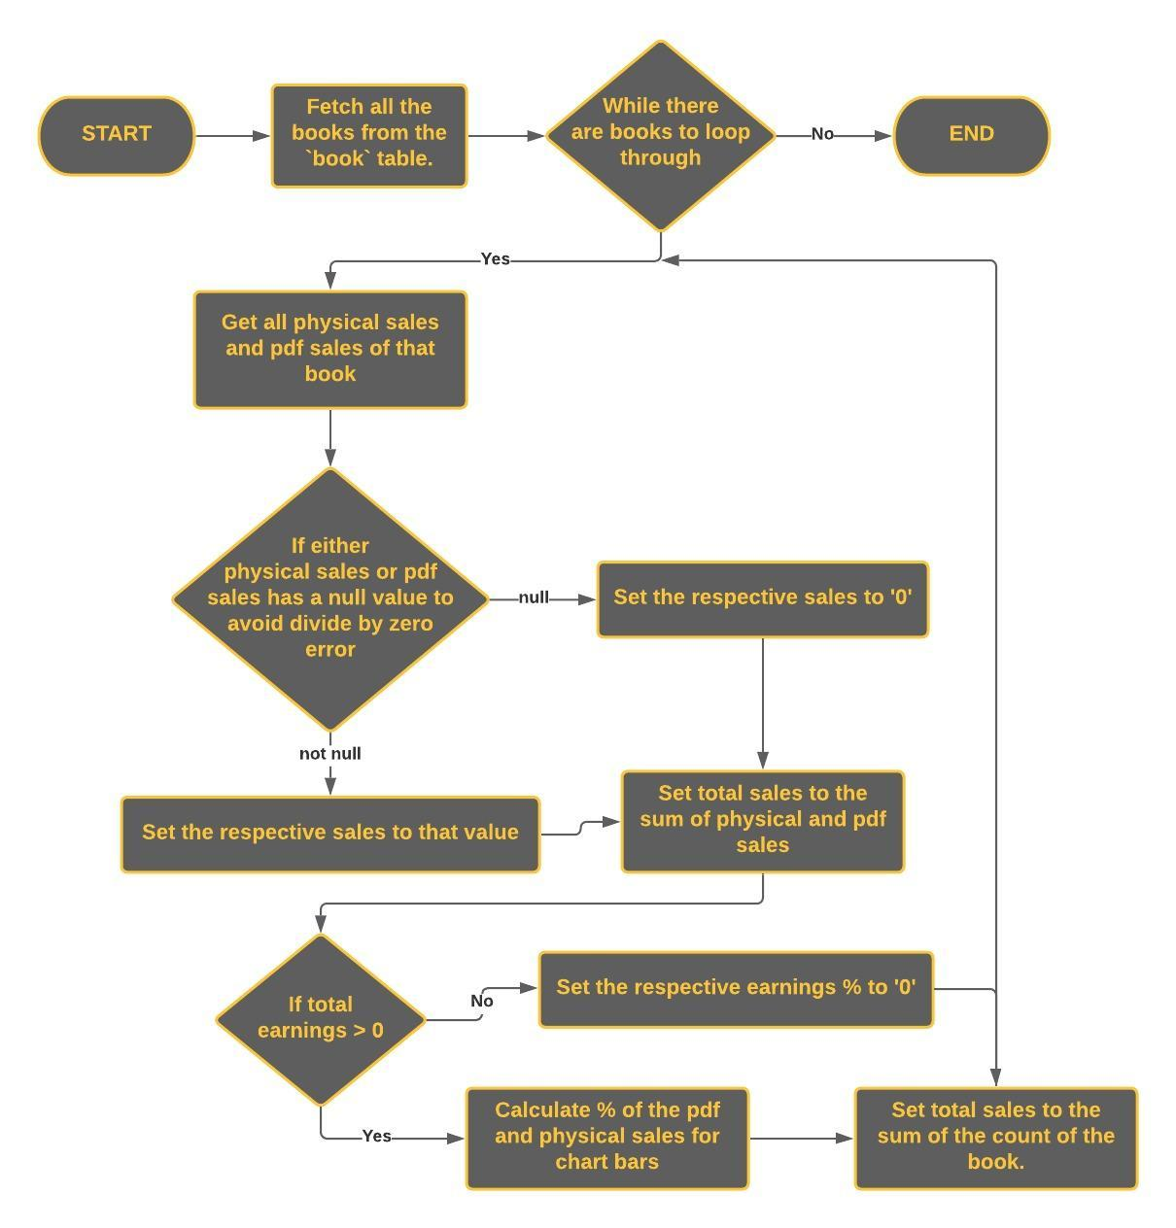

­­THANK YOU!