





­­­

E-Books

# Hamza Ahmed Rabia Sheikh Abdul Rafay Muhammad Ali Khan Supervised by Miss Nusrat

E-Project

Batch Code: PR-201910B2

Certificate of Completion



# This is to certify that

# **Hamza Ahmed Rabia Sheikh Abdul Rafay Muhammad Ali Khan**

# Have successfully designed and developed

## **E-Books**

## **Supervised by Miss Nusrat**

## **E-Project PR-201910B2**

Index

#### Acknowledgement 3

#### Project Analysis 4

#### Requirement Analysis 4

#### Requirement Gathering 4

#### Hardware / Software Requirement 4

#### Hardware 4

#### Software 4

#### HTML5 5

#### Sass 5

#### CSS3 6

#### Improvements 6

#### JavaScript 6

#### Requirement Specification 8

#### Suitable Logo 9

#### Links to Navigate 9

#### Categorization 10

#### Specifications 11

#### Gallery 12

#### Feedback 13

#### Downloadable Descriptions 14

#### User Guide 15

#### Developer’s Guide 16

#### Source Code (HTML) 17

#### Source Code (Sass) 23

ACKNOWLEDGMENT

Acknowledgment is not a mere formality but a genuine opportunity to thank all those people, whose active support made this project possible. We are thankful to Almighty Allah with his grace. The project that we are successfully presenting on “E-Books”. This project has been developed with the help of HTML5 / CSS3 / JS / PHP / MySQL. I would like to acknowledge all those who have given moral support and helped me to make this project a success. I wish to express my gratitude to Miss Nusrat for her valued guidance and support for the completion of this project.

And finally, I would like to offer many thanks to all my colleagues for their valuable suggestions and constructive feedback.

Project Analysis

# Requirement Analysis

Requirements analysis process is an important stage in the system development. It determines the functions of the whole system integrity and stability. Software Requirements analysis is an ongoing process of understanding and progressive refinement. Through requirements analysis Marina Fleet will be designed as below.

# Requirement Gathering

The purpose of this project is to create a website where the client can, with satisfaction, buy books either physical or an e-book version (pdf).

# HTML5

Hypertext Markup Language revision 5 (HTML5) is a markup language for the structure and presentation of World Wide Web contents. HTML5 supports the traditional HTML and XHTML style syntax and other new features in its markup, New APIs, XHTML and Error handling.

There are three organizations that are currently in charge of the specification of HTML5:

1. Web Hypertext Application Technology Working Group (WHATWG) created the HTML5 specification and is in charge of the HTML5 development that provides open collaboration of browser vendors and other involved parties.
2. World Wide Web Consortium (W3C) is in charge with delivering the HTML5 specification.
3. Internet Engineering Task Force (IETF) is in charge of the development of HTML5 Web Socket API.

# CSS3

Cascading Style Sheets Level 3 (CSS3) is an iteration of the CSS standard used in styling and formatting Web pages. CSS3 incorporates the CSS2 standard with some changes.

# **Improvements**

CSS3 makes changes to how some visual elements are implemented and rendered by the browser. However, it is not a single unwieldy specification, unlike CSS2. CSS3 Is separated into separate modules to facilitate development. This means that the specification comes out in   
chunks, with more stable modules than others. Some would be ready for recommendation, while others would be marked as under development drafts, the most recent of which were published as early as June 1999. Some of the major modules of CSS3 are:

* Box model
* Image values and replaced content
* Text effects
* Selectors
* Backgrounds and borders
* Animations
* User interface (UI)
* Multiple column layout
* 2D/3D transformations

# JavaScript

HTML pages are fine for displaying static content, e.g. a simple image or text. However, most pages nowadays are rarely static. Many of today’s pages have menus, forms, slideshows and even images that provide user interaction. JavaScript is the language employed by web developers to provide such interaction. Since JavaScript works with HTML pages, a developer needs to know HTML to harness this scripting language’s full potential. While there are other languages that can be used for scripting on the Web, in practice it is essentially all JavaScript.

# PHP

HTML pages are fine for displaying static content, e.g. a simple image or text. However, most pages nowadays are rarely static. Many of today’s pages have menus, forms, slideshows and even images that provide user interaction. JavaScript is the language employed by web developers to provide such interaction. Since JavaScript works with HTML pages, a developer needs to know HTML to harness this scripting language’s full potential. While there are other languages that can be used for scripting on the Web, in practice it is essentially all JavaScript.

# MySQL

HTML pages are fine for displaying static content, e.g. a simple image or text. However, most pages nowadays are rarely static. Many of today’s pages have menus, forms, slideshows and even images that provide user interaction. JavaScript is the language employed by web developers to provide such interaction. Since JavaScript works with HTML pages, a developer needs to know HTML to harness this scripting language’s full potential. While there are other languages that can be used for scripting on the Web, in practice it is essentially all JavaScript.

# Requirement Specification

**The website is to be created based on the following requirements.**

1. The Home Page should be created making use of Sections with a suitable logo, the header section can be added which will show images yachts and boats
2. The site must contain the links to navigate through any category for the information.
3. Links of fleets can be categorized like (Luxury, Sailing, and Fishing etc.)
4. Specification and Pricing of Yacht/Boat can be added along with the images.
5. Gallery section can be added for viewing different images.
6. Feedback must be allowed to enter by the viewer.
7. Site map, Gallery, about us, Queries link, Contact us link must be added.
8. The complete description must be allowed to get download as pdf or doc file.
9. The advertise section with various facilities provided should be mentioned.

Database.

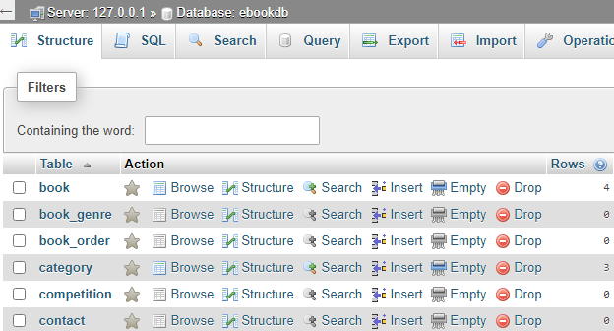

# Solution

A database was created to store book and user details, as well as keep track of orders. Entities and bridge-entities were created to normalize the database and keep data independent.

Details for Customers Only.

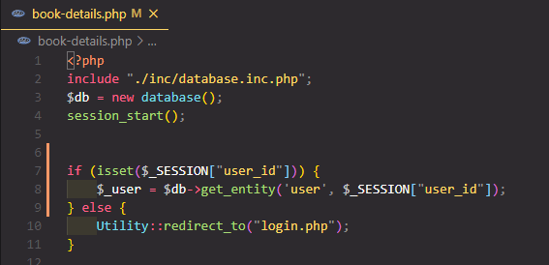  
Fig. 1

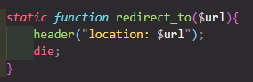  
Fig. 2

# Solution

A user can only fetch book details if he/she has logged in. Otherwise, the guest user will be redirected to the login page (Fig. 1). The *redirect_to()* function(Fig. 2) is a static function which is part of the *Utility* class. The function redirects the page to a URL *$url* and exits the current PHP script.

Uploading Book Details.

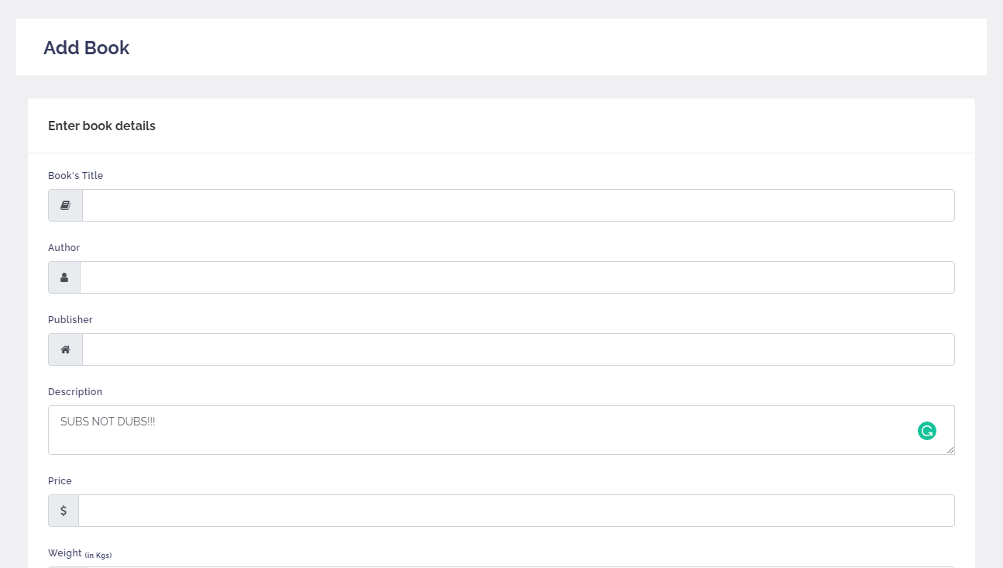

Solution  
  
The admin solely has the rights to uploading the book details, such as title, author, description, the stock, weight and price of the book.

Specifications

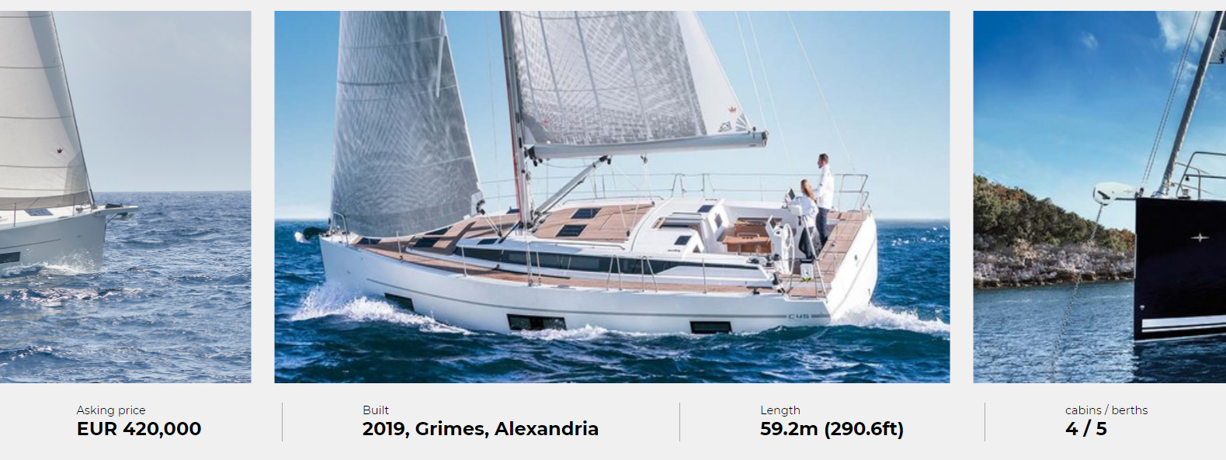

# Solution

Specifications such as price and size etc. of the boat are provided along with the images.

Gallery

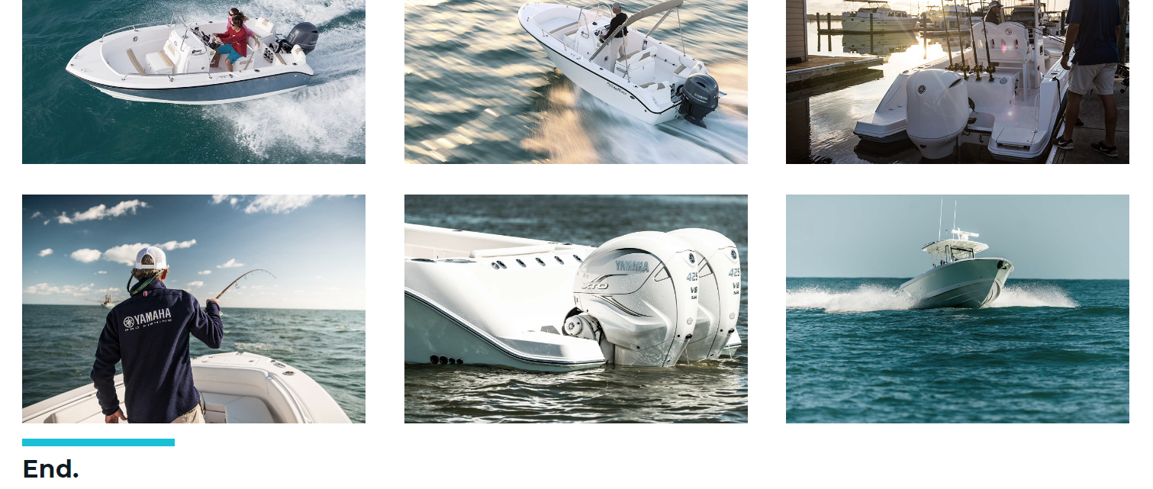

# Solution

A gallery is provided for viewing images of boats interior and exterior.

Feedback

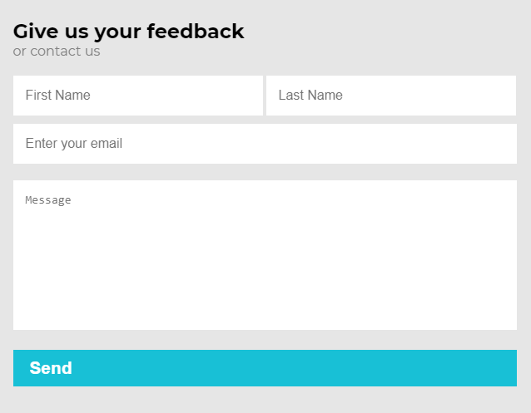

# Solution

A feedback section is provided for the user to give us his/her valued feedback. The inputs make use of patterns to limit user input so they don’t submit the wrong information.

Downloadable descriptions

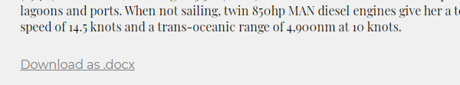

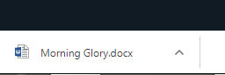

# Solution

A link created with an *anchor* tag (<a>) can be downloaded. To make the given *href* downloadable you have to put the *download* attribute in the *a* tag. E.g.

User guide

# Sitemap

**Lethansia**

**Morning Glory**

**Sycra V**

**Valquest**

**Yachts**

**Secret**

Developer’s guide

**170CC**

**340CC**

**280CC**

**230CC**

**188CC**

**370CC**

**Fishing boats**

**Sailing boats**

**Home**

**About**

**Ships**

**Gallery**

**Sitemap**

**Contact**

**The Bavaria C45**

**The Bavaria C50**

**The Bavaria Cruiser 46 Style**

**The Bavaria Easy 9.7**

**The Bavaria Vision 42**

**The Bavaria Vision 46**

**Sunrays**

Please note that the source code below doesn’t account for any last minute changes or minor tweaks made to either the HTML or CSS.

# Source Code (HTML)

Taken from index.html

<!DOCTYPE *html*>

<html *lang*="en">

<head>

    <meta *charset*="UTF-8">

    <meta *name*="viewport" *content*="width=device-width, initial-scale=1.0">

    <title>Home | Marina Fleet</title>

    <link *rel*="stylesheet" *href*="./css/main.css">

    <link *rel*="stylesheet" *href*="./css/animate.css">

    <script *defer* *src*="./js/main.js"></script>

</head>

<body>

    <div *id*="root">

*<!-- Dynamic Navbar (Hidden until the page is scrolled a certain amount.) -->*

        <div *class*="d-navbar" *id*="nav">

            <nav>

                <a *href*="index.html">

                    <div *id*="logo"><img *src*="./imgs/logo_marina_fleet.png" ></div>

                </a>

                <div *class*="nav-links">

                    <ul>

                        <li *class*="nav-link"><a *href*="index.html">Home</a></li>

                        <li *class*="nav-link"><a *href*="ships.html">Ships</a>

                            <div *class*="dropdown">

                                <ul>

                                    <li><a *href*="yachts.html">Yachts</a></li>

                                    <li><a *href*="sailing-boats.html">Sailing</a></li>

                                    <li><a *href*="fishing-boats.html">Fishing</a></li>

                                </ul>

                            </div>

                        </li>

                        <li *class*="nav-link"><a *href*="gallery.html">Gallery</a></li>

                        <li *class*="nav-link"><a *href*="sitemap.html">Sitemap</a></li>

                        <li *class*="nav-link"><a *href*="about.html">About</a></li>

                        <li *class*="nav-link"><a *href*="contact.html">Contact</a></li>

                    </ul>

                </div>

            </nav>

        </div>

*<!-- Header Section -->*

        <section *class*="header-sec" *id*="0">

*<!-- Static Navbar -->*

            <nav>

                <div *class*="nav-links">

                    <ul>

                        <li *class*="wow fadeInRight"><a *href*="index.html">Home</a></li>

                        <li *class*="wow fadeInRight"><a *href*="ships.html">Ships</a>

                            <div *class*="dropdown">

                                <ul>

                                    <li><a *href*="yachts.html">Yachts</a></li>

                                    <li><a *href*="sailing-boats.html">Sailing</a></li>

                                    <li><a *href*="fishing-boats.html">Fishing</a></li>

                                </ul>

                            </div>

                        </li>

                        <li *class*="wow fadeInRight"><a *href*="gallery.html">Gallery</a></li>

                        <li *class*="wow fadeInRight"><a *href*="sitemap.html">Sitemap</a></li>

                        <li *class*="wow fadeInRight"><a *href*="about.html">About</a></li>

                        <li *class*="wow fadeInRight"><a *href*="contact.html">Contact</a></li>

                    </ul>

                </div>

            </nav>

            <header>

                <video *src*="./vids/1477677945.mp4" *id*="vid" *autoplay* *muted* *loop*></video>

                <div *class*="box wow">

                    <h1 *class*="wow fadeIn" *data-wow-delay*="1.5s">Marina Fleet</h1>

                    <h2 *class*="wow fadeIn" *data-wow-delay*="1.75s">Discover the difference.</h2>

                    <div *class*="down-icon down" *onclick*="*scrollDown*(682*\**1)"><img

*src*="./imgs/icons/icons8-expand-arrow-24.png" >

                    </div>

                </div>

            </header>

        </section>

*<!-- About Section -->*

        <section *class*="about wow fadeIn" *data-wow-offset*="150">

            <div *class*="container">

                <img *src*="./imgs/heidi-fin-mHC0qJ7l-ls-unsplash.jpg" >

                <div *class*="text">

                    <h1>Mariana Fleet</h1>

                    <h2>Your great escape, with us.</h2>

                    <h3><a *href*="./about.html">Learn more about us</a></h3>

                    <div *class*="down-btn down" *onclick*="*scrollDown*(1280)"><img *src*="./imgs/icons/icons8-expand-arrow-24.png"

                        ></div>

                </div>

            </div>

        </section>

*<!-- Yachts -->*

        <section *class*="sec wow fadeInRight" *data-wow-offset*="150" *id*="1">

            <div *class*="info-box wow fadeIn" *data-wow-offset*="150" *data-wow-delay*="1s">

                <h3>Buy a yacht</h3>

                <h2>Your great escape. <br>

                    Tailored by Us.</h2>

                <p>Cruise in inimitable style and experience real <br> freedom. The adventure of a lifetime awaits

                    aboard <br> the

                    world’s greatest superyachts.</p>

                <a *href*="./yachts.html">

                    <h4>Yachts</h4>

                    <div *class*="more-icon"><img *src*="./imgs/icons/icons8-more-than-50.png" *width*="20" *height*="20"

                            >

                    </div>

                </a>

                <div *class*="down-btn down" *onclick*="*scrollDown*(1963)"><img *src*="./imgs/icons/icons8-expand-arrow-24.png"

                        ></div>

            </div>

            <div *class*="section-img">

                <img *src*="./imgs/nikldn-t-6GW8T6Jsc-unsplash.jpg" *height*="170%" *width*="100%" >

                <div *class*="box">

                    <h1>Unforgettable.</h1>

                </div>

            </div>

        </section>

*<!-- Sailing Boats -->*

        <section *class*="sec wow fadeInLeft" *data-wow-offset*="150" *id*="2">

            <div *class*="section-img">

                <img *src*="./imgs/armand-khoury-4qr3dUPTpOc-unsplash.jpg" *height*="240%" *style*="margin-top: -180px;"

*width*="100%" >

                <div *class*="box">

                    <h1>Escape.</h1>

                </div>

            </div>

            <div *class*="info-box wow fadeIn" *data-wow-offset*="150" *data-wow-delay*="1s">

                <h3>Buy a sailing boat</h3>

                <h2>Your life. Spent wisely.</h2>

                <p>From the global fleet of sailing boats offered for sale, we <br> hand-pick the best opportunities and

                    share

                    our expert <br> knowledge, so that you can make the best decisions.</p>

                <h4>Sailing boats</h4>

                <div *class*="more-icon"><img *src*="./imgs/icons/icons8-more-than-50.png" *width*="20" *height*="20" >

                </div>

                <div *class*="down-btn down" *onclick*="*scrollDown*(2645)"><img *src*="./imgs/icons/icons8-expand-arrow-24.png"

                        ></div>

            </div>

        </section>

*<!-- Fishing Boats -->*

        <section *class*="sec wow fadeInRight" *data-wow-offset*="150" *id*="3">

            <div *class*="info-box wow fadeIn" *data-wow-offset*="150" *data-wow-delay*="1s">

                <h3>Buy a fishing boat</h3>

                <h2>Capturing perfection.</h2>

                <p>Our market-leading intelligence paired with our unrivalled client database guarantees the smoothest

                    <br> of sales. Every time.</p>

                <h4>Fishing boat</h4>

                <div *class*="more-icon"><img *src*="./imgs/icons/icons8-more-than-50.png" *width*="20" *height*="20" >

                </div>

                <div *class*="down-btn down" *onclick*="*scrollDown*((3326))"><img *src*="./imgs/icons/icons8-expand-arrow-24.png"

                        ></div>

            </div>

            <div *class*="section-img">

                <img *src*="./imgs/thomas-millot-VdBFg55sVQw-unsplash.jpg" *height*="110%" *width*="100%" >

                <div *class*="box">

                    <h1>Success.</h1>

                </div>

            </div>

        </section>

*<!-- Feedback -->*

        <section *class*="feedback wow fadeIn">

            <div *class*="form">

                <form *action*="" *id*="feedback-form">

                    <h1>Give us your feedback</h1> <p><a *style*="color: gray;" *href*="contact.html">or contact us</a></p>

                    <tr>

                        <td><input *type*="text" *pattern*="[a-zA-Z]{3,50}" *class*="form-name" *placeholder*="First Name"

*required*></td>

                        <td><input *type*="text" *pattern*="[a-zA-Z]{3,50}" *class*="form-name" *placeholder*="Last Name"

*required*></td>

                    </tr>

                    <tr>

                        <td><input *type*="email" *placeholder*="Enter your email" *required*></td>

                    </tr>

                    <tr>

                        <td><textarea *placeholder*="Message" *required*></textarea></td>

                    </tr>

                    <tr>

                        <td>

                            <input *type*="submit" *onclick*="*feedback*()" *value*="Send">

                        </td>

                    </tr>

                </form>

            </div>

        </section>

*<!-- News Letter -->*

        <section *class*="newsletter wow pulse" *data-wow-iteration*="2">

            <h1>Sign up to our newsletter</h1>

            <form *id*="form">

                <input *type*="email" *placeholder*="Enter your email address" *id*="email" *required*>

                <input *type*="submit" *value*="" *id*="submit">

            </form>

        </section>

*<!-- Footer -->*

        <footer>

            <div *id*="left">

                <a *href*="#">Terms of use</a>

                <a *href*="#">Privacy policy</a>

                <a *href*="#">Careers</a>

                <a *href*="#">Sitemap</a>

                <div *style*="color: rgb(175, 175, 175);">© 2020</div>

            </div>

            <div *id*="right">

                <a *href*="https://facebook.com" *target*="_blank"><img

*src*="./imgs/icons/social-media/icons8-facebook-30.png" ></a>

                <a *href*="https://instagram.com" *target*="_blank"><img

*src*="./imgs/icons/social-media/icons8-instagram-30.png" ></a>

                <a *href*="https://youtube.com" *target*="_blank"><img

*src*="./imgs/icons/social-media/icons8-play-button-30.png" ></a>

                <a *href*="https://twitter.com" *target*="_blank"><img *src*="./imgs/icons/social-media/icons8-twitter-30.png"

                        ></a>

            </div>

        </footer>

    </div>

    <script *src*="./js/main.js"></script>

    <script *src*="./js/wow.js"></script>

    <script>

*new* WOW().*init*();

    </script>

</body>

</html>

# Source Code (Sass)

Taken from main.scss

*@import* 'variables', 'mixins', 'fonts';

*.box*{

    border: 3*px* solid white;

    position: relative;

    height: 80*vh*;

    width: 90*%*;

    color: white;

*@include* *flex-center*();

    flex-direction: column;

}

*{

    margin: 0;

    padding: 0;

    box-sizing: border-box;

    text-decoration: none;

    scroll-behavior: smooth;

}

h1, h2, h3, h4, h5, h6, a, p{

    font-family: 'Montserrat', sans-serif;

}

video{

    position: absolute;

    z-index: -1;

    width: 100*%*;

}

*#root*{

    width: 100*%*;

    height: auto;

}

*.d-navbar*{

    width: 100*%*;

    height: 10*vh*;

    background-color: white;

    position: fixed;

    top: -20*vh*;

    transition: top .5*s*;

    z-index: 1000;

    box-shadow: 0 2*px* 8*px* *$theme-box-shadow*;

*#logo*{

        height: 10*vh*;

        width: 396*px*;

        background-color: *$theme-color1*;

        float: left;

*@include* *flex-center*;

    }

    nav ul *.nav-link*{

        margin-left: 30*px*;

    }

    nav ul li a{

        color: black;

    }

*.menu-icon*{

        filter: none;

    }

*.enq-icon*{

        img{

        filter:invert(100*%*);

        }

    }

*.dropdown* ul li*:hover* a{

        color: white;

    }

}

*.header-sec*{

    position: relative;

    height: 100*vh*;

    width: 100*%*;

    overflow: hidden;

    background-image: linear-gradient(rgba(0,0,0,.15),rgba(0,0,0,0));

    video{

        width: 100*%*;

    }

*.menu-icon*{

        height: 20*px*;

        width: 25*px*;

        filter: invert(100*%*);

    }

    header{

        height: 80*vh*;

        width: 100*%*;

*.box*{

*@extend* *.box*;

            h1{

                text-transform: uppercase;

                font-size: 8*em*;

                letter-spacing: 10*px*;

                font-weight: 700;

            }

            h2{

                font-size: 2*em*;

                position: relative;

                top: 50*px*;

                letter-spacing: 2*px*;

            }

*.down-icon*{

                position: relative;

                height: 24*px*;

                width: 24*px*;

                filter: invert(100*%*);

                top: 70*px*;

                animation: updown 1.5*s* ease-in-out infinite;

            }

            animation: box-expand 1.5*s* ease-in-out forwards;

        }

    }

}

*@keyframes* *box-expand*{

*0%*{

        height: 0;

        width: 0;

    }

*15%*{

        height: 0;

        width: 0;

    }

*50%*{

        height: 100*%*;

        width: 0;

    }

*100%*{

        height: 100*%*;

        width: 90*%*;

    }

}

*@keyframes* *updown*{

*0%*{

        top: 70*px*;

    }

*50%*{

        top: 80*px*;

    }

*100%*{

        top: 70*px*;

    }

}

header{

*@include* *flex-center*();

}

nav

{

    height: 10*vh*;

    width: 90*%*;

    margin-left: 5*%*;

*.nav-links*

    {

        float: left;

        width: 50*%*;

        height: 100*%*;

*.menu-icon*{

            height: 20*px*;

            width: 20*px*;

        }

    }

    ul

    {

        width: 100*%*;

        height: 100*%*;

        list-style: none;

        display: flex;

        justify-content: left;

        align-items: center;

        li

        {

            margin-right: 40*px*;

            padding: 10*px* 0*px*;

            cursor: pointer;

            position: relative;

            &*::after*

            {

                content: '';

                display: block;

                position: relative;

                transform: translateX(-50*%*);

                height: 2*px*;

                width: 0;

                left: 50*%*;

                background-color: white;

                transition: .2*s* ease-in-out;

            }

            &*:hover::after*

            {

                width: 100*%*;

            }

            a

            {

                color: white;

                font-weight: 300;

            }

            &*:hover* *.dropdown*

            {

                opacity: 1;

                pointer-events: all;

                top: 100*%*;

                left: 0;

            }

        }

    }

­­THANK YOU!