188CC

USD 315,000

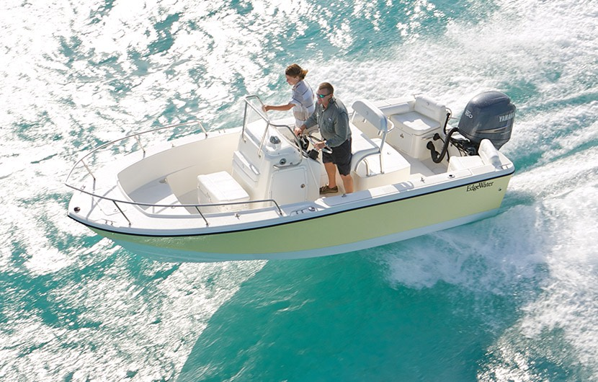

## Asking price: **USD 135,000**

## Built: **1996 (refitted 2007), Miami, U.S**

## Length: **30m (67.8ft)**

# Description:

### The rougher the weather the more you will appreciate cruising in a 188CC. Thanks to a deep V hull design, it performs brilliantly in a chop, shrugging off waves and keeping all your passengers dry and perfectly comfortable. Whether you want to take the entire gang out to an island to work on their tans or run offshore to spend the day fishing or exploring the deep depths of the ocean, the EdgeWater 188CC deep V hull gives you the versatility and confidence to go anywhere you want to.