280CC

USD 225,000

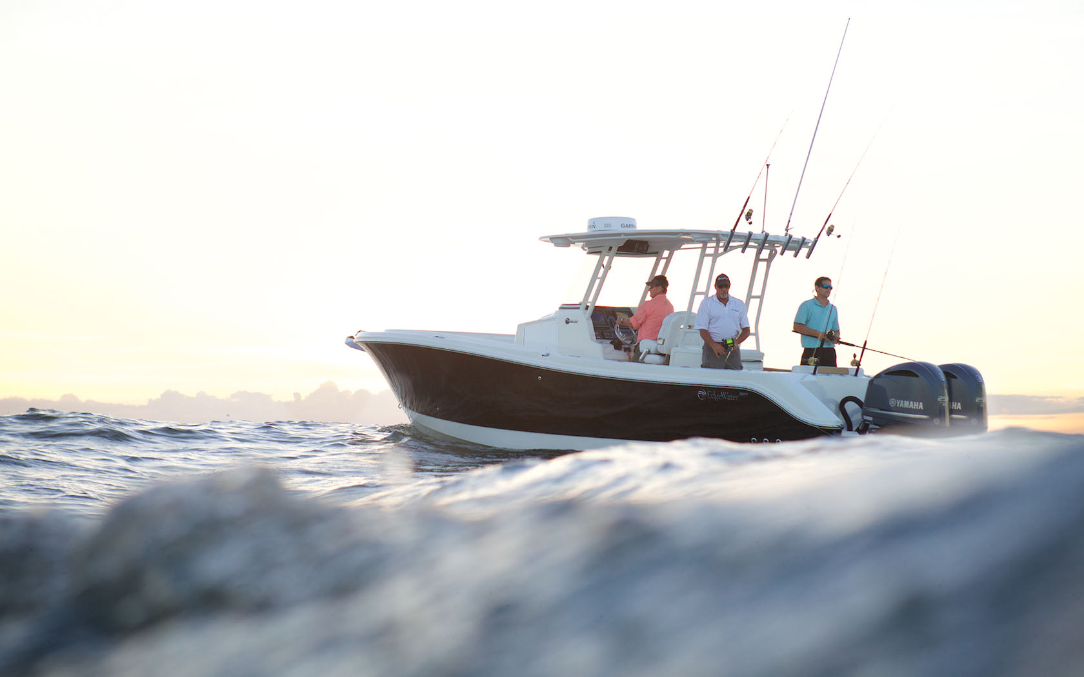

## Asking price: **USD 225,000**

## Built: **1999 (refitted 2007), Florida, U.S**

## Length: **30m (67.8ft)**

# Description:

### Originally introduced to fill a gap in the market, this boat does that and more. This large, center console boat, coupled with Single Piece Infusion or SPI, leads to a strong, superior performing boat in all conditions. A “ClearView” custom engineered windshield was specifically designed for this boat allowing for an improved line of sight for spotting that coveted game fish or added comfort when pulling up to a secluded island. This boat is sure to provide for everyone you bring along with its plush walk-in console complete with a head and a pull out shower.