340CC

USD 325,000

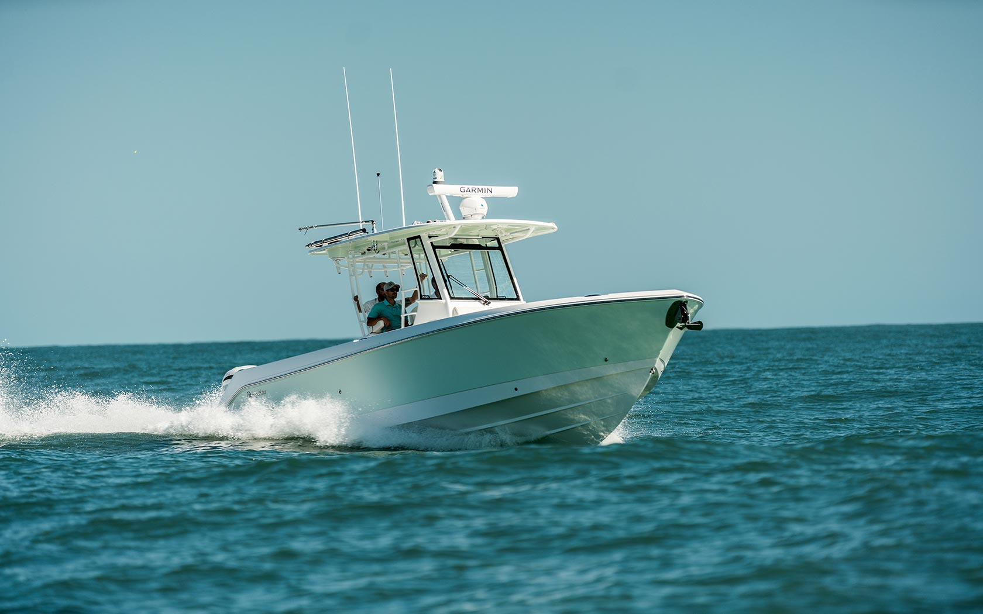

## Asking price: **USD 325,000**

## Built: **1999 (refitted 2007), Florida, U.S**

## Length: **30m (67.8ft)**

# Description:

### The Beast is awake. The 340CC is our newest model and will be premiering at the 2019 Fort Lauderdale Boat Show (Booth 2025) and Miami International Boat Show. This boat is chock-full of standard features and options that are top-notch for the family and angler. It’s a center console that can rip through the blue with its optional engine setup of twin Yamaha XTO 425hp. The optional Seakeeper can keep her even steadier in rocky conditions. Dressed to the nines in the latest Garmin electronics. Rod holders every which way you look. The console head has plenty of storage and an impressive amount of room.

### The leaning post has standard features that others would call options. But, we have those, too. The salty version of the leaning post has an aquarium livewell and tackle drawers mixed with a classy Corian countertop and cutting board. And for the family, from its plush forward sunpad lounge seat to the bow area to host dinners around the easy-to-use stowaway bow table, it’s hard not to keep bringing this boat to the water every day.