370CC

USD 315,000

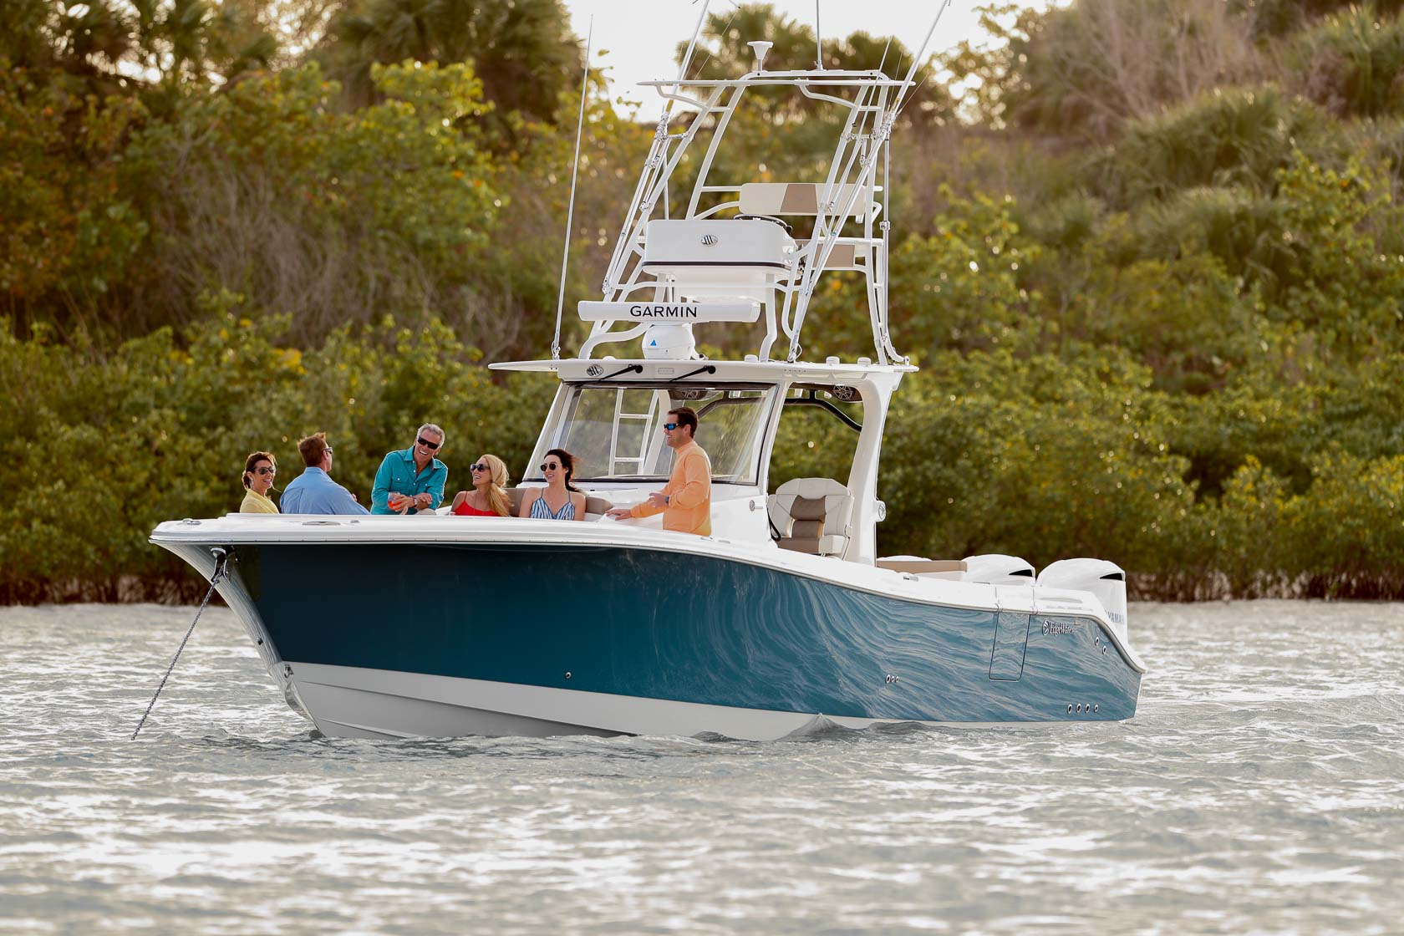

## Asking price: **USD 315,000**

## Built: **1996 (refitted 2007), Florida, U.S**

## Length: **30m (67.8ft)**

# Description:

### A rare combination of luxury and superior performance in a power boat. EdgeWater is proud to introduce the exciting new 370CC. Built using Single-Piece Infusion, or SPI, enabled us to create a lighter, more efficient, more environmentally sensitive power boat. Interior cabin loaded with everything one would need for a couple’s getaway. Designed for fishing, entertaining, and cruising. The 370 is in class of its own and will satisfy the most discerning owner.