Lethantia

EUR 8,250,000

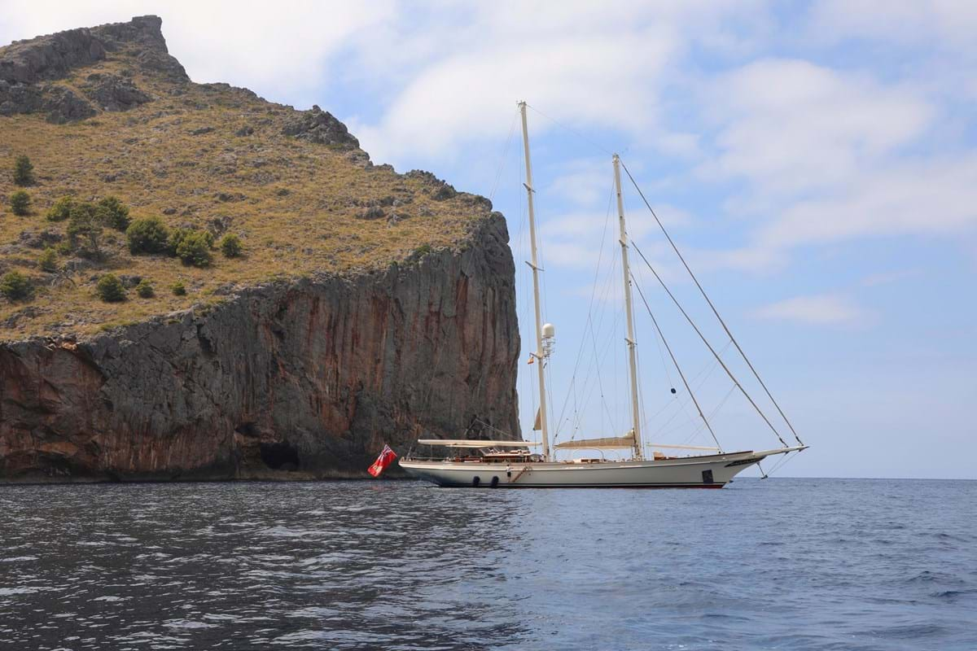

## Asking price: **EUR 8,250,000**

## Built: **1994 (refitted 2019), Royal Huisman Shipyard, Netherlands**

## Length: **43.9m (144ft)**

## Guests: **6 in 3 cabins**

# Description:

### The 43.9m (144ft) ketch LETHANTIA was built in aluminium and delivered in 1994 by revered Dutch shipyard Royal Huisman. Naval architecture and exterior design are by Lunstroo Custom Design and interiors are by the celebrated British designer John Munford. A 2017 refit post purchase saw the yacht repainted with Awlgrip, her rigs serviced and painted. And further works carried out in 2019. Having been professionally operated, maintained and serviced since delivery, she presents in excellent condition.

A pleasing sheer arcs from her wineglass stern to her 4m bowsprit and there is plenty of versatile deck space to enjoy once at anchor. Cockpit seating for her six guests is shaded by a collapsible bimini.

Steps lead down into the deckhouse where there is saloon dining to port and seating to starboard, an opening skylight to illuminate the cabinetry and views out onto the anchorage. From there steps lead forward into the main saloon where there is a forma dining area to port and a lounge area to starboard, cocooned in teak and cherry wood, again lit by a generous opening skylight.

She accommodates six guests. The full beam owner's suite, reconfigured in 2017 to include a king size double berth, is aft, down steps from the deckhouse. It is en suite and two large decklights provide natural light. Forward of the main saloon are two double cabins, also en suite and each with a decklight. She also sleeps six crew in quarters forward with separate deck access.

Two aluminium masts by Rondal carry 720sqm (7,750sqft) of sails, by North Sails and Hood and all sails are handled by modern hydraulic operated furlers, captive drum and reel winches so she is easily managed by a shorthanded crew. In calms a single 650hp MTU diesel engine gives her a top speed of 13 knots and a cruising speed of 10 knots.

This yacht is of exceptional quality throughout. Asking EUR 8,250,000 with EU VAT paid, she is lying in Palma where a virtual tour can be arranged.

# Key features:

* A mod*ern classic schooner designed to be easily sailed*
* *Comfortable voluminous interior*
* *Classic John Munford interior design*
* *Fantastic Dutch pedigree*
* *Fully redesigned master cabin*