Secret

EUR 99,000,000

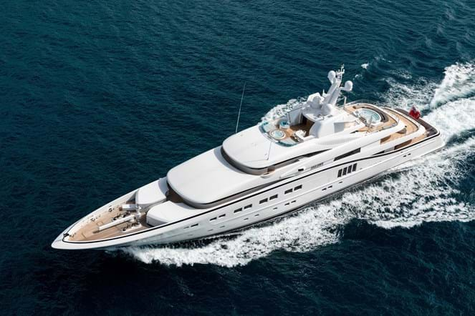

## Asking price: **EUR 99,000,000**

## Built: **2013 (refitted 2018), Abeking, Germany**

## Length: **85.5m (280.4ft)**

## Guests: **18 in 9 cabins**

# Description:

### Commissioned and operated by an experienced yacht owner, SECRET has consistently been maintained to a very high standard. Having completed her 5-year Class Survey in 2018 and a full repaint in 2017, SECRET is in turnkey condition and ready for a new owner.

This outstanding 82.5 meter Abeking & Rasmussen combines exceptional craftsmanship with striking exterior lines by the acclaimed Sam Sorgiovanni. SECRET accommodates 12 guests in 6 cabins with an additional 7th guest-finished cabin accommodating 3 children or staff.

She offers several luxurious features including a cinema, gymnasium, elevator, massage room, and two large tenders. This yacht is capable of taking its Owner and guests global cruising in the most luxurious of style.

# Key features:

* Interior design by Jim Harris with exterior by acclaimed Sam Sorgiovanni
* Fully equipped gym on the bridge deck
* Large cinema with 1000+ movies
* Massage room on the main deck
* Versatile deck space across five decks
* Consistently maintained to the highest standards