Sunrays

EUR 129,000,000

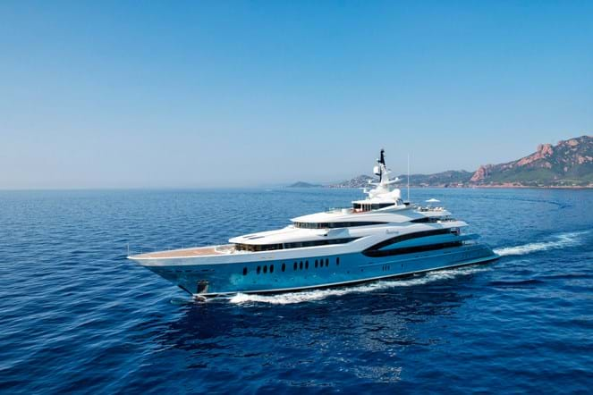

## Asking price: **EUR 125,000,000**

## Built: **2010 (refitted 2019), Oceanco, Netherlands**

## Length: **85.5m (280.4ft)**

## Guests: **18 in 9 cabins**

# Description:

### Distinctive in every way, the 85.5m (280.4ft) SUNRAYS redefines opulence. With flowing lines and an elegant teal blue hull she is known for her good looks, but she also has the powerful cruising capabilities inherent in an Oceanco build. Delivered in 2010 and maintained to the highest standards on a regular works programme, she is in pristine condition having also undertaken a complete overhaul in 2018.

Designed by Terence Disdale, her elegant interior is a blend of mid-tones with an ethnic Oriental influence, and with 2,867GT of interior volume she offers an abundance of facilities. Her six deck areas include an entire deck dedicated to wellness with a hammam and sauna, a lounge that converts to a cinema, and a spacious main saloon comprising a lounge and formal dining area.

Throughout the main living areas secret panels allow for rooms to be interconnected thereby creating large entertaining areas or intimate lounges. Nine suites include an owner’s suite on the upper deck, with a private terrace and jacuzzi, and an adjoining VIP suite with private balcony. The owner’s area also has an additional space for a third cabin allowing for flexibility. SUNRAYS was specifically designed for family use and as such every guest area allows for multi-functional entertaining spaces and flexible accommodation. A second VIP suite is located on the main deck along with two double and two twin cabins, while a third VIP suite on the lower deck has a private sea-level balcony.

Out on deck there are no less than four jacuzzi pools including a large double pool on the main deck surrounded by sunpads, and a large oval jacuzzi pool on the sun deck. She also has an elevator, a helipad, inside-outside gym and a beach club area.

Powered by twin 4,680hp MTU 16V595TE70 diesel engines, SUNRAYS has a top speed of 19 knots. She also has an economical range of 5,500 nautical miles while cruising at 14 knots. Still in her original ownership, and owner of an excellent charter record, SUNRAYS is one of the finest northern European large yachts for sale on the market today.

# Key features:

* Up to 22 guests when privately used
* Excellent proven charter platform
* Striking Johansson / Disdale design
* Helipad suitable for an EC 145 or similar
* Lift / Gym / Spa / Extensive water sports
* Still in original ownership
* Substantial 2018 refit
* Wheelchair friendly