Valquest

EUR 9,250,000

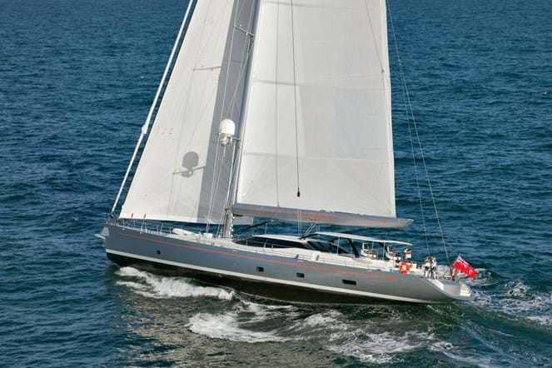

## Asking price: **EUR 9,250,000**

## Built: **1994 (refitted 2019), Van Breeman, Netherlands**

## Length: **40.9m (133ft)**

## Guests: **9 in 4 cabins**

# Description:

### Launched by Bloemsma van Bremen in 2009 from the drawing boards of Dubois Naval Architects, VALQUEST is a high performance aluminium sailing yacht boasting a low profile deck house. Her elegant but simple interior design features high quality mahogany and a white leather finish throughout. She accommodates nine guests in four cabins, comprising of a large master suite, two doubles and one twin.

# Key features:

* *Designed by Dubois Naval Architects*
* *Split level saloon and separate dining area*
* *Completely repainted and new sails in 2016*
* *Lloyd's 10 year Special Survey complete in 2019*
* *Accommodation for up to 9 guests in 4 cabins (1 master, 2 doubles and 1 twin)*
* *Range 3,000nm at economical speed*
* *Lloyds Register classification + 100A1 LMC*
* *2 x Tenders (foredeck and aft peak)*