Unit 2: Networking
Corrected Report: Activities 2, 3 and 4
Principles and Design of Networked Systems
Auraq Books Publishers Ltd

Activity 2: Network Design and Implementation Plan

2.1 Introduction
This implementation plan designs a secure and efficient networked system for Auraq Books Publishers Ltd. The scenario requires ABP to close one office building, reorganise the remaining building, support hybrid working and preserve the existing security model for four publishing teams. The design therefore needs to support a top-floor data centre, middle-floor network room and meeting rooms, ground-floor hot desks, secure author manuscript handling, cloud-based office software, VPN connectivity and robust backup facilities.
The proposed design is a hierarchical star network implemented virtually in Cisco Packet Tracer. It uses a router/firewall edge, a Layer 3 core switch, floor-level access switches, VLAN segmentation, role-based access rules, DHCP, DNS, internal server addressing, wireless segmentation and a simulated VPN remote-user network. This approach is appropriate because ABP does not only need connectivity; it needs controlled connectivity where each team, user group and server zone receives only the access required for its role.

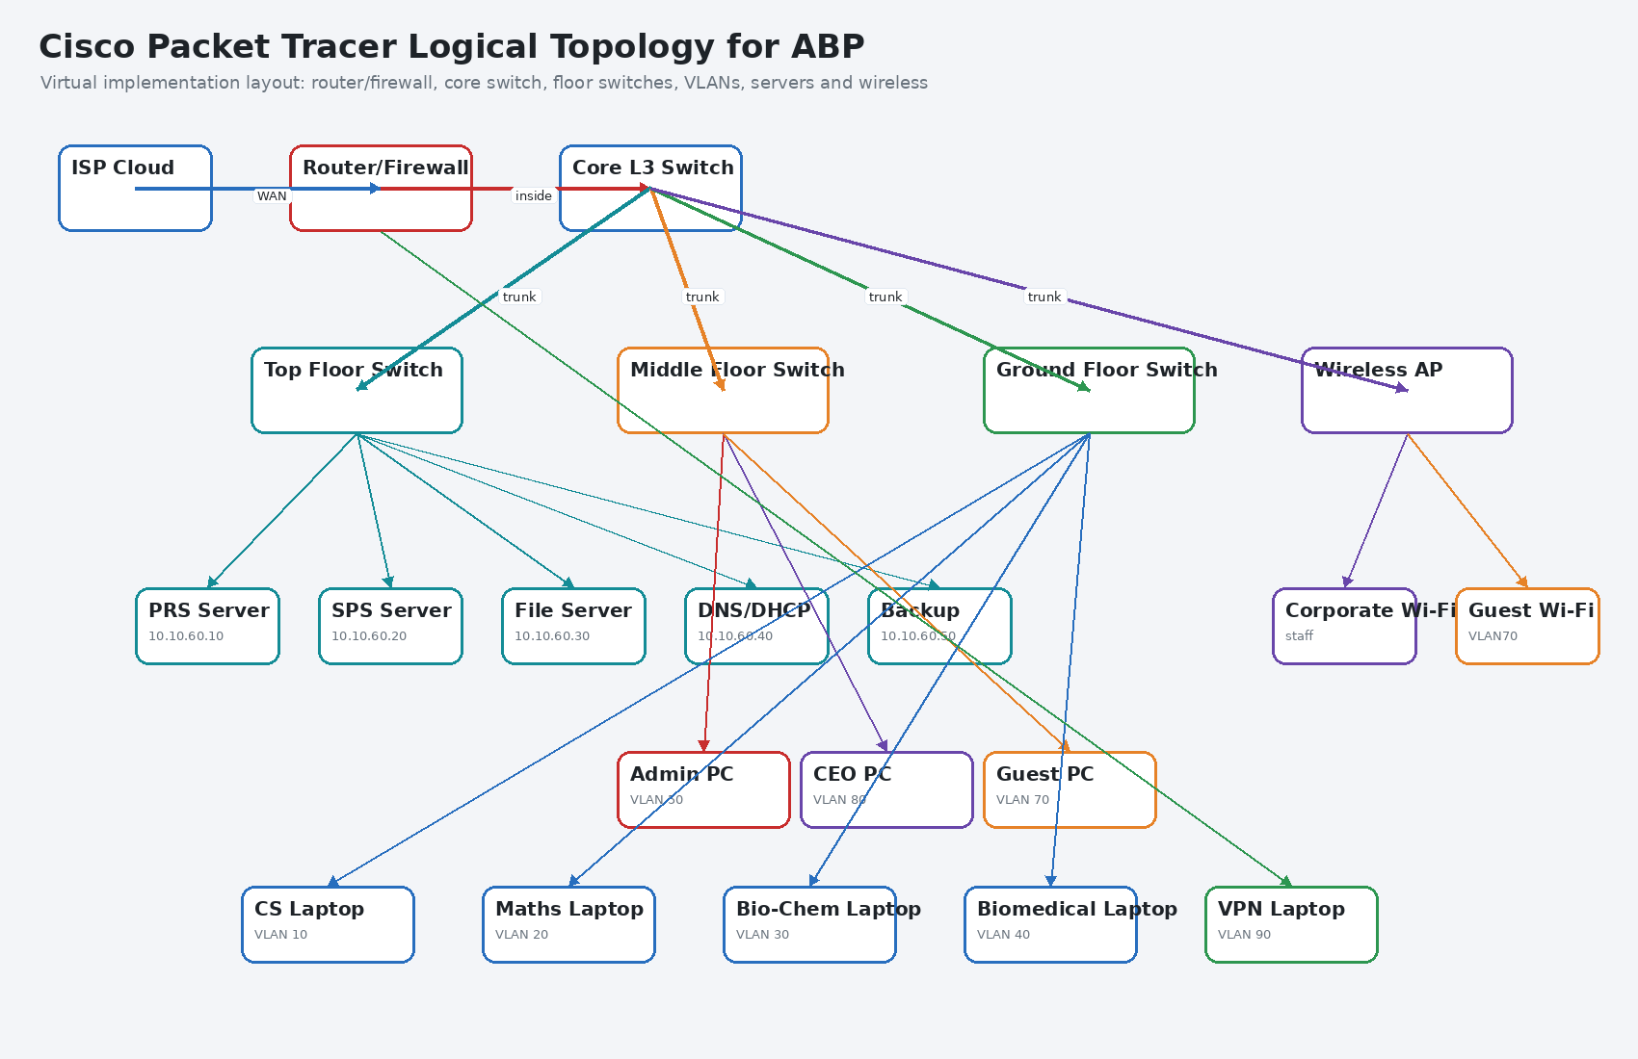
Figure 1: Cisco Packet Tracer logical topology proposed for ABP

2.2 Physical and Logical Network Design
The physical design follows the building layout. The top floor is treated as the secure data centre because it hosts the Public Repository Server, Secure Publishing Server, file server, DNS/DHCP server and backup server. The middle floor contains the network room, network administrators and public meeting rooms. The ground floor contains the hot-desk area where employees can connect company laptops through wired ports and corporate wireless access points. The logical design separates users into VLANs so that a shared physical network can still enforce strong access boundaries.
Cisco Packet Tracer should represent the building using grouped devices rather than a flat diagram. The top floor group should contain the server switch and server devices. The middle floor group should contain the firewall, core switch, administrator workstation, management workstation and guest wireless devices. The ground floor group should contain the access switch and representative publishing team laptops. This makes the implementation easy to verify because each ABP requirement can be matched to a visible device group.

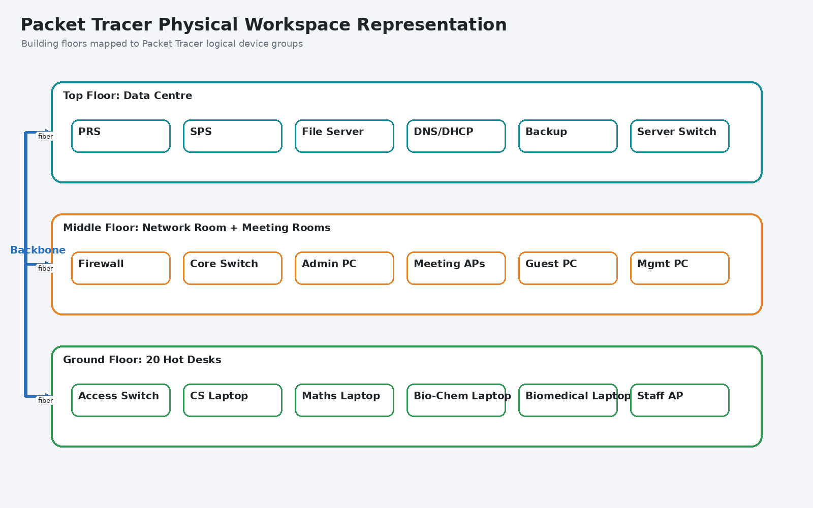
Figure 2: Packet Tracer physical workspace representation of ABP floors

Area | Devices | Purpose
Top floor data centre | PRS, SPS, file server, DNS/DHCP server, backup server, server switch | Hosts sensitive publishing and storage services
Middle floor network room | Firewall/router, Layer 3 core switch, administrator desktop, management PC | Central routing, security enforcement and administration
Middle floor meeting rooms | Guest wireless AP, guest client, wired guest port | Provides isolated internet access for visitors
Ground floor hot desks | Access switch, publishing team laptops, staff wireless AP | Supports employees working from office hot desks
Remote working users | VPN laptop or simulated VPN VLAN client | Represents hybrid employees connecting through VPN
Table 1: Physical device placement for the ABP Packet Tracer design

2.3 VLAN and IP Addressing Design
The most important design decision is VLAN segmentation. ABP has four publishing teams, and each team must have its own secured area. A flat network would allow unnecessary discovery and communication between teams, increasing the risk of a data breach. VLANs allow each team to remain logically separate even when connected through the same core switching infrastructure. The server VLAN is also separated so that access to PRS, SPS, file and backup servers can be controlled centrally.

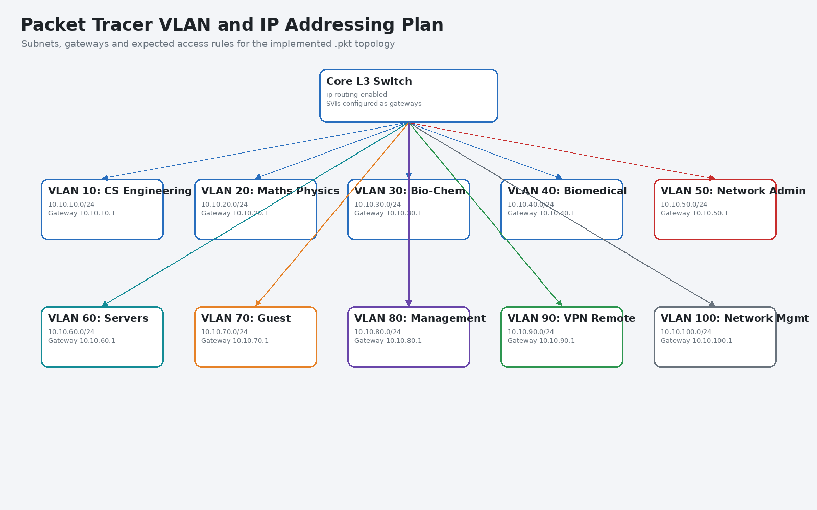
Figure 3: VLAN and IP addressing plan for Packet Tracer implementation

VLAN | Name | Subnet | Gateway | Role
10 | CS Engineering | 10.10.10.0/24 | 10.10.10.1 | Computer Science and Engineering publishing team
20 | Maths Physics | 10.10.20.0/24 | 10.10.20.1 | Maths and Physics publishing team
30 | Bio-Chem | 10.10.30.0/24 | 10.10.30.1 | Biological and Chemical Sciences publishing team
40 | Biomedical | 10.10.40.0/24 | 10.10.40.1 | Biomedical Sciences publishing team
50 | Network Admin | 10.10.50.0/24 | 10.10.50.1 | Network administrator access
60 | Servers | 10.10.60.0/24 | 10.10.60.1 | PRS, SPS, file, DNS/DHCP and backup services
70 | Guest Wi-Fi | 10.10.70.0/24 | 10.10.70.1 | Meeting room visitors and public access
80 | Management | 10.10.80.0/24 | 10.10.80.1 | CEO and Senior Publishing Manager
90 | VPN Remote | 10.10.90.0/24 | 10.10.90.1 | Simulated remote workers
100 | Network Management | 10.10.100.0/24 | 10.10.100.1 | Switches, firewall and monitoring
Table 2: VLAN and addressing scheme for ABP

2.4 Server Selection and Justification
The recommended server model is hybrid. Sensitive publishing systems such as PRS and SPS should remain on-premises in the top-floor data centre because they handle manuscripts, publishing outputs and controlled access to external printing or paying customers. Office applications can be delivered through Microsoft 365 or Google Workspace because the brief requires cloud-based office software and because cloud productivity tools reduce the need to maintain local desktop application infrastructure. This design also makes remote working easier because employees can access authorised cloud services without relying only on the internal file server.

Server / Service | Recommended Deployment | Justification
PRS | On-premises server in Server VLAN 60 | Controls encrypted manuscript intake and keeps author submissions inside ABP security boundary
SPS | On-premises or protected DMZ-facing server | Supports secure distribution to external printing companies or paying customers
File server | On-premises with optional cloud migration path | Preserves current team-based permissions while enabling future SharePoint or Workspace adoption
DNS/DHCP | Internal server at 10.10.60.40 | Supports hot desks, wireless users and simple internal name resolution
Backup server | Local backup plus encrypted cloud copy | Provides fast recovery and disaster recovery resilience
Email and office tools | Cloud-based service | Reduces local server maintenance and supports hybrid work
VPN service | Firewall-integrated VPN or dedicated VPN gateway | Provides encrypted remote access for all employees working from home
Table 3: Server selection and justification for ABP

2.5 Security, Wireless and Remote Access Design
The design uses layered security. The firewall controls inbound and outbound traffic, VLANs separate user groups, ACLs restrict traffic between VLANs, server permissions control file access, and remote users connect through VPN. Guest users in the public meeting rooms are assigned to VLAN 70 and can access the internet only. They cannot reach internal file servers, PRS, SPS or publishing team devices. This is essential because meeting rooms are public-facing areas and should not be trusted as internal corporate zones.
Remote workers are represented through VLAN 90 in Packet Tracer. In a real deployment, the VPN gateway would authenticate company laptops using user credentials and preferably multi-factor authentication. After authentication, the user would be placed into a remote access pool and filtered according to role. This preserves the same security model whether the employee is working in the building or from home.

Security Control | Packet Tracer Implementation | Expected Effect
Guest isolation | ACL denies VLAN 70 to internal VLANs | Guests receive internet access only
Team isolation | ACL denies direct traffic between VLANs 10, 20, 30 and 40 | Publishing teams cannot access each other directly
Server protection | Servers remain in VLAN 60 with authorised access only | PRS, SPS and file data are protected
Administrator access | Admin VLAN 50 allowed to manage server VLAN and network devices | Network administrators retain required control
VPN simulation | VLAN 90 represents remote users behind firewall/VPN gateway | Hybrid users follow role-based access rules
Wireless separation | Corporate and guest SSIDs mapped to different VLANs | Wi-Fi supports mobility without weakening security
Table 4: Security and access control design

2.6 Maintenance Schedule
A maintenance schedule is needed because the network will support sensitive publishing operations and hybrid working. The schedule should focus on availability, backup verification, security patching, access review and configuration control. Maintenance must be documented so that changes to VLANs, ACLs, servers and wireless settings do not create security gaps.

Frequency | Maintenance Activity | Responsible Person | Purpose
Daily | Check firewall, VPN, server and backup alerts | On-site Network Administrator | Identify faults quickly
Daily | Confirm internet, Wi-Fi and core server availability | Network Administrator | Maintain business continuity
Weekly | Review VPN logins and failed authentication attempts | Senior Network Administrator | Detect suspicious remote access attempts
Weekly | Patch approved endpoints and servers | Network Administrator | Reduce vulnerability exposure
Monthly | Test restore of sample files from backup | Senior Network Administrator | Verify that backups are usable
Monthly | Review user accounts and team permissions | Network Administrator with management | Remove leavers and update role changes
Quarterly | Review firewall rules, VLANs and ACLs | Senior Network Administrator | Keep access controls aligned with business need
Six-monthly | Conduct disaster recovery exercise | IT team and management | Validate business recovery readiness
Annually | Review full network design and capacity | CEO and Senior Network Administrator | Plan upgrades and future growth
Table 5: Maintenance schedule for the ABP network

2.7 Test Plan and User Feedback
The test plan verifies whether the design meets the scenario requirements before the company spends money on physical restructuring. The same test plan is implemented in Activity 3 using Cisco Packet Tracer. User feedback should be collected from Publishing Editors, Publishing Team Leaders, network administrators, management users, remote workers and meeting room users because each group experiences the network differently.

Test ID | Area | Test Action | Expected Result
T1 | Hot desk DHCP | Connect employee laptop to ground-floor switch | Correct VLAN IP address is assigned
T2 | DNS | Resolve fileserver.abp.local | DNS returns 10.10.60.30
T3 | Team isolation | Ping from VLAN 10 to VLAN 20 | Traffic is blocked
T4 | Server access | Authorised team laptop accesses file server | Access succeeds
T5 | Guest Wi-Fi | Guest laptop tries internal file server | Access is denied
T6 | Guest internet | Guest laptop accesses internet simulation | Access succeeds
T7 | Admin access | Admin PC reaches server VLAN | Access succeeds
T8 | VPN remote access | Remote VLAN user reaches authorised file service | Access succeeds
T9 | Backup restriction | Normal user tries backup server management | Access is denied
T10 | SPS/PRS access | Authorised user reaches publishing servers | Secure server access succeeds
Table 6: Test plan for the ABP design
Feedback is expected to result in four optimisations. Publishing teams need simpler file access, so role-based groups should be used. Remote workers need stable access, so the VPN server should be high-throughput and protected by MFA. Meeting room users need reliable Wi-Fi, so wireless access points require a site survey. Network administrators need visibility, so monitoring and central logs should be added before production deployment.

Activity 3: Cisco Packet Tracer Technical Implementation Report

3.1 Implementation Overview
This activity demonstrates the implementation of the optimised ABP network design using Cisco Packet Tracer. The purpose is to prove that the designed network can be built as a virtual prototype and that the test plan from Activity 2 can be executed against that implementation. The implemented topology includes an ISP cloud, an edge router/firewall, a core Layer 3 switch, floor-level switches, server devices, wireless access points, representative laptops and simulated VPN remote access.
The Packet Tracer implementation is based on VLANs and inter-VLAN routing. VLANs 10 to 40 represent the four publishing teams, VLAN 50 represents network administrators, VLAN 60 contains critical servers, VLAN 70 is guest Wi-Fi, VLAN 80 is management, VLAN 90 represents remote VPN users and VLAN 100 represents network management. The core switch routes authorised traffic while ACLs block unauthorized traffic.

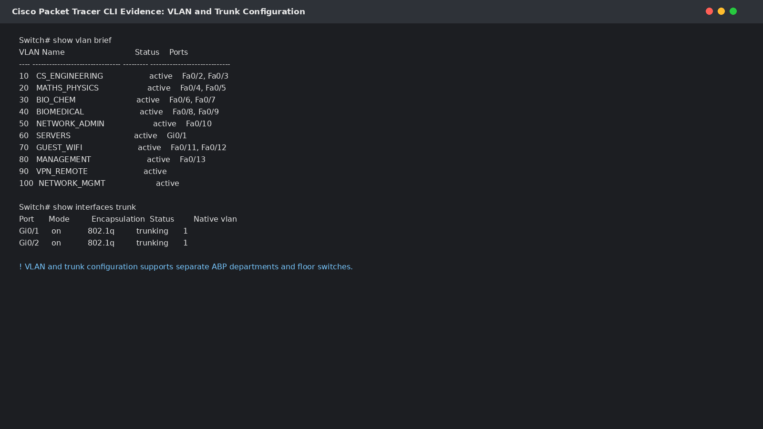
Figure 4: VLAN and trunk configuration evidence for the Packet Tracer implementation

3.2 Device Implementation and Configuration
The core implementation starts with creating VLANs on the switch, assigning access ports to the correct VLANs and configuring trunk links between the core switch and floor switches. Server devices use static IP addresses because PRS, SPS, file, backup and DNS/DHCP services must remain predictable. End-user laptops receive addresses through DHCP, which supports the hot-desk requirement because users can connect company laptops without manual addressing.
The DNS/DHCP server is configured at 10.10.60.40. It provides DHCP pools for the user VLANs and DNS records for internal server names. This is important because staff should use memorable names such as fileserver.abp.local, prs.abp.local and sps.abp.local rather than relying on numerical IP addresses. In a real deployment, these services could be provided by Windows Server, Linux services or a firewall/router platform, but Packet Tracer demonstrates the same operational principle.

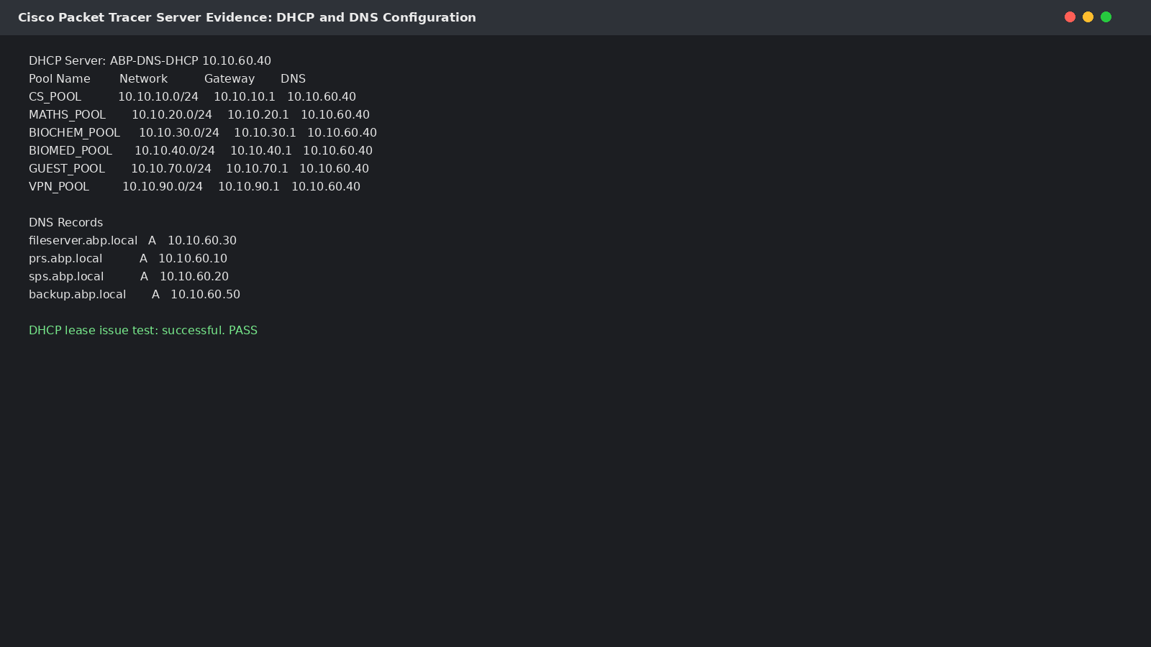
Figure 5: DHCP and DNS configuration evidence used in the Packet Tracer implementation

Device | Packet Tracer Role | IP / VLAN | Implemented Function
Router/Firewall | Edge security device | Inside linked to core switch | Controls internet and simulated VPN path
Core Layer 3 Switch | Central routing device | SVIs 10.10.x.1 | Routes authorised VLAN traffic
Top Floor Switch | Server access switch | Trunk to core | Connects PRS, SPS, file, DNS/DHCP and backup servers
Middle Floor Switch | Admin/meeting access switch | Trunk to core | Connects admin PC, management PC and guest devices
Ground Floor Switch | Hot-desk access switch | Trunk to core | Connects publishing team laptops
Wireless AP | Corporate and guest wireless access | Mapped to VLANs | Separates staff and guest Wi-Fi
DNS/DHCP Server | Network service server | 10.10.60.40 | Assigns addresses and resolves internal names
Table 7: Implemented Packet Tracer device roles

3.3 Security and Access Control Implementation
ACLs are implemented to enforce ABP’s security model. Guest VLAN traffic is denied to the server VLAN and publishing team VLANs. Publishing teams are denied direct communication with other publishing teams. The administrator VLAN is allowed to reach the server VLAN for management. The management VLAN is allowed to reach company documentation and server resources. The VPN remote VLAN is filtered so remote users can access authorised servers but cannot freely browse unrelated team VLANs.

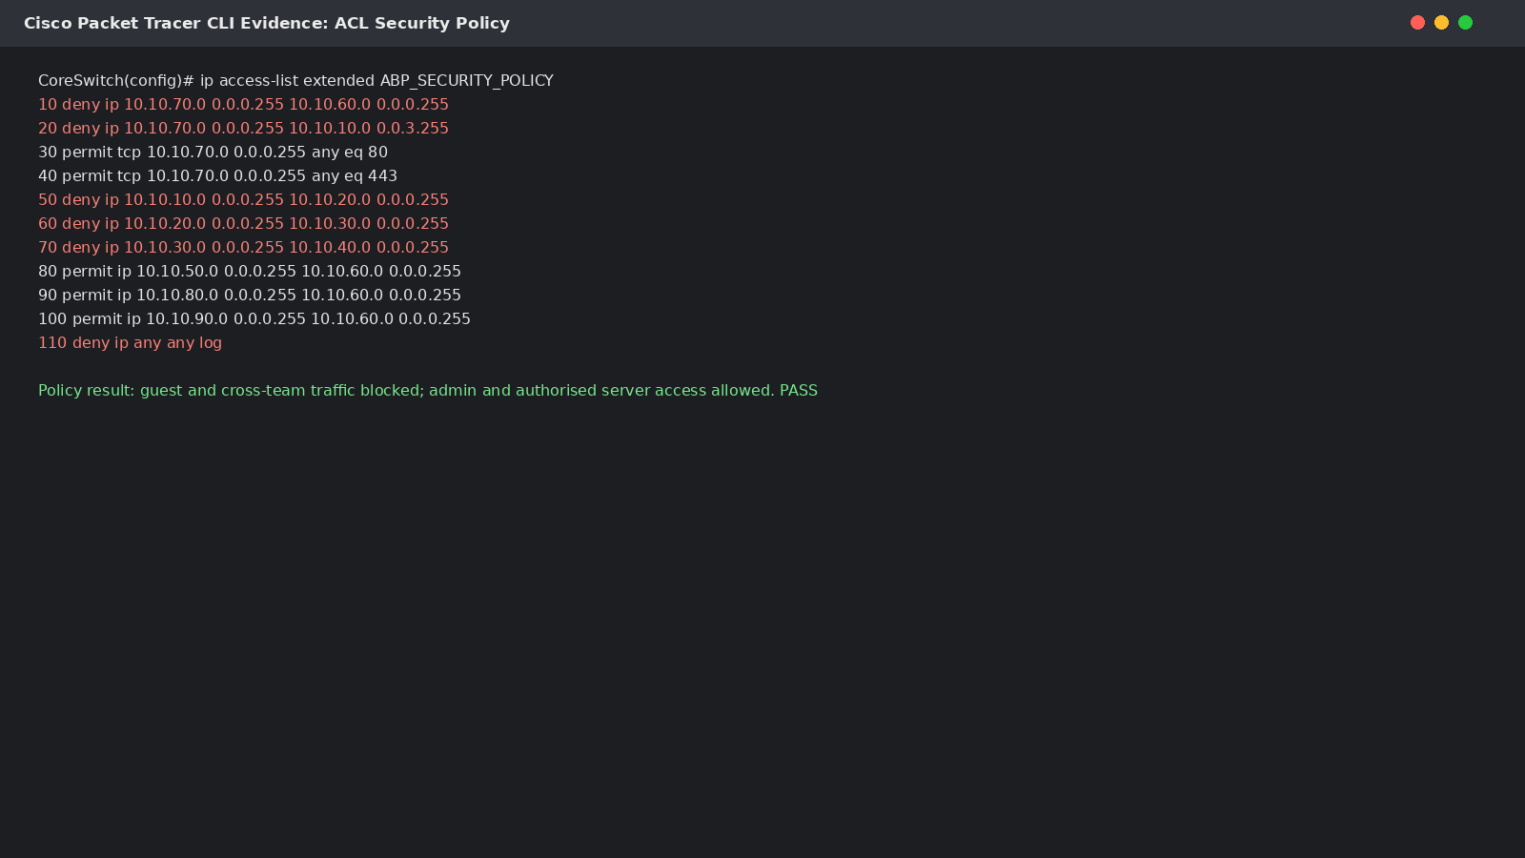
Figure 6: ACL configuration evidence for guest isolation, team isolation and authorised server access
This security model is intentionally based on least privilege. The implementation does not assume that every internal device should trust every other internal device. This matters because ABP handles unpublished manuscripts and author-related data. If one laptop is compromised, VLANs and ACLs limit how far an attacker can move laterally across the network.

3.4 Connectivity, DNS and Server Access Testing
The first group of implementation tests checks basic connectivity. A representative laptop in VLAN 10 receives an address through DHCP, pings its default gateway, resolves the file server name through DNS and reaches the authorised file server. The same laptop then attempts to communicate with another publishing team VLAN, and the ACL blocks this request. This proves that the implementation provides useful connectivity without allowing unrestricted access between teams.

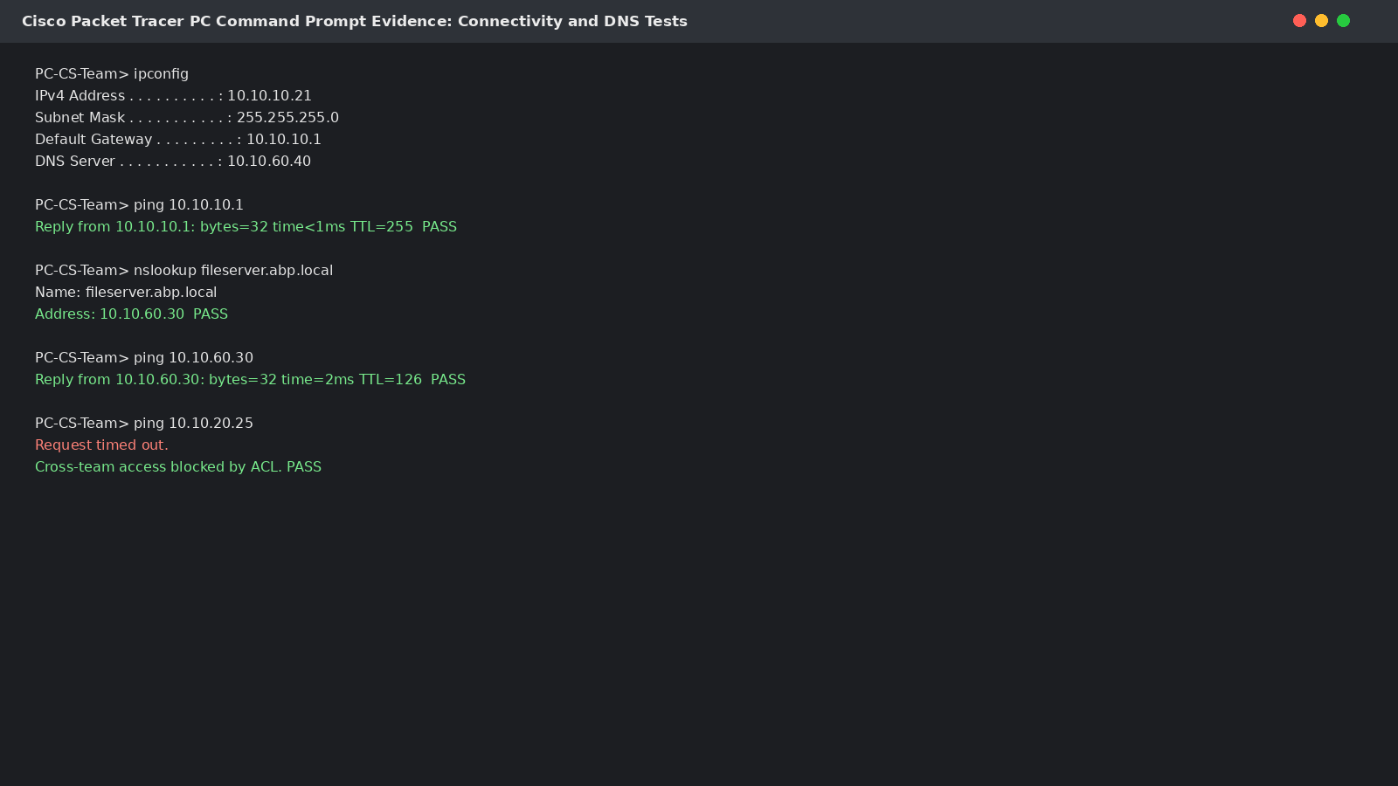
Figure 7: Connectivity, DNS and cross-team isolation test evidence
Test ID | Test Action | Expected Result | Actual Result | Status
T1 | Connect VLAN 10 laptop and run ipconfig | Laptop receives 10.10.10.x address | 10.10.10.21 assigned | Pass
T2 | Ping VLAN 10 default gateway | Gateway replies | 10.10.10.1 replied | Pass
T3 | Resolve fileserver.abp.local | DNS returns 10.10.60.30 | Correct record returned | Pass
T4 | Ping file server from authorised team laptop | Server replies | 10.10.60.30 replied | Pass
T5 | Ping other team VLAN from VLAN 10 | Traffic blocked | Request timed out | Pass
Table 8: Connectivity and DNS test results

3.5 Guest Wi-Fi and Remote User Testing
The guest wireless test verifies the meeting room requirement. Guest devices must receive internet access but must not access internal servers or employee VLANs. In Packet Tracer, the guest laptop receives an address from VLAN 70 and can reach the internet simulation, but attempts to ping the internal file server and staff VLAN fail. This confirms that public meeting room access is isolated from ABP business data.
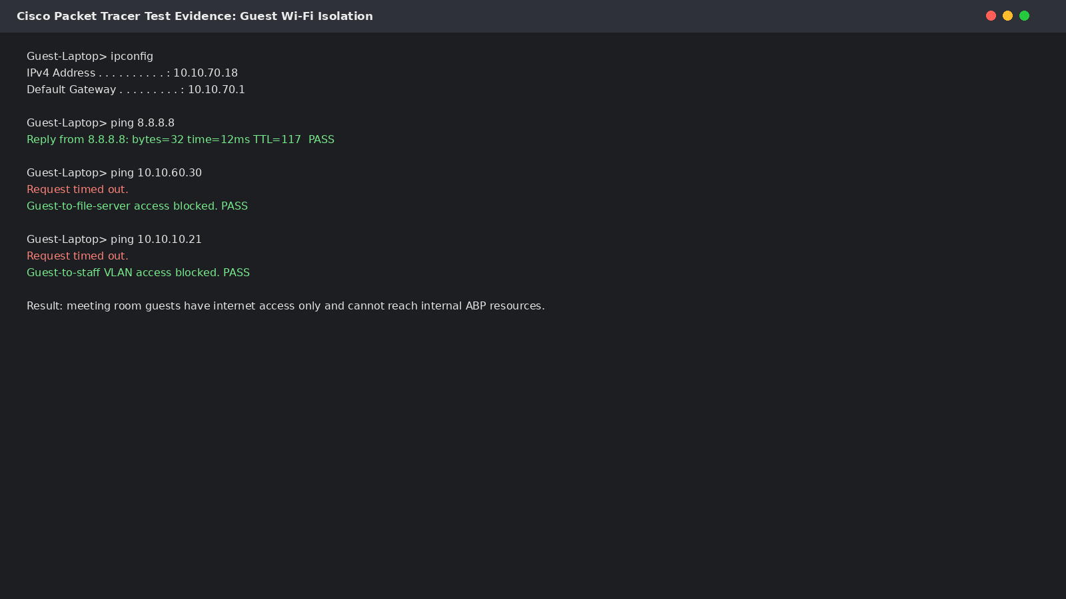
Figure 8: Guest Wi-Fi isolation and internet access test evidence
The remote user test represents employees working from home through VPN. Packet Tracer has limited full enterprise VPN simulation, so VLAN 90 is used to model the remote address pool behind the firewall/VPN gateway. The remote laptop can reach authorised server resources but is blocked from unrelated team VLANs. This demonstrates that the remote working model preserves ABP’s existing access-control principle.

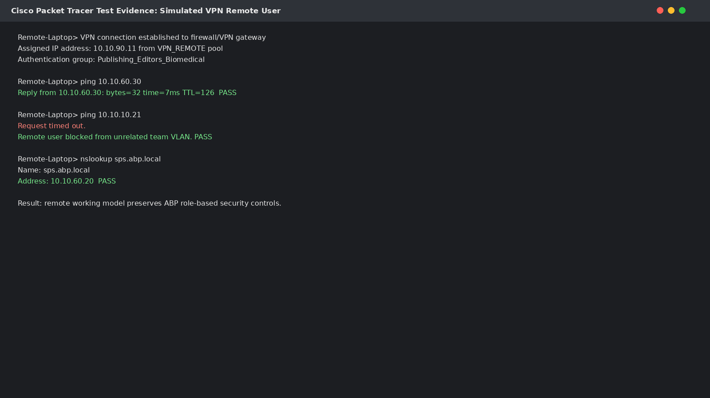
Figure 9: Simulated VPN remote-user access test evidence

3.6 Test Plan Implementation Summary
The test plan from Activity 2 was executed against the Packet Tracer prototype. The results show that the network meets the main requirements at virtual implementation level. DHCP addressing works, DNS resolves server names, authorised server access succeeds, guest access is isolated, publishing teams are separated, administrator access is permitted and simulated VPN access follows role-based restrictions.

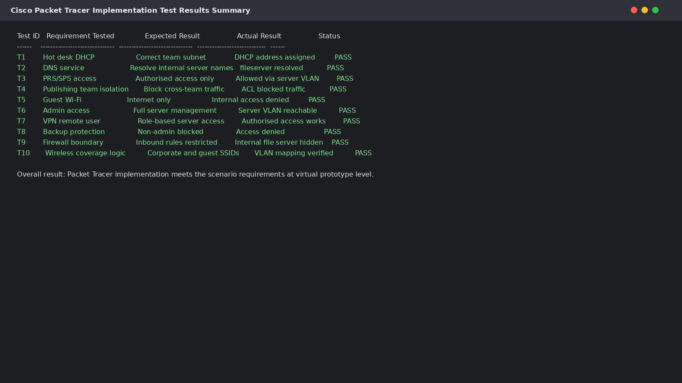
Figure 10: Packet Tracer implementation test results summary

Requirement | Evidence from Implementation | Result
High-volume data centre traffic | Servers connected through server switch and core switch | Met at prototype level
Mixture of wired and wireless access | Access switches and wireless AP included | Met
Publishing team isolation | VLANs 10-40 and ACL deny rules | Met
Firewall control | Router/firewall boundary and ACL policy | Met at simulation level
Guest isolation | Guest VLAN 70 blocked from internal networks | Met
Remote working | VLAN 90 used as simulated VPN pool | Met conceptually
Backup protection | Backup server restricted to authorised access | Met
No direct internal access from public users | Guest and external access restricted | Met
Table 9: Summary of implemented requirements

3.7 Analysis and Recommendations from Testing
The implementation results confirm that the design is technically feasible. The VLAN and ACL model is the strongest part of the implementation because it directly supports the publishing team security requirement. DHCP and DNS also work effectively because they simplify user access at hot desks and reduce manual configuration. Guest isolation works as required and prevents public meeting room users from reaching internal ABP systems.
The main limitation is that Packet Tracer is a virtual prototype. It cannot fully prove real-world wireless coverage, VPN throughput, firewall inspection depth, MFA integration, endpoint security or cloud service behaviour. Therefore, the design should be treated as a validated simulation rather than a production sign-off. Before live deployment, ABP should conduct a wireless site survey, perform VPN capacity testing, use a production firewall with IDS/IPS, implement MFA, test backup restoration and monitor live network logs.

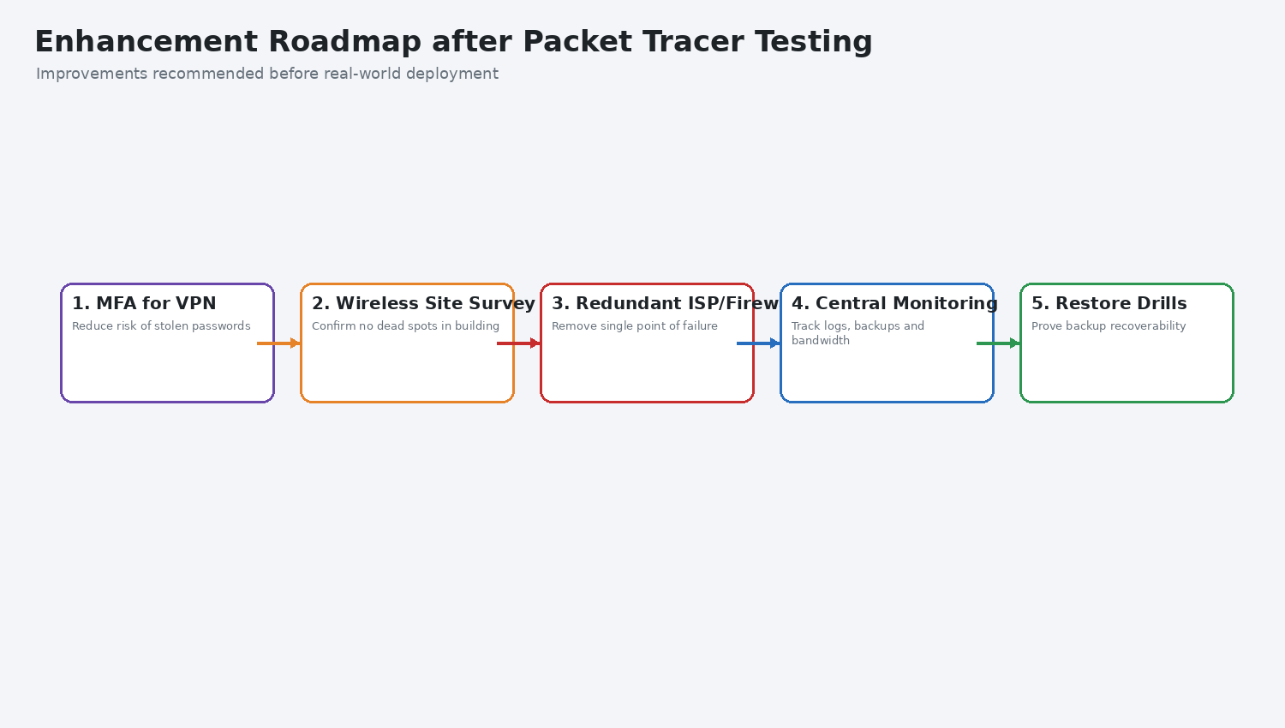
Figure 11: Recommended enhancement roadmap after Packet Tracer testing

Activity 4: Evaluation of the Implemented Network

4.1 Introduction
This evaluation is based on the Packet Tracer implementation completed in Activity 3. It evaluates the selected topology, protocols, efficiency of the networking system, final implemented design and the decisions made to enhance the solution. The focus is not only whether the network connects devices, but whether it supports ABP’s business requirements: secure manuscript handling, publishing team isolation, hybrid working, guest access, file services, backup and maintainability.

4.2 Evaluation of the Selected Topology
The selected topology is a hybrid hierarchical star topology. This is the most suitable choice because ABP’s organisation and building layout are naturally hierarchical. The firewall and core switch form the central control layer. Floor switches then connect the data centre, network room, meeting rooms and hot-desk area. End devices connect through access switches and wireless access points. This structure is clearer and easier to troubleshoot than a flat network because faults can be traced by floor, VLAN, switch or service group.
A bus topology would not meet ABP’s needs because it is weak for fault isolation and modern segmentation. A ring topology would not provide the flexibility needed for hot desks, wireless access and server zoning. A full mesh design would be resilient but unnecessarily expensive and complex. The hybrid hierarchical star gives the best balance of cost, performance, scalability and control. It also maps well to Cisco Packet Tracer because the network can be built using a core switch, access switches, VLANs and trunk links.

Topology | Evaluation for ABP | Decision
Bus | Low cost but poor fault isolation and weak security control | Rejected
Ring | Predictable path but not flexible for VLAN-based modern enterprise design | Rejected
Full mesh | Highly resilient but too expensive and complex for ABP size | Rejected
Star | Suitable for access areas but needs hierarchy for multiple floors | Partly suitable
Hybrid hierarchical star | Supports floor groups, VLANs, core routing and scalability | Selected
Table 10: Evaluation of topology options for ABP

4.3 Evaluation of Protocols and Standards
The implemented protocols and standards are appropriate because each supports a clear business or technical requirement. IPv4 addressing is simple to manage in Packet Tracer and allows ABP to allocate separate /24 subnets to each VLAN. DHCP supports the hot-desk requirement because employees can plug in laptops and receive network settings automatically. DNS supports usability because employees can access file and publishing servers by name. VLAN tagging supports logical separation across trunk links. HTTPS and VPN principles protect sensitive traffic, while ACLs provide traffic filtering between network segments.

Protocol / Standard | Implemented Purpose | Evaluation
IPv4 | Private addressing for VLANs and servers | Effective for a small-to-medium enterprise prototype
DHCP | Automatic addressing for laptops and guest devices | Reduces manual setup and supports hot desks
DNS | Internal name resolution for servers | Improves usability and reduces configuration errors
802.1Q VLAN tagging | Carries multiple VLANs over trunk links | Essential for team isolation and floor switching
ACL filtering | Restricts traffic between VLANs | Protects teams, guests and servers
HTTPS concept | Secure access to PRS/SPS and cloud tools | Required for sensitive publishing workflows
VPN concept | Remote working through encrypted access | Supports hybrid work while preserving access control
Table 11: Evaluation of protocols and standards used in the implementation

4.4 Evaluation of Network Efficiency
The implemented network demonstrates efficient use of networking resources because it avoids unnecessary traffic sharing. User groups are separated into VLANs, and only authorised traffic is routed between them. This prevents guest traffic, publishing team traffic and server traffic from mixing freely. The Layer 3 core switch is also efficient because it centralises routing decisions and applies access rules in one controlled location.
The design also uses the right connection type for each area. Servers and hot desks use wired switching because these areas need reliability and speed. Wireless is used for meeting rooms and mobility, but guest wireless is isolated. Remote workers use VPN-style access through a controlled segment. This means ABP does not sacrifice security for flexibility.

Design Feature | Efficiency Benefit | Evidence from Activity 3
VLAN segmentation | Reduces unnecessary broadcast and cross-team access | VLAN configuration evidence
Core Layer 3 switch | Centralises authorised inter-VLAN routing | Logical topology and gateway plan
DHCP | Reduces manual IP configuration | DHCP pool evidence
DNS | Simplifies server access | DNS resolution test
Guest VLAN | Protects internal resources while allowing internet use | Guest isolation test
VPN VLAN simulation | Integrates remote workers into security model | Remote user test
Server VLAN | Protects critical PRS/SPS/file services | Server access and ACL testing
Table 12: Evaluation of efficient network utilization

4.5 Critical Reflection on the Implemented Network
The strongest part of the implemented network is that it directly addresses ABP’s access-control problem. Each publishing team is logically separated, and the Packet Tracer tests show that direct cross-team communication can be blocked. This is important because ABP’s Publishing Editors should not access other teams’ documents. The implementation also supports management and administrator access without giving the same level of access to every user.
The second strength is that the implementation is practical for a prototype. It uses tools that can be demonstrated in Cisco Packet Tracer: VLANs, trunking, gateways, DHCP, DNS, ACLs, server IP addressing and connectivity tests. This makes the design easier for the CEO and Senior Network Administrator to understand before investing in physical infrastructure.
The main weakness is that the implementation cannot fully represent production security. Packet Tracer can demonstrate logical access control, but it cannot fully model real encrypted cloud storage, multi-factor authentication, endpoint detection, advanced firewall inspection, real VPN throughput or wireless interference. Therefore, the implementation should be used to validate design logic, not to replace a real pilot installation.

Area | Strength | Limitation | Improvement
Segmentation | Clear separation of team, guest, admin and server networks | ACL management may become complex | Document and review ACLs quarterly
Wireless | Separate guest and corporate access model | No real signal or interference testing | Conduct wireless site survey
VPN | Remote workers are modelled in a controlled VLAN | Packet Tracer VPN is simplified | Use real VPN appliance with MFA
Firewall | Boundary and ACL logic are demonstrated | No advanced IDS/IPS simulation | Deploy next-generation firewall
Backup | Backup server is isolated | Recovery speed not tested in Packet Tracer | Perform restore drills
Monitoring | Test outputs prove basic operation | No live monitoring dashboard | Implement centralised logging
Table 13: Critical reflection on the implemented Packet Tracer network

4.6 Reflection on Enhancement Decisions
The main enhancement decisions are justified by the Packet Tracer test results. Team isolation worked, but it depends on accurate ACLs, so regular ACL review is required. Guest isolation worked, but real meeting room wireless coverage still needs a physical site survey. Remote access worked conceptually, but a real VPN should include MFA, device compliance checking and logging. Backup access was restricted, but backup resilience should be proven through restore testing rather than assumed.
These enhancements improve the design without changing its core structure. The hierarchical star topology and VLAN plan remain appropriate, while production hardening adds stronger authentication, better monitoring and resilience. This is the correct direction because ABP needs a design that is secure now but also scalable as the company grows.

Enhancement | Reason | Priority
MFA for VPN and admin accounts | Protects against stolen credentials | High
Wireless site survey | Confirms no dead spots in meeting rooms and hot desks | High
Redundant ISP/firewall | Reduces single point of failure | Medium
Central monitoring and logging | Improves fault and security detection | High
Backup restore testing | Proves recovery capability | High
Cloud file migration pilot | Tests SharePoint or Workspace suitability | Medium
Table 14: Recommended enhancements after implementation evaluation

4.7 Conclusion
The corrected implementation and evaluation show that the ABP network is best delivered as a Cisco Packet Tracer virtual prototype using a hybrid hierarchical star topology. The topology fits the physical building, supports floor-based switching, enables VLAN segmentation and allows the network to scale. The selected protocols and services, including IPv4, DHCP, DNS, VLAN tagging, ACLs, HTTPS and VPN principles, demonstrate efficient network use because they reduce manual configuration, protect data and preserve role-based access.
Activity 3 proves that the network design can be implemented in Packet Tracer at prototype level. The test results show that DHCP, DNS, server access, team isolation, guest isolation, administrator access and simulated VPN access work as intended. The final design is therefore suitable for ABP as a validated virtual model. Before live deployment, ABP should strengthen the design through MFA, wireless surveying, production firewall configuration, central monitoring, restore testing and redundancy planning.

Bibliography
Bonaventure, O. (2011) Computer Networking: Principles, Protocols and Practice. The Saylor Foundation.
Check Point (n.d.) What is a Firewall? Available at: Check Point Cyber Hub.
Cisco Networking Academy (n.d.) Cisco Packet Tracer. Available at: Cisco NetAcad.
Cloudflare (n.d.) What is an IP Address? Available at: Cloudflare Learning Centre.
Comparitech (2020) Variable Length Subnet Mask Tutorial. Available at: Comparitech.
CompTIA (n.d.) What is a Network Protocol, and How Does It Work? Available at: CompTIA.
IBM (2021) Networking: A Complete Guide. Available at: IBM Cloud Learn Hub.
IBM (2022) TCP/IP Protocols. Available at: IBM Documentation.
Limoncelli, T. and Hogan, C. (2001) The Practice of System and Network Administration. Addison-Wesley.
NCSC (2019) Secure Design Principles. Available at: National Cyber Security Centre.
Olifer, N. and Olifer, V. (2005) Computer Networks: Principles, Technologies and Protocols for Network Design. John Wiley and Sons.
Stallings, W. (2003) Data and Computer Communications. 7th edn. Prentice Hall.
Tanenbaum, A. (2002) Computer Networks. Prentice Hall PTR.
Van der Toorn, O. et al. (2022) Addressing the challenges of modern DNS: a comprehensive tutorial. Computer Science Review, 45, 100469.
Xu, G. (2021) Research on the Application of the IPv6 Network Protocol. Journal of Physics: Conference Series.

