|  |
| --- |
| Report on smartphone features and specifications |

# Abstract

This report presents a comprehensive analysis of a dataset containing information on various smartphone features and specifications. The primary goal is to uncover trends and insights into the key attributes that influence smartphone ratings and user preferences. The dataset comprises 1,020 entries with 23 features, including processor speed, battery capacity, RAM, internal memory, and camera specifications. By employing descriptive statistics and visualizations, we aim to provide a detailed overview of the data, address missing values through data cleaning techniques, and derive meaningful conclusions about the factors that impact smartphone performance and consumer satisfaction.

# Problem Statement

In the competitive smartphone market, understanding the factors that influence customer satisfaction and pricing is crucial. This analysis identifies key attributes correlating with higher ratings and prices, aiding in strategic decision making for product development and marketing.

# Data Processing

Key steps in cleaning and processing the data included:

Price: Removed "Rs" from the price column.

SIM Features: Extracted the presence of 5G, NFC, and IR Blaster.

Brand and Processor: Extracted brand names and processor details.

Battery and RAM: Extracted battery capacity, fast charging, RAM, and internal memory.

Display: Extracted screen size, refresh rate, and resolution.

Camera: Counted the number of rear and front cameras, extracted primary camera resolutions.

OS and Extended Memory: Extracted OS type and support for extended memory.

# Finding

The analysis of the smartphone dataset aims to provide a comprehensive overview of the key attributes and trends observed. The findings are derived from the examination of various features such as ratings, processor speed, battery capacity, RAM, internal memory, and other critical specifications. This section presents the results of the descriptive statistics and visualizations, shedding light on the distribution, central tendency, and variability of the smartphone characteristics.

# Data Cleaning and Imputation

The dataset contained several missing values which were addressed through data cleaning techniques. Missing values in numeric columns were imputed with the mean of their respective columns. This step ensured that the analysis could proceed without biases introduced by missing data.

# Visualization Insights

1. **Rating vs. Price Range**: A bar plot visualizes the relationship between the price range and the ratings of smartphones. The plot indicates that smartphones across different price ranges tend to have varying ratings, reflecting consumer preferences and perceived value.

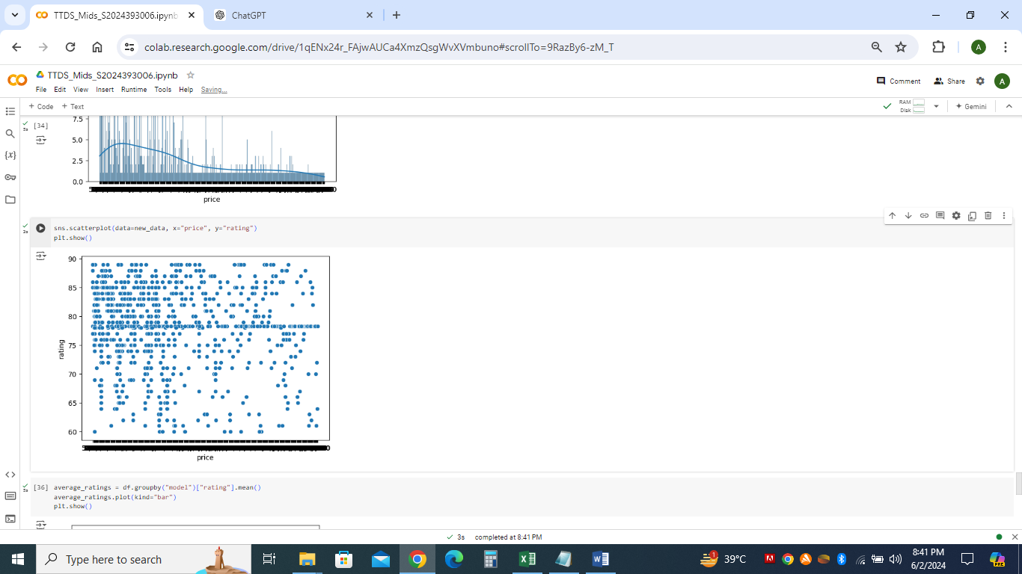

1. Distribution of extended memory: A count plot illustrates the distribution of extended memory support across different operating systems. It highlights that most Android smartphones support extended memory, whereas other operating systems have limited or no support for this feature.
2. Bar Plot of Average Ratings by Model: Compares average ratings across models.

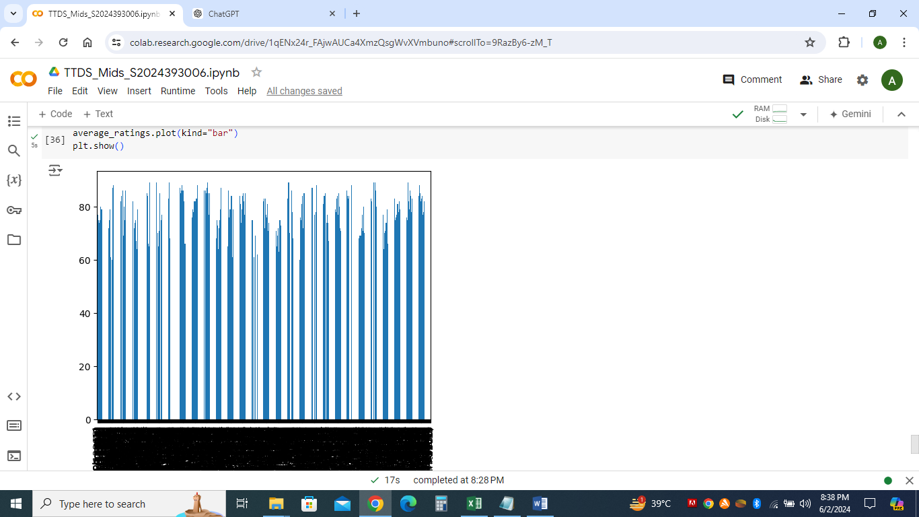

## Descriptive Statistics Overview

The dataset comprises 1,020 entries with 23 columns, each representing a different attribute of smartphones. Below is a summary of the descriptive statistics for the numerical attributes:

* **Rating:** The average rating is approximately 78.26, with a standard deviation of 7.40. The ratings range from 60 to 89.
* **Processor Speed:** The mean processor speed is 2.42 GHz, with a standard deviation of 0.48 GHz, ranging from 1.0 to 3.22 GHz.
* **Battery Capacity:** The average battery capacity is around 4756 mAh, with a substantial variation indicated by a standard deviation of 1100.52 mAh. The range spans from 800 to 22,000 mAh.
* **Fast Charging:** The average fast charging capacity is 34.63 watts, with a wide range from 0 to 240 watts.
* **RAM Capacity:** The mean RAM capacity is approximately 6.29 GB, with a standard deviation of 2.98 GB, ranging from 0 to 18 GB.
* **Internal Memory**: The average internal memory is about 130.51 GB, with a standard deviation of 89.24 GB, ranging from 0 to 512 GB.
* **Screen Size:** The average screen size is 6.26 inches, with a standard deviation of 1.31 inches, ranging from 0 to 8.03 inches.
* **Refresh Rate:** The mean refresh rate is 66.87 Hz, with a standard deviation of 56.59 Hz, ranging from 0 to 240 Hz.
* **Number of Rear Cameras:** The average number of rear cameras is approximately 2.11, with a standard deviation of 1.00, ranging from 0 to 3 cameras.
* **Number of Front Cameras:** The mean number of front cameras is about 0.94, with a standard deviation of 0.30, ranging from 0 to 2 cameras.
* **Primary Camera (Front):** The average resolution of the primary front camera is 16.09 MP, with a standard deviation of 10.56 MP, ranging from 1 to 60 MP.
* **Extended Memory:** The mean value for extended memory support is 0.62, indicating that many phones support extended memory.

# Conclusion

This analysis highlights key features and their impact on smartphone pricing and ratings. Higher priced smartphones tend to receive better ratings, indicating customer satisfaction with premium features. Dominant brands offer a range of models. Features like 5G, NFC, and multiple cameras are common in well rated smartphones. These insights can guide manufacturers and retailers in optimizing product offerings to meet market demand and improve customer satisfaction.