Software Requirements Specification

for

Hospital Management System

Version 1.0 approved

Prepared by :Lama Z auiter

Maryam Shqeer &

Aliaa Hussein

Software requirements specification for Hospital Management System

Table of Contents

Table of Contents ii

Revision History ii

1. Introduction 1

1.1 Purpose 1

1.2 Document Conventions 1

1.3 Intended Audience and Reading Suggestions 1

1.4 Project Scope 2

1.5 References 2

2. Overall Description 2

2.1 Product Perspective 3

2.2 Product Features 3

2.3 User Classes and Characteristics 3

2.4 Operating Environment 3

2.5 Design and Implementation Constraints **Error! Bookmark not defined.**

2.6 User Documentation 4

2.7 Assumptions and Dependencies 4

3. System Features 4

3.1 System Feature 1 **Error! Bookmark not defined.**

3.2 System Feature 2 (and so on) 5

4. External Interface Requirements Error! Bookmark not defined.

4.1 User Interfaces **Error! Bookmark not defined.**

4.2 Hardware Interfaces **Error! Bookmark not defined.**

4.3 Software Interfaces **Error! Bookmark not defined.**

4.4 Communications Interfaces **Error! Bookmark not defined.**

5. Other Nonfunctional Requirements 7

5.1 Performance Requirements 10

5.2 Safety Requirements 10

5.3 Security Requirements 11

5.4 Software Quality Attributes 11

6. Other Requirements 12

Appendix A: Glossary 12

Appendix B: Analysis Models 14

Appendix C: Issues List Error! Bookmark not defined.

Revision History

|  |  |  |  |
| --- | --- | --- | --- |
| **Name** | **Date** | **Reason For Changes** | **Version** |
|  |  |  |  |
|  |  |  |  |

**Introduction**

**The Hospital Management System (HMS) we are developing is a comprehensive, user-friendly, and scalable solution tailored to the operational needs of modern healthcare facilities. This system integrates core features such as a custom login page, role-based access control (for admins, staff, and other users), patient and doctor management, appointment scheduling, staff and department management, medical records, room booking, basic PDF reports, and a full Arabic translation. Its professional user interface is designed to match the hospital’s identity, ensuring streamlined workflows, improved patient care, and enhanced administrative efficiency.**

**At its core, the Hospital Management System (HMS) will include the following essential features:**

* **Custom Login Page with a secure authentication process.**
* **Role-Based Access Control to define permissions for Admin, Staff, and other user roles.**
* **Patients Management for efficient handling of patient records.**
* **Appointments Scheduling to optimize doctor and patient time.**
* **Doctors and Staff Management to maintain up-to-date records of hospital personnel.**
* **Departments Management for better organization of hospital units.**
* **Medical Records for centralized and easily accessible patient history.**
* **Room Booking for patient admissions and transfers.**
* **Basic PDF Reports for essential hospital statistics and summaries.**
* **Full Arabic Translation for accessibility in Arabic-speaking environments.**
* **Professional UI/Theme aligned with the hospital’s brand identity.**

**To further enhance its capabilities, the system will also integrate advanced features, including:**

* **Health Insurance Integration for managing insurance companies, packages, eligibility checks, and direct billing submissions.**
* **Pharmacy Management covering prescription handling, drug expiration tracking, and stock alerts.**
* **Smart Notification System with automated appointment and test reminders via SMS, Email, and WhatsApp.**
* **Electronic Archive for storing medical files, X-rays, and test results with fast search functionality.**
* **Electronic Payment Support for seamless billing and transactions.**
* **Management Dashboard providing real-time insights into the hospital’s overall performance, including patient load, department status, and financial overview.**
* **Ambulance Department Management with records of ambulances, drivers, and assignments.**
* **Blood Bank Storage Management including details of available blood bags, donor registration, blood type tracking, and expiration alerts.**
* **Smart Appointment Management with real-time queue tracking and automatic appointment reminders via SMS, WhatsApp, or Email.**

**By combining these core and advanced functionalities, the proposed HMS will not only fulfill the fundamental requirements of healthcare operations but also introduce innovative tools to enhance productivity, reduce errors, and ensure a better patient experience.**

**System Objectives**

**The primary objectives of the Hospital Management System (HMS) are to:**

1. **Enhance Operational Efficiency – Automate and streamline hospital workflows, reducing manual paperwork and minimizing delays.**
2. **Improve Patient Care – Provide quick and easy access to patient history, medical records, and appointments to support informed decision-making.**
3. **Ensure Data Accuracy & Security – Maintain precise medical and administrative records with robust security measures to protect sensitive information.**
4. **Enable Seamless Communication – Facilitate effective coordination among departments, staff, and patients through integrated notifications and messaging systems.**
5. **Support Multi-Language Environments – Offer full Arabic and English language support to ensure accessibility in diverse healthcare settings.**
6. **Integrate with External Systems – Connect with insurance providers, payment gateways, and IoT-enabled medical devices for smarter, more efficient hospital management.**
7. **Provide Real-Time Insights – Deliver dashboards and reports that enable administrators to make data-driven decisions quickly and accurately.**

**Scope of the System**

**The proposed Hospital Management System (HMS) is designed to cover the following key areas:**

* **Administrative Management – Overseeing hospital staff, roles, permissions, and departmental structures.**
* **Patient Management – Handling patient registration, appointment booking, admissions, and discharge processes.**
* **Medical Records – Storing and accessing detailed patient medical histories, test results, and diagnostic images.**
* **Resource Management – Managing rooms, medical equipment, and pharmacy inventory efficiently.**
* **Financial Management – Handling billing, insurance claims, and electronic payments.**
* **Communication & Notifications – Sending automated reminders and alerts to patients and staff.**
* **Reporting & Analytics – Generating PDF reports and dashboards for operational, financial, and clinical data.**

**The system will be web-based, fully responsive, and accessible from desktops, tablets, and mobile devices. It will be developed using Odoo as the primary ERP framework, ensuring modularity, scalability, and ease of customization.**

## 

## **Operating Environment**

**The Hospital Management System will be developed and deployed using Odoo 18 Community Edition in a web-based environment. The system will be accessible through any modern web browser and optimized for both desktop and mobile devices.**

**Server Environment:**

* **Operating System: Ubuntu 22.04 LTS (Linux-based hosting environment).**
* **Application: Odoo 18 Community Edition.**
* **Database: PostgreSQL 15 or higher.**
* **Python Version: Python 3.10+.**

**Additional Integrations:**

* **SMS/Email/WhatsApp notification gateways.**
* **Payment gateway APIs for electronic payments.**

**System Features**

**Core Features :**

1. **Custom Login Page  
   A branded and secure login page customized to the hospital’s identity, ensuring only authorized users can access the system.**
2. **Role-Based Access Control  
   Assigns different access permissions for Admin, Doctors, Nurses, Receptionists, and other staff to ensure data confidentiality and proper workflow management.**
3. **Patient Management  
   Centralized database for storing patient personal details, medical history, contact information, and emergency details.**
4. **Appointment Scheduling  
   Allows booking, rescheduling, and canceling appointments with doctors, including viewing availability in real-time.**
5. **Doctor Management  
   Stores doctor profiles, specialties, availability schedules, and consultation records.**
6. **Staff Management  
   Maintains records for all hospital staff, including roles, shifts, and personal information.**
7. **Department Management  
   Organizes hospital services into departments (Cardiology, Pediatrics, Radiology, etc.) with department-specific resources.**
8. **Medical Records  
   Stores and manages patient medical history, diagnoses, prescriptions, and lab results.**
9. **Room Booking  
   Tracks hospital room availability, patient admissions, and discharge dates.**
10. **Basic PDF Reports  
    Generates reports for patients, appointments, doctors, and other key entities.**
11. **Full Arabic Translation  
    Complete system localization for Arabic-speaking users.**
12. **Professional UI/Theme  
    Customized interface aligned with the hospital’s branding and colors for better user experience**

**Additional Features :**

1. **Integration with Health Insurance**
   * **Manage insurance companies and package types.**
   * **Verify insurance eligibility before booking.**
   * **Submit billing details directly to insurance companies.**
2. **Pharmacy Management**
   * **Manage prescriptions and dispense medicines electronically.**
   * **Track drug expiry dates.**
   * **Manage inventory with low-stock alerts.**
3. **Smart Notification System**
   * **Send reminders via SMS, Email, and WhatsApp for appointments and tests.**
4. **Electronic Archive (Document Management)**
   * **Store medical files, X-rays, and test results in a centralized location.**
   * **Fast search functionality by patient name or file number.**
5. **Electronic Payment Support**
   * **Integrate payment gateways for online bill settlement.**
6. **Management Dashboard**
   * **Visual dashboard displaying hospital performance, appointment statistics, and key metrics.**
7. **Ambulance Department Management**
   * **Add ambulance records.**
   * **Maintain details of ambulances and drivers.**
8. **Blood Bank Storage Department**
   * **Track available blood bags, including blood type, group, and donation date.**
   * **Register donor information and donation dates.**
   * **Display blood stock by type and issue alerts before bag expiration.**
9. **Smart Appointment Management**
   * **Real-Time Queue: Patients can view their position in the queue from their mobile device.**
   * **Automatic Appointment Reminders: Notifications sent before the appointment via SMS, WhatsApp, or Email.**

**System Modules and Features Map**

**• The following mind map illustrates the initial planning structure of the Hospital Management System, including main modules, core features, and additional functionalities.**

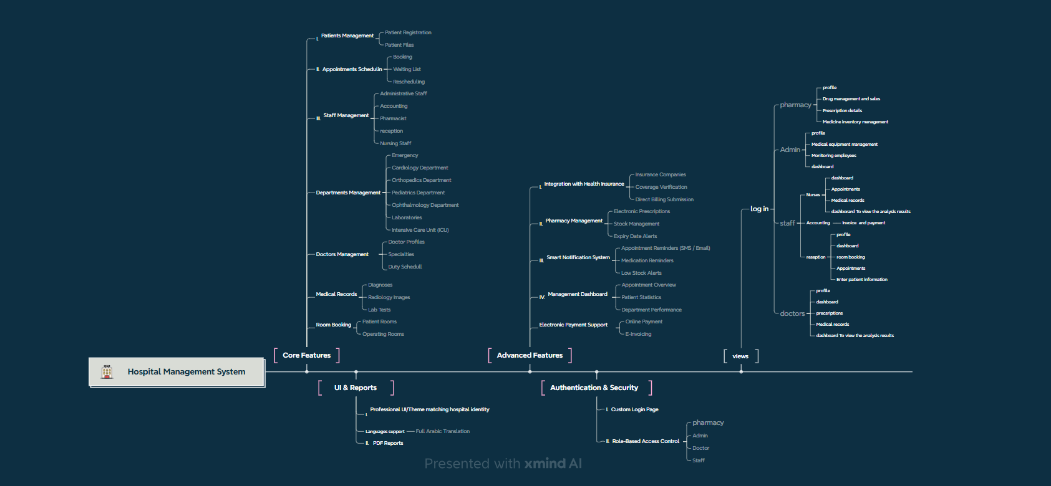

**Data Base Diagram : https://www.drawdb.app/editor**

**The Gant Char : https://app.ganttpro.com/#/project/1755264817682/gantt**