**Analytical SQL Project**

Aliaa Adel

# Question 1

* At what time does most transactions happen

select sub.*

from(

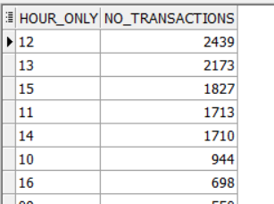SELECT distinct(TO_CHAR(invoicedate, 'HH24')) as hour_only, count(*) over(partition by TO_CHAR(invoicedate, 'HH24')) no_transactions

FROM tableRetail)sub

order by no_transactions desc

here it appears that most transactions happen at 12 and 1 pm thus to increase total sales special promotions or flash sales can be offered to customers

* What are the top 10 selling products?

select STOCKCODE, sales ,product_rank

from (

select STOCKCODE ,sum(price * quantity) sales,

rank() over (order by sum(price * quantity) desc) product_rank

from tableRetail

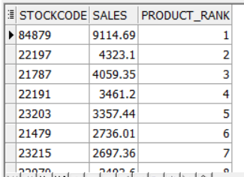 group by STOCKCODE

)

where product_rank <= 10;

the sales of each product is the product of the quantity and price

* What is the percentage difference from previous month’s sales?

with sales_change as(

select sub.*, lead(sales,1) over(order by sub.date_month desc ) prev_month_sales from(

select to_char(invoicedate, 'YYYY-MM') date_month ,

sum(price * quantity) over(partition by to_char(invoicedate, 'YYYY-MM')) sales

from tableRetail)sub

group by sub.date_month, sub.sales

)

select cte.* , round(((sales-prev_month_sales)/prev_month_sales)*100,2) change

from sales_change cte ;

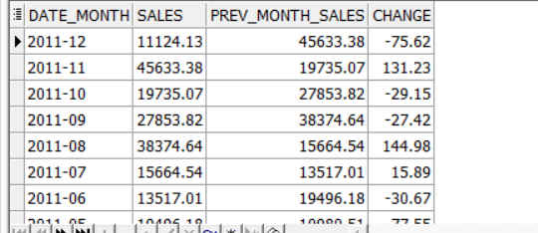it’s shown that December 2011 has the lowest percentage difference but when looking at the previous month sales it’s approx. 132% increase as it was during black Friday sales so it makes sense

while august has the highest positive percentage difference as it’s the start of summer vacation and a lot of festivals take place during that time

* What are the total sales for weekends and weekdays per month?

select sub.*

from( select

sum(case when to_char(invoicedate, 'D') in (1, 7) then price * quantity else 0 end ) over(partition by to_char(invoicedate, 'YYYY-MM')) weekend_sales,

sum(case when to_char(invoicedate, 'D') not in (1, 7) then price * quantity else 0 end ) over(partition by to_char(invoicedate, 'YYYY-MM')) weekday_sales,

to_char(invoicedate, 'YYYY-MM') date_month

from tableRetail) sub

group by sub.date_month,sub.weekend_sales,sub.weekday_sales

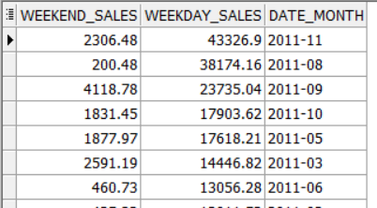order by sub.weekday_sales desc

from this results it’s shown that weekdays sales are much higher than weekends but with respect to each type of sales (weekend /weekday) it’s found that September has the highest weekday sales because of the holiday season and September has the highest weekend sales

knowing this information, we could push ads to the customer for the most selling products during these days in the month that has the highest sales during 12 to 1 pm at which most transactions happen

# Question 2

*** note that I ran this commands in sql plus first

*--ALTER SESSION SET NLS_DATE_FORMAT = 'MM/DD/YYYY HH24:MI';*

Then changed the datatype of invoice date to date

*-- started by craeting the RFM values first*

with RFM as(

select distinct(customer_id) , count(distinct(invoice)) over(partition by customer_id) frequency,

round(max(invoicedate) over () - max(invoicedate) over( partition by customer_id)) recency,

sum(price*quantity ) over( partition by customer_id) monetary

from tableretail

order by customer_id

)

*-- then creating the system by calculating each score*

, sys as(

select customer_id, frequency,recency,monetary,r_score, round((f_score+m_score)/2) fm_score

from (

select cte.* , ntile(5) over(order by frequency) f_score ,

ntile(5) over(order by recency desc) r_score,

ntile(5) over(order by monetary) m_score

from RFM cte)

order by customer_id

)

*-- segementation of the customers based on the scores*

SELECT

s.customer_id,

s.r_score,

s.fm_score,

CASE CONCAT(r_score, fm_score)

WHEN '55' THEN 'Champions'

WHEN '54' THEN 'Champions'

WHEN '45' THEN 'Champions'

WHEN '52' THEN 'Potential Loyalists'

WHEN '42' THEN 'Potential Loyalists'

WHEN '33' THEN 'Potential Loyalists'

WHEN '43' THEN 'Potential Loyalists'

WHEN '53' THEN 'Loyal Customers'

WHEN '44' THEN 'Loyal Customers'

WHEN '35' THEN 'Loyal Customers'

WHEN '34' THEN 'Loyal Customers'

WHEN '51' THEN 'Recent Customers'

WHEN '41' THEN 'Promising'

WHEN '31' THEN 'Promising'

WHEN '32' THEN 'Customers Needing Attention'

WHEN '23' THEN 'Customers Needing Attention'

WHEN '22' THEN 'Customers Needing Attention'

WHEN '25' THEN 'At Risk'

WHEN '24' THEN 'At Risk'

WHEN '13' THEN 'At Risk'

WHEN '15' THEN 'Can''t Lose Them'

WHEN '14' THEN 'Can''t Lose Them'

WHEN '12' THEN 'Hibernating'

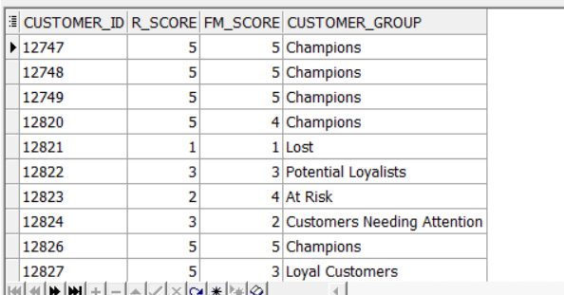 WHEN '11' THEN 'Lost'

ELSE 'other'

END AS customer_group

from sys s;

# Question 3

Question 3a

with consecutive_days as (

select sub3.* ,first_value(sub3.running_sum) OVER (PARTITION BY sub3.CUST_ID,sub3.groups ORDER BY sub3.running_sum desc )days

from(

select sub2.*, sum(date_diff) OVER (PARTITION BY CUST_ID,groups ORDER BY CALENDAR_DT) running_sum

from (

select sub.* ,sum(case when date_diff =1 then 0 else 1 end) OVER (PARTITION BY CUST_ID ORDER BY CALENDAR_DT) groups

from

(

select CUST_ID, CALENDAR_DT , COUNT (*) OVER (PARTITION BY CUST_ID ORDER BY CALENDAR_DT

RANGE BETWEEN INTERVAL '1' DAY PRECEDING AND CURRENT ROW)-1 AS date_diff

from transactions) sub) sub2)sub3

)

select CUST_ID , max(days) max_consecutive_days

from consecutive_days cte

group by cust_id

order by max(days) desc;

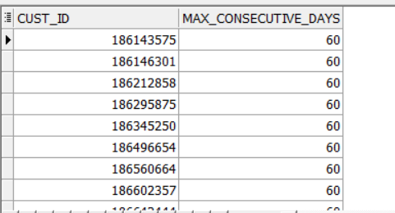

Question 3b

select distinct(cust_id) ,first_value(days_count) over(PARTITION BY CUST_ID ORDER BY days_count desc) max_days_till_250LE

from(

select cust_id, calendar_dt,amt_le,

count(*) over(PARTITION BY CUST_ID ORDER BY CALENDAR_DT) days_count,

sum(amt_le) over(PARTITION BY CUST_ID order by CALENDAR_DT) total

from transactions) sub

where total <= 250

order by cust_id;

