**KMeans Clustering**

**MNIST digits Dataset**

**Report By**

**Aliaa Mohamed Ali Abbas 3747**

**Instructor**

**Dr/Marwan el Torki**

**Objective:**

In this project we apply KMeans clustering algorithm to cluster the MNIST digit dataset.

**Introduction:**

Originally the dataset is meant for classification purposes and is so labeled, as clustering by definition is performed on unlabeled datasets we don’t use labels during training at all. As will be shown in results section, the ‘mean images’ obtained by reshaping the cluster centers into the image dimensions show that the centers appear to have taken the pattern of the digits.

To make sure that the centers have done this we test them with the labels (Again, the labels are not used to train the model only to discover what sort of clusters the model found). We primarily test quality using the KMeans inertia (Objective function)

We also map each of our clusters to a label, by counting the max number of images of a certain label in the cluster and assigning that label to it.

The code snippet to map the labels is below, using this we can map a cluster ‘i’ to a label ‘k’ and see if the mean image of the cluster represents the label so we can have an intuition as to the patterns the model recognized:

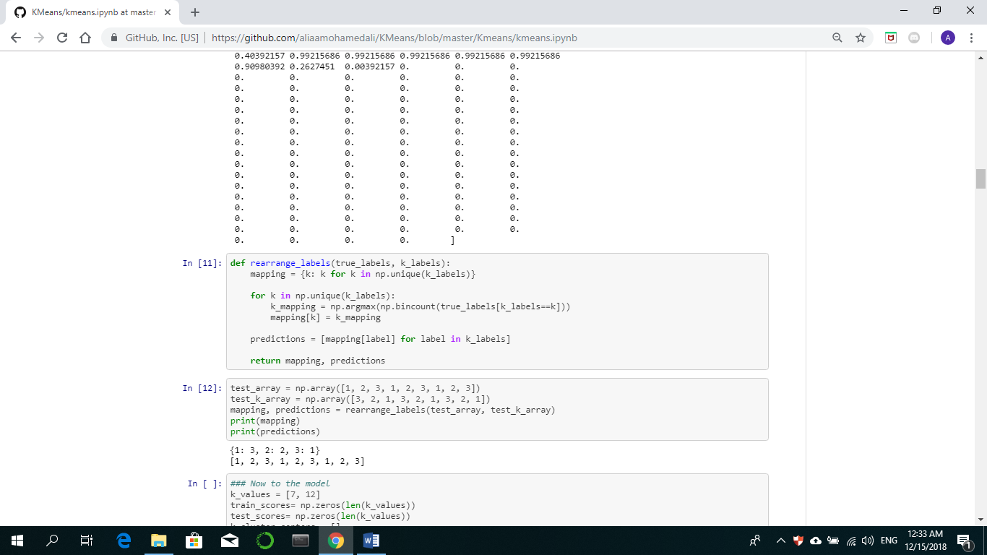

**Parameters:**

We run the program for values of K (5, 7, 10, 12)

*We re-initialize the centroids 5 times for each value of K*

*We run the program for a maximum number of iterations = 300.*

*The KMeans algorithm aims to minimize inertia, that is distance between points and their cluster centroids.*

**Results:**

For k = 5:

Run1: Max= 2005877.525, Min= 1824012.219

Run2: Max= 1985790.222, Min= 1824030.471

Run3: Max= 2058536.885, Min= 1824011.109

Run4: Max= 2017129.383, Min= 1824011.315

Run5: Max= 1957515.944, Min= 1824012.14

Train Accuracy = 0.4511, Test Accuracy = 0.4537

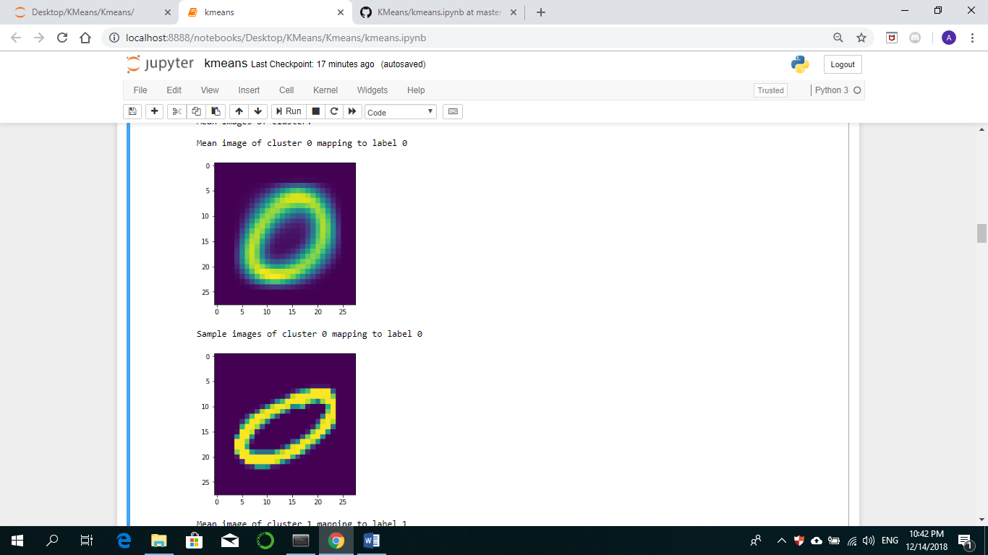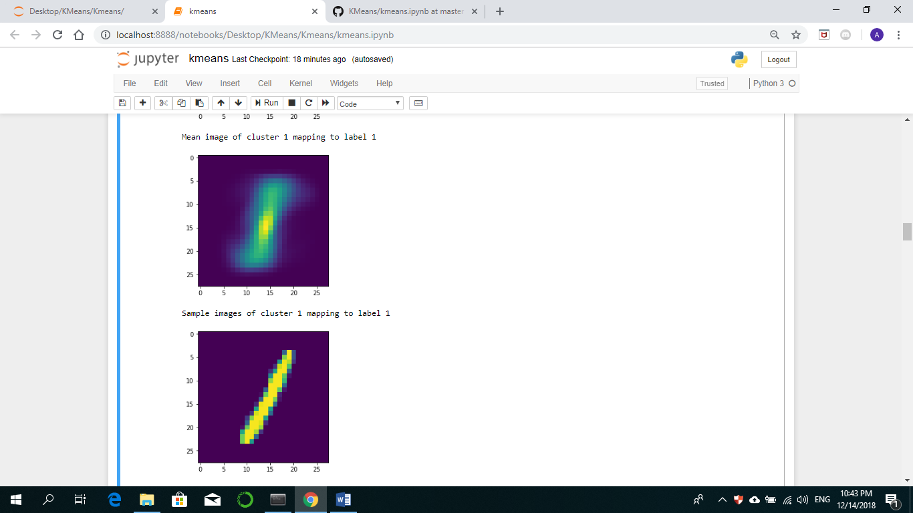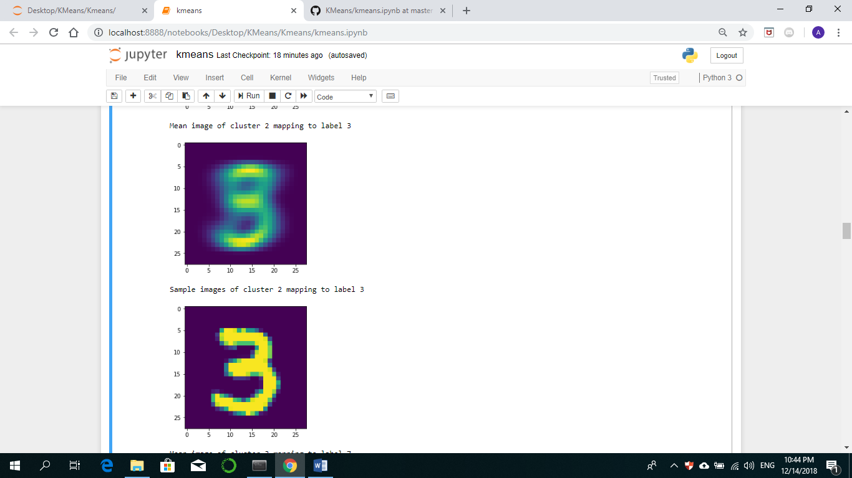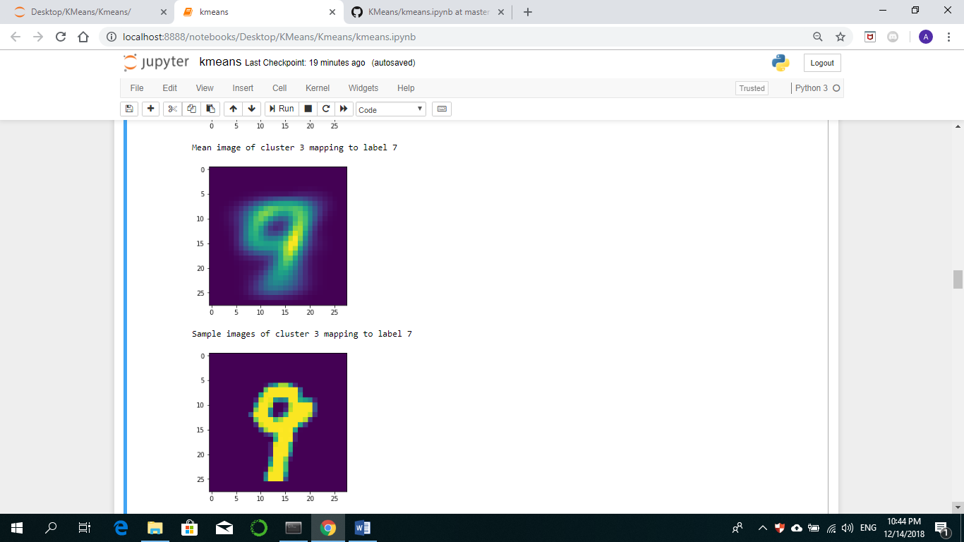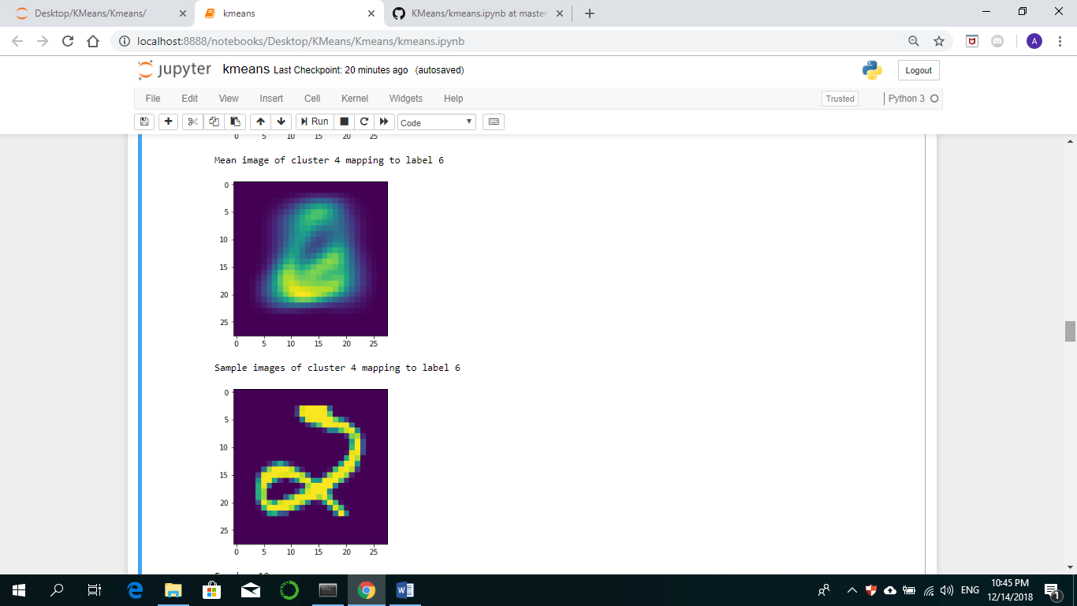

Mappings 0->0, 1->1, 2->3, 3->7, 4->6

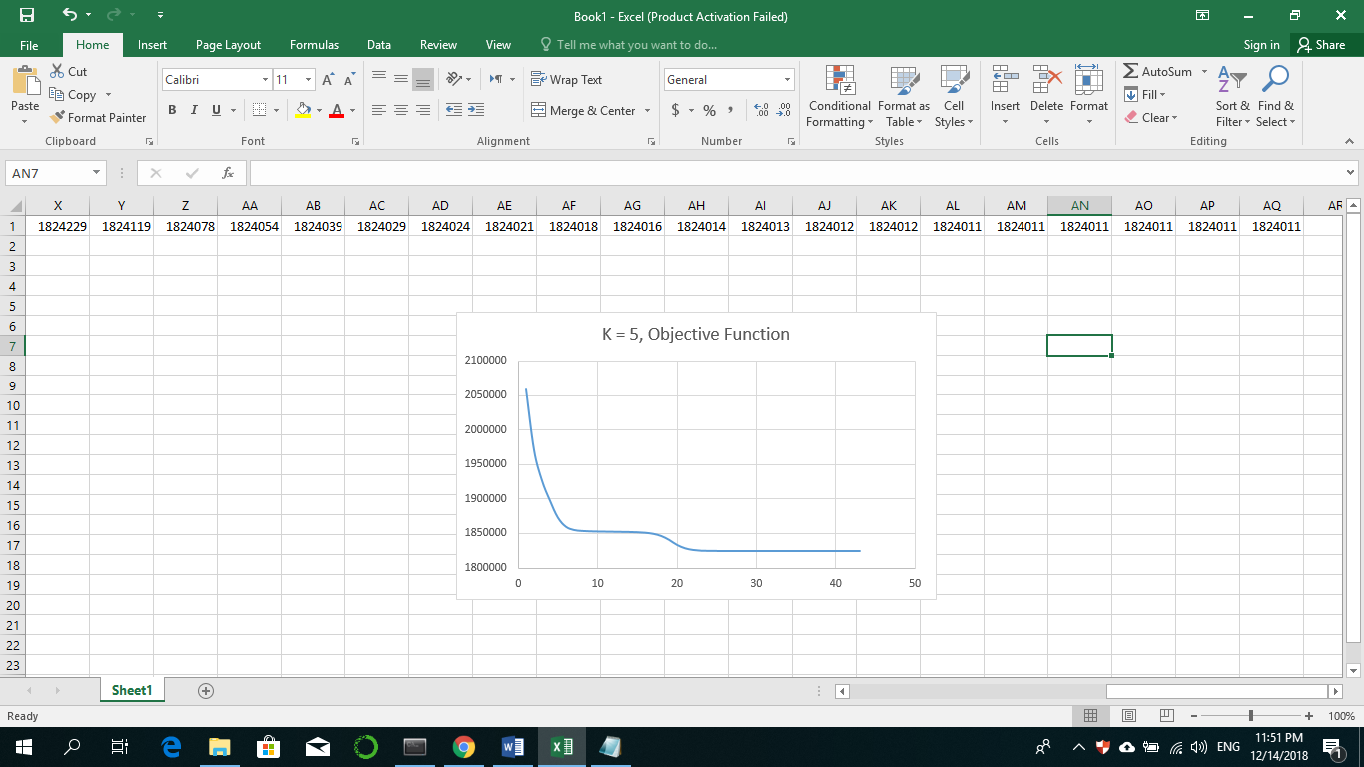

For k = 7:

Run1: Max= 1867412.635848724, Min= 1735097.3918885968

Run2: Max= 1834291.6736012741, Min= 1735097.9146356802

Run3: Max= 1792639.742930492, Min= 1735097.4671158127

Run4: Max= 1804453.0941065643, Min= 1735097.9146356802

Run5: Max= 1834414.5604952567, Min= 1750063.3164397313

Train Accuracy = 0.5083, Test Accuracy = 0.5064

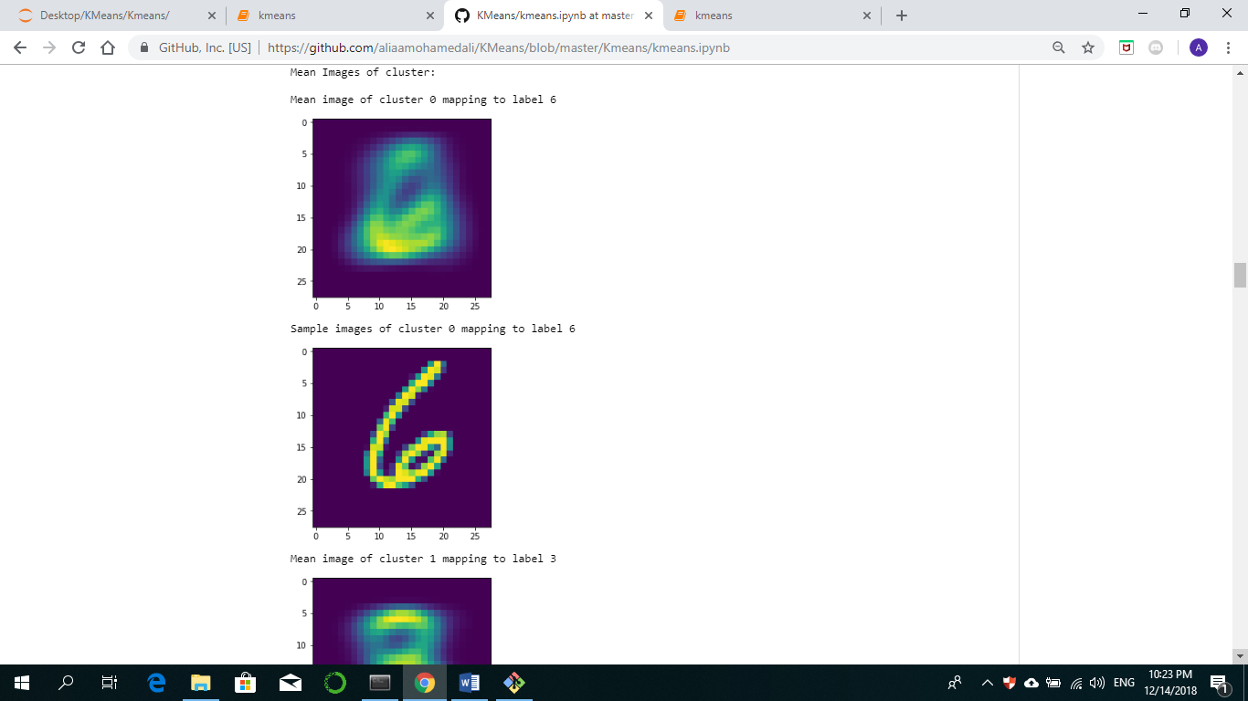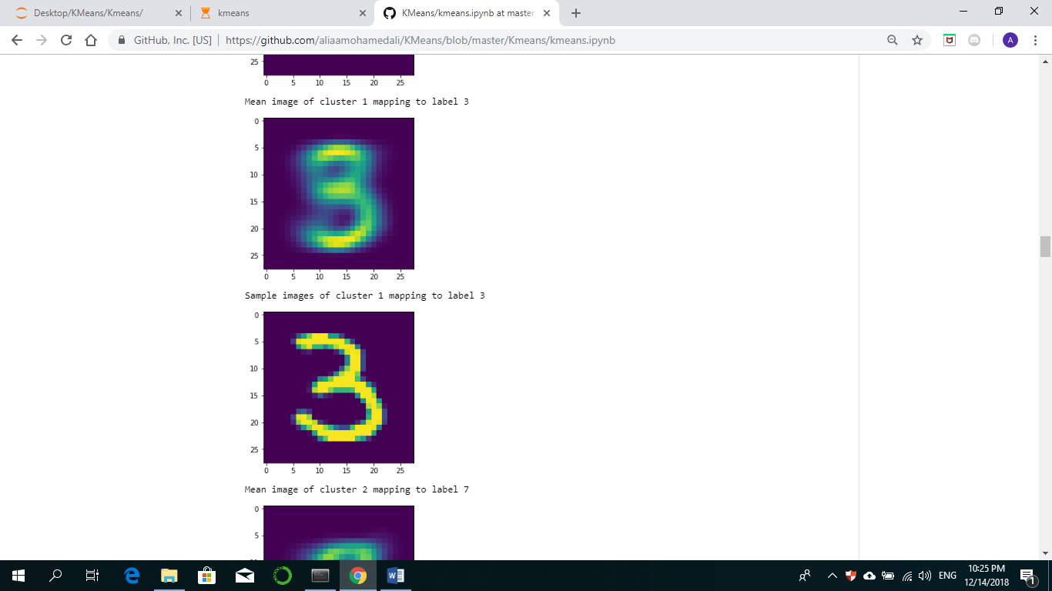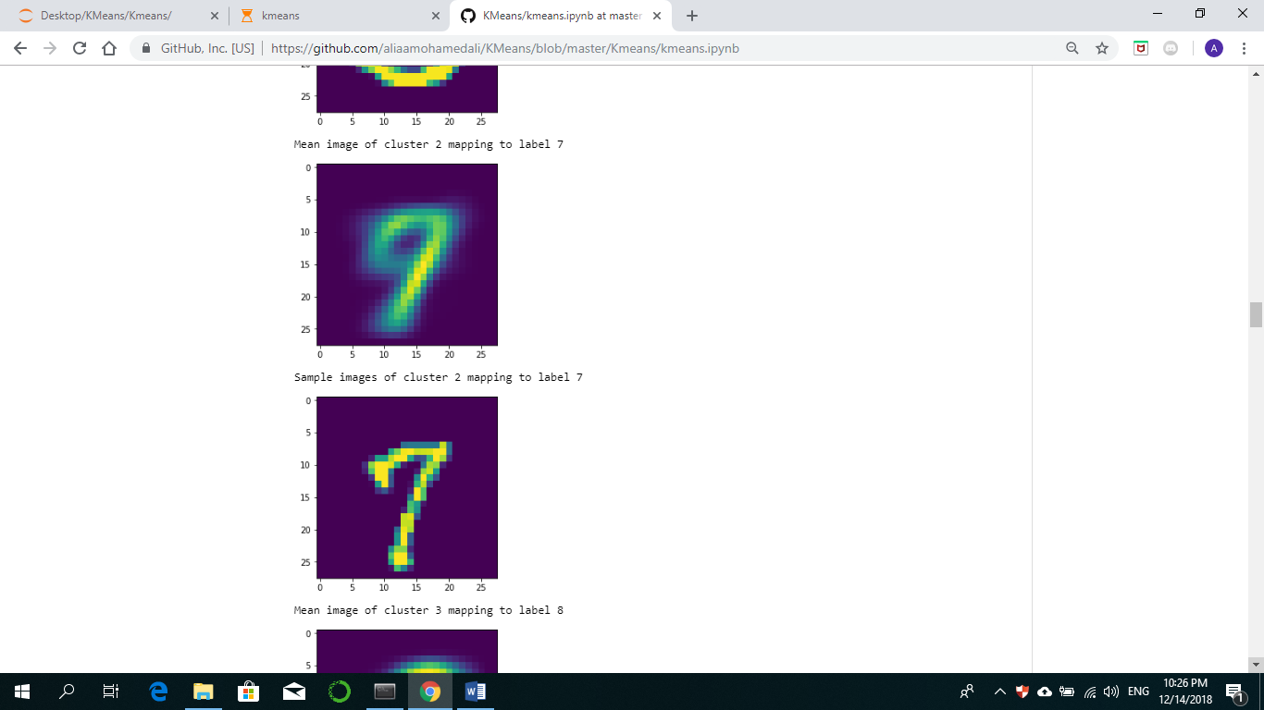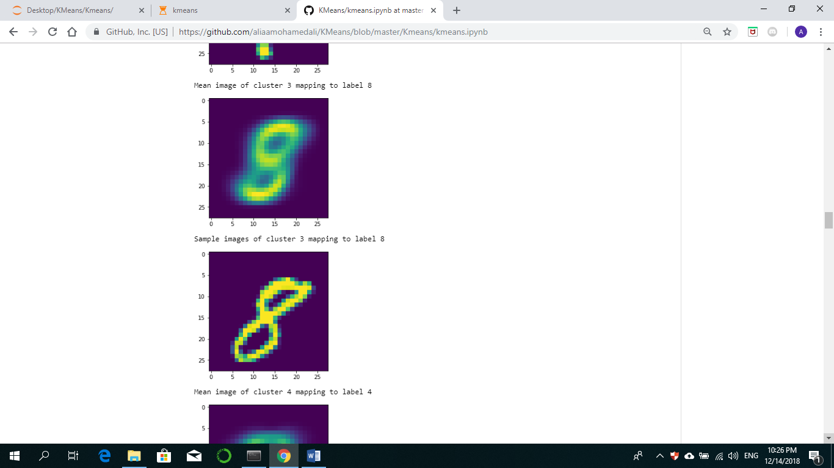

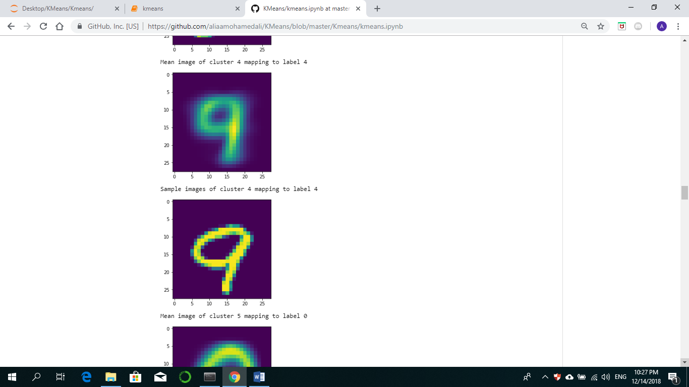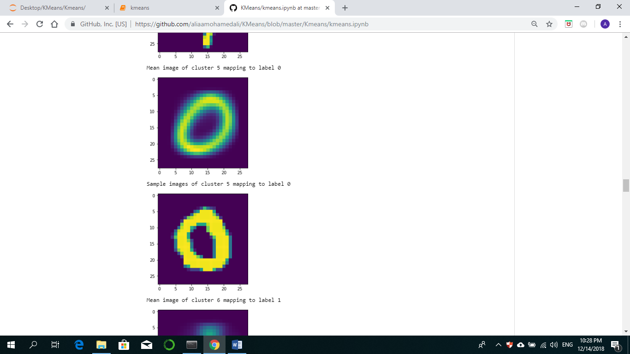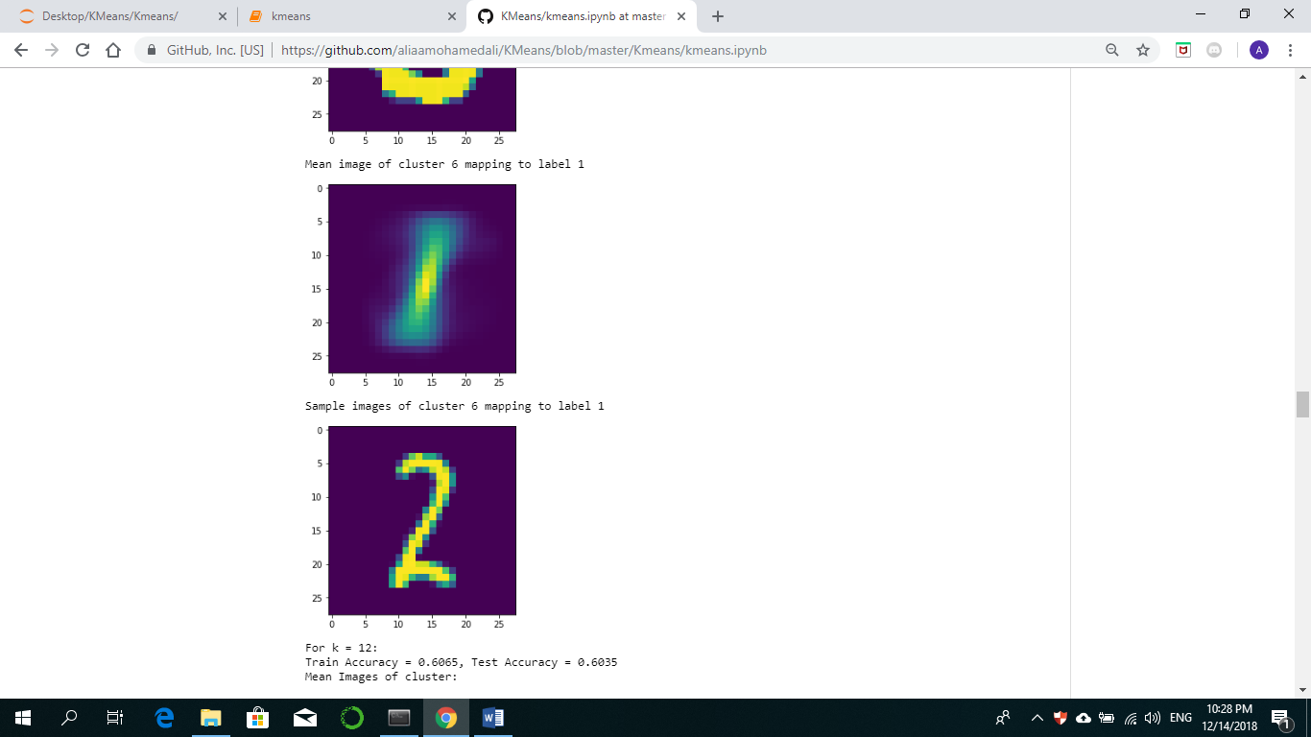

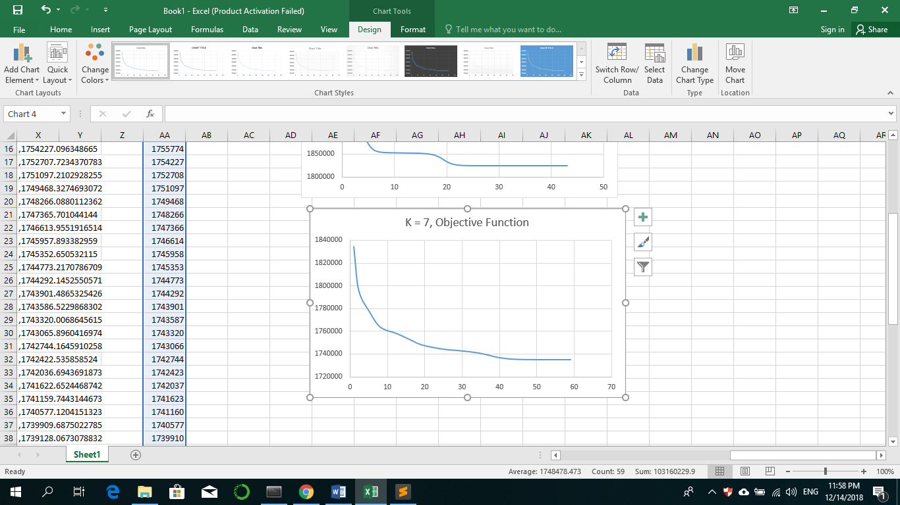

For k = 10:

Run1: Max= 1842558.399211303, Min= 1651141.5429655006

Run2: Max= 1868784.6883395873, Min= 1646039.2485595671

Run3: Max= 1850150.4099327181, Min= 1645926.690151455

Run4: Max= 1848641.2613696465, Min= 1646031.9300724927

Run5: Max= 1824945.3455359973, Min= 1665512.9291154451

Train Accuracy = 0.5920, Test Accuracy = 0.5883

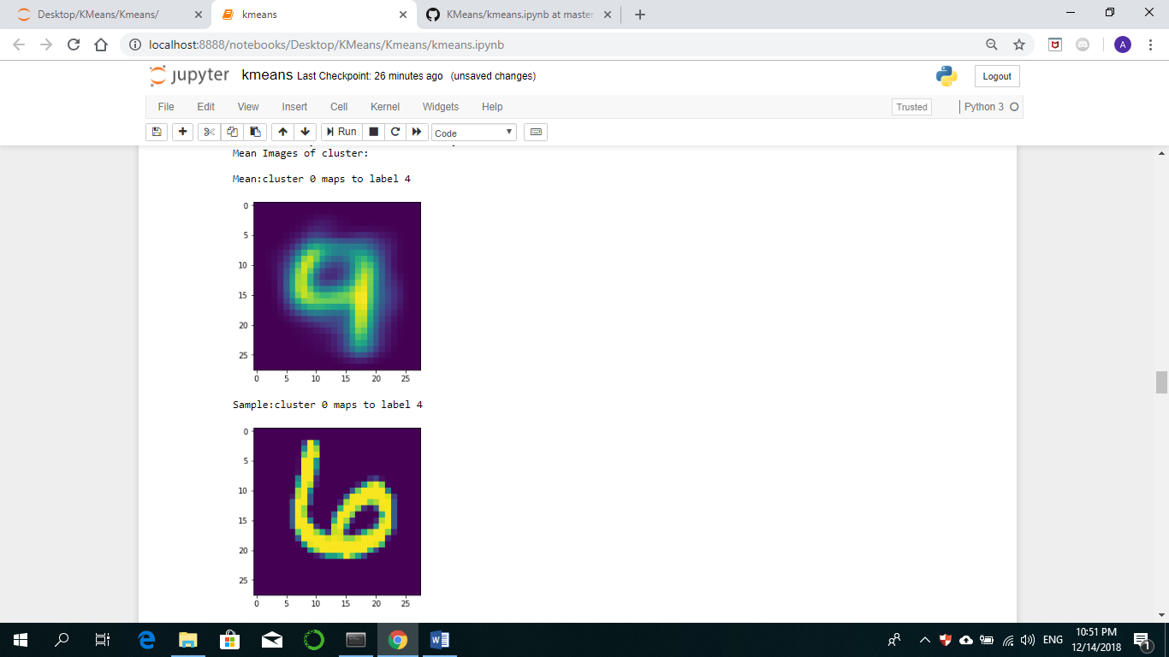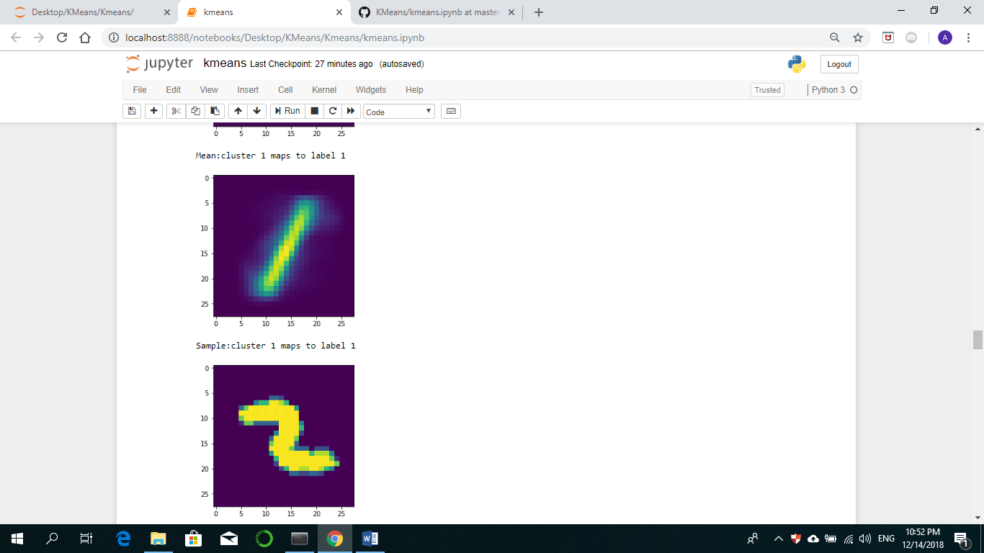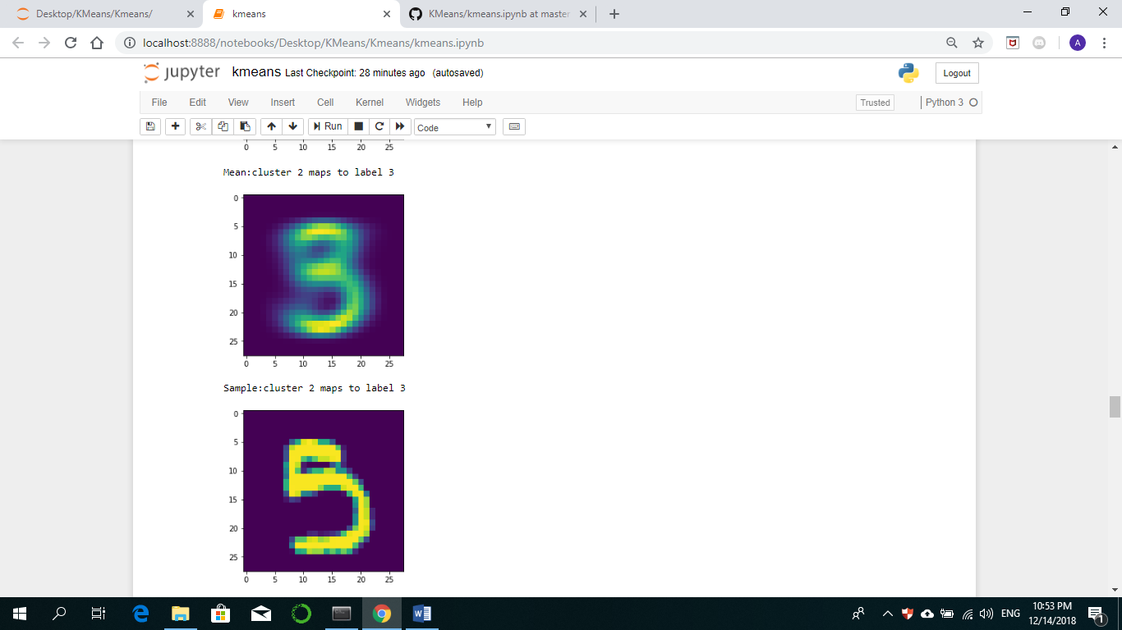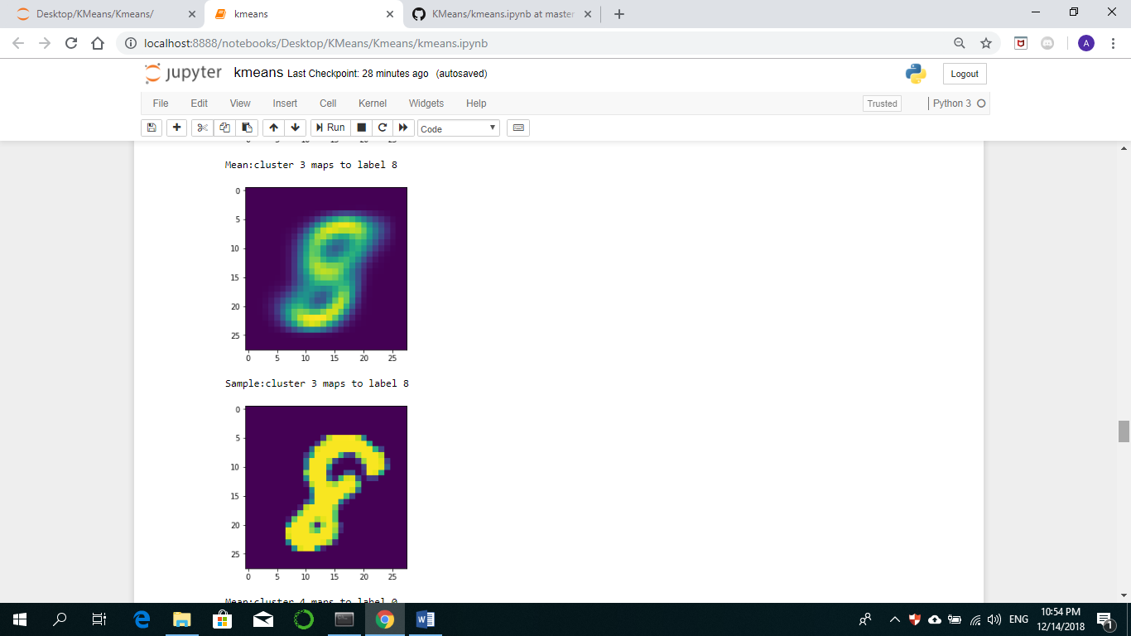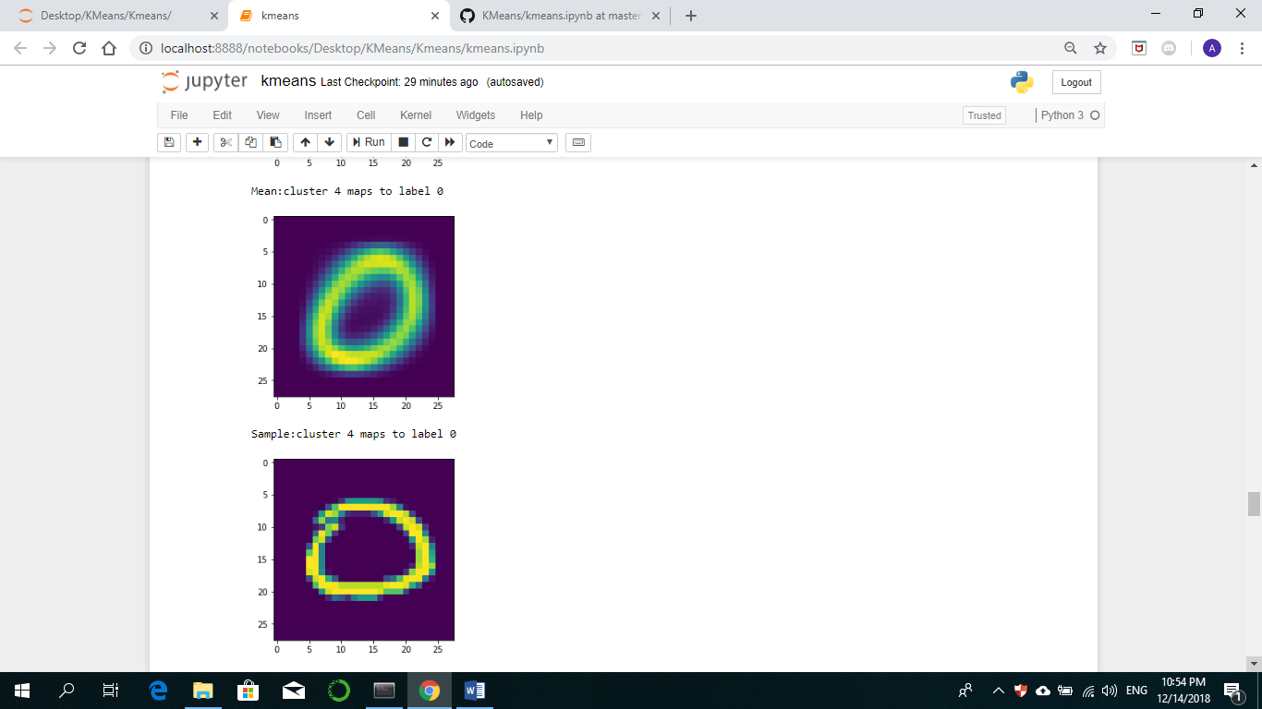

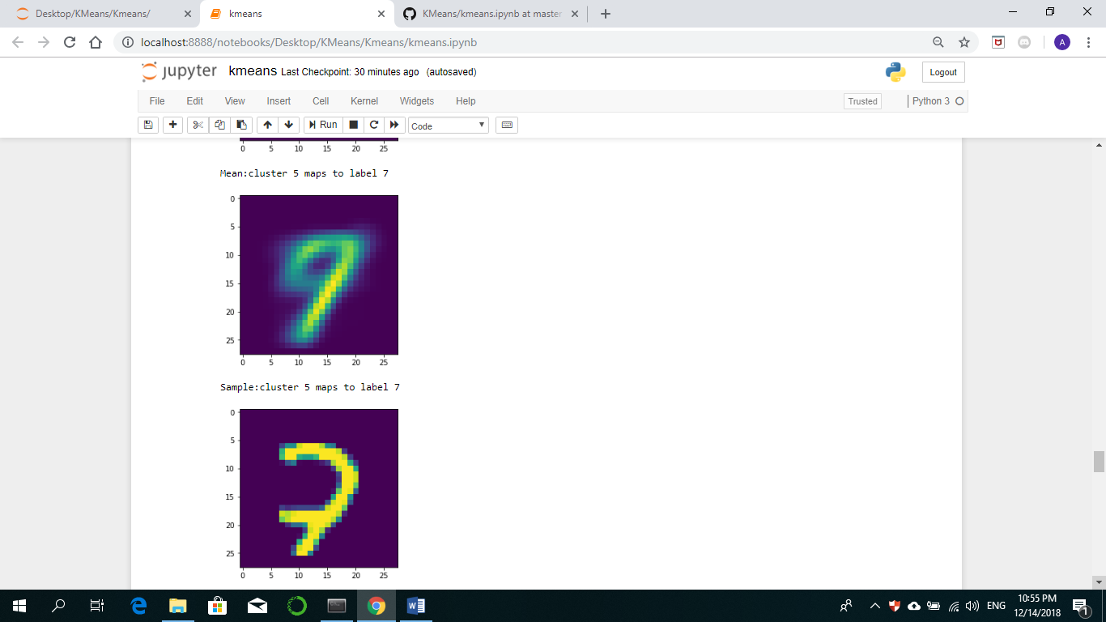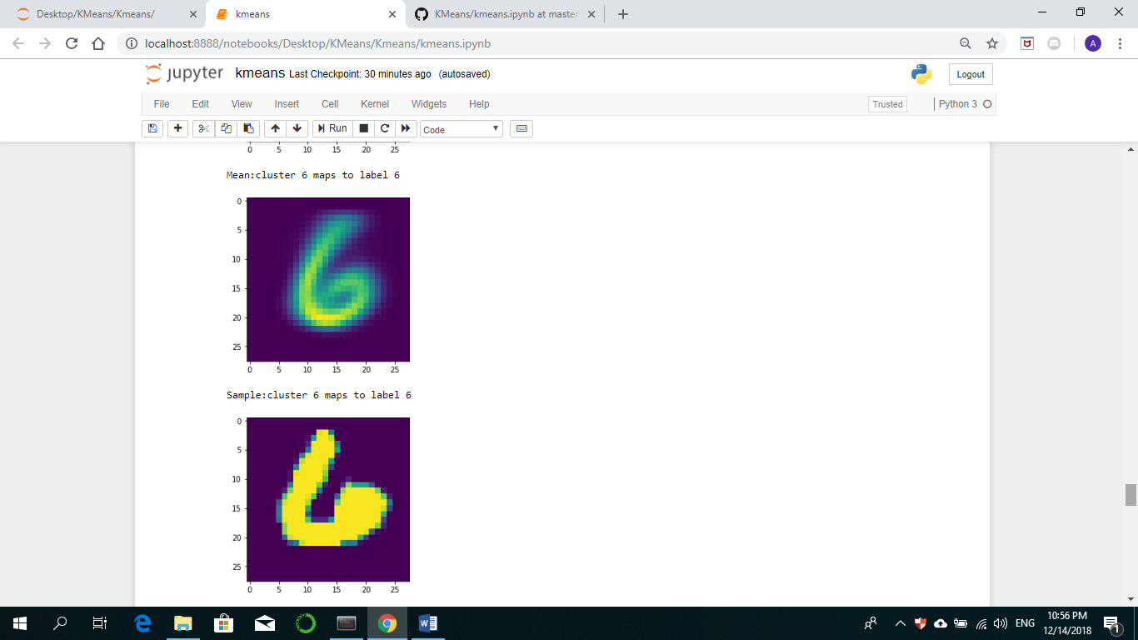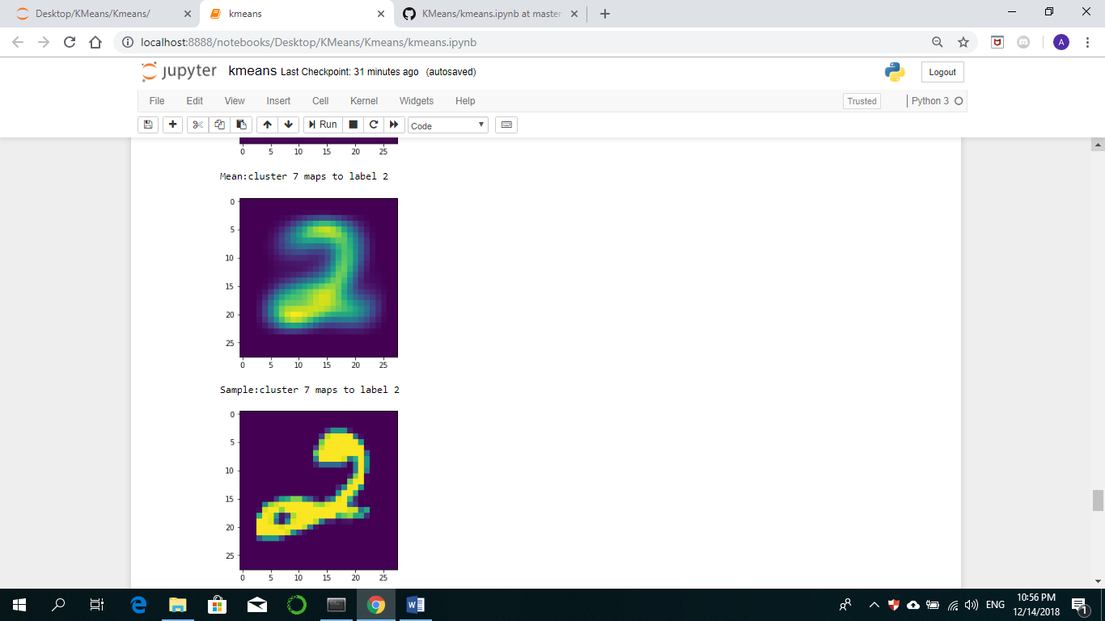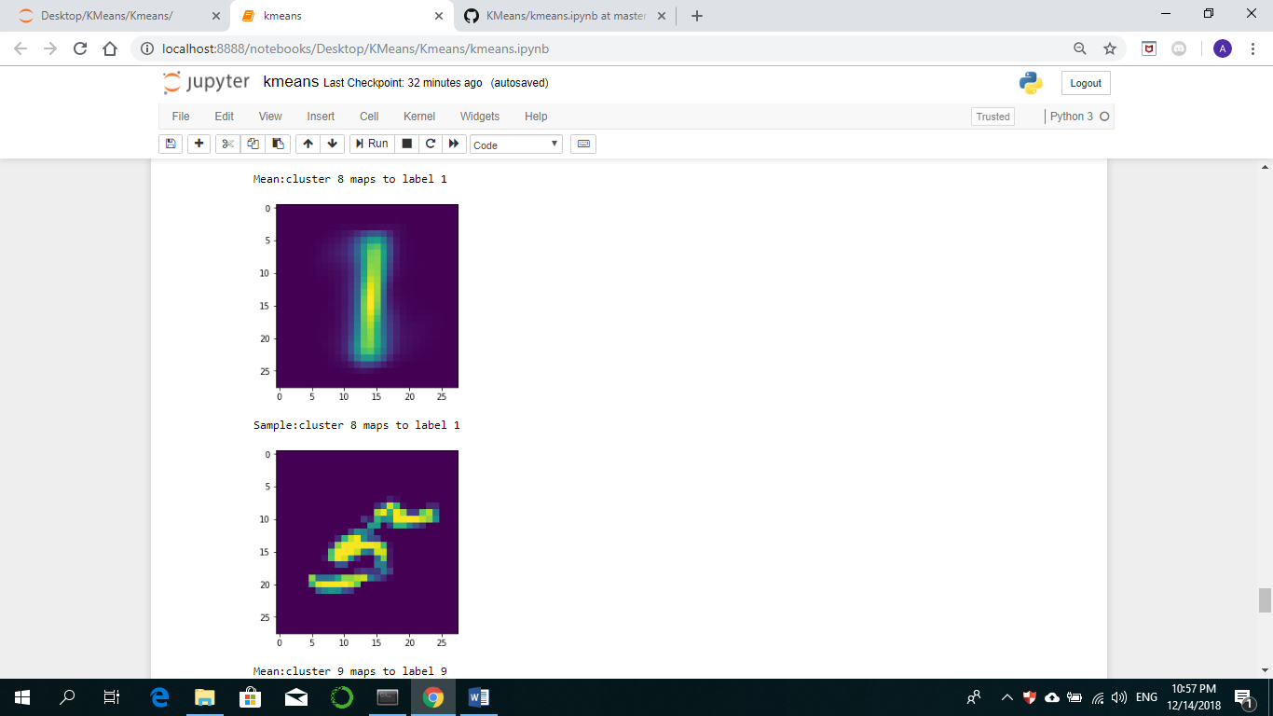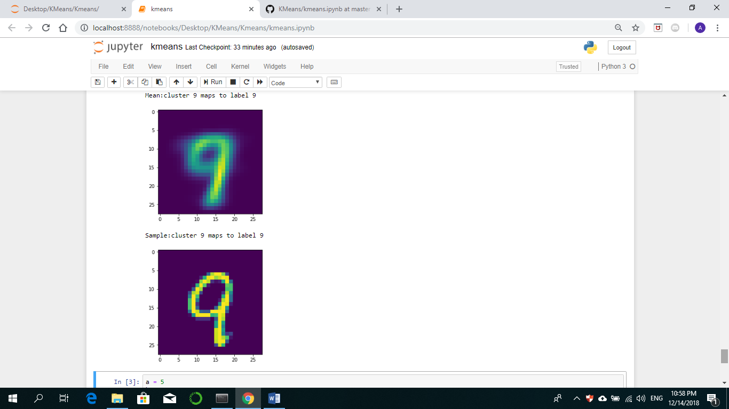

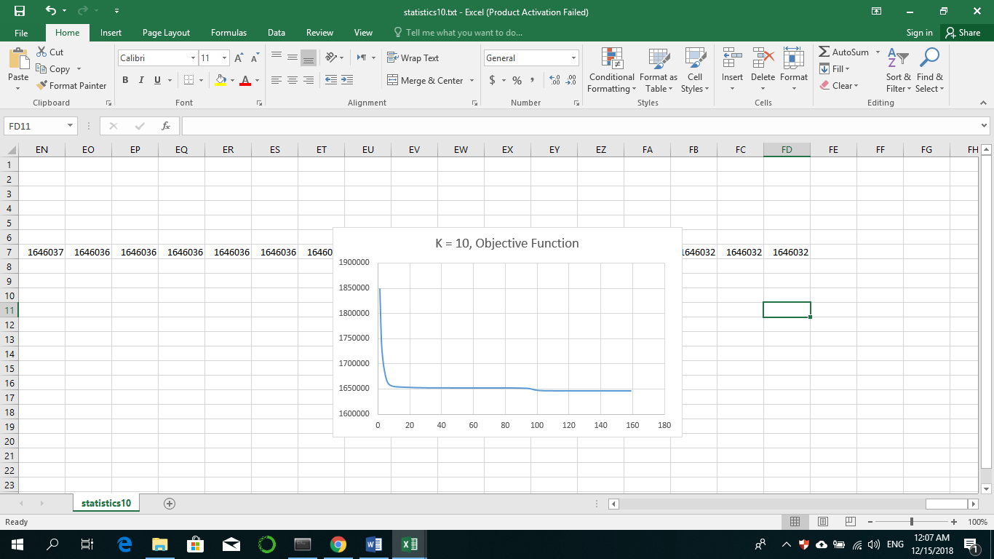

For k = 12:

Run1: Max= 1810431.295040314, Min= 1598411.390134471

Run2: Max= 1806245.0786733285, Min= 1597737.9590808046

Run3: Max= 1774087.2499047131, Min= 1597737.9511413954

Run4: Max= 1777668.7371507126, Min= 1597737.4860982485

Run5: Max= 1779308.8004898103, Min= 1598417.5902334058

Train Accuracy = 0.6065, Test Accuracy = 0.6035

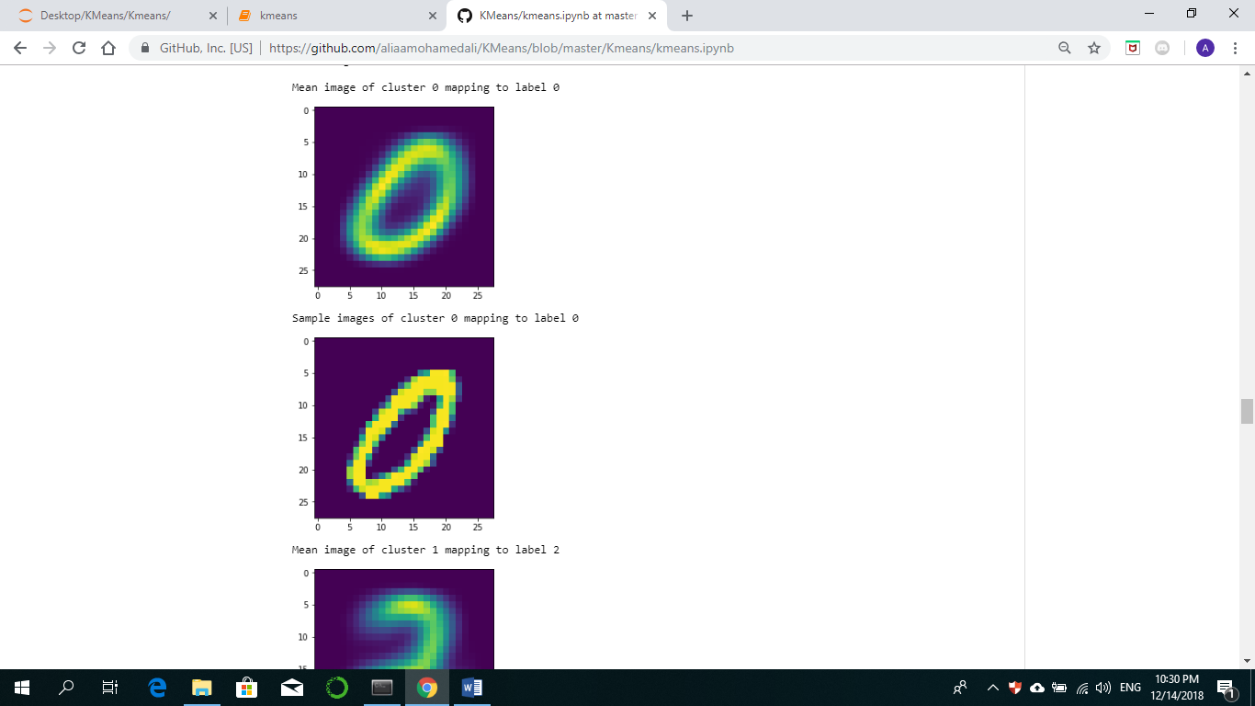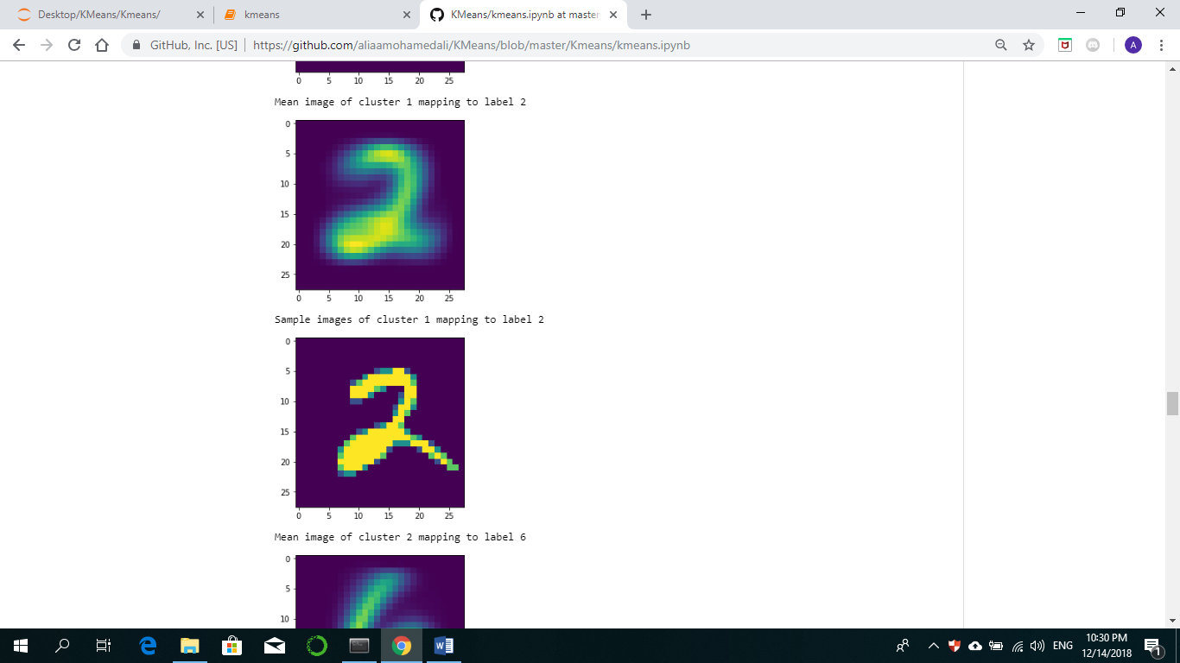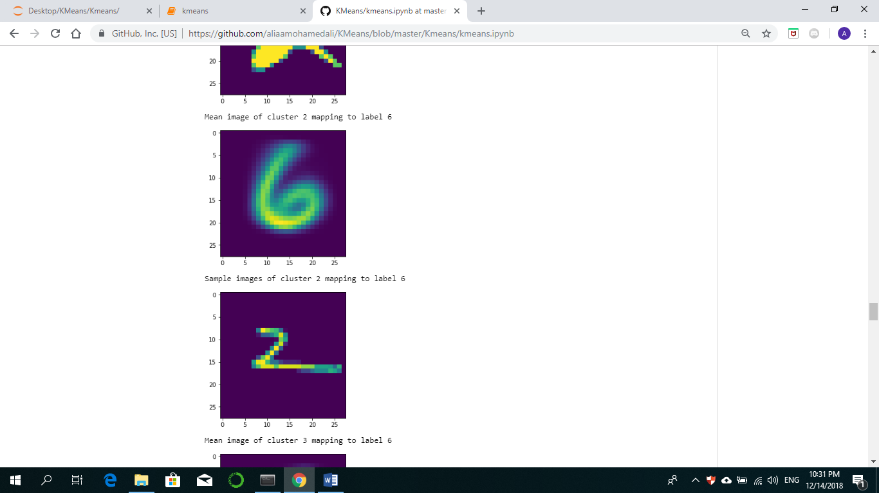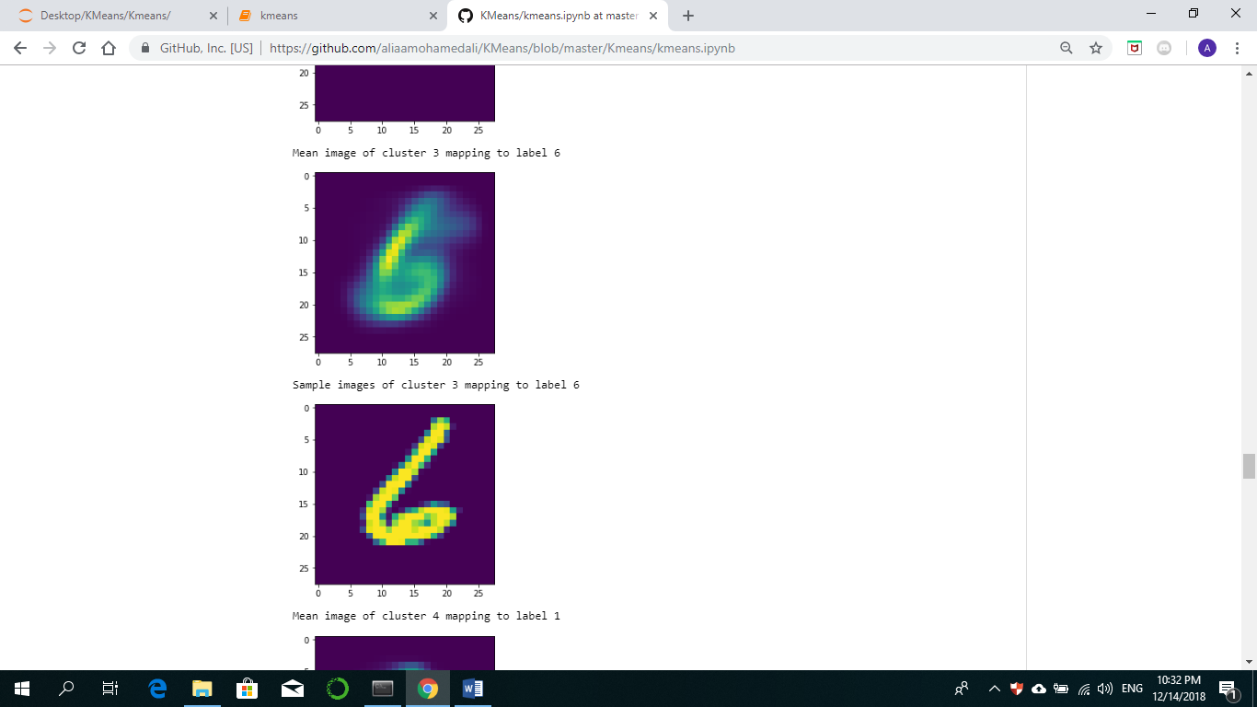

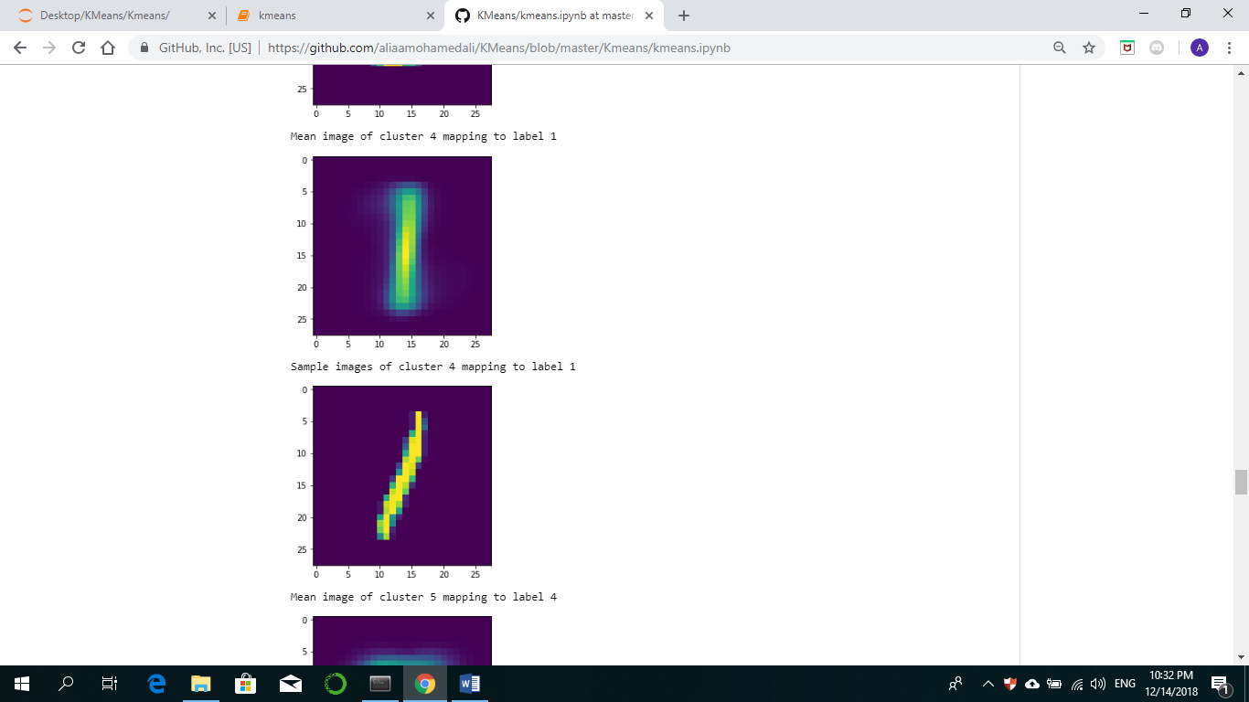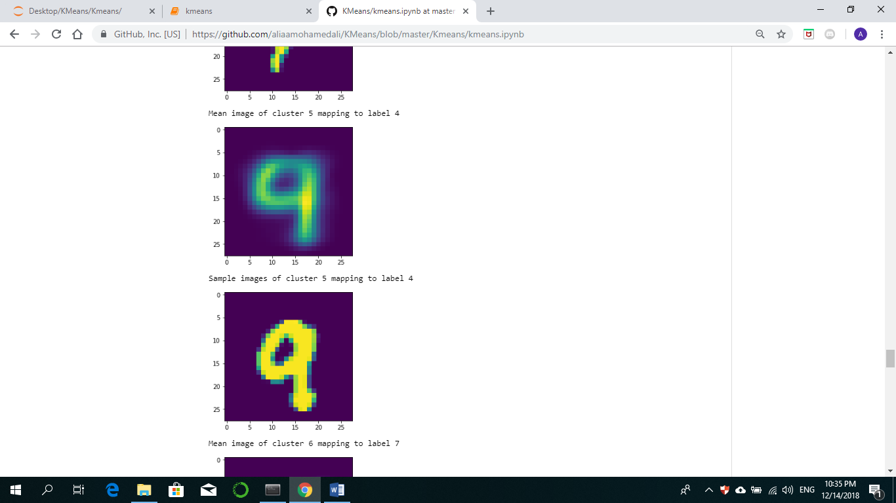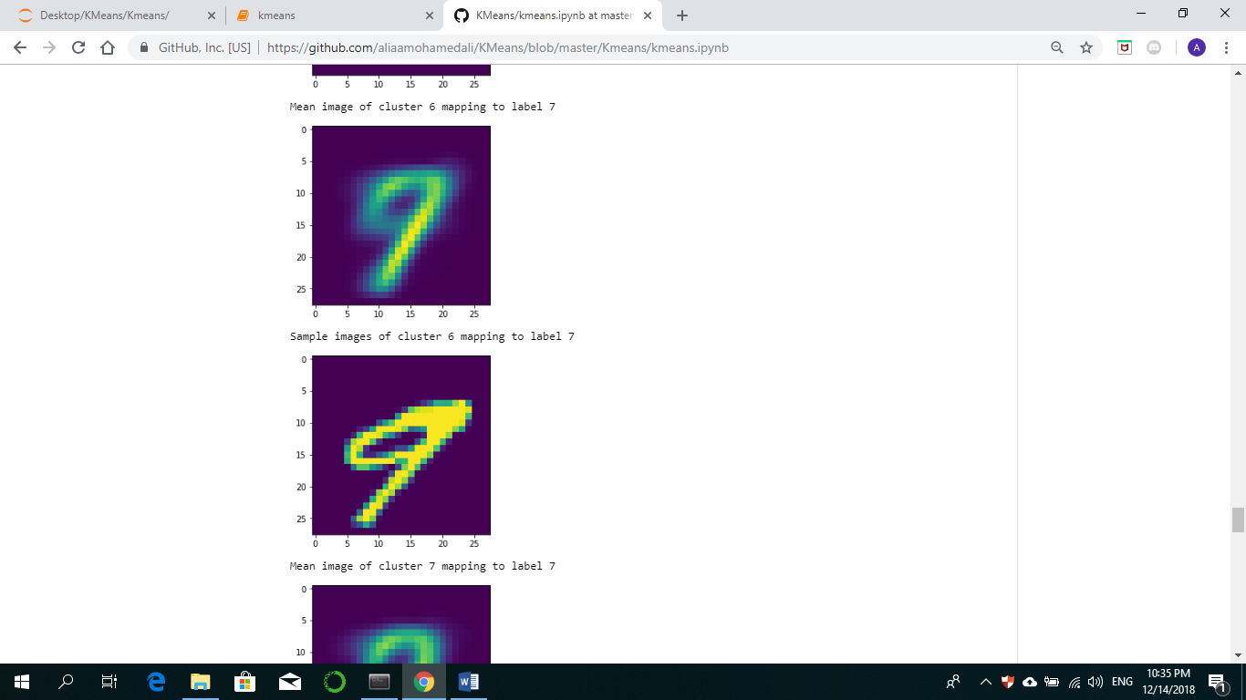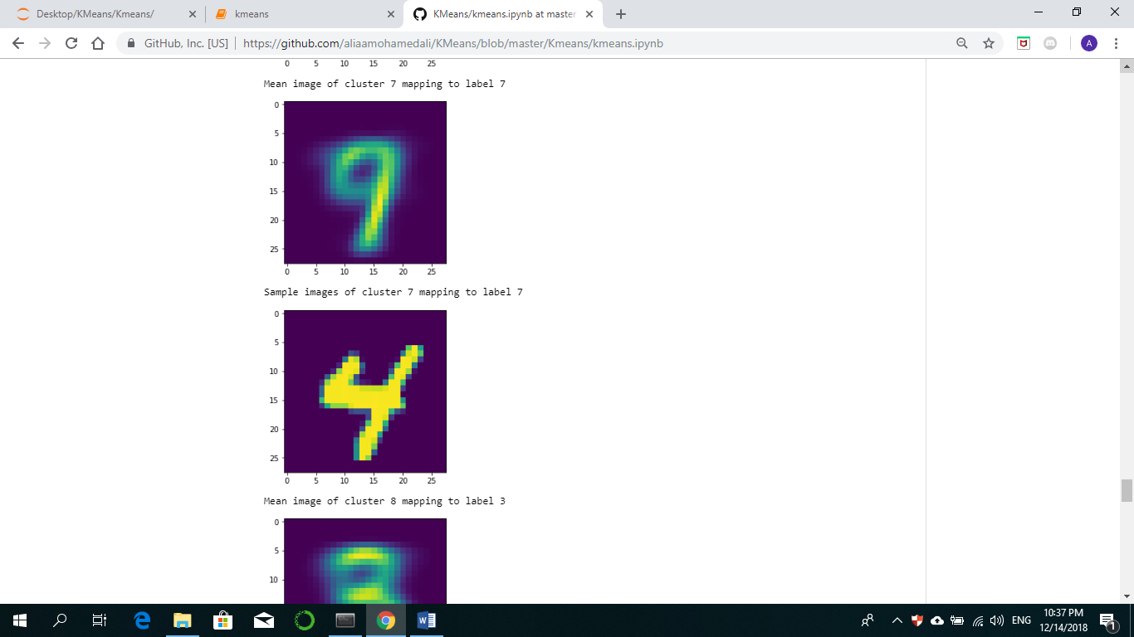

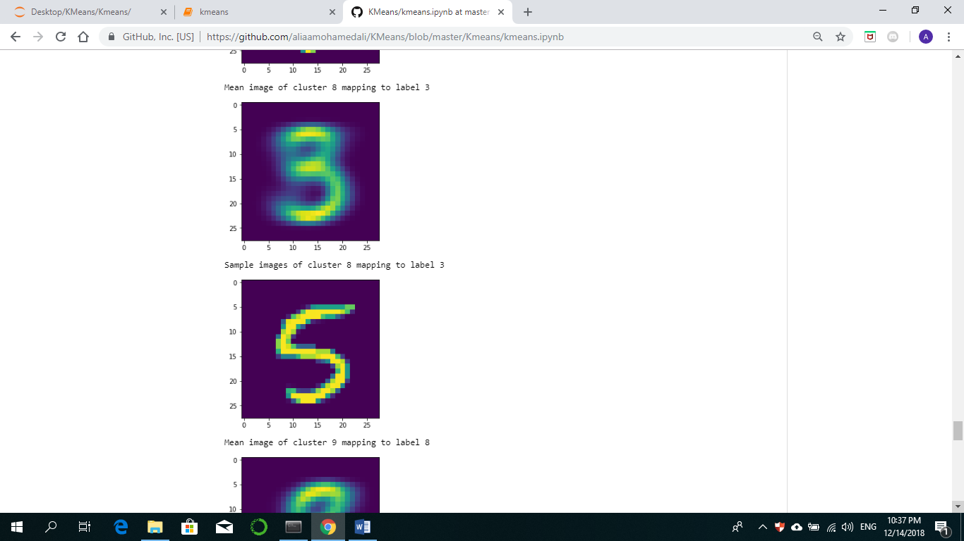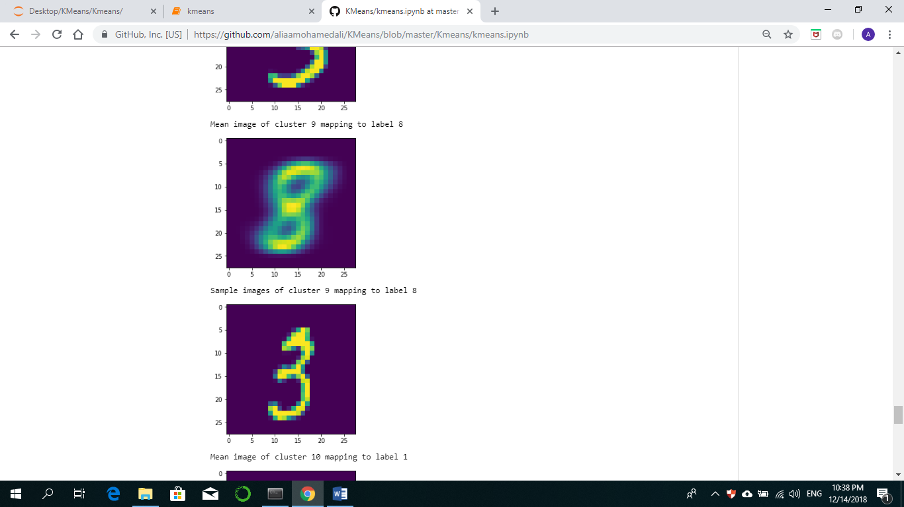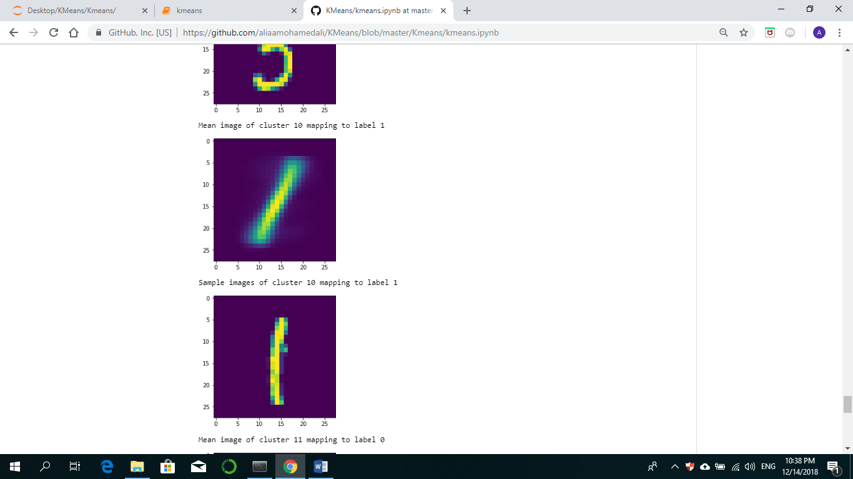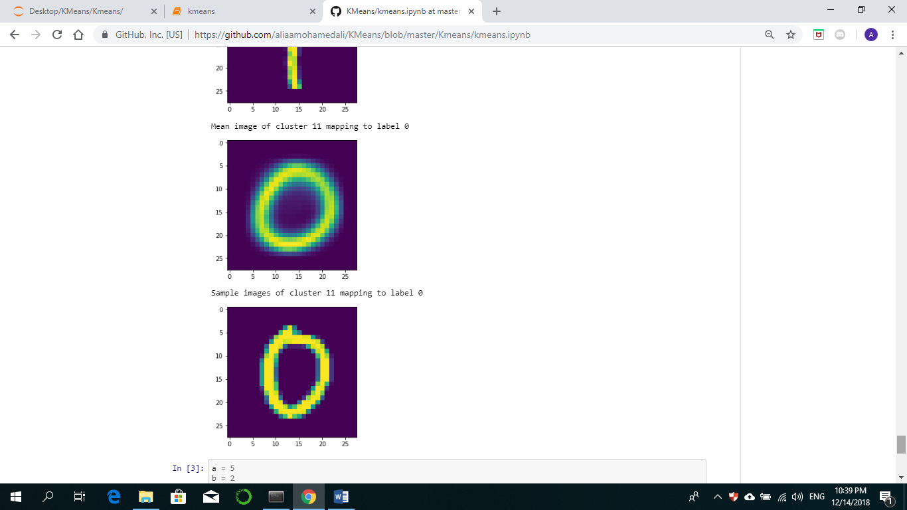

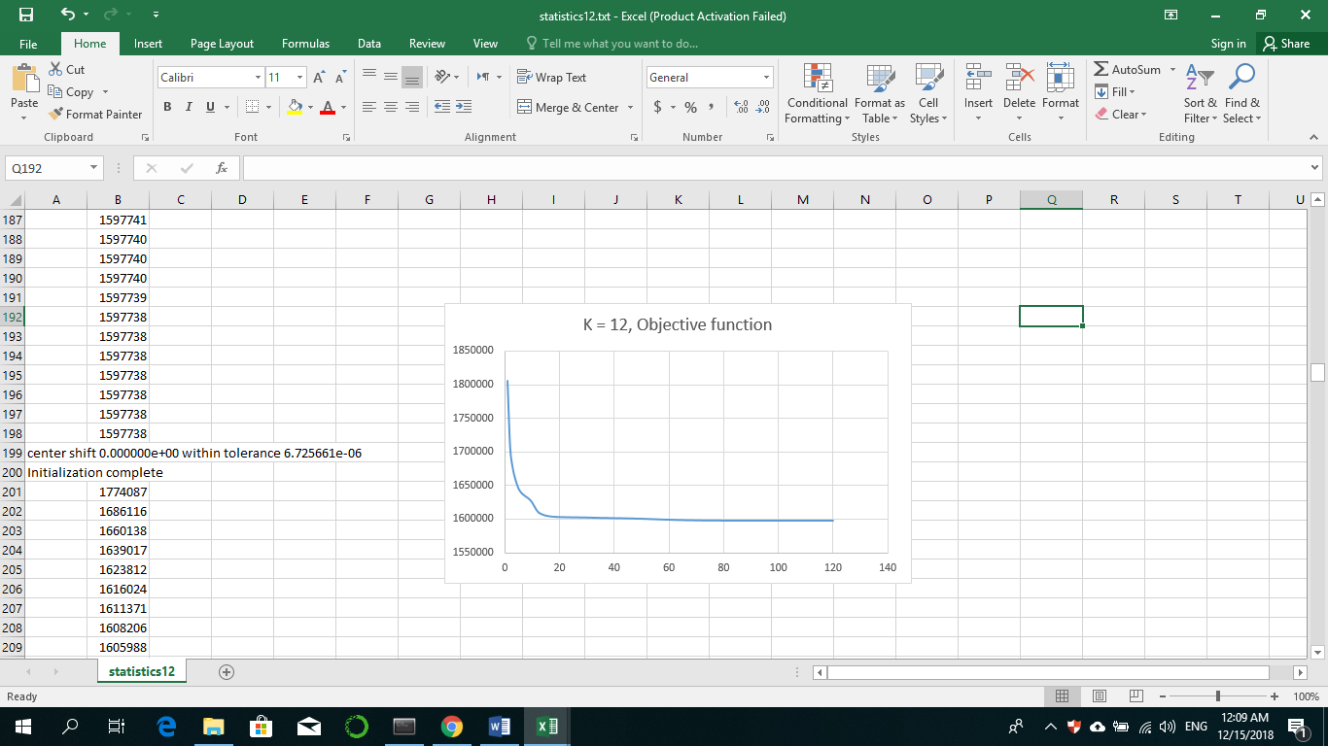

**Conclusion:**

After 300 iterations the model seems to have found mean images corresponding to the digits of the dataset, we ‘inspect’ if the images in the cluster correspond to said digit using the labels and it shows that most of the image in the cluster really correspond to the digit the center mean image shows.