**Circuits (II)**

**Experiment (III)**

**Low Pass and High Pass RC Filters**

**Report By:**

**Aliaa Mohamed Ali Abbas 3747**

**Part(I): Low Pass Filter**

**Introduction:**

A Filter is a circuit designed to pass specific ranges of frequencies while rejecting others. A passive filter consists of passive circuit elements such as resistors, capacitors and inductors.

The four Basic Types of Filters are:

**Low Pass -** High Pass - Band Pass - Band Stop

**Passive Filters:** Simple First-order passive filters (1st order) can be made by connecting together a single resistor and a single capacitor in series across an input signal, ( Vin ) with the output of the filter, ( Vout ) taken from the junction of these two components.

**Passive Low Pass Filter:** A simple passive RC Low Pass Filter or LPF, can be easily made by connecting together in series a single Resistor with a single Capacitor as shown below. The input signal ( Vin ) is applied to the series combination (both the Resistor and Capacitor together) but the output signal ( Vout ) is taken across the capacitor only. At low frequencies the capacitive reactance, ( Xc ) of the capacitor will be very large compared to the resistive value of the resistor, R and as a result the voltage across the capacitor, (Vc) will also be large while the voltage drop across the resistor, (Vr) will be much lower. The equation to calculate the output voltage using the voltage divider method is given by:

Vout = Vin

Frequency response: As the input frequency increases the value of capacitive reactance and thus the voltage across it diminishes resulting in a decreased gain until it tends to zero.The transfer Function Magnitude is then:

$$\frac{Vout}{Vin}= \frac{1}{\sqrt{{(RCω)}^{2}+1 }}= \frac{1}{\sqrt{{(\frac{ω}{ω0})}^{2}+1 }}$$

Where the cut-Off frequency $ω0= \frac{1}{RC}$

**Objective:**

Design a passive low Pass Filter using RC circuit. Analyze the effect of varying frequencies to output voltage of Low Pass Filter. Plot the graph of frequency response in non-ideal Filters. Obtain a theoretical and practical measure of the cutoff frequency ( ƑC).

**Schematic:**

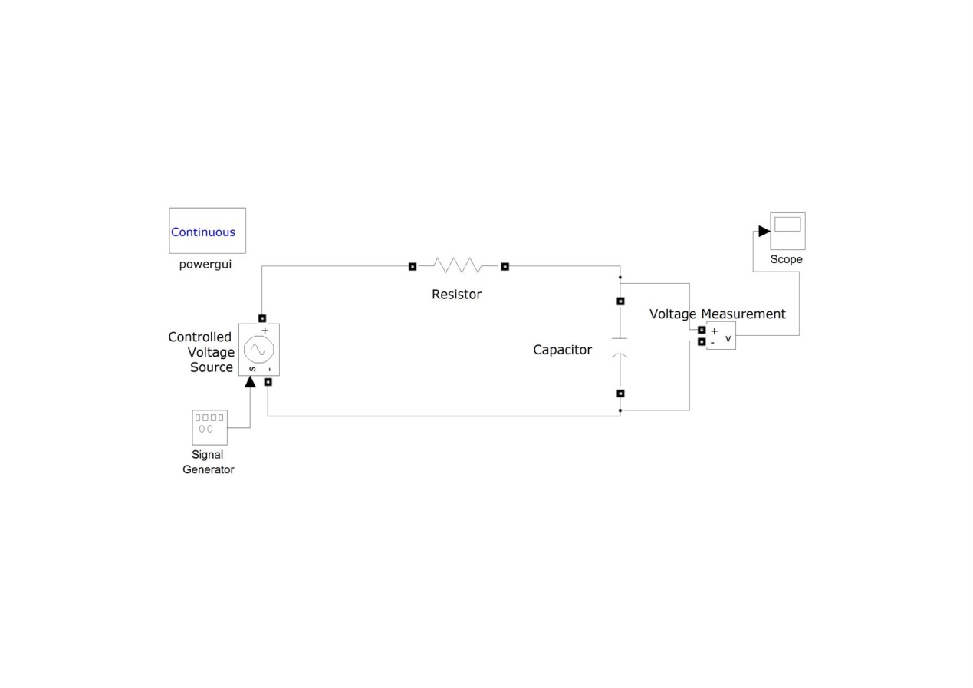

**Procedure:**

1. Set up the RLC circuit as shown the schematic with the component values R = 1000 Ω and C = 100 nF and switch on the function generator.

2. Apply a 10 Vp-p Sinusoidal wave as input voltage to the circuit.

3. Select CH1 of the Oscilloscope to visualize Vout across the capacitor.

4. Vary the frequency of the sine-wave on the Function Generator panel from 200Hz to 50 KHz and measure VoutMax to feed the table below. And calculate the **gain** (Vout/ Vin).

**Results:**

**Measurement Table:**

|  |  |  |  |
| --- | --- | --- | --- |
| **Gain** | **Vout** | **Vin** | **Frequency** |
| **0.984** | **4.92** | **5** | **200** |
| **0.944** | **4.72** | **5** | **600** |
| **0.816** | **4.08** | **5** | **1000** |
| **0.752** | **3.76** | **5** | **1200** |
| ***0.72*** | ***3.6*** | ***5*** | ***1300*** |
| **0.672** | **3.36** | **5** | **1500** |
| **0.272** | **1.36** | **5** | **5000** |
| **0.016** | **0.8** | **5** | **10000** |
| **0.048** | **0.24** | **5** | **50000** |

**Plot of Gain-vs-Frequency:**

**Frequency Response:**

FTheoretical: 1/2пRC = 1592 Hz. FPractical= 1300 Hz

Error = |1592 – 1300|/ 1592 = 18%

**Conclusion:**

The table outputs and graph plot confirm to the theoretical analysis and function of a low pass filter where the gain decreases as the frequency increases until it tends to zero. The practical measurement of Cut-Off Frequency deviates from the theoretical measurement by 18%.

**Part (II) High Pass Filter**

**Introduction:**

A **high Pass Filter** allows passage of frequencies higher than a certain Cut-Off frequency and attenuates frequencies below it. The Amount of attenuation varies according to the Filter Design. In an RC Passive High Pass filter the cut-Off frequency is at the half-power frequency where the gain = 70.707% of the Input.

The design of a simple Passive High Pass Filter consists of a series-connected RC circuit where the output Voltage (Vout) is taken across the Resistance.

Using Voltage divider to calculate (Vout):

Vout = Vin

**Frequency Response & Gain:** As the input Frequency increases the value of the capacitive Reactance and decreases. Along with it decreases the voltage across the capacitor terminals. At 𝝎 = infinity the Capacitive Reactance is equal to zero constituting a short circuit and the output voltage is completely consumed across the resistor resulting in a gain = 1 in the case of an ideal Filter.

**Objective:**

Design a passive High Pass Filter using RC circuit. Analyze the effect of varying frequencies to output voltage of High Pass Filter. Plot the graph of frequency response in non-ideal Filters. Obtain a theoretical and practical measure of the cutoff frequency ƑC).

**Schematic:**

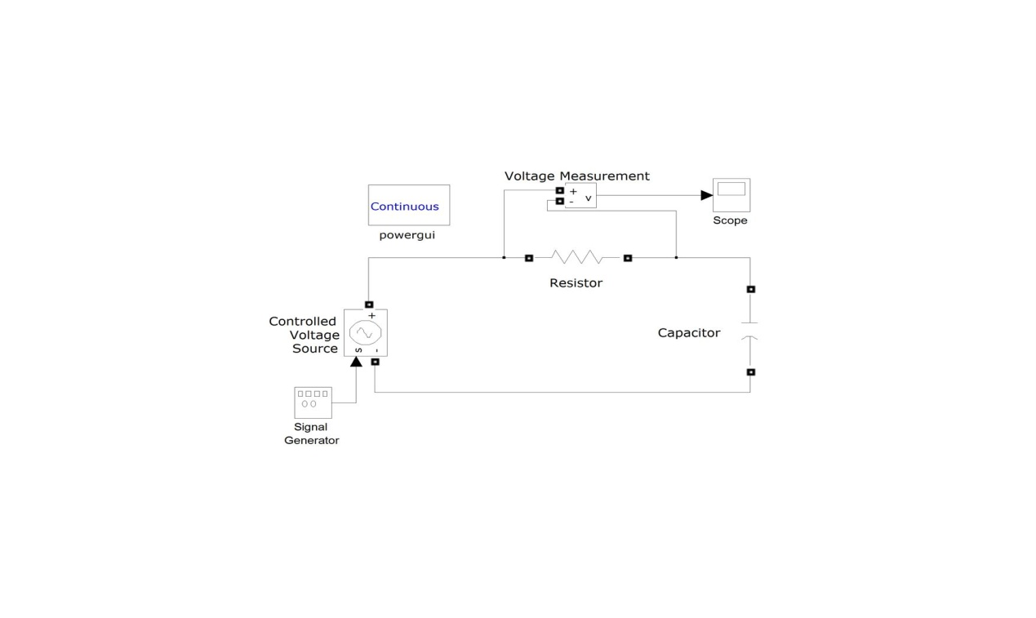

**Procedure:**

1. Set up the RLC circuit as shown the schematic with the component values R = 1000 Ω and C = 100 nF and switch on the function generator.

2. Apply a 10 Vp-p Sinusoidal wave as input voltage to the circuit.

3. Select CH1 of the Oscilloscope to visualize Vout across the Resistor.

4. Vary the frequency of the sine-wave on the Function Generator panel from 200Hz to 50 KHz and measure VoutMax to feed the table below. And calculate the **gain** (Vout/ Vin).

**Results:**

**Measurement Table:**

|  |  |  |  |
| --- | --- | --- | --- |
| **Gain** | **Vout** | **Vin** | **Frequency** |
| **0.18** | **0.9** | **5** | **200** |
| **0.24** | **1.2** | **5** | **600** |
| **0.54** | **2.7** | **5** | **1000** |
| **0.68** | **3.4** | **5** | **1200** |
| ***0.712*** | ***3.56*** | ***5*** | ***1300*** |
| **0.76** | **3.8** | **5** | **1500** |
| **0.944** | **4.72** | **5** | **5000** |
| **0.984** | **4.92** | **5** | **10000** |
| **0.992** | **4.96** | **5** | **50000** |

**Plot of Gain-vs-Frequency:**

**Frequency Response:**

FTheoretical: 1/2пRC = 1592 Hz. FPractical= 1300 Hz

Error = |1592 – 1300|/ 1592 = 18%

**Conclusion:**

The table outputs and graph plot confirm to the theoretical analysis and function of a high pass filter where the gain tends to zero at low frequencies and increases as the frequency increases until it reaches a value close to the max gain (in this circuit 1). The practical measurement of frequency Response deviates from the theoretical measurement by 18%.