**Circuits (II)**

**Experiment (II)**

**Transient Response of RC Circuits**

**Report By:**

**Aliaa Mohamed Ali Abbas 3747**

**Theory:**

In this Experiment, we apply a square waveform to the RC circuits to analyze its transient response, the pulse-width relative. A Capacitor has the ability to store electrical charge and energy. The voltage across the capacitor is related to charge by equation:

v = Q/C

for steady values, or in instantaneous value:

dV = dq/C

**Time Constant (**Ʈ**):** A measure of time required for certain changes in voltages and currents in RL & RC circuits. Generally, at t= 5* Ʈ. The current & Voltage have reached their final values, also known as steady-state response.

The time constant of both the Capacitor current and voltage in an RC circuit when a Voltage source is suddenly applied is the product of equivalent capacitance and the Thevenin resistance as viewed from terminals of the equivalent capacitor:

Ʈ =RC

**Pulse:** A voltage/current that changes periodically where the length of its cycle is called its period. When it's high time equals its low time it's called a square wave.

F = 1/ 2*tp

**Objective:**

- Study the transient response in storing an electrical charge on a capacitor as well as the decay of an initial charge on a capacitor in an RC circuit.

- Understand the Time constant (Ʈ) in an RC circuit and how it changes.

**Requirements:**

Resistor 1 KΩ

Capacitor 100 nF

Signal Generator

Oscilloscope

**Procedures:**

- Set up the circuit in the schematic diagram below

- Set the generator to obtain a square wave of frequency = 600 Hz & peak-to-peak voltage = 5 Volts

- Set Channel 1 of the oscilloscope to read the voltage across the Resistance.

- Shift the cursor laterally to where V = 0.632*Vmax and

Measure the time elapsed time = (distance in x-axis)* (time/division)

- At this point Ʈ = time elapsed.

- Or simply read the elapsed time measured by Oscilloscope.

**Schematic:**

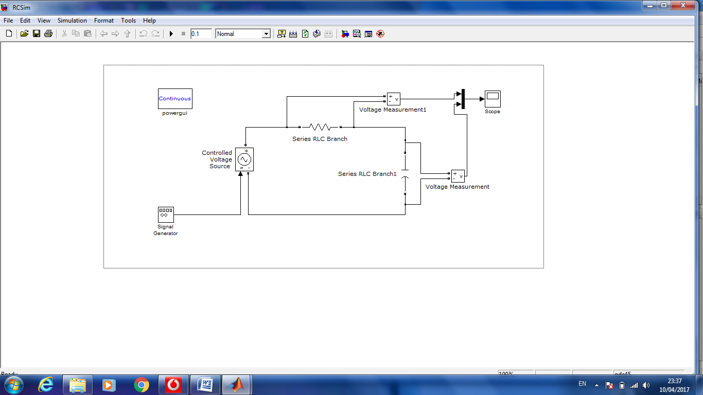

**Simulation wave forms:**



**Results:**

Ʈ (Theoretical) = RC= 1000*100*10-9 = 10-4 = 100 µS

Ʈ(Practical) = 140 µS

Error % = | Ʈ th – Ʈ pr| / Ʈ th = 40%

**Conclusion:**

Practical observations and measurements were inconsistent with the theoretical analysis of the Transient response of RC circuits with a deviation error of 40%. The error can be accounted for by two major sources of error: Voltage source internal impedance and its inability to make an ideal jump between 0-1 voltages. Inaccuracies in measurements may also be a factor in the error as well.