**Circuits (II)**

**Experiment (I)**

**Transient Response of RL Circuits**

**Report By:**

**Aliaa Mohamed Ali Abbas 3747**

**Theory:**

In this Experiment, we apply a square waveform to the RL circuits to analyze its transient response, the pulse-width relative **Time Constant (**Ʈ**):** Measure of time required for changes in voltages and currents in RL & RC circuits. Generally, at t = Ʈ, the current has risen to 63.2% of its maximum value & when t = 5* Ʈ, it has reached 99.5% of its max value, when the circuit is switched off current doesn't instantly fall to zero. At t= Ʈ it reaches 36.8% of its maximum value and reaches zero at t = 5* Ʈ.

Ʈ = L/R

**Pulse:** A voltage/current that changes periodically where the length of its cycle is called its period. When it's high time equals its low time it's called a square wave.

F = 1/ 2*tp

**Objective:**

Study the transient response of an RL circuit and obtain a practical measurement for the Time constant (Ʈ) using a function generator and an Oscilloscope.

**Requirements:**

Resistor 1 KΩ

Inductor 4mH

Signal Generator

Oscilloscope

**Procedures:**

- Set up the circuit in the schematic diagram below

- Set the generator to obtain a square wave of frequency = 20 KHz & peak-to-peak voltage = 5 Volts

- Set Channel 1 of the oscilloscope to read the voltage across the Resistance, and the channel 2 across the coil.

- Shift the cursor laterally to where V = 0.632*Vmax and

Measure the time elapsed time = (distance in x-axis)* (time/division)

- At this point Ʈ = time elapsed.

- Or simply read the elapsed time measured by Oscilloscope.

**Schematic:**

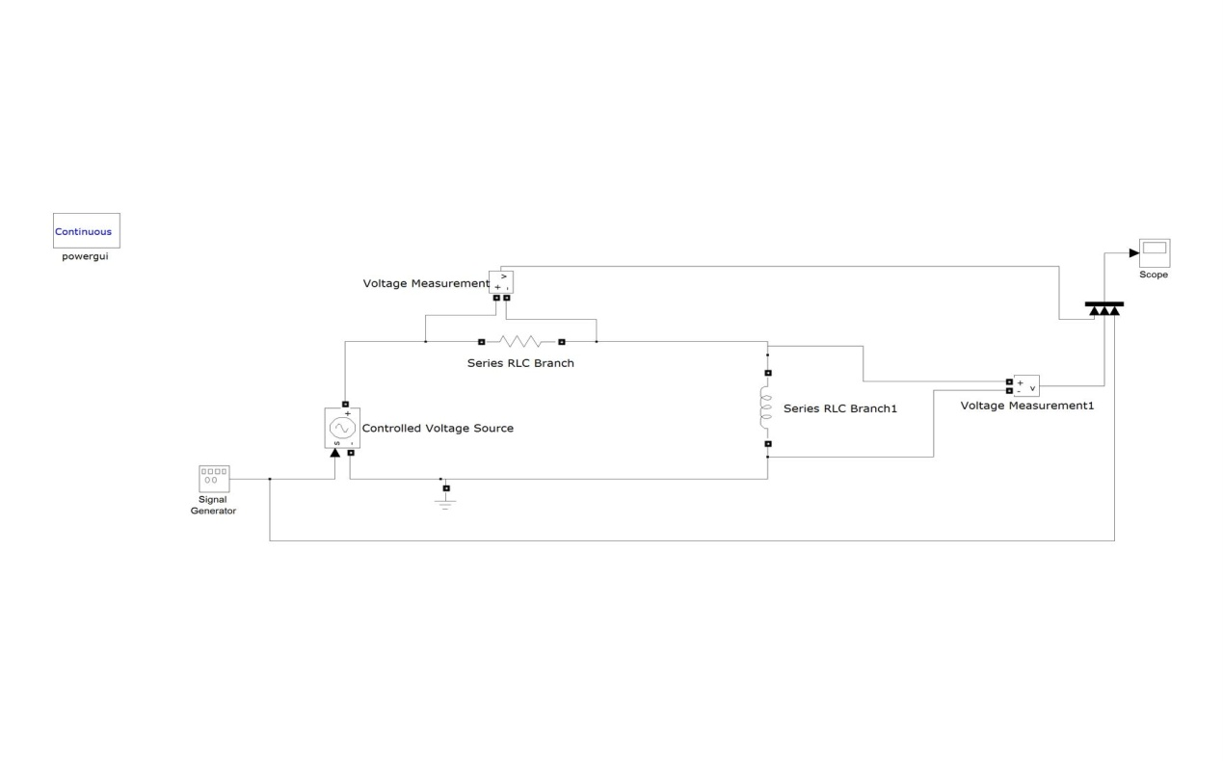

**Simulation wave forms:** 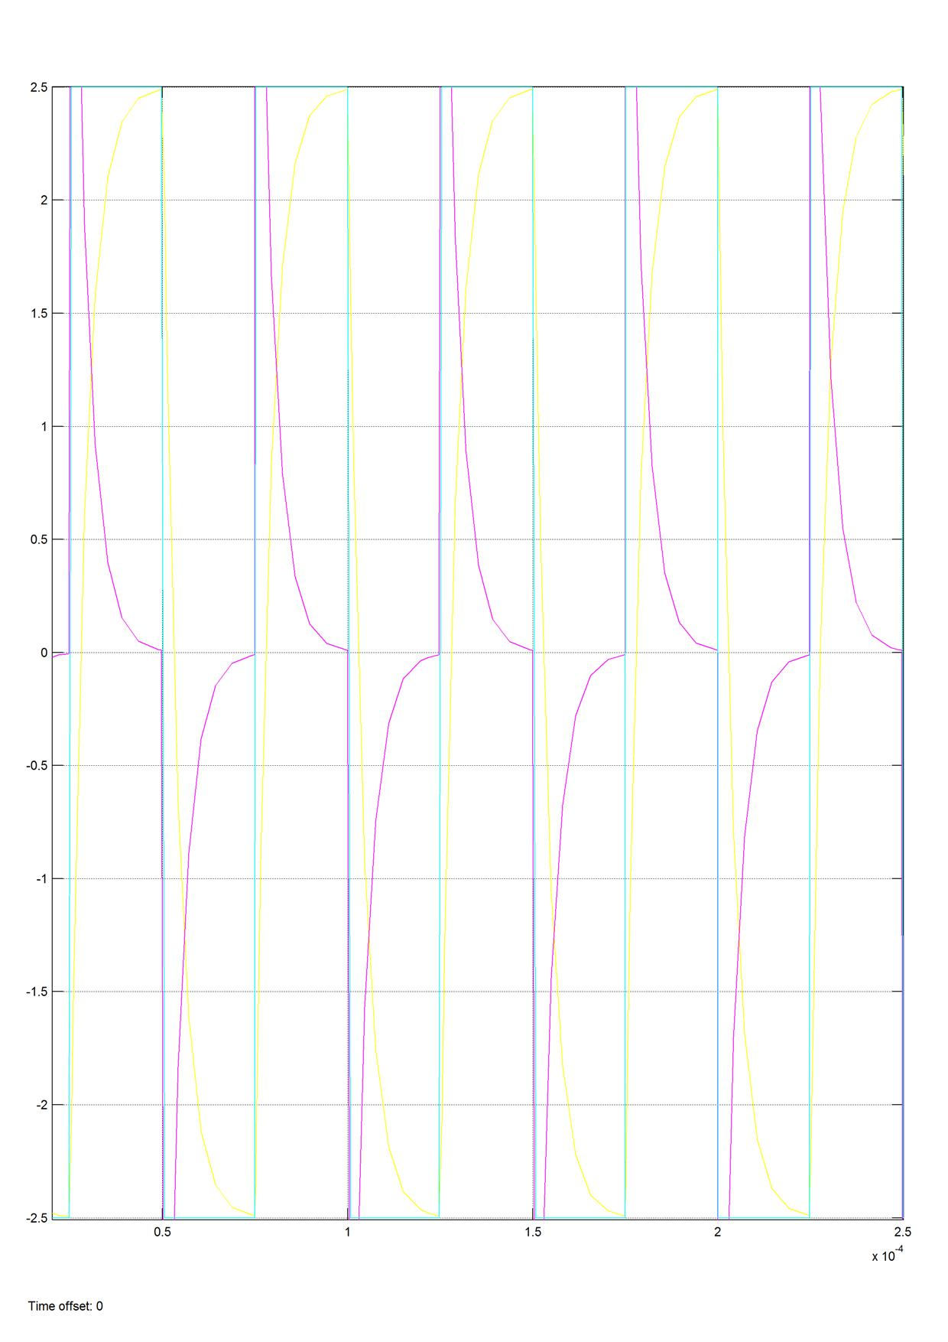

**Results:**

Ʈ (Theoretical) = L/R = 4*10-3/1000 = 4* 10-6 = 4 µS

Ʈ(Practical) = 3.934*10-6 = 3.934 µS

Error % = | Ʈ th – Ʈ pr| / Ʈ th = 1.62 %

**Conclusion:**

Practical observations and measurements are consistent with the theoretical analysis of the Transient response of RL circuits with a deviation error of 1.62%.