

Rectifiers

Half-wave & Full-Wave

Aliaa Mohamed Ali | 3747 | Electronics

# **Objective:**

* Show Effect of half and full-wave rectifiers on output voltages to a load

**Introduction:**

A Full-wave rectifier is a device to rectify alternating current components in an alternating supply into a purely direct current! It differs from a half-wave rectifier in that while the latter only allows one half of the alternating wave (positive half) to pass through, the full-wave rectifier offers full advantage of all signal in both halves after rectifying them. Most electronic devices cannot withstand high voltage or alternating current due to high power. The use of batteries in all devices is not practical as their replacement and durability is a huge problem and the device may have to be dismantled in order to maintain it. Therefor rectifiers are used in electronic devices like TVs, Radios and Chargers.

**Components:**

* Diodes (x4) - Resisitor (1 kOhm)
* Function Generator - Oscilloscope

**Schematics:**

**Half-Wave Rectifier**

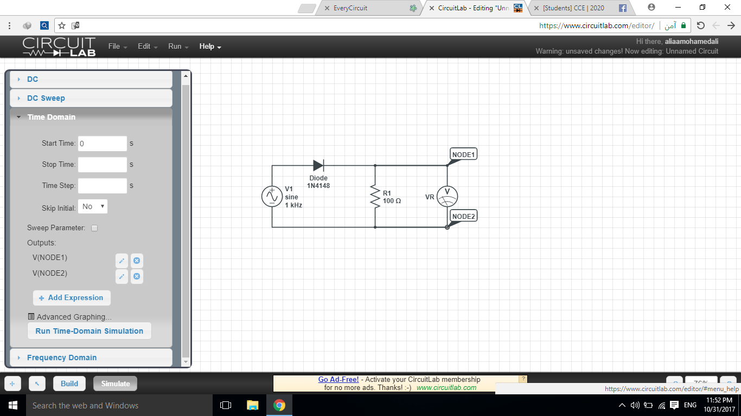

**Full-Wave Rectifier**

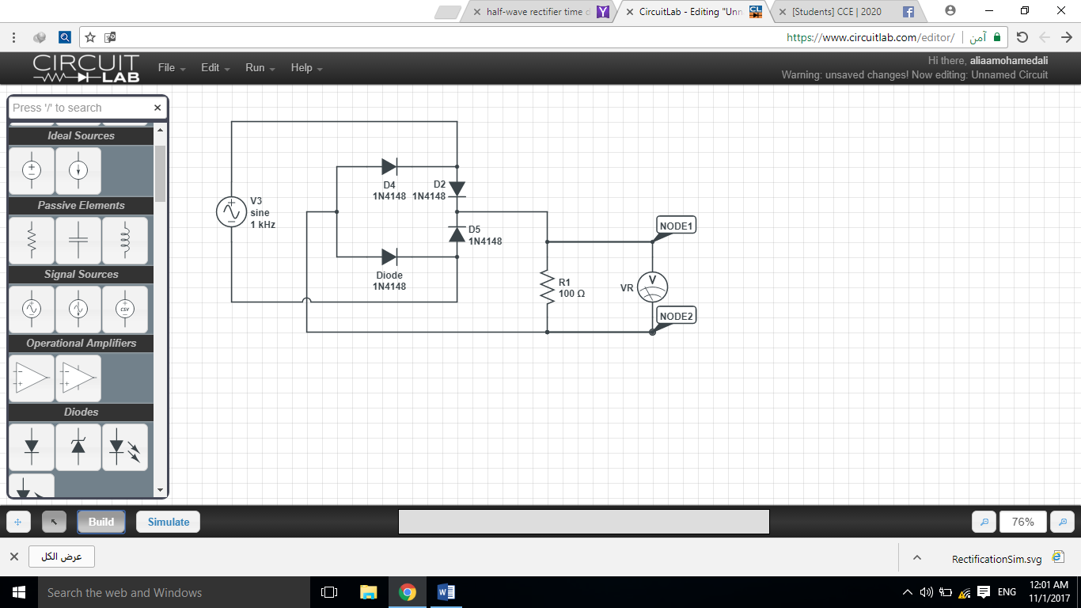

**Plots:**

**Half-Wave Rectifier:**

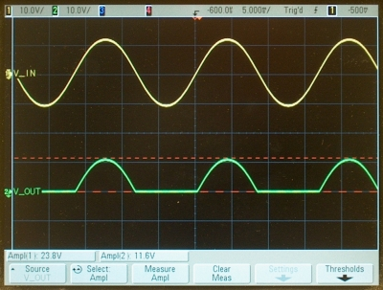

**Full-Wave Rectifier:**

