[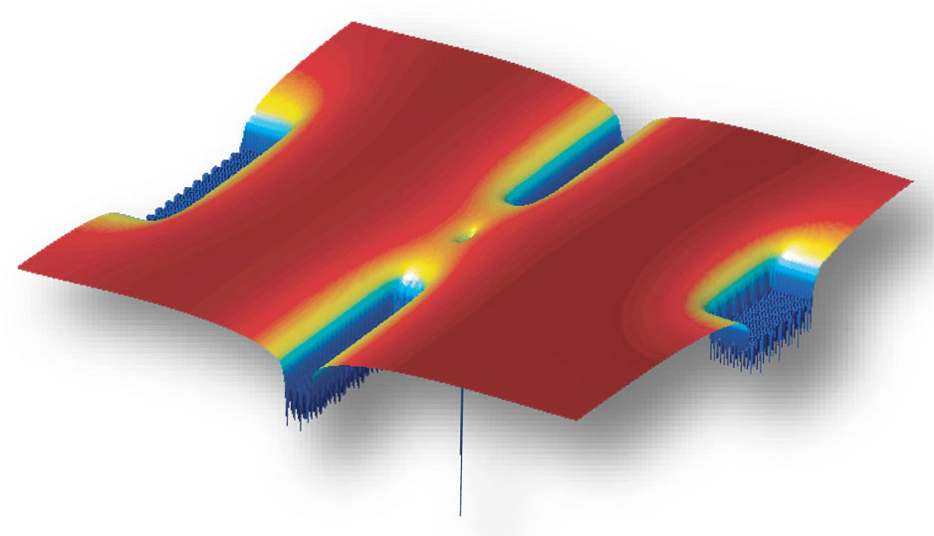](https://spectrum.ieee.org/img/singleatom01-1330368133233.jpg)

Single-Atom Transistor

History, Mechanism and Applications

Aliaa Mohamed Ali | 3747 | Electronics & Devices

# **Definition:**

[**Molecular electronics**](https://spectrum.ieee.org/searchContent?q=molecular+electronics&type=&sortby=relevance) promise a time when the basic building blocks of electronics are individual molecules. Of course, the [**transistor**](https://spectrum.ieee.org/searchContent?q=transistor&type=&sortby=relevanc) is today’s fundamental building block for computing. And along these lines, researchers showed that it was possible [**to make a transistor from a single atom**](https://spectrum.ieee.org/semiconductors/nanotechnology/a-singleatom-transistor).

That work and much that has followed since is not going to lead to practical devices any time soon. But all of this basic research may someday result in practical devices.

A **single-atom transistor** is a device that can open and close an electrical circuit by the controlled and reversible repositioning of one single atom. In Single atom transistor device, there exist an single atom in between the source and drain electrode which can move reversibly with applied bias at the gate terminal and thus close or open the gap between the source and drain. As a result, the movement of the atom controlled by the gate voltage can turn the device ON or OFF.

**Beginnings:**

The Single-Atom Transistor was invented and first demonstrated in 2004 by **Prof. Thomas Schimmel** and his team of scientists at the **Karlsruhe Institute of Technology** (former University of Karlsruhe). By means of a **small electrical voltage applied to a control electrode**, the so-called **Gate electrode**, a single atom is reversibly moved in and out of a tiny junction, in this way closing and opening an electrical contact.

Therefore, the Single-Atom Transistor works as an atomic switch or atomic relay, where the switchable atom opens and closes the gap between two tiny electrodes called Source and Drain. The Single-Atom Transistor opens perspectives for the development of future atomic-scale logics and quantum electronics.

At the same time, the device of the Karlsruhe team of researchers marks the lower limit of miniaturization, as **feature sizes smaller than one atom cannot be produced lithographically**. The device represents a **quantum transistor**, the conductance of the Source-Drain channel being defined by the rules of quantum mechanics. It can be operated at room temperature and at ambient conditions, i.e. neither cooling nor vacuum are required.

Few atom transistors have been developed at **Waseda University** and at **Italian CNR** by **Takahiro Shinada** and **Enrico Prati**, who observed the Anderson-Mott transition in miniature by employing arrays of only two, four and six individually implanted as or P atoms

**Phosphorous Model:**

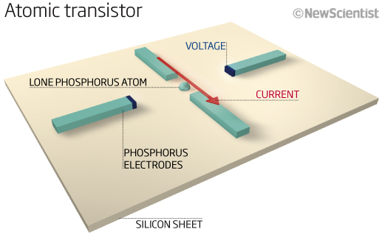

**Single-Atom Transistor:**A phosphorous atom [center of computer model] sits in a channel in a silicon crystal. It acts as the smallest transistor yet and could be key to future quantum computers.

Researchers have created a working transistor out of a single phosphorus atom and in the process have shown that Moore’s Law, the cornerstone of the semiconductor industry, might hold true much longer than anyone expected.

To make their [tiny transistor](http://dx.doi.org/10.1038/nnano.2012.21), the group, which was led by [**Michelle Simmons**](http://www.cqc2t.org/biography/98), a researcher at the **University of New South Wales, in Australia**, bathed silicon in phosphine gas. They then used a scanning tunneling microscope (STM) and a technique common in lithography to replace one silicon atom in a six-atom lattice with a phosphorus atom. **“Controlling a chemical reaction so that just one phosphorus atom was introduced into the device was challenging,”** says Simmons.

When the team—which also included researchers from the **Korea Institute of Science and Technology Information, Purdue University**, and the **universities of Sydney** and **Melbourne**—applied a voltage across the phosphorus atom, it behaved like a transistor, switching and amplifying an electrical current.

The researchers took great pains to assure themselves that the effects they observed were not the product of multiple atoms. “The great thing is that [the atom’s appearance] under the scanning probe microscope and its electronic fingerprint agree well with both theoretical predictions and earlier optical measurements of a single phosphorus atom in silicon,” says Simmons. (In a [related discovery](https://spectrum.ieee.org/semiconductors/nanotechnology/ohms-law-survives-at-the-atomic-scale), last month Simmons and her colleagues from **Purdue and the University of Melbourne** showed that Ohm’s Law, which is fundamental to circuit theory and chip design, works at the atomic level.)

Experts who did not take part in the research were impressed by the work but said that it would be a while before there would be any practical applications in conventional electronics.

**Moore’s Law:**

Although definitions can vary, simply stated Moore's Law holds that the number of transistors that can be placed on a processor will double approximately every 18 months. The latest Intel chip, the "Sandy Bridge," uses a manufacturing process to place 2.3 billion transistors 32 nanometers apart. A single phosphorus atom, by comparison, is just 0.1 nanometers across, which would significantly reduce the size of processors made using this technique, although it may be many years before single-atom processors actually are manufactured.

“To me, this is the physical limit of Moore’s Law,” **Gerhard Klimeck**, who directed the Purdue group that ran the simulations, claims. “We can’t make it smaller than this.”

According to **University of New South Wales Prof. Michelle Simmons**, “We made a single-atom transistor roughly 8 to 10 years ahead of where the industry’s going to be,” consistent with Moore’s law, in 2020.

It is predicted that transistors will reach the single-atom level by about 2020 to keep pace with Moore's Law  
This major advance has developed the technology to make this possible well ahead of schedule and gives valuable insights to manufacturers into how devices will behave once they reach the atomic limit, says Professor Simmons

**Potential Applications:**

**Scalable Quantum Computers:**

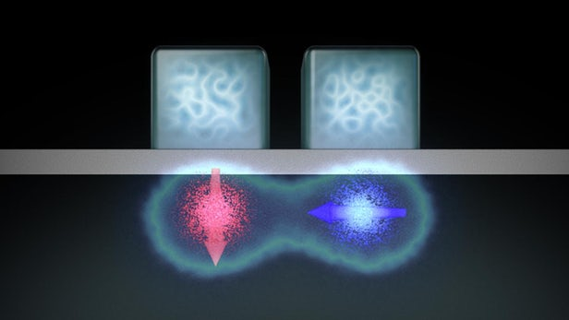

The original motivation for the work had been to build solid-state silicon [quantum computers](https://spectrum.ieee.org/tag/quantum%20computer), Simmons says. In 1998, **University of Maryland** physicist Bruce Kane hypothesized that one way to build a solid-state quantum computer would be to use the[**nuclear spins of phosphorus atoms embedded in silicon**](http://www.newsdesk.umd.edu/scitech/release.cfm?ArticleID=1327). Simmons and her collaborators were inspired by that idea—although their single-atom transistor is based on the electron rather than the nuclear spins of phosphorus atoms.

Kane calls the single-atom transistor “an experimental and engineering tour de force” and says he is optimistic that more progress will be made soon. “I expect that they will be able to demonstrate some sort of quantum logic device using their technology in the next few years,” he says.

The single-atom transistor could lead the way to building a quantum computer that works by controlling the electrons and thereby the quantum information, or qubits.

**Constraints and Challenges:**

One important question is whether Simmons’s painstaking STM technique, which makes transistors one at a time, can ever be refined to yield the millions or billions of transistors that are integrated onto a single piece of silicon in today’s chips. “Can the precise atomic spacing be maintained over large areas, and can the manufacturing costs and times be brought into the reasonable realm?” wonders [**Dick Slusher**](http://www.gtqi.gatech.edu/peopleGTRI.shtml), director of the Georgia Tech Quantum Institute.

**Ioannis Kymissis**, head of the [**Columbia Laboratory for Unconventional Electronics**](http://www.kymissis.columbia.edu/), says that more modeling of the device is necessary to ensure that **“the electrodes are [not so small that] their quantum effects start to mix”** with those of the phosphorus atom. What’s more, the experts point out, the single-atom phosphorus transistor switches only at cryogenic temperatures, making it impractical for real-life applications unless the operating temperature is raised.

The single-atom transistor does have one serious limitation: It must be kept very cold, at least as cold as liquid nitrogen, or minus 391 degrees Fahrenheit (minus 196 Celsius).

"The atom sits in a well or channel, and for it to operate as a transistor the electrons must stay in that channel," Klimeck says. "At higher temperatures, the electrons move more and go outside of the channel. For this atom to act like a metal you have to contain the electrons to the channel.

**Progress in Practical Distribution:**

**Single-Molecule Transistors Get Reproducibility and Room-Temperature Operation:**

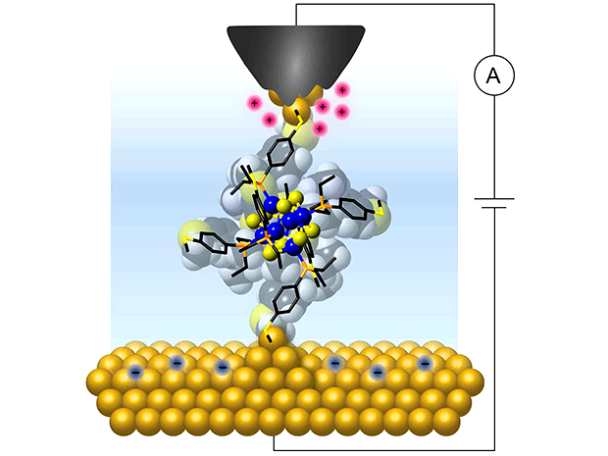Illustration: Bonnie Choi/Columbia University of Columbia researchers wired a single molecular cluster to gold electrodes to show that it exhibits a quantized and controllable flow of charge at room temperature.

In the latest step in this long journey, researchers at Columbia University have [**fabricated a small cluster of atoms into a two-terminal transistor**](https://www.eurekalert.org/emb_releases/2017-08/cuso-smc080917.php) capable of switching from insulator to conductor when charge is added or removed, one electron at a time.

In research described in the journal [***Nature Nanotechnology***](http://nature.com/articles/doi:10.1038/nnano.2017.156)**,** the Columbia researchers were able to **create a geometrically ordered cluster of atoms with a central core consisting of just 14 atoms**. They linked that 14-atom core to gold electrodes that allowed them to monitor its electrical response as they varied the applied bias voltage.

With this arrangement, the researchers created a device that reproducibly demonstrated a current blockade at room temperature. While there have been many other devices that function as a single-electron transistor, most do not do so reproducibly, and very few have demonstrated this capability at room temperature, according to [**Latha Venkataraman**](http://www.venkataramangroup.org/), leader of the research team at Columbia, in an e-mail interview with *IEEE Spectrum*.

“One of the key innovations in this research was our use of atomically precise inorganic clusters made of just 14 atoms as the functional element in these devices,” “And we also developed a novel method to gate the devices using just two terminals that relies on an electrochemical environment.”

In this electrochemical environment, the **researchers were able to change the applied bias voltage to alter the density of ions around the molecular junction, charging the cluster.** “By changing the electrostatic environment around the cluster, we allow its charge state to be modified enabling a current to flow across the single-molecule junction,”

"We found that these clusters could perform very well as room-temperature nanoscale diodes whose electrical response we can tailor by changing their chemical composition," says Venkataraman in a press release.

[**Quantum dots**](https://spectrum.ieee.org/searchContent?q=quantum+dots&type=&sortby=relevance)—which are nanoscale structures within semiconducting materials that hold tiny reservoirs of electrons, acting like an artificial atom—have been able to do more or less the same thing as this cluster of inorganic atoms. However, quantum dots are not perfectly reproducible, some are smaller and some are larger, leading to their properties not always being consistent.

The Columbia researchers were **able to make their inorganic molecular clusters with complete control over their structure, resulting in perfectly identical shapes and structures every time**. This makes it possible to fabricate and measure thousands of junctions with reproducible characteristics.

 “With these molecular clusters, we have complete control over their structure with atomic precision and can change the elemental composition and structure in a controllable manner to elicit certain electrical response,” says Venkatraman.

In addition to reproducibility and the ability to operate at room temperature, the on/off ratio for this device is extremely high, a quality sorely lacking in other molecular-based transistors.

Along with its high on/off ratio, each electron transited through the junction by first stopping on the cluster momentarily before passing on—a property known as a “sequential” mode of charge flow. This stands in contrast to typical small-molecule junctions in which the electrons go through the junction from one electrode to another continuously so that the number of electrons on the molecule at each instant of time is not well-defined.

"We say the cluster becomes 'charged' since, for a short time interval before the transiting electron jumps off into the other metal electrode, it stores one extra charge," says Bonnie Choi, a graduate student and co-lead author of the work, in a press release. "Such sequential, or discrete, conduction mode is due to the cluster's peculiar electronic structure that confines electrons in strongly localized orbitals.”

Choi added that these orbitals of the electrons also account for the observed “current blockade” regime when a low bias voltage is applied to a cluster junction.

“The current drops to a very small value at low voltage as electrons in the metal contact don't have enough energy to occupy one of the cluster orbitals,” said Choi. “As the voltage is increased, the first cluster orbital that becomes energetically accessible opens up a viable route for electrons that can now jump on and off the cluster, resulting in consecutive 'charging' and 'discharging' events. The blockade is lifted, and current starts flowing across the junction.”

In continuing research, the Columbia team will be looking to increase the on/off ratio of the devices and increase the number of atoms used while maintaining the precision and uniformity of the devices.