**Circuits (II)**

**Lab (6)**

**Two Port Networks**

**Report By:**

**Aliaa Mohamed Ali Abbas 3747**

***Introduction:***

In theory, a network may have one port, two-ports, or N ports, depending on the number of circuit mesh. For two port Networks, The port on the right is usually called the output port. This is a standard convention used in describing two-port networks. In this laboratory exercise we will be considering networks described as two-port networks. 2 There are four sets of parameters commonly used to describe two-port networks. There is a fifth set but most often it is omitted. The four main parameters are:

The two-port described using Y (admittance) parameters•

The two-port described using Z (impedance) parameters•

The two-port described using H (hybrid) parameters•

The two-port described using ABCD (transmission) parameters•

The network can contain resistors, inductors, capacitors, transformers, transistors and in general any linear circuit device, including dependant devices but no independent sources are allowed. Essentially, there are two ways to view the two-port network problem. First, view the problem as if you were in a laboratory and you actually had a “box” with an input port and output port. Depending on the parameters one desires to find, measurements are made of currents I1 and I2 with sources V1 and V2 present and with the sources replaced with short or open circuits. The second way to view the problem is as if you knew the construction of the network and you determined the various open-circuited voltages and short-circuited currents. In both cases one uses open-circuited voltages, shorted terminals, and short circuit currents to determine the parameters. This may sound confusing but the whole process is rather straightforward.

**Z-Parameters:**

Described with equations below:

$$\begin{matrix}V1 \\ V2\end{matrix}=\begin{matrix}Z11 & Z12 \\ Z21 & Z22\end{matrix}*\begin{matrix}I1 \\ I2\end{matrix}$$

We can deduce that:

Z11 = with I2 = 0 input impedance.

Z21= with I2 = 0 input impedance.

Z12= with I1 = 0 input impedance.

Z22= with I1 = 0 input impedance.

***Objective:***

Study the function of two port networks and relation between its parameters.

Calculate z-Parameters of T-Networks & Pi-Networks.

***Schematics:***

***(T-Network)***

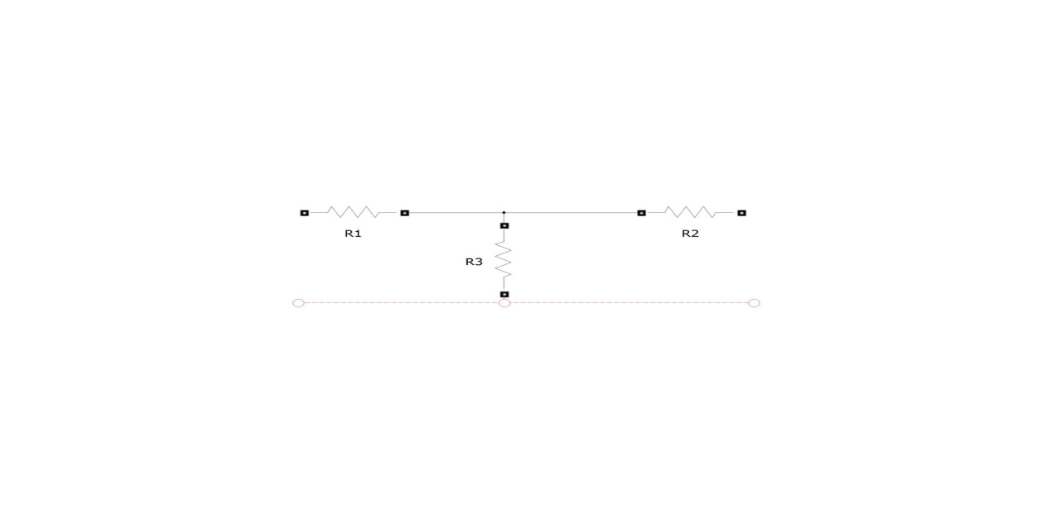

***(*п-Network)**

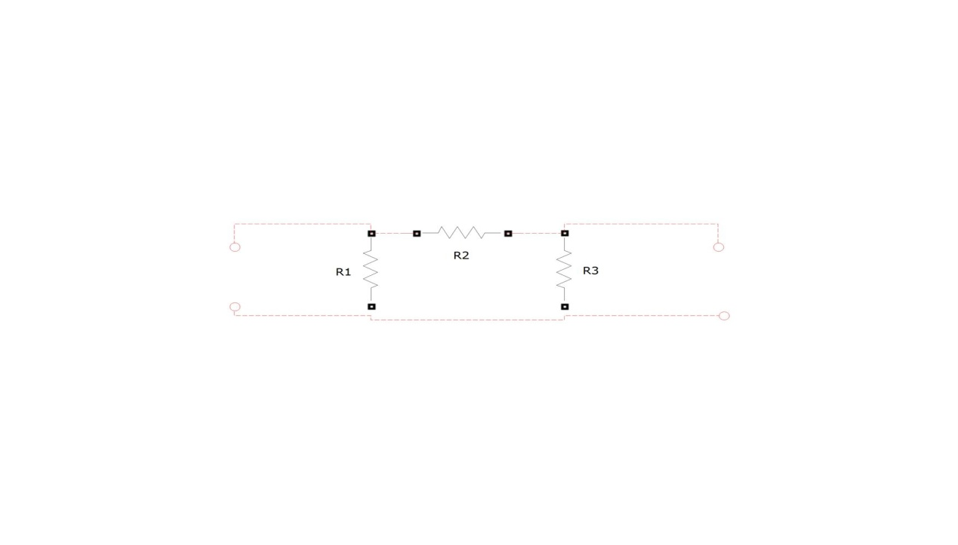

***Procedure:***

Apply a 5 volt (rms) source to *port-1 (V1.)*

Put an open circuit across *port-2 (V2)* and measure I1 and the voltage across V2. Note that I2=0.

Calculate Z11 & Z21 using the equations in introduction.

Apply a 5 volt (rms) source to *port-2 (V2.)*

Put an open circuit across *port-1 (V1)* and measure I2 and the voltage across V1. Note that I2=0.

Calculate Z22 & Z12 using the equations in introduction.

Repeat same procedure for T-Network.

***Results:***

T – Network

(V2 open Circuit ; I2=0)

V1 = 5V rms ; I1 =2.45 mA

V2 = 2.48 rms

Z11 = 2040.81

***Z21 = 1012.244***

(V1 open Circuit ; I1=0)

V2 = 5V rms ; I2 =2.35 mA

V2 = 2.37 rms

Z22 = 2127.66

***Z12 = 1008.51***

п – Network

(V2 open Circuit ; I2=0)

V1 = 5V rms ; I1 =1.6 mA

V2 = 3.69 rms

Z11 = 3125

***Z21 = 2306.5***

(V1 open Circuit ; I1=0)

V2 = 5V rms ; I2 =1.92 mA

V2 = 4.42 rms

Z22 = 2604.167

***Z12 = 2302.08***

***Conclusion:***

In each experiment the Z12 & Z21 parameters were equal with a slight deviation. This is expected as Z parameters are open circuit impedance parameters where Z11 & Z22 are the ***input impedance*** while Z12 & Z21 are the ***transfer impedance*** between ports.