**Assignment 2**

**Report**

**Matlab Functions to Generate Sequences**

**Aliaa Mohamed Ali Abbas**

**[3747]**

**Functions Required:**

**Exercise One:**

write down Matlab instructions to generate a signal in form

1/ DC segment from -2 till 0 seconds

2/ Quarter Cycle of a sinusoidal wave from 0 till 1

3/ DC segment from 1 till 3

Frequency = 100 Hz

**Exercise Two:**

Two Discrete Time signals are T= 2s

x[nT] = cos(2n/3)

y[nT] = cos(8pi*n/38)

i) plot x[n] , y[n] for T<40 seconds, continuous time sinusoid

ii) Are sequences periodic or not ? Use Stem, and determine the period if they are.

**Matlab Instructions & Results:**

**Exercise One:**

>> t = linspace(0,1,100);

>> n = linspace(-2,3,500);

>> y1 = 4*ones(1, 200);

>> y2 = sin(2*pi*t/4);

>> y3 = 3*ones(1,200);

>> total = [y1 y2 y3];

>> plot(total);

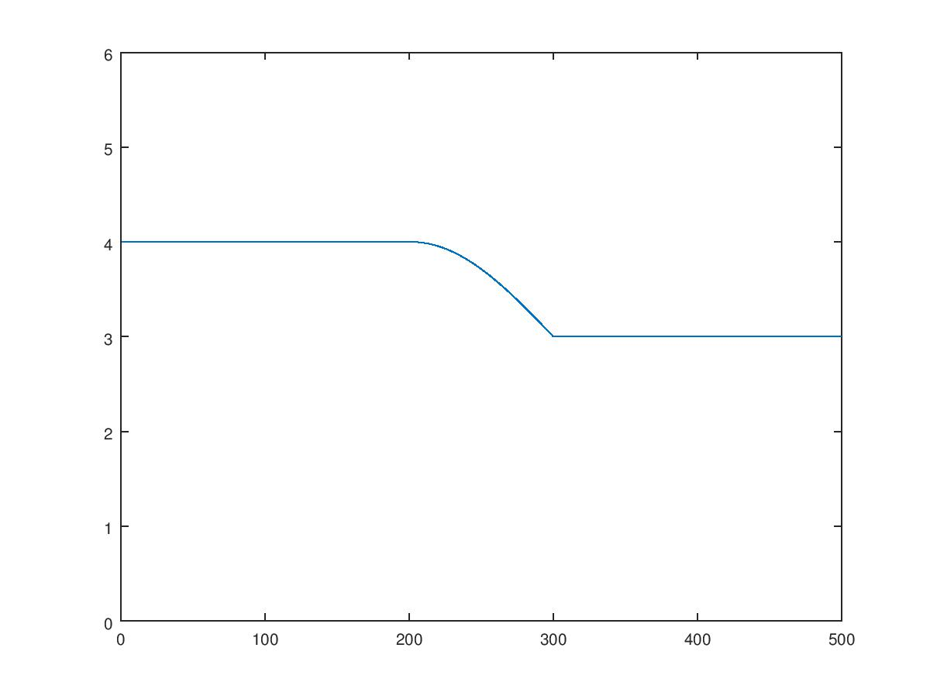

**Exercise Two:**

>> %% i)

>>t = [-40:2:40];

>> xt = cos(2*t/3);

>> yt = cos(8*pi*t/38);

>> plot(xt);

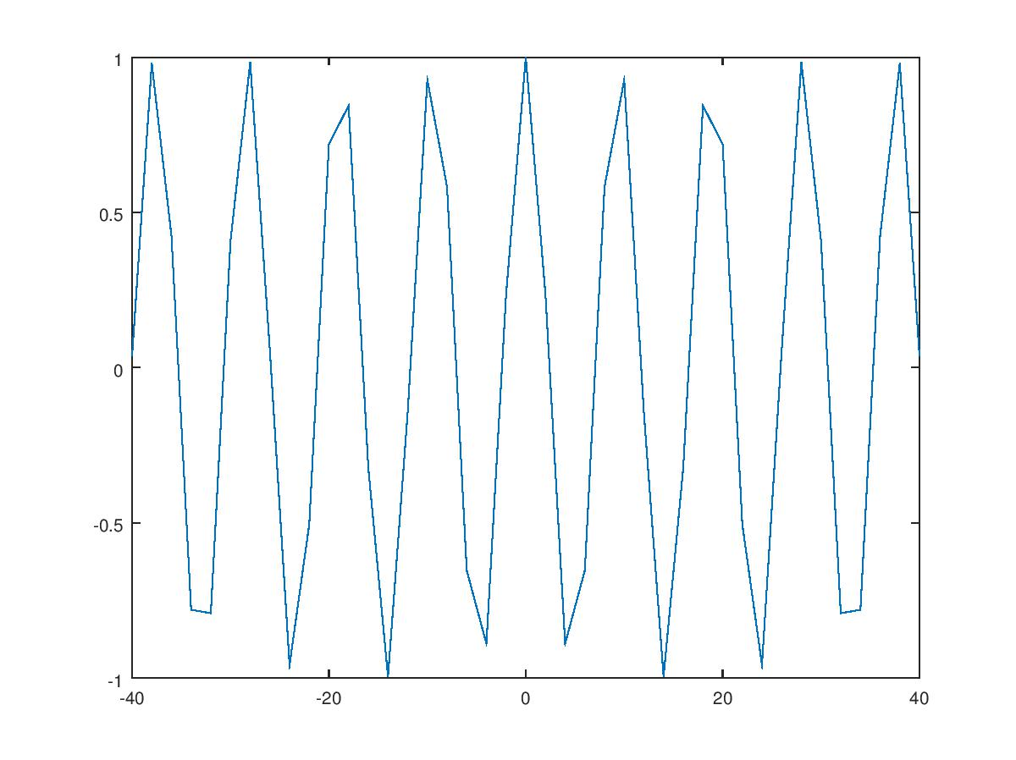

**>> Plot(yt)**

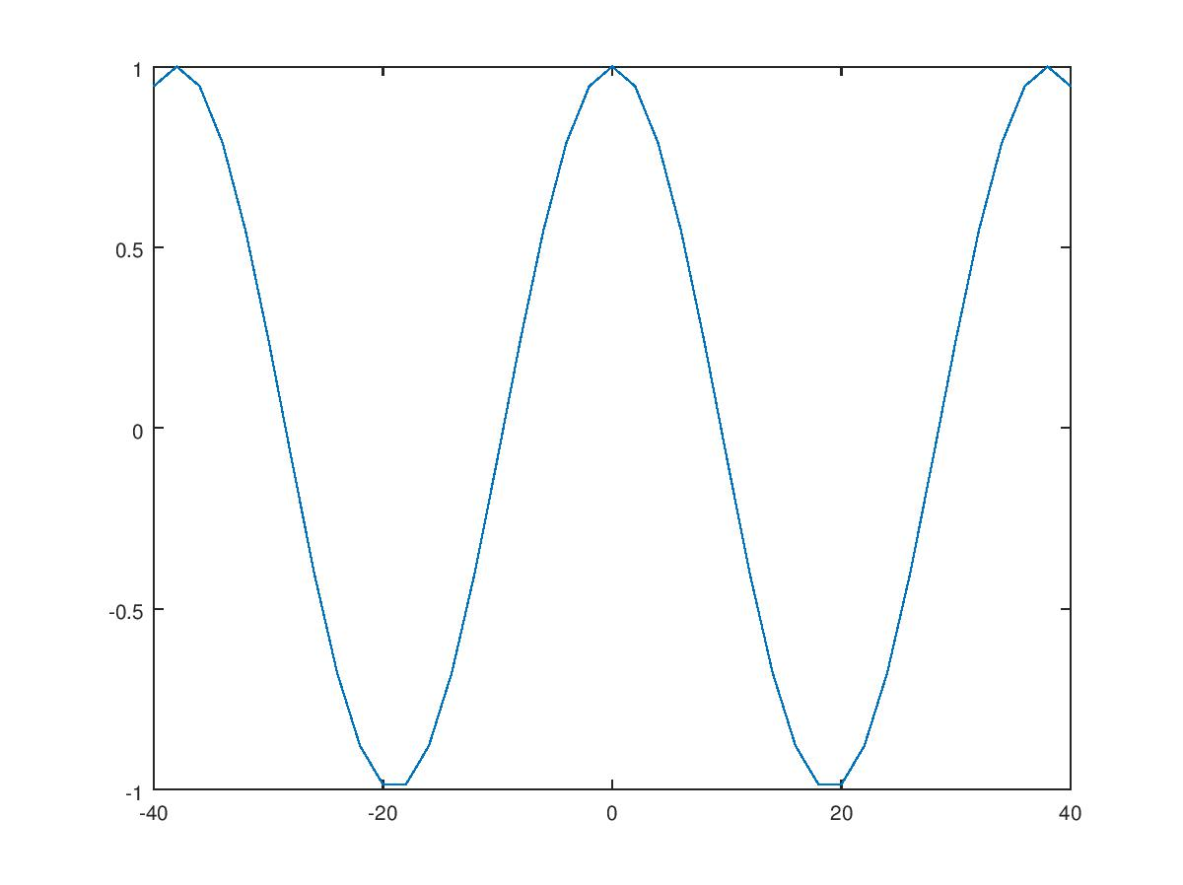

>> %%ii)

>> stem(x_discrete);

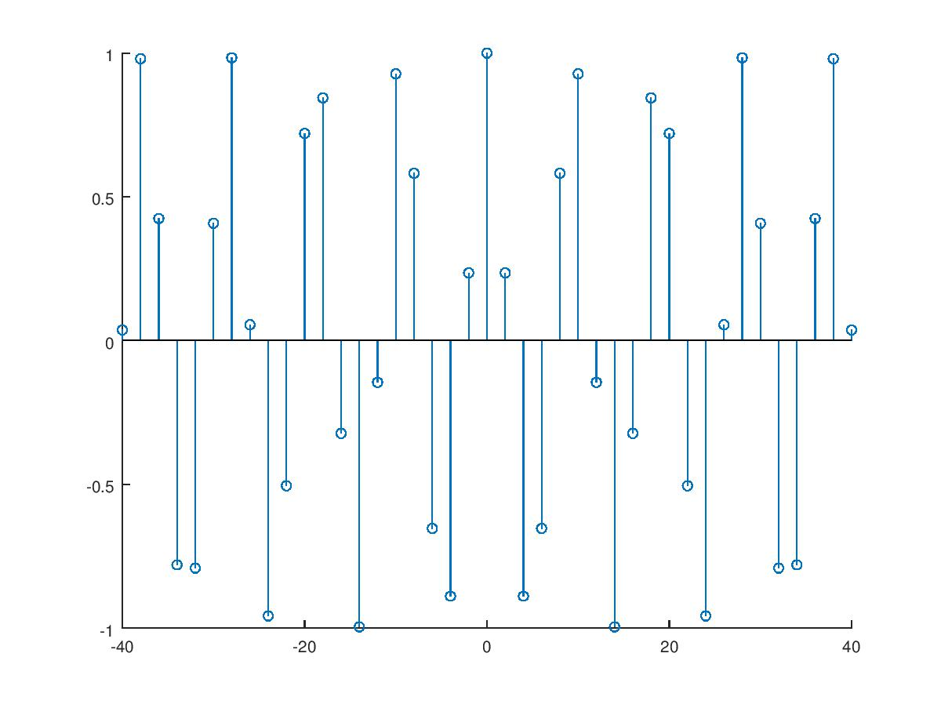

>>stem(y_discrete);

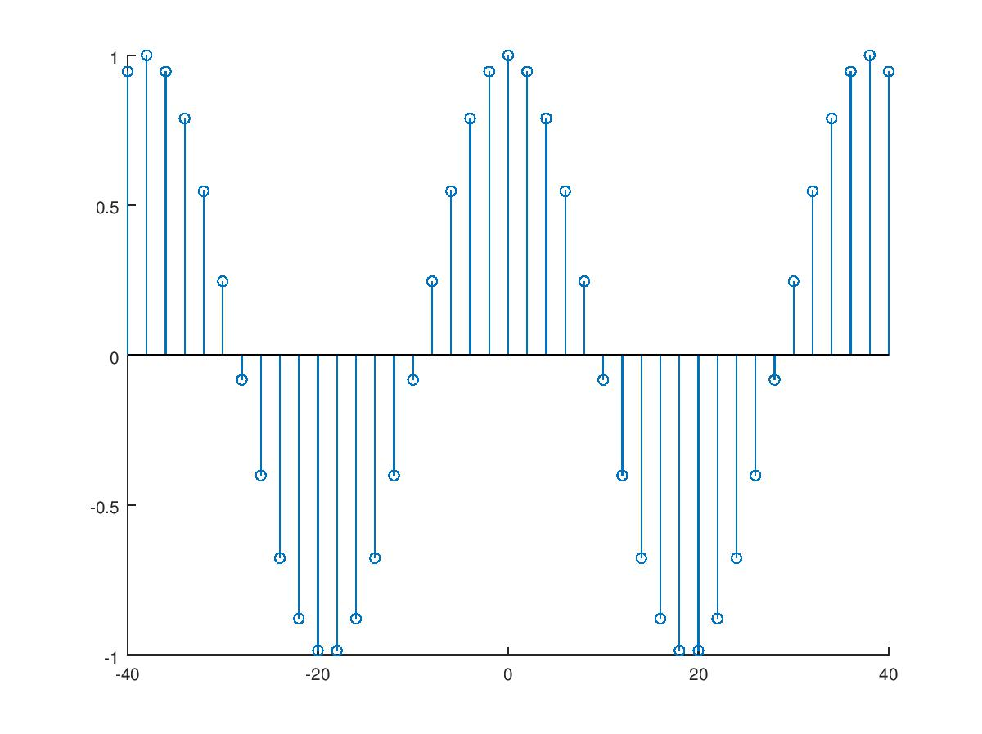

**Observation:**

**x[n] -> Not Periodic …… y[n] -> Periodic with Period = 38/4. (2π/(8π/38))**