**DSP lab (final project)**

1. **Sampling and periodicity of sinusoidal signals :**

**a-**

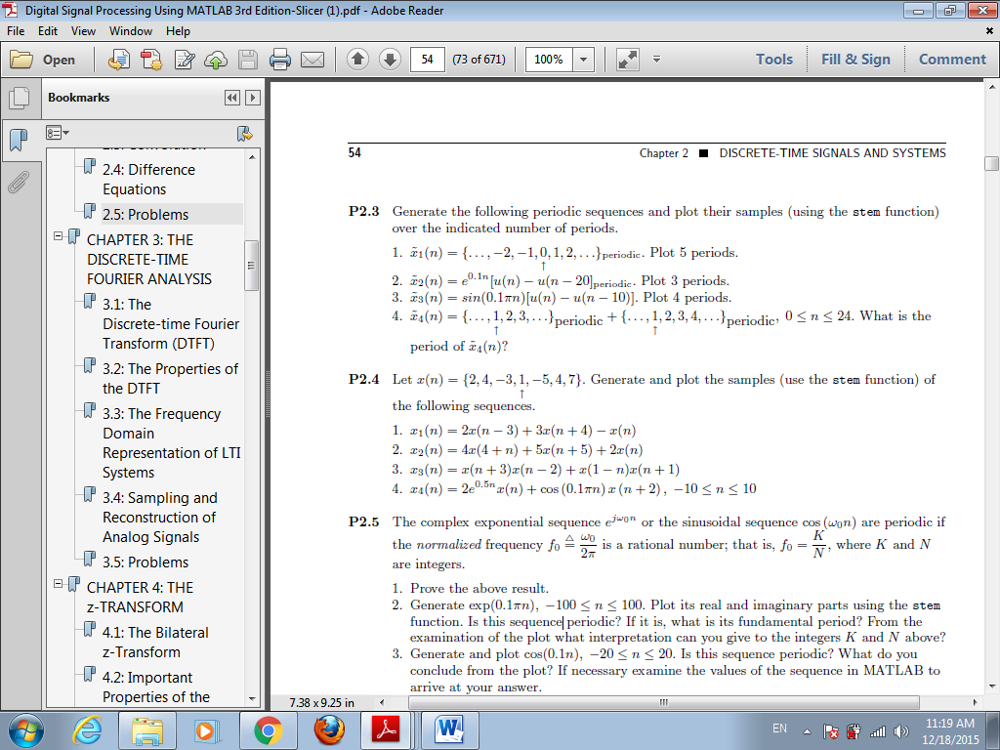

**b-**



**(2) Time domain analysis of LTI systems:**

Compute and plot the convolution between the following pair of sequences:

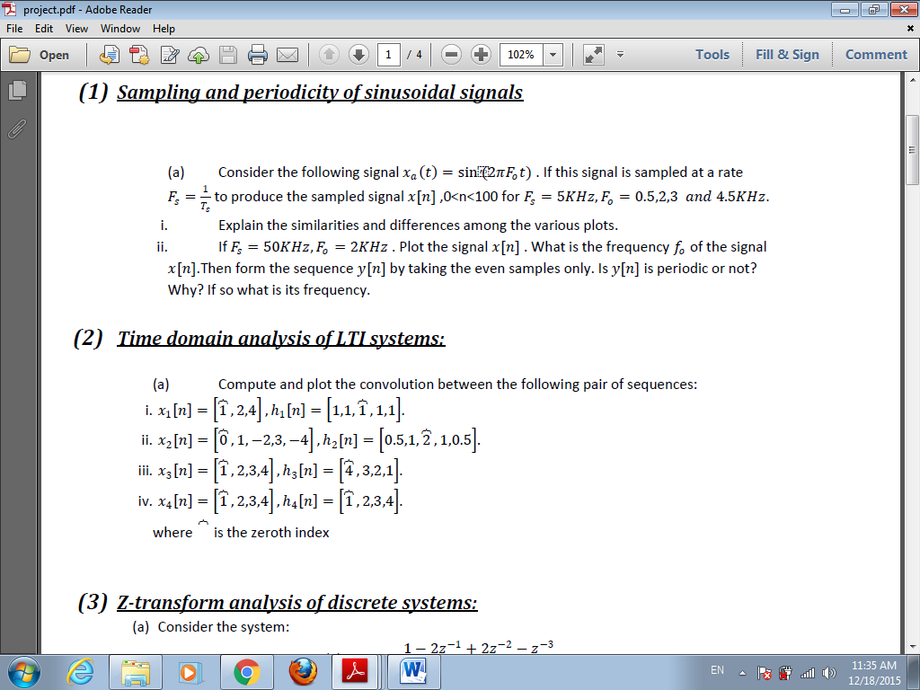

**(3) Z-transform analysis of discrete systems:**

1. **Consider the system:**

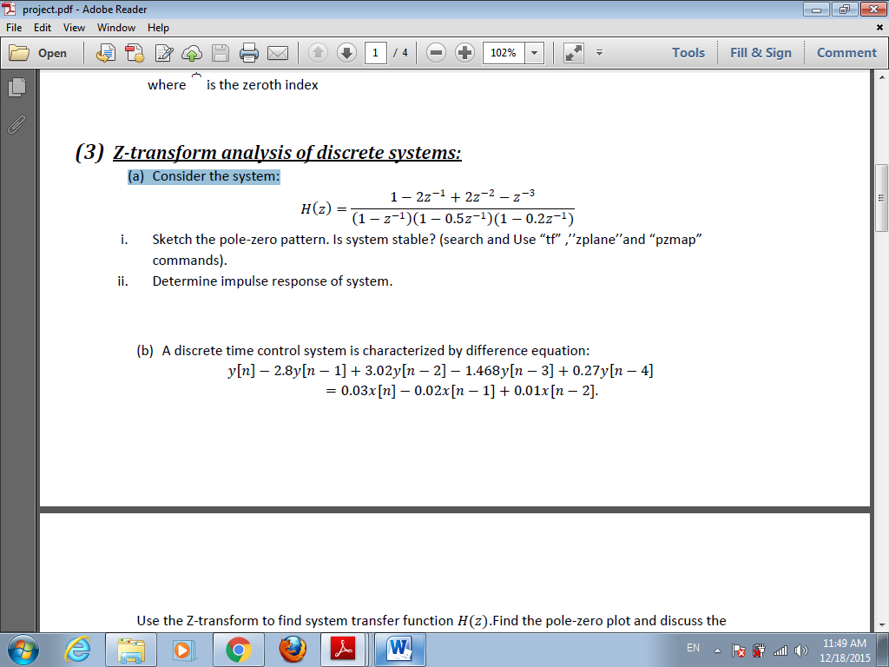

**(b) A discrete time control system is characterized by difference equation:**

𝑦 (𝑛) −2.8𝑦 (𝑛−1) +3.02𝑦 (𝑛−2) −1.468y( 𝑛−3) +0.27𝑦 (𝑛−4 )=

0.03x( n)−0.02𝑥 (𝑛−1 )+0.01𝑥 (𝑛−2) .

Use the Z-transform to find system transfer function H (𝑧).Find the pole-zero plot and discuss the stability. Then determine and plot the system output when

𝑥 (𝑛) =5u( 𝑛).

**(4) Fourier-transform analysis of discrete systems:**

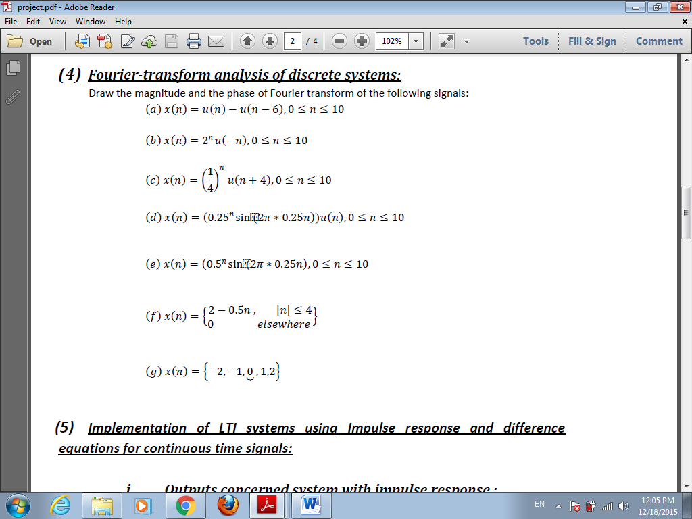

**Project's regulations**

• Each one will prepare **a softcopy report** referencing all steps and results you have made, as well as MATLAB code .

• Submit report electronically to :

engmarwamostafa@yahoo.com

* Deadline of submission is **19/5/2018**.
* Individual group.
* Copied reports will take zero .