**MATLAB ASSIGNMENT**

**BY:**

**Eyad Sherif Nawar [ID]**

Code and Documentation:

%%%%%%%% Exercise 1 %%%%%%%%

%% write down Matlab instructins t generate a signal in form

%% 1/ DC segment from -2 till 0 seconds

%% 2/ Quarter Cycle of a sinusoidal wave from 0 till 1

%% 3/ DC segment from 1 till 3

%% Frequency = 100 Hz

sig1 = 4*ones(1, 200);

t = linspace(0,1,100);

sig2 = sin(2*pi*t/4);

sig3 = 3*ones(1,200);

n = linspace(-2,3,500);

signal = [sig1 sig2 sig3];

plot(signal);

%%%%%%%% Exercise 2 %%%%%%%%

%% Two Discrete Time signals are T= 2s

%% x[nT] = cos(2n/3)

%% y[nT] = cos(8pi*n/38)

%% i) plot x[n] , y[n] for T<40 seconds, cntinuous time sinusoid

n = [-40:2:40];

x_discrete = cos(2*n/3);

y_discrete = cos(8*pi*n/38);

t = [-40:2:40];

x_cont = cos(2*t/3);

y_cont = cos(8*pi*t/38);

plot(t, x_cont);

hold_on;

plot(t, y_cont);

%% ii) Are sequences periodic or not ? Use Stem,

stem(n,x_discrete);

hold on;

stem(n,y_discrete);

# Plots and Figures:

EXERCISE ONE:

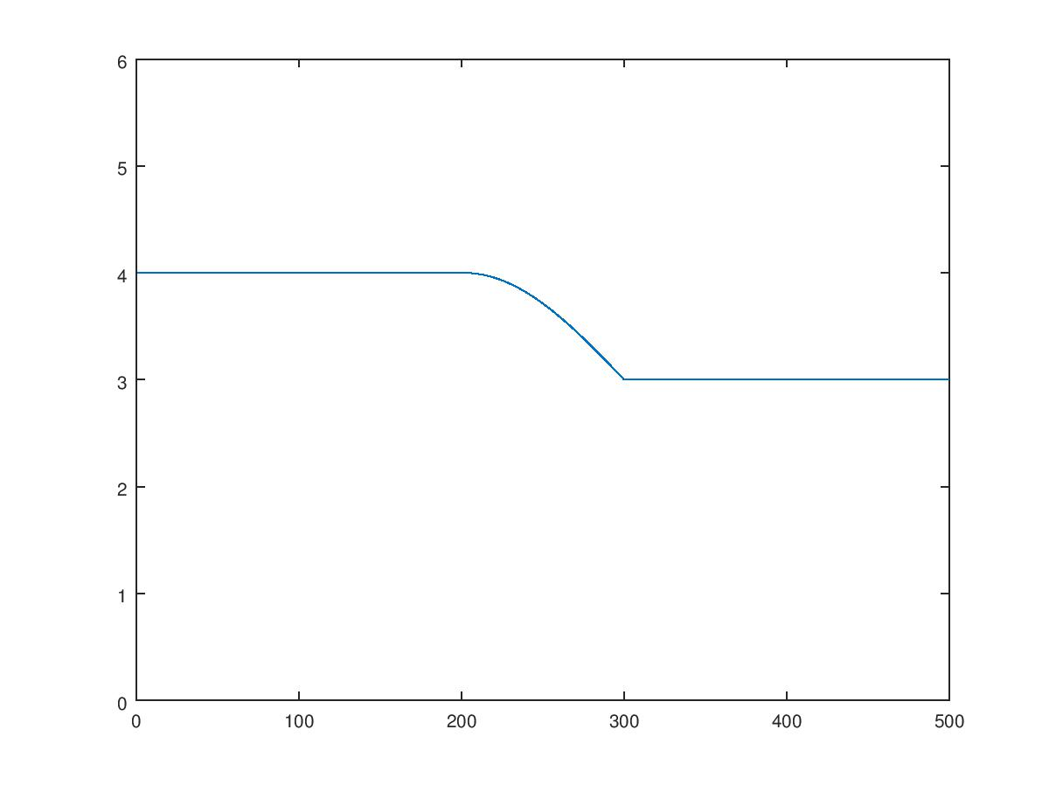

EXERCISE TWO

A)

X[T]

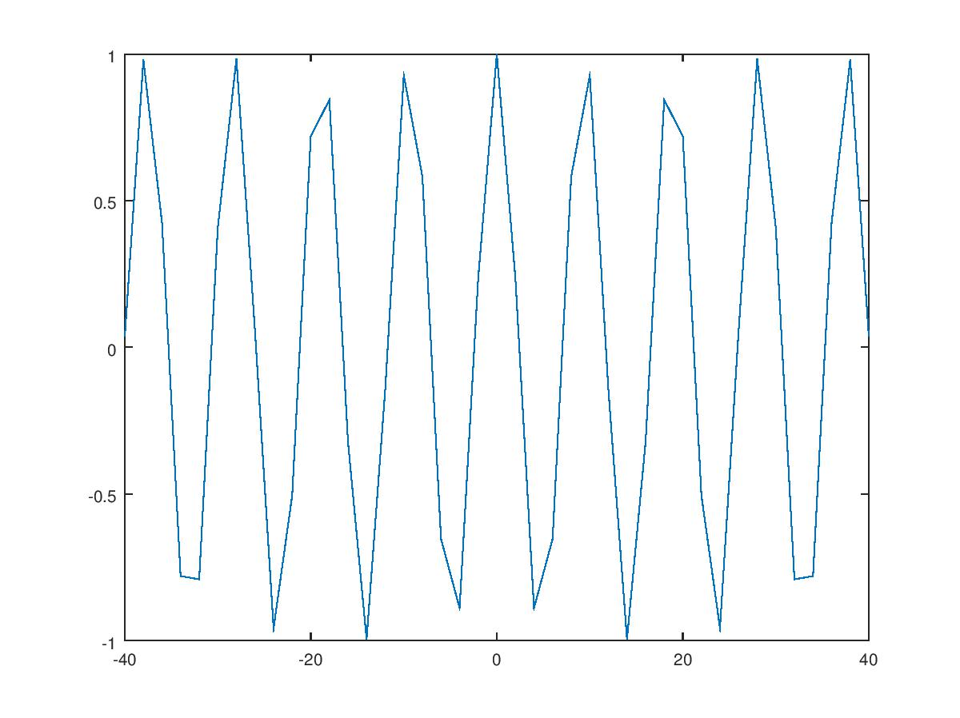

Y[T]

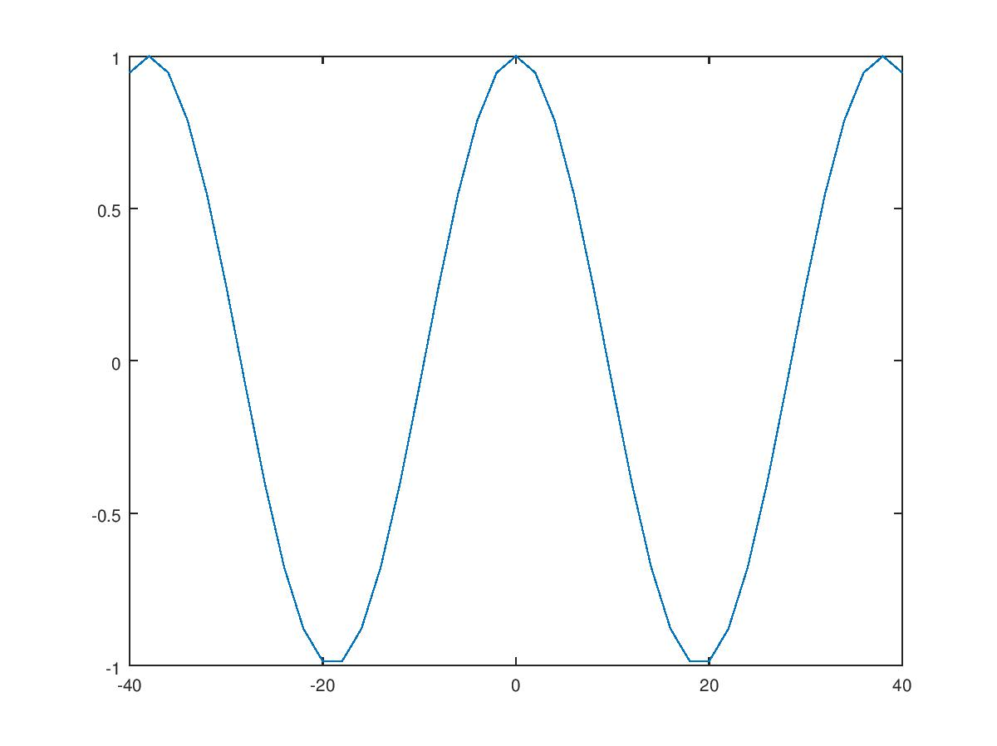

**B)**

**X[N]**

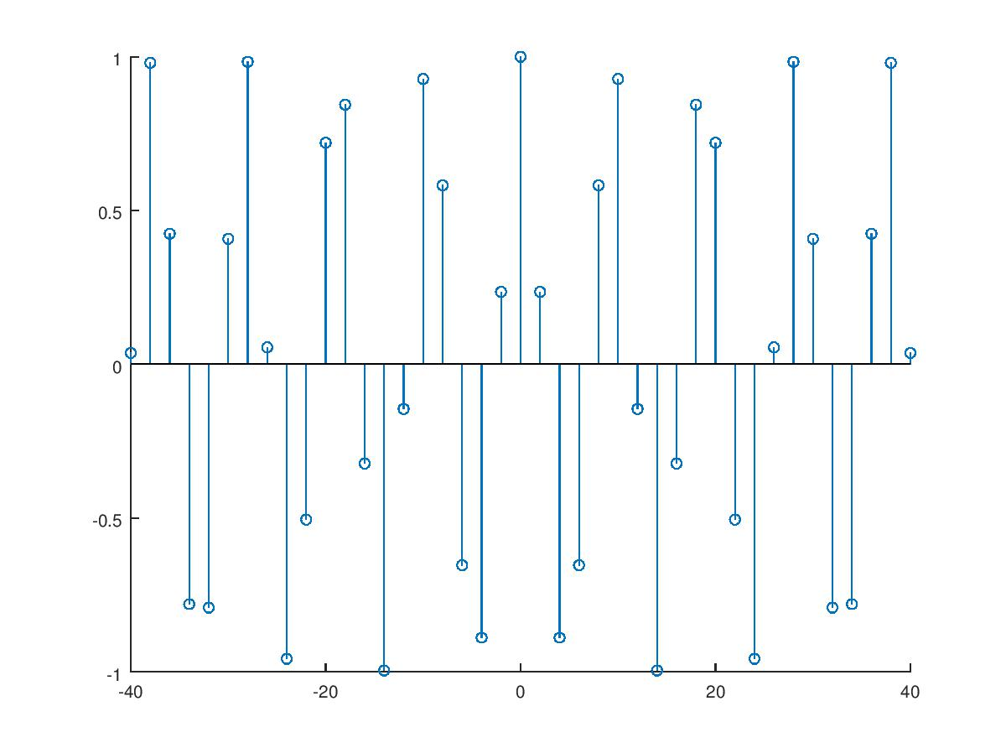

**Y[N]**

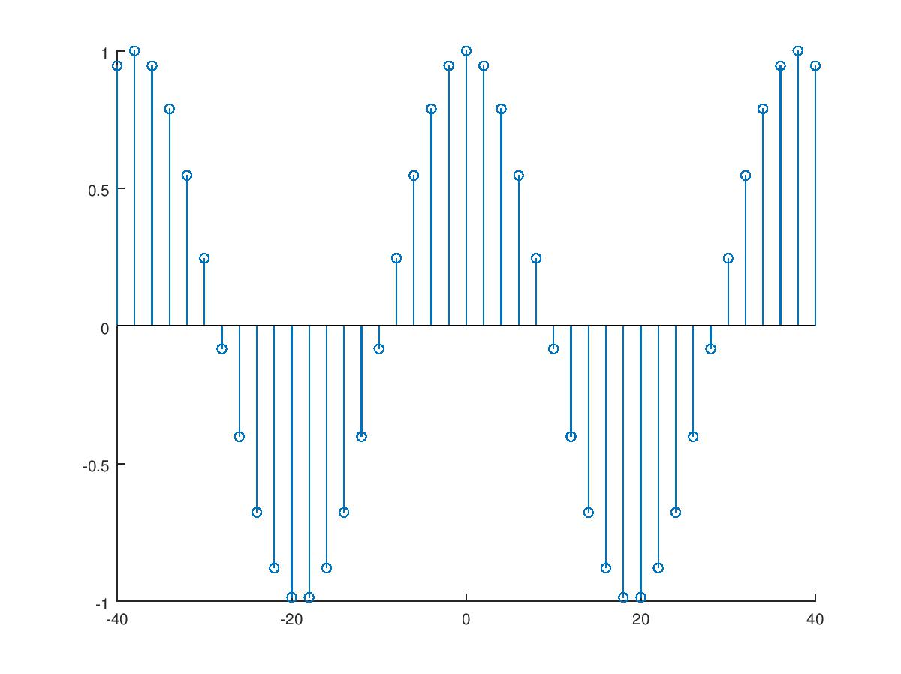

**Comments:**

**x[n] is not periodic while y[n] is periodic with a period of: 2*pi/(8*pi/38) = 38/4**