**Digital Signal Processing**

**Matlab Assignment 4**

**Report**

**Aliaa Mohamed Ali 3747**

**Functions Required:**

**Exercise One:**

For Function : (Z+1) / (Z^2-0.9Z+0.81)

a. Generate transfer function.

b. Find the frequency response of system.

c. Find step response of system.

d. Check stability of system use two different Methods.

e. Find impulse response use two different Methods

**Exercise Two:**

A causal LTI system is described by the following difference equation:

y(n) = 0.81y(n − 2) + x(n) − x(n − 2)

a. Determine the system function H(z).

b. The unit impulse response h(n) .

c. The unit step response s(n).

d. Plot zeros and poles of this system.

e. The frequency response function H(ejw), and plot its magnitude and phase response.

**Matlab Instructions & Results:**

**Exercise One:**

>> num = [0 1 1];

>> den = [1 -0.9 0.81];

>> a = tf(num, den, -1, 'Variable', 'z^-1');

>> freqz(num,den,1000,1);

>> c = step(a);

>> plot(c);

>> zplane(num, den);

>> [poles, zeros] = pzmap(a)

>> impulse(a);

>> [r, p, k] = residuez(num, den);

>> disp(r);

>> disp(p);

>> disp(k);

H =

z^-1 + z^-2

------------------------

1 - 0.9 z^-1 + 0.81 z^-2

Sample time: 0.1 seconds

Discrete-time transfer function.

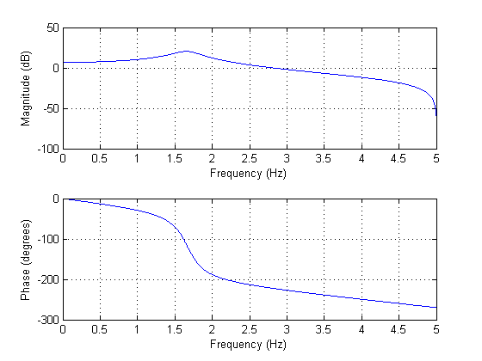

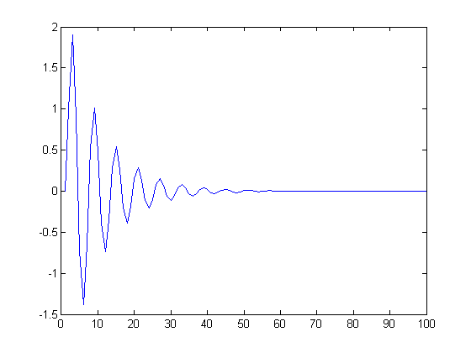

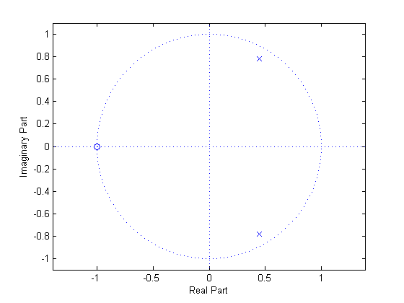

p =

0.4500 + 0.7794i

0.4500 - 0.7794i

z =

-1

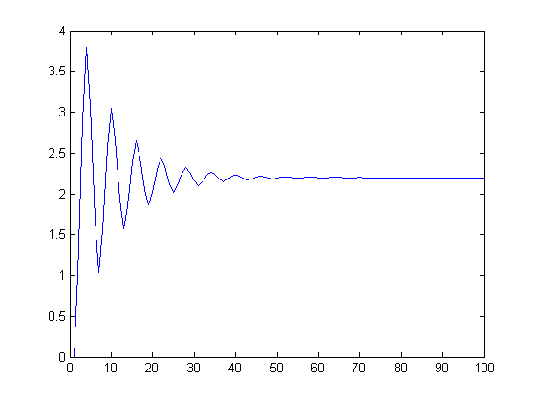

**Exercise Two:**

>> num = [1 0 -1];

>> den = [1 0 -0.81]

>> a = tf(num, den, -1, 'Variable', 'z^-1');

>> display(a);

>> plot(impulse(a));

>> plot(step(a));

>> zplane(num, den);

>> freqz(num, den);

a =

1 - z^-2

-------------

1 - 0.81 z^-2

Sample time: 0.1 seconds

Discrete-time transfer function.

