**MATLAB ASSIGNMENT**

**BY:**

**Eyad Sherif Nawar [4292]**

**Code and Documentation:**

**%%%%%%%%%%%%%% Exercise One %%%%%%%%%%%%%%**

%%%% For Function : (Z+1) / (Z^2-0.9Z+0.81)

%%%% a. Generate transfer function.

%%%% b. Find the frequency response of system.

%%%% c. Find step response of system.

%%%% d. Check stability of system use two different Methods.

%%%% e. Find impulse response use two different Methods

num = [0 1 1];

den = [1 -0.9 0.81];

%%% 1.a

a = tf(num, den, -1, 'Variable', 'z^-1');

%%% 1.b

freqz(num,den);

%%% 1.c

c = step(a);

plot(c);

%%% 1.d

zplane(num, den);

[poles, zeros] = pzmp(a);

disp(poles);

disp(zeros);

%%% 1.e

impulse(a);

[r, p, k] = residuez(num, den);

disp(r);

disp(p);

disp(k);

**%%%%%%%%%%%%%% Exercise Two %%%%%%%%%%%%%%**

%%%% A causal LTI system is described by the following difference

%%%% equation: y(n) = 0.81y(n − 2) + x(n) − x(n − 2)

%%%% a. Determine the system function H(z).

%%%% b. The unit impulse response h(n) .

%%%% c. The unit step response s(n).

%%%% d. Plot zeros and poles of this system.

%%%% e. The frequency response function H(ejw), and plot its magnitude and phase response.

num = [1 0 -1];

den = [1 0 -0.81]

%%% 2.a

a = tf(num, den, -1, 'Variable', 'z^-1');

display(a);

%%% 2.b

impulse(a);

%%% 2.c

step(a);

%%% 2.d

zplane(num, den);

%%% 2.e

freqz(num, den);

**Results and Figures:**

**Exercise One:**

a =

z^-1 + z^-2

------------------------

1 - 0.9 z^-1 + 0.81 z^-2

Sample time: 0.1 seconds

Discrete-time transfer function.

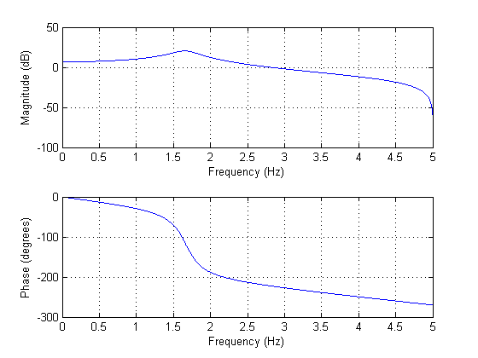

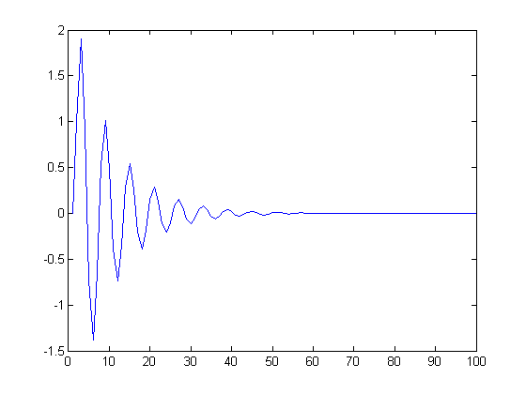

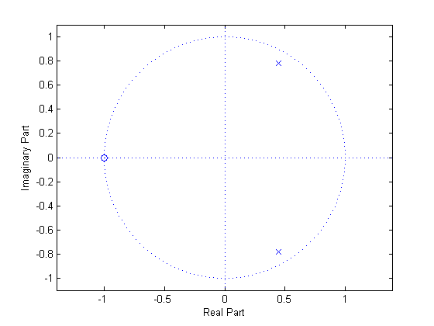

p =

0.4500 + 0.7794i

0.4500 - 0.7794i

z =

-1

**Exercise Two:**

a =

1 - z^-2

-------------

1 - 0.81 z^-2

Sample time: 0.1 seconds

Discrete-time transfer function.

