1)

>> num1 = [0 1 1];

>> den1 = [1 -0.9 0.81];

H =

z^-1 + z^-2

------------------------

1 - 0.9 z^-1 + 0.81 z^-2

Sample time: 0.1 seconds

Discrete-time transfer function.

>> freqz(num1,den1,1000,10)

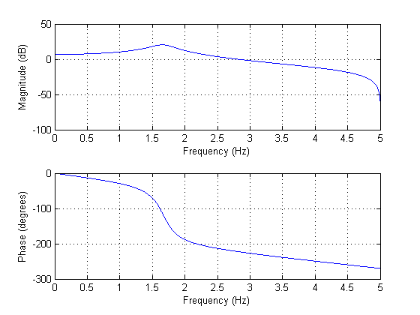

>>h = filter(num1,den1,[1 zeros(1,99)]);

>> plot(h)

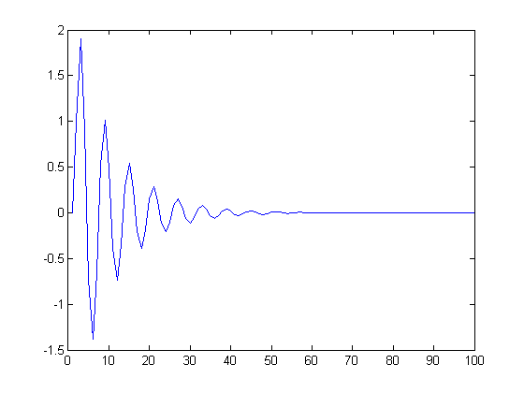

>> zplane(num1,den1)

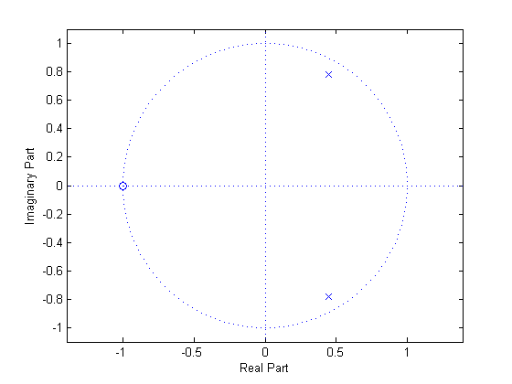

>> [p z] = pzmap(num1,den1)

p =

0.4500 + 0.7794i

0.4500 - 0.7794i

z =

-1

>> p = abs(p)

p =

0.9000

0.9000

>> s = filter(num1,den1,[1 ones(1,99)]);

>> plot(s)

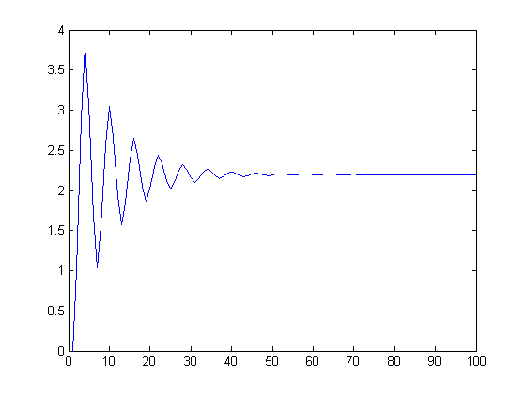

2)

>> num2 = [1 0 -1];

>> den2 = [1 0 -0.81];

>> H = tf(num2,den2,0.1,'variable','z^-1')

H =

1 - z^-2

-------------

1 - 0.81 z^-2

Sample time: 0.1 seconds

Discrete-time transfer function.

>> h = filter(num2,den2,[1 zeros(1,99)]);

>> plot(h)

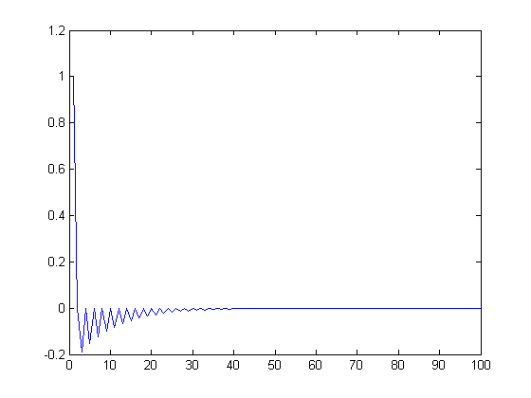

>> s = filter(num2,den2,[1 ones(1,99)]);

>> plot(s)

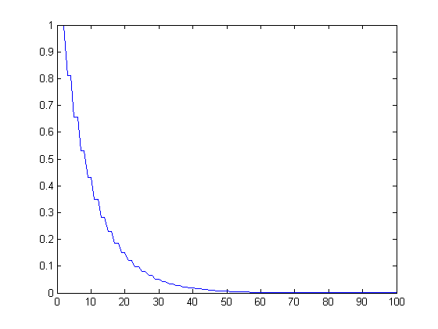

>> zplane(num2,den2)

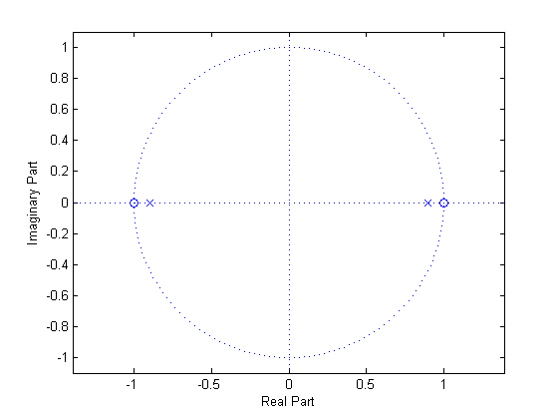

>> freqz(num2,den2,100,10)

