Instructions:

//mention the default values in the system…

//each step should contain 2 explanations (CLI and GUI)

d. Adding new supplier to the system:

since the Suppliers Manager is the responsible of adding a new supplier to the system we need to start the system with Suppliersmanager as an argument and choosing the type of UI (CLI/GUI) we want to use as follows :



this command will open the CLI and present this menu:

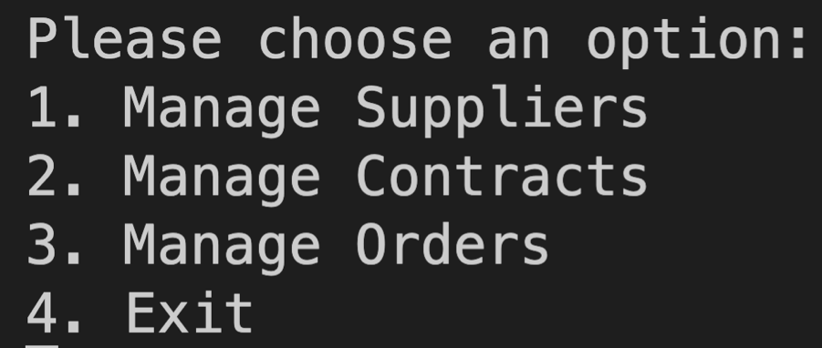

1 should be pressed then to open the Manage Suppliers option which shows another menu:   
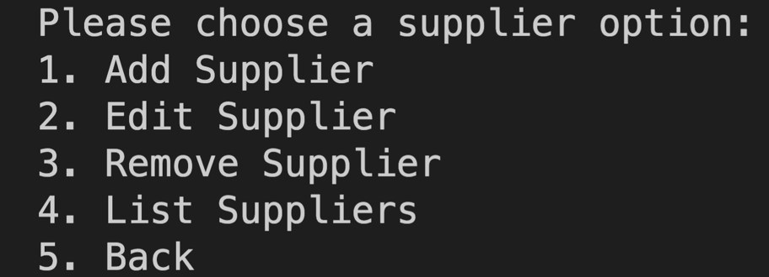

to achieve the desired operation of adding a supplier, 1 should be pressed again and the required fields should be filled for the system:  
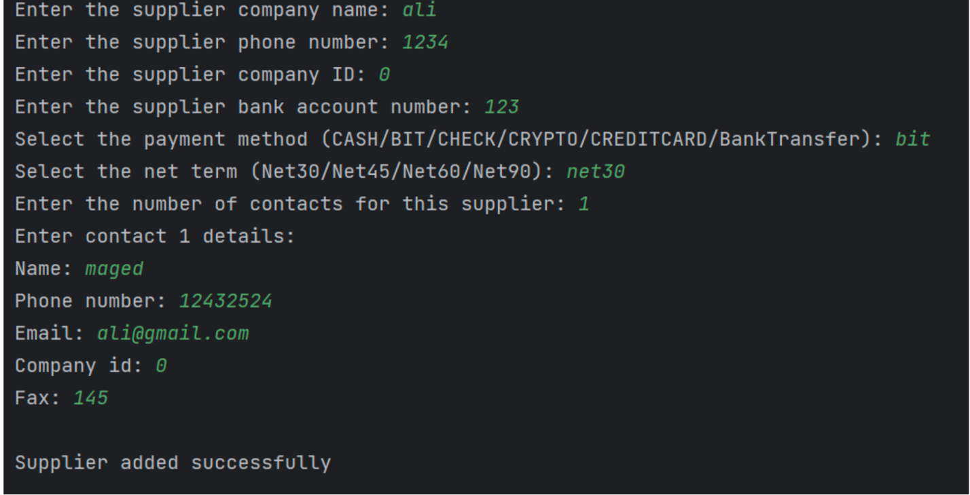

• We choose the number of contacts the supplier have and for each contract we fill the right details.

Supplier added successfully!

e. Making a periodic order:

since the Suppliers Manager class is the class that manages the orders thus making it the class that’s responsible for placing and making a periodic order (regarding the implementation) we need to start the system by passing the arguments:



this command will open the CLI and present this menu:



3 should be pressed so that the orders managing menu shows:  
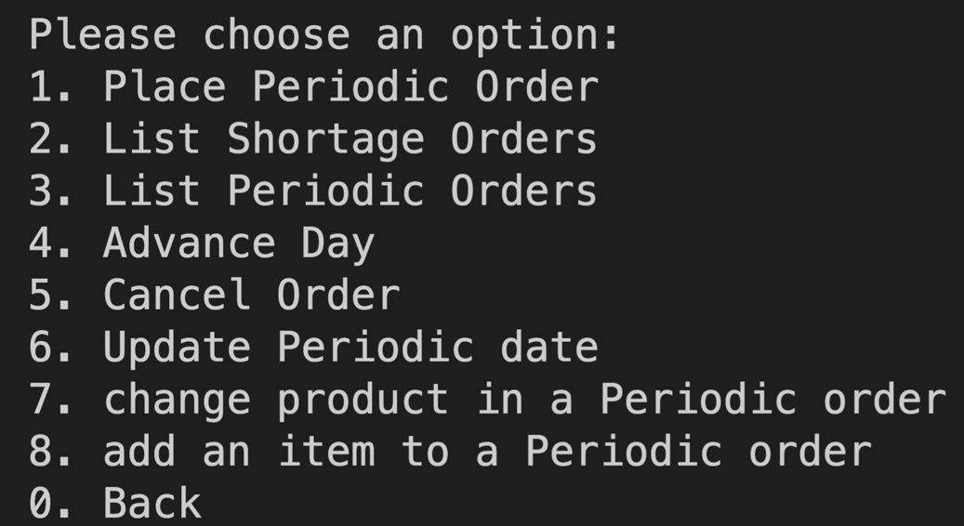

Rightly after, after pressing 1, the system shows fields that need to be filled so the periodic order gets added to the database:

\*Note: we need to fill specific information to match a pre-defined data that was added to the system before to save time and simplify the testing.

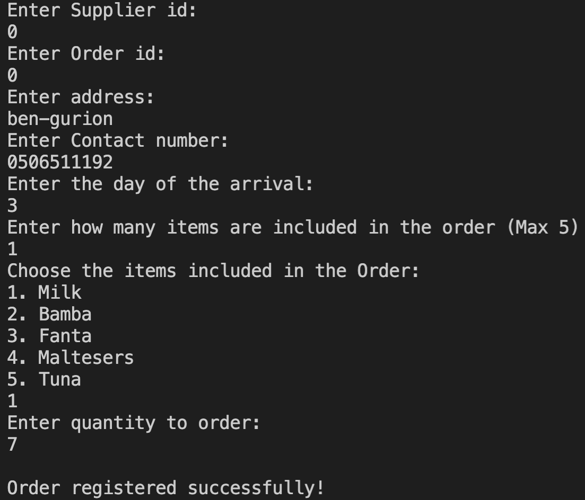

The periodic ordered is registered in the system!

c. Updating stock and sending an alert for shortage:

since the store manager is the responsible for managing and watching the items quantities, we will pass the following command with these arguments so we can start the store manager panel:



this will open the following menu:

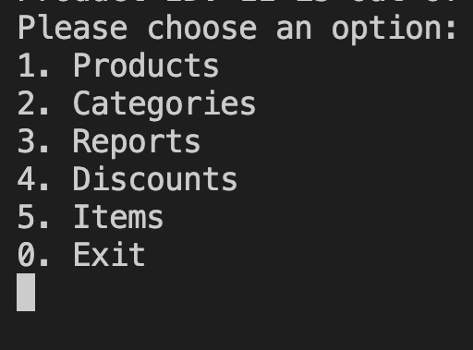

Then 5 should be pressed to open the items menu and show the option to update items (remove) quantity from the store therefore triggering its minimum amount restriction and making the system alert for stock shortage automatically:  
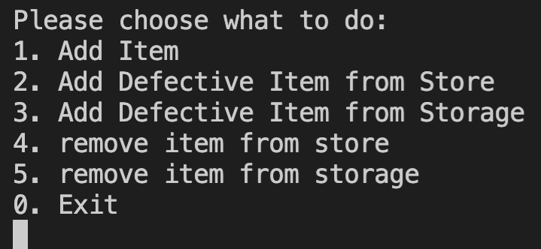

4 should be pressed then to update stock amount:

\*Note: we need to fill specific information to satisfy a pre-defined data that was added to the system before to save time and simplify the testing.

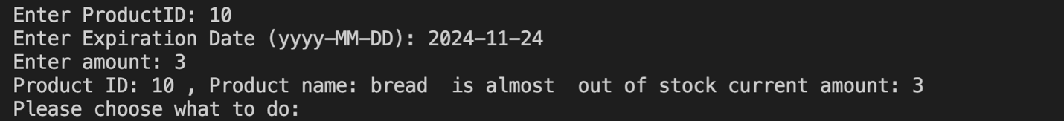

The system automatically detected a shortage and sent an alert!

f. Making a shortage order:

since the shortage order is made automatically by the system, we need to update an item’s stock quantity for it to reach below the minimum amount so that the system places an urgent shortage order, the stock manager panel is responsible of updating quantities so we need to send this command:



this will open the following menu:



Then 5 should be pressed to open the items menu and show the option to update items (remove) quantity from the store therefore triggering its minimum amount restriction and making the system alert for stock shortage automatically:  


4 should be pressed then to update stock amount:

\*Note: we need to fill specific information to satisfy a pre-defined data that was added to the system before to save time and simplify the testing.



At this point there is an item that reached it’s minimum amount (or below) and an alert is sent, the next day the system will automatically make a shortage order containing all the items that are below their respective minimum amount.

\*to do this we have to click the option of “Advance day” so we manually simulate the day passing just so we simplify the process and avoid waiting an actual day

So after filling the information we return to this menu:



0 need to be clicked to get back to the previous menu :  
  
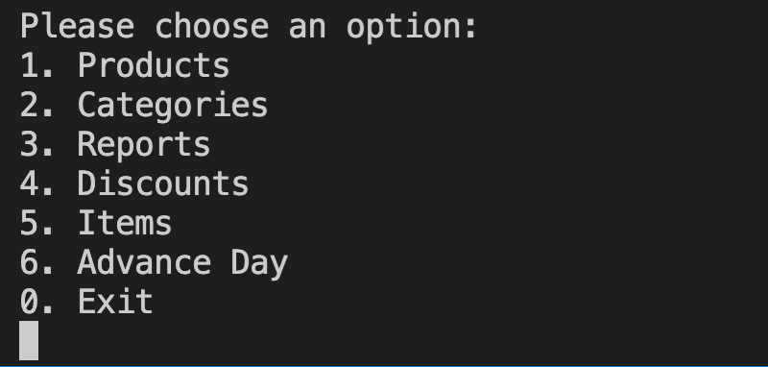

We advance the day to get to the next day by typing 6 in the cmd  
and the order will be prepared for all the alerted items and placed automatically by the system and saved in the database!