**Contracts:**

**-Validate report contract:**

|  |  |
| --- | --- |
| Operation: | Validate_Order(order_id:INTEGER,Supp_id:INTEGER,items:List<Record>) |
| Reference: | Cases: Place_Periodic_Order, Place_Shortage_Order |
| Pre-conditions: | -There is an underway Order  -a warning has been made or a periodic order is being placed/updated |
| Post-conditions: | -given order information are accepted or refused |

**-Placing a shortage order contract:**

|  |  |
| --- | --- |
| Operation: | Place_shortageOrder(items:Map<Product,INTEGER>) |
| Reference: | Cases: Place_Shortage_Order |
| Pre-Conditions: | -there must be pre-made contracts with the associated suppliers  -the required items should be in the minimum defined amount  -a warning stating there are items that reached minimum amounts has been received  -Order is validated |
| Post-Conditions: | -the order or orders are registered and saved in the system  -the orders are associated to the corresponding suppliers |

|  |  |
| --- | --- |
| Operation: | Add_PeriodicOrder(supp_name:String,supp_id:INTEGER,address:String,contact_number:String,items:List<Record>) |
| Reference: | Cases:Place_Periodic_Order |
| Pre-Conditions | -There is an underway Order  -given supplier must have the configuration to come in fixed days.  -There is a pre-made contract with the given supplier  -Order is validated |
| Post-Conditions | -The order is saved in the system as a periodic order  -Order is kept the same until updated at least one day before delivery  -the given supplier is associated to the made and saved periodic order |

**-Placing a periodic order contract:**

-**warning occurred:**

|  |  |
| --- | --- |
| Operation: | Alert() |
| Reference: | Cases: warning occurred. |
| Pre-Conditions: | -some of the items reached minimum amount. |
| Post-Conditions: | -a warning is send to the mangers about the shortage.  -A report order process is initiated . |

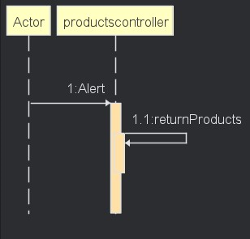

-**Receive Report:**

|  |  |
| --- | --- |
| Operation: | getMinReport() |
| Reference: | Cases: warning occurred. |
| Pre-Conditions: | -none. |
| Post-Conditions: | -a warning is send to the mangers about the shortage.  -A report about items needed quantities is prepared. |

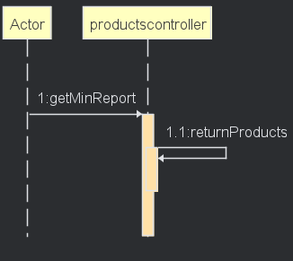

-Receive Order:

|  |  |
| --- | --- |
| Operation: | Receive_Order() |
| Reference: | Cases: alert. |
| Pre-Conditions: | -an order has arrived to the supper lee store. |
| Post-Conditions: | -the storage quantity of the items in the order is updated according to the order.  -a copy of the order is saved in the system. |

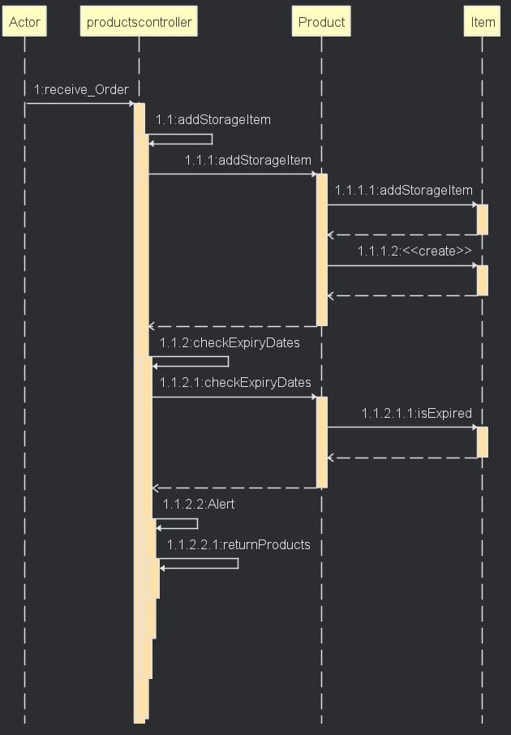

-Save Order:

|  |  |
| --- | --- |
| Operation: | Archive_Order() |
| Reference: | Cases: Save order. |
| Pre-Conditions: | -an order has arrived to the supper lee store. |
| Post-Conditions: | -a copy of the order is saved in the system. |

