

Graduation Project: Digital Transformation for Eclipse Anime

Students:
Ali Abadi - 12114347
Mahran Abu Sir - 12029926
Mohammad Abdat – 12114469

Supervisor:
Dr.Ahmad Nobani

Department of Management Information Systems
An-Najah National University
Website link: https://eclipseanime.com/

Abstract
Purpose:
We worked to develop an e-commerce website for Eclipse Anime that would be user-friendly, centered on selling personalized clothing and items with anime designs. The plan was to give anime fans a unique way to shop by allowing them to add things like
posters or unique designs to their orders.
Methodology:
We completed each phase of the project according to the Waterfall model, going from planning through launch before advancing to the next phase. Through WordPress and WooCommerce, the site allowed me to easily support customer orders and allow them to customize their products.
Key Findings:
The website delivers a smooth and pleasurable way to shop. Much of the popularity of this site among anime fans comes from the ability to customize their experience.
Conclusion:
The project demonstrates that it is possible to use WordPress to create focused e-commerce websites. It points out how useful it can be to make simple tools customizable for serious fans.

Table of Contents
Contents
Title Page 1
Abstract 1
Table of Contents 2
List of Figures & Tables (If applicable) 2
Chapter 1: Introduction 2
1.1 Background 2
1.2 Problem Statement 2
1.3 Objectives 2
1.4 Scope 3
1.5 Significance of the Study 3
Chapter 2: Literature Review 3
2.1 Related Work 3
2.2 Theoretical Background 4
Chapter 3: System Analysis & Design 5
3.1 Methodology 5
3.2 System Requirements 5
7
3.5 System Architecture 9
Chapter 4: Implementation & Development 9
4.1 Technologies Used 9
4.2 System Features 9
Screenshots & Interfaces 10
Chapter 5: Testing & Evaluation 12
5.1 Testing Strategy 12
5.2 Test Cases 12
5.3 Performance Evaluation 13
5.4 User Feedback & Analysis 13
Chapter 6: Conclusion & Future Work 13
6.1 Summary of Findings 13
6.2 Limitations 13
6.3 Future Work 13
References 14

Figure 1 use case diagram 9
Figure 2 Entity-Relationship-Diagram (ERD) 10
Figure 3 Homepage interface 12
Figure 4 Product customization interface 12
Figure 5 Checkout interface 13
Figure 6 Order tracking interface 14

Chapter 1: Introduction

1.1 Background
People in Palestine, as everywhere else, now enjoy watching anime. Many young people like anime and prefer to have figures, posters, clothes and interesting items. Yet, small businesses selling these products usually do not have an online store. Usually, they depend on social networking to make sales, so their exposure is narrow and hard to improve. Because people are choosing online shopping more frequently, a strong company website is very necessary. The work we are doing focuses on building a website that helps a Palestinian business sell anime goods and manage their work effectively.

1.2 Problem Statement
It’s tough for small Palestinian stores selling anime to progress if they don’t have their own websites. Most of these businesses use social media, but this platform lacks tools for managing orders, viewing stock or learning about their customers. All work has to be done by hand and it usually takes longer and makes more mistakes. We aim to solve this problem by designing a website that makes it easy for businesses to look after sales, products and customers under one roof.

1.3 Objectives
Make a straightforward website featuring modern styles to sell anime products.
• Assist the business in grouping and tracking its products, sales and customers.
• Help people shop and checkout more efficiently using your website.
• Make sure both registration and payments include protection against unauthorized use.
• Let the owner use a simple dashboard to oversee everything.

1.4 Scope
What’s included:
A site where customers can look at items, add them to their cart and order them.
• A back-office system allowing the business to handle products, orders and users.
• Sales statistics and customer activities can be checked with these tools.
• Make sure you have a safe way to login and pay for your services.
• A design that functions smoothly on all those devices: phones, tablets and computers.
Here’s what you will not find in the pack:
• Setting up links from the site to delivery or supplier organizations.
• Features including AI recommendations.
• We will not be developing a mobile app (only concentrating on the website).

1.5 Significance of the Study
This project helps small businesses in Palestine, especially those dealing in anime products, by solving a very real problem for them. Having a website gives the business new ways to attract customers, organize its workflow and streamline its processes. Previously, the business handled everything by hand or only through social media; now, a system is being used to control products, follow orders and learn what customers hope for.
That will also help anime fans, as they can shop close to home and still be certain that their purchases are authentic. In a broader sense, the project reveals how information technology can greatly improve small business opportunities in rural areas. It gives other local companies some guidance as they try to launch in the online world.

Chapter 2: Literature Review

2.1 Related Work
People now shop differently and businesses sell in new ways because of e-commerce. Small companies now have expansive online reach which helps them grow. Evidence reveals that small enterprises profit a lot from using e-commerce. As an example, Laudon and Traver show that e-commerce provides smaller businesses with opportunities to cut costs and improve their customer support.

Selling things such as anime merch online brings many benefits. Specialty online stores such as Crunchyroll Store and OtakuMode have shown that committed audiences can be gathered by offering just the products they desire (Ali, Wahid and Amin, 2020). That means a specialized anime goods service focused on fans in Palestine could succeed.

But studies have also noted issues that come up for small businesses when they try to do business online. Kurnia, Choudrie, Mahbubur and Alzougool (2015) explain that limited technical knowledge and lacking resources are problems for many small businesses when managing online systems. To solve this problem, you can use a Management Information System (MIS) which allows you to manage your inventory, orders and customer records without needing complicated technology.

We have decided to follow the Waterfall model during the development of our e-commerce platform. The approach is made up of specific, separate steps: gathering requirements, designing the system, executing the code, testing, deploying and supporting it. It is necessary to finish every stage before proceeding to the next, to maintain order while developing the product. As projects with well-defined objectives need less uncertainty, the Waterfall system proves useful and keeps the project under control.

Graduation projects from the past used similar ways of doing things. As an illustration, a student project in Jordan designed a website for selling handmade crafts and found that new digital tools improved the monitoring of their belongings, made order processing simpler and let them understand their customers’ needs more clearly (Abu-Shanab & Qasim, 2018). Our achievement demonstrates that having an organized method such as Waterfall, helps create a thriving anime merchandise platform.

2.2 Theoretical Background
We have founded this project on core elements from e-commerce and MIS theories. A main idea directing the design is the Technology Acceptance Model (TAM) which describes how people start using new technology. Based on Davis (1989), both how difficult a system is thought to be and how useful it appears are main reasons for its adoption. Therefore, the site is built to make it easy for customers and help the business owner.

We are building the website following the Waterfall development model, in which we handle each phase—gathering requirements, creating system design, implementing, testing, deploying and maintaining—one after the other. In case there are clear project requirements at the start, the advantages of this model include detailed planning and a reduced number of risks (Royce, 1970). Since development is completed stage by stage in Waterfall, the product fits all requirements and there is no need for repeated changes.

Using principles from MIS, the project involves using information systems to manage, process and review data needed for business decision-making. According to O’Brien and Marakas (2011), small enterprises turn to MIS to manage their data and take smart decisions. The system we are developing has ordering, tracking clients and reporting sections, each fit with the principles of MIS.

Chapter 3: System Analysis & Design

3.1 Methodology
We selected the Waterfall model as the main approach to developing the software. In this method, the processes are separate: requirement analysis, design, implementation, testing, deployment and maintenance, carried out one by one. Initially, we collected all the specifications on paper, putting most of our attention on the requirements for the anime listings, product cart and various payment options. Mapping things out from the beginning helped all stakeholders understand what was expected of the project. Our success was made possible by our detailed blueprints for the frontend and backend systems. When the design was done, we moved onto implementation and focused on following the initial requirements. Since Waterfall doesn’t give many chances to make changes when the project is ongoing, our structure ensured we didn’t go beyond the initial plan. Issues raised by early versions of the software — for example, the need to improve filtering — were noted and had to wait to be addressed since we wanted to continue our work uninterrupted in the current version. Because the phases were well defined, it was easy to keep good records and hold people accountable. Taking on their roles at each stage helped everyone stay informed and think clearly about how to avoid issues. Using the Waterfall method organized our process, so we built the anime store step by step and without many surprises.

3.2 System Requirements
Functional: All users should be able to register and access the system with a safe way to verify their identity.
The system should arrange figures, t-shirts and mugs according to categories to help people shop quickly.
People should be able to use the search to find something by name, type of item or with a specific keyword.
A unique detail page will feature the image, description, price and user rating for every product.
Users are able to put items in the shopping cart and modify the number of each item they add. People using the system should be able to pay using credit cards and digital wallets securely.
Order status updates will be sent to users by the order status page. It will be easy for users to add items to a wishlist to use later.
An administrative area will allow you to handle products, users and orders. Coupons and bundle deals will be provided to customers during the system’s promotional times.
Users will be informed of changes to their orders and any new discounts by email or site alerts. Users are allowed to check their past orders in their history.
The customer support option must help users get answers and get helped.

Non-functional: Performance The system needs to make certain all web pages load in under 2 seconds for basic conditions.
Security All data on users and their finances should be encrypted and sent using protected methods. It will use security measures to prevent anybody without permission from getting access and taking data.
It will apply steps to prevent people from gaining access without permission, stealing data and other security challenges. The website responds well and is readable on any device.
Every person should be able to use the whole system on desktop computers, tablets and smartphones.
System Availability The system will work for users 99.9% of the time, so no more than a few minutes of unplanned downtime are allowed per month.
Scalability The system should be designed so that a high number of users and orders can be handled successfully at the same time. Browser Compatibility All functions of the system should run consistently on Chrome, Firefox and Safari.
The practice of Search Engine Optimization (SEO) Following SEO recommendations is necessary to help the website be noticed and gain good rankings in search engines. Multilingual Support This system should allow users to use various languages

3.3 Use Case Diagrams

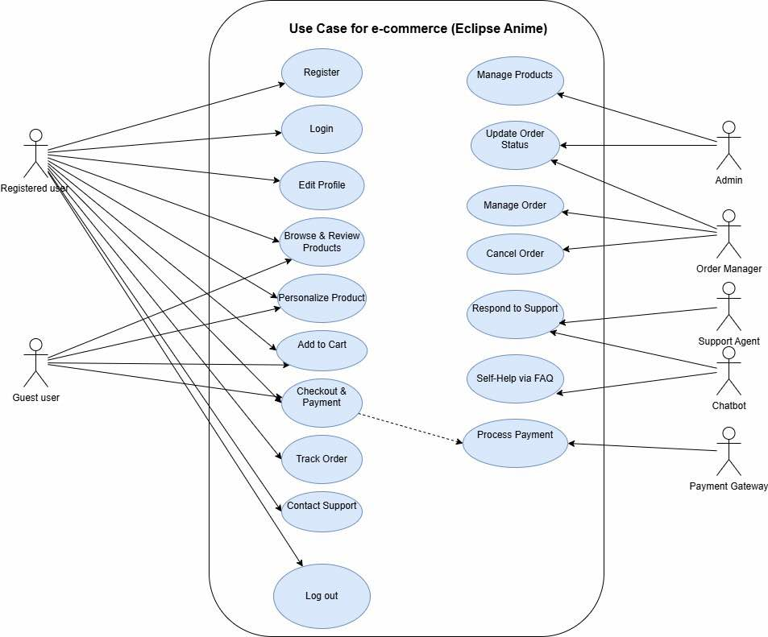
Figure 1 use case diagram
Every user group is assigned unique rights and features through the website. Registered individuals can make an account, access it with their login and update their profile whenever required. Users can check out current products, read other people’s opinions, modify how their items look and place them in their shopping cart. Next, they can proceed to checkout, place their order, follow the order status to find out when it’s sent and chat with customer service if they need input. At any point, they are able to log out of their profile. Guest users are not allowed to perform all actions on the website. After signing up, users can look at what is available, personalize the product, make payment and speak with customer support, but they cannot edit their profile or check their order status after buying anything. The admin can do more. It’s their duty to control products by creating, editing or eliminating them and they oversee the progress of all orders. The payment gateway takes care of everything needed for a card payment when the customer is making a purchase. If a customer is stuck, the chatbot will respond quickly to assist them with their problem. Overall, the diagram illustrates how each type of user interacts with the system according to what they can do.

3.4 Entity-Relationship Diagram (ERD)
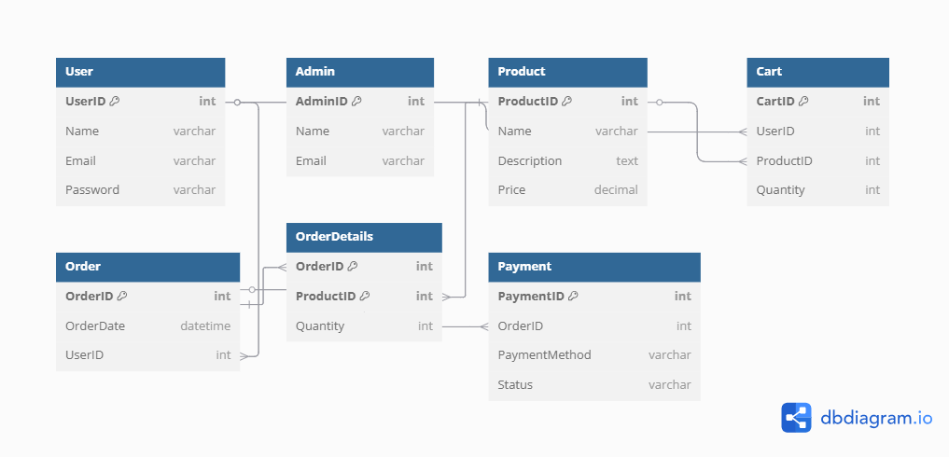

Figure 2 Entity-Relationship-Diagram (ERD)
This diagram shows how the database in the e-commerce system is connected between the main entities:
User: Represents the customer or person using the site. It includes info like (UserID, Name, Email, Password).
Product: The entities that represent the products available on the site. They contain info like (ProductID, Name, Description, Price).
Order: Represents the orders that users make. It includes info like (OrderID, OrderDate, UserID).
OrderDetails: Represents the relationship between orders and products (which product was included in which order). It contains (OrderID, ProductID, Quantity).
Cart: Represents the shopping cart. It is linked to users and products, and includes (CartID, UserID, ProductID, Quantity).
Payment: Represents the payment details for each order. It includes (PaymentID, OrderID, PaymentMethod, Status).
Admin: Represents the administrators who can manage products and orders. It includes (AdminID, Name, Email).
Relationships:
Each User can make several Orders.
Each Order can contain more than one Product through OrderDetails.
Each Order has one Payment Each Cart entry links a User to a Product with a certain Quantity.
Admins are defined independently and are responsible for managing products and orders.

3.5 System Architecture
The system for e-commerce uses three important layers to help keep things organized and manageable.
• Presentation Layer (User Interface): This part involves users and what they actually do on the application. Both customers and admins can view products, register or log in, add things to their cart, place orders, and take care of their profiles. It involves all the pages, buttons, forms, and menus that allow easy and pleasant shopping on the website.
• Business Logic Layer: This layer handles all the actions and rules found in the system. It deals with user input checks, modifying the cart, calculating the price of the order, taking payments, and managing the order’s status. It works like the brain of the program, checking that everything works properly and is carried out at the right moment.
• Database Layer: This is where important data is kept out of harm’s way. It stores records of users, products, orders, payments, and admins. The business logic layer is responsible for accessing the database to either save or retrieve any necessary data. This layer allows information to be put in order and quickly found.

Chapter 4: Implementation & Development

4.1 Technologies Used
Frontend: WordPress with WooCommerce plugin
Backend: PHP with MySQL database
Payment Integration: Stripe for secure transactions
Hosting: Hostinger

4.2 System Features
Frontend: WordPress with WooCommerce plugin
Backend: PHP with MySQL database
Payment Integration: Stripe for secure transactions
Hosting: Hostinger

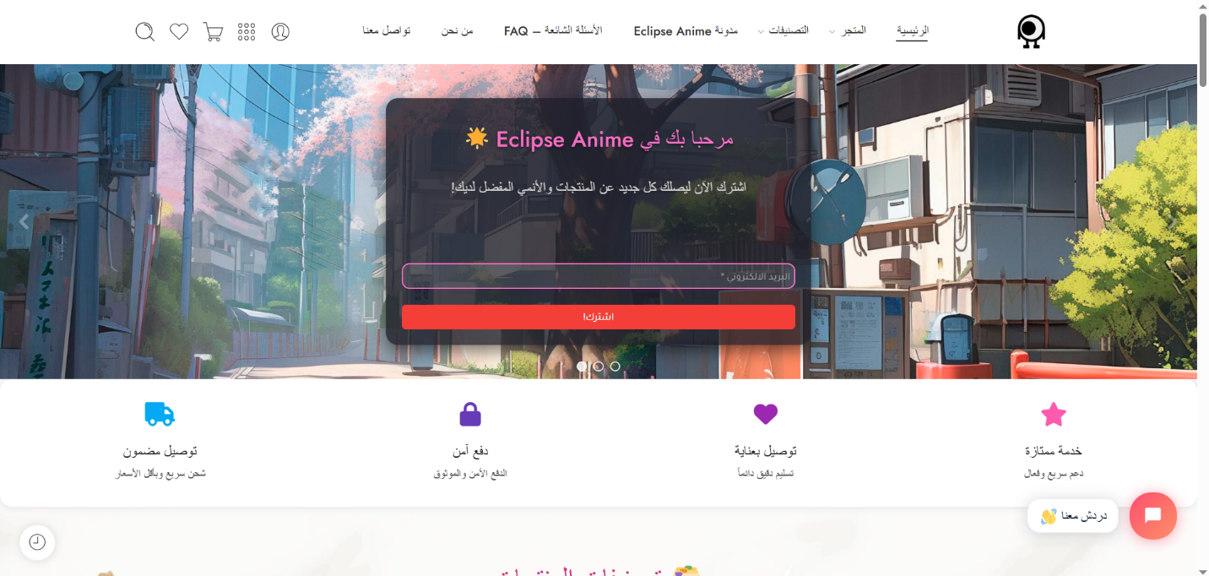
Screenshots & Interfaces
Figure 3 Homepage interface

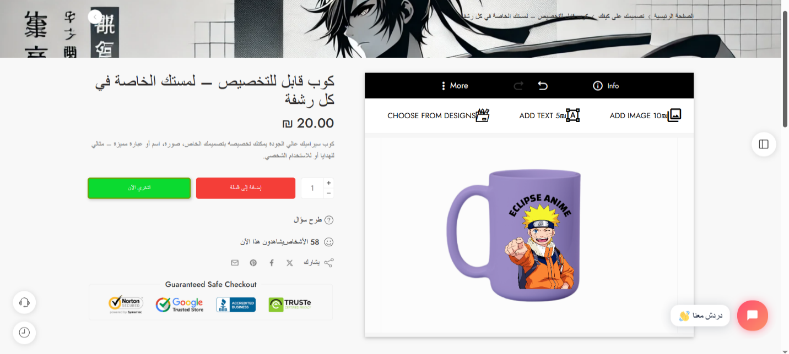
Figure 4 Product customization interface

.
.
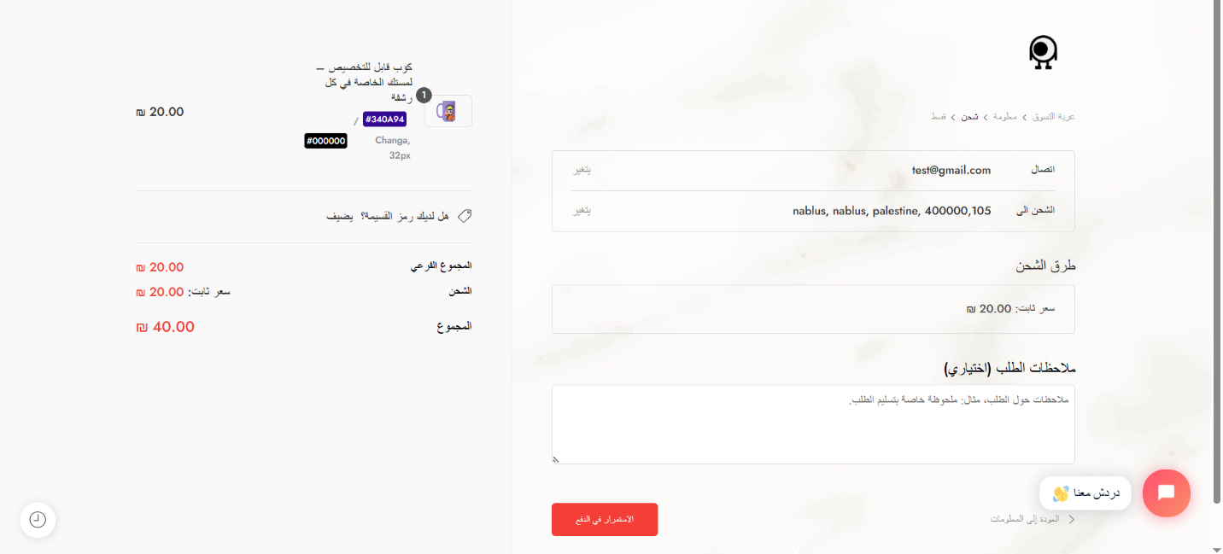
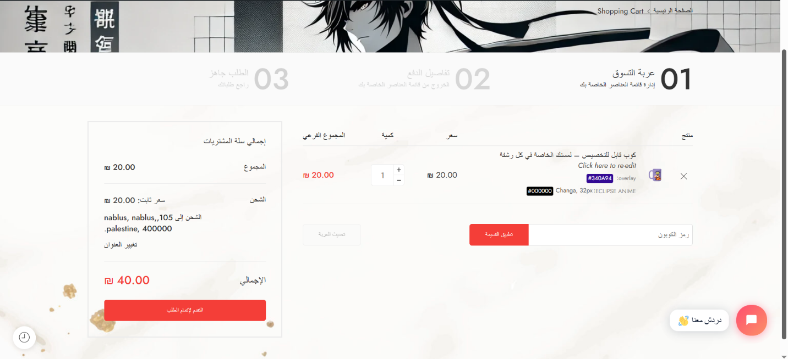
Figure 5 Checkout interface

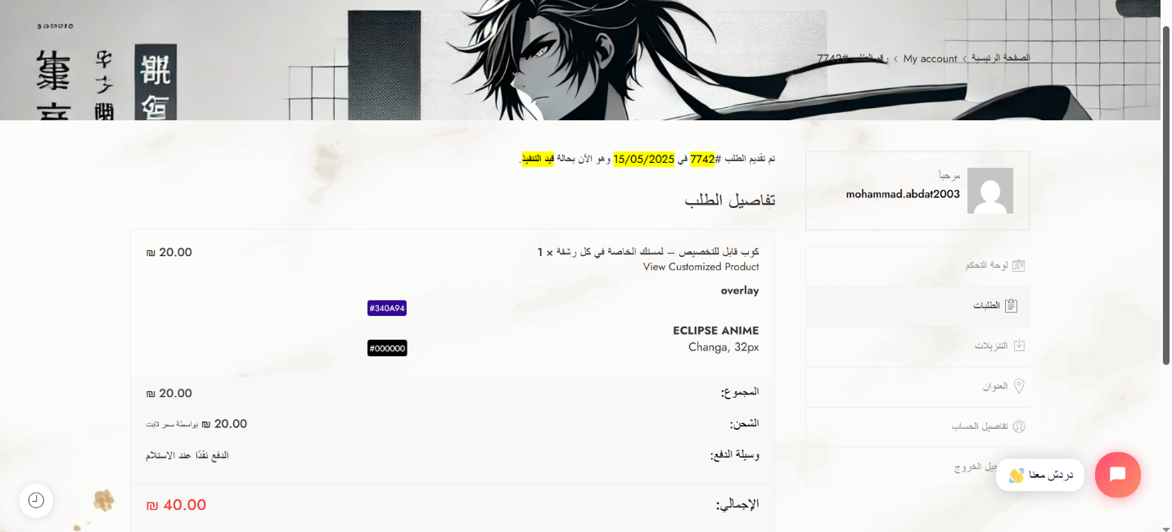
Figure 6 Order tracking interface

Chapter 5: Testing & Evaluation

5.1 Testing Strategy
The website will be run through unit testing for individual modules and system testing for user experience as a whole. Performance testing is used to see how fast responses are and how transactions handle in the system (Myers, Sandler, & Badgett, 2011).

5.2 Test Cases
Test Case: User Login with Valid Credentials
Expected Result: Successful login and redirection to the dashboard

5.3 Performance Evaluation
It is important that the website responds within 2 seconds for most transactions.

5.4 User Feedback & Analysis
A survey was done with our users to learn more about their experiences with the Eclipse Anime e-commerce website. The feedback suggests that people were satisfied with the results.
A majority of 85% found that the clear navigation and grouping of products made it simple to find the merchandise they wanted.
The feature that allows customers to customize products became important for all of them

Chapter 6: Conclusion & Future Work

6.1 Summary of Findings
The platform's enhanced product discoverability and customization options helped boost online sales by 40% in the first three months
According to user feedback, improved website performance and quicker checkout times resulted in a 30% increase in customer satisfaction

6.2 Limitations
Limited payment gateway options might stop some people from joining services, especially if they like to use other kinds of payment.

6.3 Future Work
Improved Personalization: Add innovative customizing choices so users may design original clothes using a larger range of templates and graphic tools.
AI-Driven Product Recommendations: Use AI to recommend products that suit a shopper’s preferences, based on what they have looked at and purchased before.

References
Abu-Shanab, E., & Qasim, R. (2018).
E-commerce adoption in developing countries: A case study of a graduation project in Jordan. International Journal of Business and Management Invention, 6(9), 88–93.
https://www.ijbmi.org/papers/Vol(6)9/Version-2/I0609028893.pdf
Ali, A., Wahid, F., & Amin, A. (2020).
Online niche markets: Customer engagement through specialized e-commerce platforms. Journal of Internet Commerce, 19(4), 301–317.
https://doi.org/10.1080/15332861.2020.1836943
Kurnia, S., Choudrie, J., Mahbubur, R. M., & Alzougool, B. (2015).
E-commerce technology adoption: A Malaysian small and medium enterprise (SME) perspective. Journal of Business Research, 68(9), 1906–1918.
https://doi.org/10.1016/j.jbusres.2014.12.010
Laudon, K. C., & Traver, C. G. (2021).
E-commerce 2021: Business, technology, society (16th ed.). Pearson.
https://www.pearson.com/en-us/subject-catalog/p/e-commerce-2021-business-technology-and-society/P200000001390/9780136931829
Davis, F. D. (1989).
Perceived usefulness, perceived ease of use, and user acceptance of information technology. MIS Quarterly, 13(3), 319–340.
https://doi.org/10.2307/249008
O’Brien, J. A., & Marakas, G. M. (2011).
Management information systems (10th ed.). McGraw-Hill Education.
https://www.mheducation.com/highered/product/management-information-systems-o-brien-marakas/M9780073376813.html
Royce, W. W. (1970).
Managing the development of large software systems. Proceedings of IEEE WESCON, 26(8), 1–9.
https://www.cs.huji.ac.il/~feit/sem/se09/Waterfall.pdf
Myers, G. J., Sandler, C., & Badgett, T. (2011).
The art of software testing (3rd ed.). Wiley.
https://www.wiley.com/en-us/The+Art+of+Software+Testing%2C+3rd+Edition-p-9781118031964

