UI Modernization Project
Document Development and Approval
Version 1.0

Procedure Number:

409-NJS-PMO-PRO
Table of Contents
1. INTRODUCTION 1
1.1 Purpose 1
1.2 Scope 1
1.3 Document Management 1
1.4 Roles and Responsibilities 1
1.5 Materials 2
2. PROCESS DESCRIPTION 2
2.1 Overview 2
2.2 Process Flow 3
2.3 Process Detail 4
2.3.1. Entry Criteria for Document Development and Deliverable Approval Process 4
2.3.2. Input 4
2.3.3. Tasks 4
2.3.4. Output 7
2.3.5. Exit Criteria for the Document Development and Deliverable Approval Process 7
3. MEASUREMENTS 7
4. VERIFICATION 7
5. REFERENCES: 7
6. CHANGE HISTORY 8

INTRODUCTION

Purpose
The purpose of this document is to provide a process for initiating, and maintaining an Ecommerce business at the same time getting an insight on what the customer preferences are and how the market trend will be.

Website development and approval is a critical component in ensuring that requirements are being satisfied and project scope is being managed effectively by maintaining a structured document development, review, and approval structure.

Scope
This process describes the roles, tools, and activities involved in E-commerce website development and approval.

Management
All versions of this document are managed and controlled by the UniqueITSolutionz. The same is also the owner of the processes supporting this document and is responsible for maintaining this document. You can visit the website of the company for more information: http://uniqueitsolutionz.com

Roles and Responsibilities
The system has two roles:
1) Admin
2) Users

Role | Responsibility
Admin | The owner of the website.
Admin | Adds new items
Admin | Updates existing items
Admin | Deletes existing items.(single or multiple)
Admin | Views existing orders.
Admin | Views customers’ list
Admin | Views Orders’ list
Admin | Views accounts
Admin | Views Inventory
Admin | Can Login
Admin | Can add users
Admin | Applies discounts and offers
Table 1: Roles and Responsibilities of Admin

Role | Responsibility
User | Uses the website.
User | Views items
User | Searches items
User | Add items to the Wish List
User | Add items to the Shopping Cart
User | Orders items
User | Registers to the website
User | Orders items based on the previous history
User | Can get discounts
Table 2: Roles of User

Materials
This section includes all documents necessary for the document deliverable and approval process. The documents are broken down into templates, checklists, and tools.

Type | Title | Location
Checklist | Document (Specific Deliverable) Checklist | Document Repository
Template | MS Word for: Document (Specific Deliverable) | Document Repository
Template | Letter of Acceptance | Document Repository
Template | Letter of Acknowledgement | Document Repository
Tool | Deliverable Tracking Sheet | Document Repository
Table 2: Materials

PROCESS DESCRIPTION

Overview
The website will provide a critical level interface to end user about the things on display and sell. It is very critical that the interface provided is appealing at the same time self-explanatory and easy to use. The technologies used to develop the site will help side load instantly and site will work equally well on all major web browsers.
This process used to develop website supports the maintenance of scope and mitigates risk that can be created by continuous review and response cycles that cause schedule lapses and potential increases in scope.

Step | Activity
1 | Review Document Architecture
2 | Establish Acceptance Criteria
3 | Construct Document Deliverable
4 | Provide Drafts for Preliminary Input
5 | Review with VV&T for Compliance
6 | Submit for Formal Review
7 | Address Comments
8 | Submit for Approval
9 | Deliverable Acceptance
10 | Deliverable Baseline

Process Flow
The following flowcharts depict the major steps of the document development and approval process:

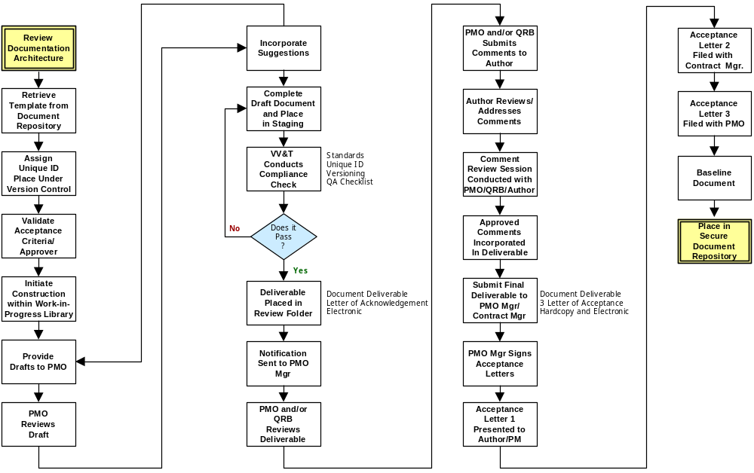

Process Detail

Figure 1 – Document Development and Approval Process Flow

Entry Criteria for Website development Approval Process
- E-commerce Website Deliverable Requirements

Input
- Project Plan - Requirements
- Project Schedule – Timeframe
- Document Architecture
- Document Template

Tasks

Website Architecture
The website will be developed in Microsoft .Net technologies with standard project structure and the main focus of development will focus on security aspects and enabling best users experience.

Establish Acceptance Criteria
The purpose of this step is to establish acceptance criteria for each deliverable in the project. Each deliverable should have a stated criterion by which the successful completion of the deliverable will be judged for approval. The acceptance criteria are essential in providing an objective guide for knowing when a deliverable is both complete and compliant with the stated requirements of the project.

Acceptance Criteria should cover, for example, the following topics:

- Target Delivery Dates
- Format/Appearance
- Content/Major functions
- Personnel level required to use/operate the product
- Performance levels
- Capacity
- Accuracy
- Availability
- Reliability
- Development Cost
- Operation Cost
- Security
- Ease of use
- Timings

Construct Document Deliverable
With the template and the criteria on which the deliverable will be mapped for approval, the author will then initiate construction of the document deliverable. The construct should take place in the Work-in-Progress folder in the Document Repository set up by the PMO for the specific project. This folder will facilitate routine backup and recovery procedures are adhered to, and that proper folder security is provided.

Submit for Final Acceptance
The resolutions for the comment review sessions will be incorporated into the final document and presented to the PMO for a final review by the primary review and sign-off. A packet including an electronic and hardcopy version of the document will be provided to the PMO, along with two to three “Letters of Acceptance” for that specific deliverable.

The primary distinction as to the number of letters will be if a vendor, contracting with the Department of Labor, submits the project deliverables. If that is the case 1 signed Letter of Acceptance will go to the project manager for that deliverable or the author, a second signed letter will go to the PMO Contract Manager to be used in invoice processing/validation, and the third will be kept in the PMO. If the project is entirely internal to the state, there will only be two signed Letters of Acceptance, one the project manager, and one to the PMO.

Deliverable Acceptance
The PMO Manager and the PMO Contracts Manager will conduct a final review to make sure that the changes have been made and noted in the revision history. At that point the PMO Manager and the PMO Contract Manager will sign the two “Letters of Acceptance”. One will be placed in the PMO Library, and the other returned to the project manager for their record.

Deliverable Baselined
An email will be sent to the individual responsible for maintaining the Document Repository, who take the electronic versions of the revised document and place it in the “Approved Deliverable” Folder for the project, which is “read only”. The version number on the cover will be set to X.0 to reflect a baselined version, and will available to the organization.

Output
- Approved/Baselined Deliverable
- Signed Acceptance Letter
- Deliverable Checklist

Exit Criteria for the Document Development and Deliverable Approval Process
- Required deliverable – approved and baselined.

MEASUREMENTS
- Deficiencies from checklist
- Deliverable Tracking

VERIFICATION
The Verification, Validation and Testing (VV&T) group reviews and audits the activities and work products for each deliverable, including mapping the submitted document against the checklist for that deliverable. The project manager reviews the acceptance criteria with the PMO and defines the expectations for completion, and reviews the final product before submission to ensure compliance with the acceptance criteria and QA checklist. The PMO facilitates the review processes and compliance with stated acceptance criteria.

REFERENCES:
Title | Code | Location
Program Glossary | 701-NJS-PMO-REF | Document Repository
Document Architecture | 702-NJS-PMO-REF | Document Repository
Document Template Library | None | Document Repository

CHANGE HISTORY
Version | Date | Change Description
0.1 | April 30, 2004 | Draft for review
1.0 | May 31, 2004 | Baselined Procedure

