CSE 211 Web Programming, Fall Semester 24/25

Assignment #1: Websites conceptual Design and mock-up

222101010,Ali Ahmed Aboughadeer

**Core idea:**

The assignment aims to practice web designing and how to plan

**part 1: research**

**Characteristics from Web 2.0 to Web 4.0**

**Web 2.0**

- Interactivity and user participation are central.

- The shift to dynamic content that allows users to interact,contribute, and collaborate.

- Community and social networking drive much of the web experience.

**Web 3.0**

- Data-driven,machine-readable web with a focus on meaning and semantic connections between information.

- Emphasis on decentralization and personalized experiences, where AI plays a crucial role.

**Web 4.0**

- A symbiotic relationship between humans and machines, where AI-driven systems become more autonomous and integrated into daily life.

- The web becomes ubiquitous and intelligent, seamlessly interacting with users through loTand immersive technologies like VR and AR.

**Key features of Web 2.0 and how it empowers the power of networks:**

- User-Generated Content: Empowers individuals to contribute, share, and disseminate information, fostering widespread participation and community building.

- Collaborative Work: Facilitates teamwork and project collaboration through online tools, enabling global connectivity for shared goals and productivity.

**Key features of Web 3.0 and how it empowers the meaning of data and knowledge connections:**

- Linked Data: Connects data from various sources, giving users more comprehensive and meaningful experiences by providing relevant and enriched content.

- Decentralization: Distributes control, enabling data ownership to shift from central authorities to individuals, creating trustless systems that enhance security and privacy.

**Key features of Web 4.0 and how it empowers intelligence connections:**

- Real-Time Interactivity: Smart environments (homes, cities) can respond to user inputs and external data in real-time, enhancing convenience and efficiency.

- Collective Intelligence: Harnesses the power of multiple systems and networks working together to offer intuitive, data-driven experiences that adapt to users' needs.

**The importance of collective intelligence, social networking, social media and social bookmarking:**

Collective intelligence calls on different perspectives to solve problems or foster creativity with. Social networking brings people together; such that they can exchange information and help one another. As a communication tool, social media enables one- or business-connected persons to spread information to many people, while social bookmarking enables users to categorize and share useful web resources. In total, these tools foster collaboration and support the construction of community in our networked lives.

**How these technologies empower the current and future business plans:**

The transition from the Web 2.0 to Web 4.0, many opportunities for businesses used to develop new channels for customer interaction and effectiveness. Web 2.0 is all about working together with others and responding through the social media feedback. By Web 3.0, as the business worldwide begin to utilize data and intelligent systems to better comprehend the needs of their customers and make superior decisions. In Web 4.0, smart devices and automation are implemented, and business can work more effectively and can easily adapt to the changes. These are the many aspects that make it easier for businesses to be established and completed in the existing world economy.

**How do I intend to use the latest technologies in my profession:**

I will employ AI tools to analyze data and spot trends and enhance my website with interactive features to improve user experience.

**Part 2:website planning**

**Purpose of the Website**

The website is for my football store, where I will sell football gear like jerseys, shoes, and accessories.

**What I Want the Website to Accomplish**

I want the website to make it easy for people to buy football products online and to help build a community of football fans.

**Intended Audience**

My audience includes football players, fans, parents of young players, and anyone interested in football merchandise.

**Opportunities and Issues Addressed**

The website will solve the problem of finding football gear easily, especially for people who can’t find it in local stores. It will provide a convenient shopping option for busy individuals.

**Content to Incorporate**

The website will include:

Product listings with pictures and descriptions.

**How the Site Will Serve the client**

The site will provide a user-friendly shopping experience, helpful content, and good customer support. Easy navigation and a smooth checkout will make shopping enjoyable.

**Best Method for Users**

Users will find what they want through clear menus, a search bar, and organized categories for products.

**How Users Will Find the Function**

Users will discover functions through a simple design with clear buttons for shopping, browsing products, and accessing the blog.

**How Results Will Be Received**

After placing an order, users will receive confirmation emails and tracking information to keep them updated.

**What the Receiver Will Do with Entries**

I will review orders, questions, and feedback to ensure everything is handled quickly and correctly.

**How the Receiver Will Deal with Results**

I will manage orders for shipping, respond to customer inquiries, and use feedback to improve the website and products.

**Follow-Up Needed**

Follow-ups will include sending emails to customers after their purchases for feedback, letting them know about new products, and offering promotions to encourage them to shop again. I will also regularly check website analytics to see how it’s performing and make improvements.

**Part 2: website planning**

1. **Purpose of the Website**

The website is for my football store, where I will sell football gear like jerseys, shoes, and accessories.

1. **What I Want the Website to Accomplish**

I want the website to make it easy for people to buy football products online and to help build a community of football fans.

1. **Intended Audience**

My audience includes football players, fans, parents of young players, and anyone interested in football merchandise.

1. **Opportunities and Issues Addressed**

The website will solve the problem of finding football gear easily, especially for people who can’t find it in local stores. It will provide a convenient shopping option for busy individuals.

1. **Content to Incorporate**

The website will include: Product listings with pictures and descriptions.

1. **How the Site Will Serve the client**

The site will provide a user-friendly shopping experience, helpful content, and good customer support. Easy navigation and a smooth checkout will make shopping enjoyable.

1. **Best Method for Users**

Users will find what they want through clear menus, a search bar, and organized categories for products.

1. **How Users Will Find the Function**

Users will discover functions through a simple design with clear buttons for shopping, browsing products, and accessing the blog.

1. **How Results Will Be Received**

After placing an order, users will receive confirmation emails and tracking information to keep them updated.

1. **What the Receiver Will Do with Entries**

I will review orders, questions, and feedback to ensure everything is handled quickly and correctly.

1. **How the Receiver Will Deal with Results**

I will manage orders for shipping, respond to customer inquiries, and use feedback to improve the website and products.

1. **Follow-Up Needed**

Follow-ups will include sending emails to customers after their purchases for feedback, letting them know about new products, and offering promotions to encourage them to shop again. I will also regularly check website analytics to see how it’s performing and ma34ke improvements.

1. **Related sites found on the web:**

Adidas and nike because they are the most famous

1. **Planning Analysis sheet:**

a. **Website Goal**  
The goal of this website is to provide a user-friendly online football store where visitors can browse, purchase, and review football gear. The website will offer a wide range of products, including jerseys, shoes, and accessories, along with recommendations and special offers to enhance the shopping experience.

b. **List of Working Titles for Pages**

* New Arrivals
* Categories
* Contact Us
* About Us
* Search
* Shopping Cart

c. **Description of Page Contents**

**New Arrivals**  
Description: This page highlights the latest football gear available in the store. Users can browse new arrivals, view product images, prices, and read brief descriptions. There’s an option to add items to the cart.  
Content: New product images, prices, descriptions, and "Add to Cart" buttons.

**Products**  
Description: The products page organizes products by type. Users can select a product, view items, and quickly add them to their cart.  
Content: List of product categories, images, brief descriptions, and filters for easy browsing.

**Contact Us**  
Description: This page allows users to get in touch with the store. It includes a contact details like phone numbers and business hours.  
Content: Customer service details, and business hours.

**About Us**  
Description: The About Us page shares the story behind the store—its purpose, and founding. It highlights the mission and values of the football store.  
Content: Company background, mission statement, and team information.

**Search**  
Description: Users can search for specific football products by entering keywords, such as product names or brands. The page will display results with images, prices, and descriptions.  
Content: Search bar, product search results including images, prices, and descriptions.

**Shopping Cart**  
Description: This page displays the items users have added to their cart. Users can see the total price, adjust quantities, remove items, and proceed to checkout to complete their purchase.  
Content: List of selected products, total price, quantity adjustments, and checkout button.

d. **Description of Forms and How Users Will Interact**

Newsletter Subscription Form: Visitors can enter their email to subscribe to a newsletter for updates on new book releases and sales.

Review/Rating Submission Form: After purchasing a book, users can rate and leave a review using a form that allows them to choose a rating (e.g., 1-5 stars) and provide written feedback.

Contact Us Form: A basic form allowing users to submit questions or concerns. This will include fields like name, email, and a message box.

**e. Flowchart**

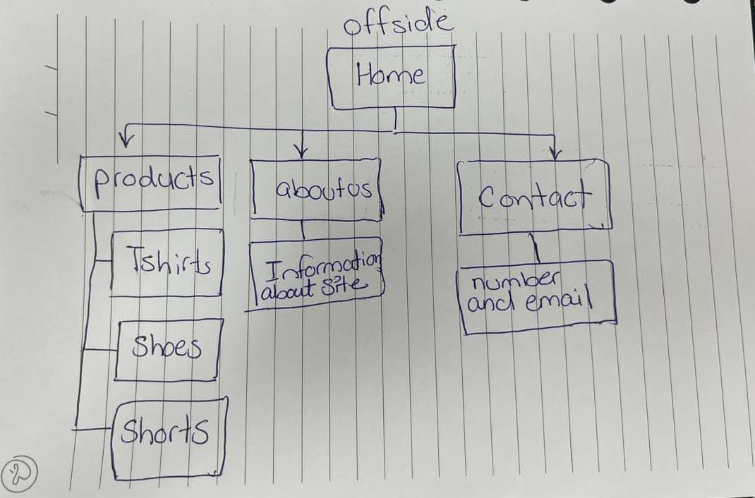

**Part 3: website design**

**[A]:**

### **1. Law of Pragnanz (Good Figure, Law of Simplicity)**

**Implementation**: Use a clean, minimalist layout with a simple navigation bar. Products will be showcased in a grid format, allowing users to quickly scan items. Avoid clutter by limiting text and using high-quality images that speak for themselves.

### **2. Closure**

**Implementation**: Create product categories using icons or images that suggest their contents. Even if the entire item isn’t visible, the brain will complete the image, helping users understand the categories without needing detailed descriptions.

### **3. Symmetry and Order**

**Implementation**: Organize the homepage with a symmetrical layout that features products evenly spaced in rows and columns. This helps users process information quickly and intuitively, directing their attention to key areas like promotions or bestsellers.

### **4. Figure/Ground**

**Implementation**: Use contrasting colors for the background and product images. For example, a dark background with brightly colored footballs makes the products stand out. Adequate spacing ensures that the products remain the focus, avoiding distractions.

### **5. Uniform Connectedness**

**Implementation**: Group related products (like footballs, cleats, and training gear) visually by using consistent styling elements (e.g., borders or backgrounds) that link them together, signaling to users that they are part of the same collection.

### **6. Common Region**

**Implementation**: Use sections or cards that are visually enclosed to create areas for different categories, like “Men’s Gear,” “Women’s Gear,” and “Kids’ Gear.” This visually connects items within the same category and helps users navigate easily.

### **7. Proximity**

**Implementation**: Position related items close together. For instance, place a football next to matching cleats or accessories. This encourages users to see the items as related and consider purchasing them together.

### **8. Continuation**

**Implementation**: Create a visual flow through the website using lines or arrows that guide users from one product to another or through a promotional banner. This ensures that users’ eyes move naturally across the content without disruption.

### **9. Common Fate (Synchrony)**

**Implementation**: Use animations for product displays (e.g., when a user hovers over a product, it could slightly enlarge). This movement suggests a relationship between the items and creates a dynamic shopping experience.

### **10. Parallelism**

**Implementation**: Align product listings and text descriptions in parallel rows. Items that are visually similar, such as shoes in different colors, can be displayed side by side to reinforce their relationship and make comparisons easier.

### **11. Similarity**

**Implementation**: Use consistent styling for products within the same category (e.g., all footballs have the same background color). This visual similarity signals to users that these items belong together, making it easier to browse.

### **12. Past Experience**

**Implementation**: Leverage familiar e-commerce patterns (like cart icons, search bars, and user reviews) to enhance usability. Users will feel more comfortable navigating the site if it adheres to common online shopping conventions based on their past experiences.

**[B]:**

**1.Screen Resolution:**

1440,2513

**2.Color Palette:**

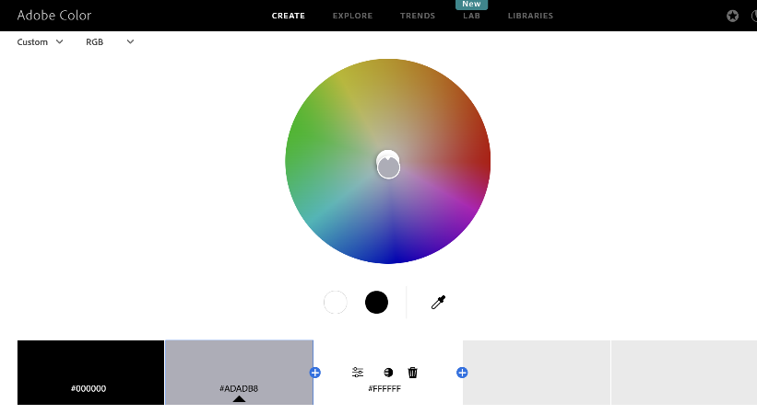

**3. Minimum Contrast Accessibility**

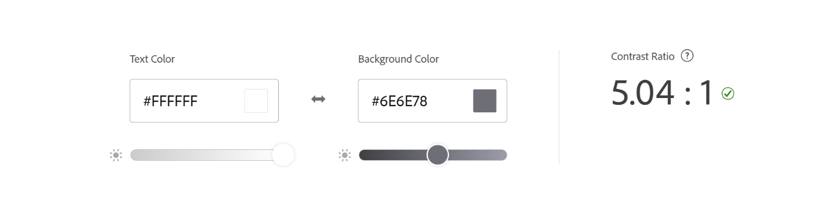

**4.Front-end development technologies:**

I’ll use HTML to build the website's structure, CSS to style it, and JavaScript to add interactive features.

**5.Content Management Systems (CMS):**

For the store, I think Shopify, Wix, and Squarespace are great options. They’re easy to set up and have customizable themes with built-in e-commerce tools. If you want more control, WordPress with WooCommerce or Magento is powerful but needs some technical skills. All these platforms help you showcase products, manage inventory, and process payments easily.

**6. Back-end development technologies**:

I’ll use PHP for building web pages and Laravel for a user-friendly interface. This will give me flexibility and creative options.

**7. Metrics planning to use for measuring website performance:**

- I’ll use Google PageSpeed Insights to regularly check how fast the website loads. This tool will show me areas that need improvement, like reducing image sizes or improving server response time, so I can ensure the site runs smoothly and quickly for users.

**8. HTML5 Structure:**

<!DOCTYPE html>

<html lang="en">

<head>

    <meta charset="UTF-8">

    <meta name="viewport" content="width=device-width, initial-scale=1.0">

    <title>Offside</title>

    <link rel="stylesheet" href="styles.css">

</head>

<body>

    <header>

        <h1>Offside</h1>

        <nav>

            <ul>

                <li><a href="home.html">Home</a></li>

                <li><a href="products.html">Products</a></li>

                <li><a href="about.html">About Offside</a></li>

                <li><a href="contact.html">Contact us</a></li>

            </ul>

        </nav>

    </header>

 <!-- img -->

</body>

</html>

**Website design:**

