**Mohamed Essam | 20190462**

**Ahmed Hesham | 20190079**

**Ali Adel | 20190337**

**Task 1**

A genetic algorithm is a search heuristic that is inspired by the process of natural selection and genetics. It is used to find approximate solutions to optimization and search problems. The basic idea of a genetic algorithm is to start with a population of candidate solutions to a problem, and then iteratively improve the population by applying genetic operators such as selection, crossover, and mutation.

Here's a step-by-step explanation of how a genetic algorithm works:

Initialization: The first step is to create an initial population of **12 chromosomes**. Each candidate solution is represented as a chromosome, which is a string of genes that encode the solution. The initial population is generated randomly.

Evaluation: The next step is to evaluate the score of each candidate solution in the population.

Selection: Once the fitness of each chromosome has been evaluated, the next step is to select chromosomes for reproduction. The idea is to select chromosomes with higher fitness scores for reproduction, since they are more likely to produce offspring that are also good solutions to the problem. (wheel selection)

Crossover: The selected chromosomes are then recombinedusing a crossover operator. Crossover involves swapping parts of two parent chromosomes to create two offspring chromosomes. The idea is to combine the good features of the parent chromosomes to create even better offspring chromosomes. (one-point crossover)

Mutation: After crossover, the offspring chromosomes may be subject to mutation. Mutation involves randomly changing one or more genes in the chromosome.

**Tetris Board Selected Features**

1. **Aggregate Height**

This calculates a sum of all the column heights.

1. **Number of holes**

The number of unreachable bits.

1. **Number of columns with at least one hole**
2. **Row transitions**

The number of transitions from occupied to unoccupied tiles in each row summed.

1. **Column transitions**

Like above but column wise.

Last Evolution Results

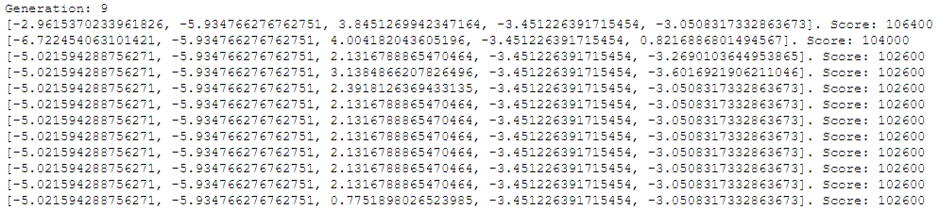

Test Results

* Score: 136600
* Pieces: 600
* Chromosome:

**[2.267276308367965, -2.295426131194769, -0.023305390559922756, -1.9415914736182591, -8.095768479075492]**