Workout Tracker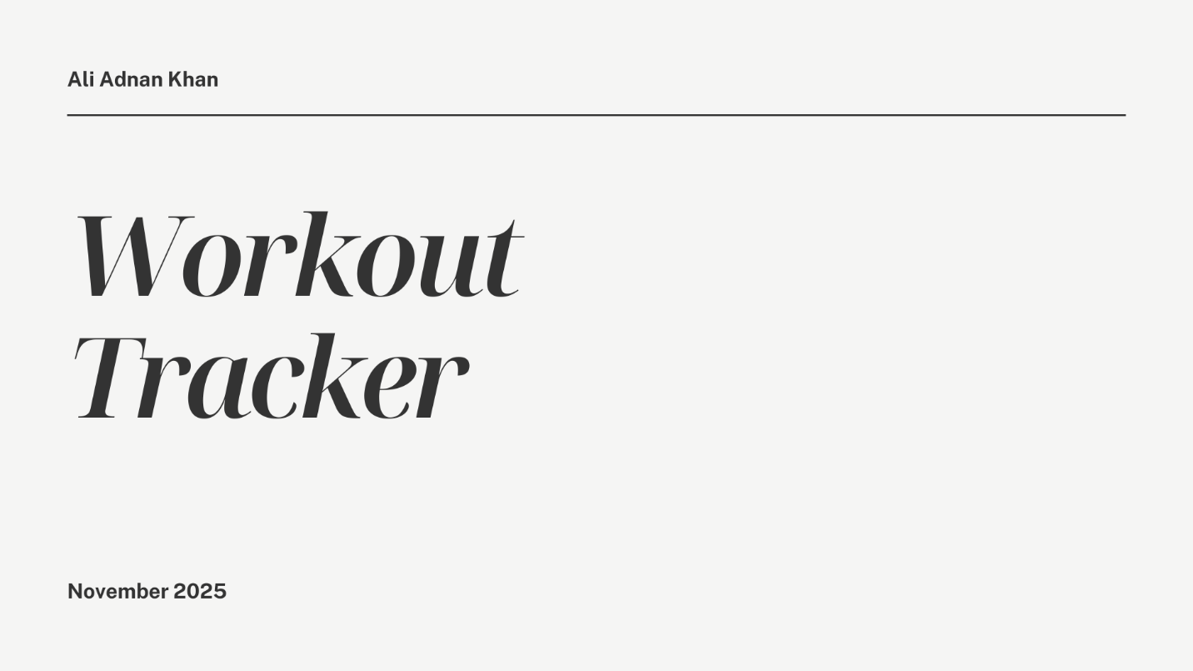
The workout tracker tracks your workouts, using several attributes that you would use anyways to track them, but this makes them easy to view and keeps them safe.
Attributes:
Workout Name:
Description:
Duration:
Sets:
Reps:
Date:

