Homework 1

Question 3

*Select a node on the Discovery Cluster and report the following information about that node:*

After running the secure shell command and once in the login command line of the Discovery cluster, we first run the command “srun --pty /bin/bash” to access one node in the Discovery Cluster.

1. *The CPU model*

To access the CPU information of the node, we run the commant “lscpu”, which returns the following information:

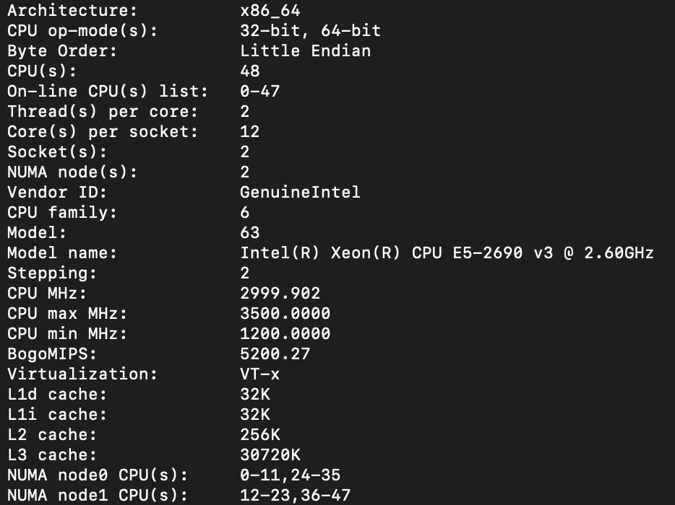

Figure 1: Node information

Where we can observe the CPU model: Intel® Xeon® CPU E5-2690 v3 @ 2.60GHz

1. *The cache memory hierarchy, including the size and associativity*

From Fig.1 we can also observe the cache memory hierarchy and size, consisting in 4 levels:

* L1d (32KB)
* L1i (32KB)
* L2 (256KB)
* L3 (30720KB)

If we run the command “getconf -a | grep CACHE” we obtain the following information:

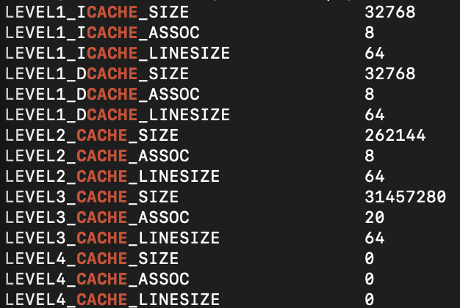

Figure 2: Cache information

From Fig. 2 we observe that cache memories L1i, L1d and L2 have 8-way associativity, whereas L3 have a 20-way associativity. A higher associativity of the cache would bring a higher probability of a cache hit at the expense of performance, since there are more addresses to check.

1. *The main memory size of this node.*

With the command “ free –mega” we can determine the amount of memory dedicated to this node:



Figure 3: Main memory size of the node

From Fig. 3 we see that the allocated node has a total memory size of 128GB approximately.

1. *The version of Linux installed*

Using the command “cat /etc/os-release” we obtain the output displayed in Fig.4. From there, we observe that the Linux version is “CentOS Linux release 7.9.2009 (Core).

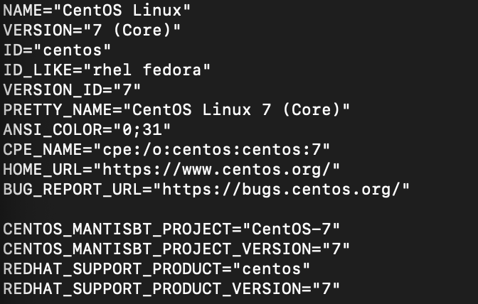

Figure 4: Linux version