Homework 4

Question 1

*Develop a simple MPI program using C/C++ and OpenMPI that uses at least 2 nodes on Discovery and utilizes at least 16 processes on each node (a minimum of 32 processes in total). You are suggested to use the sample batch script provided on Canvas for specifying your OpenMPI configuration and running your program.*

1. *Start with an integer variable that you will pass to each process, where process 1 prints the value, increments the value by 1, and sends it to process 2. Process 2 prints the value, then increments the value by 1 and sends it to process 3. Repeat this for all 64 processes. When performing printing, print both the integer value, as well as identify which process is printing, and on which node this process is running on.*

Code for this part of the assignment is included in the file “*Q1a.c”* and can be executed by running the “*Q1a.script”* file. The results obtained are reported in Figure 1.

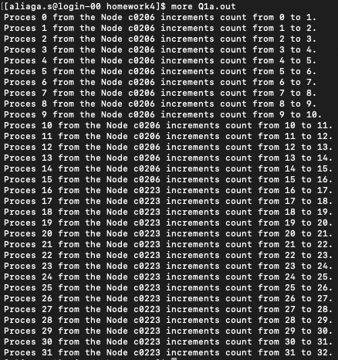

Figure 1: Results of the count to 32 with OpenMPI

1. *Next, continuing the printing, but once the value gets to 64, decrement the value, and continue to print out the value until the decremented value is zero.*

Code for this part of the assignment is included in the file “*Q1b.c”* and can be executed by running the “*Q1b.script”* file. The results obtained are reported in Figure 2.

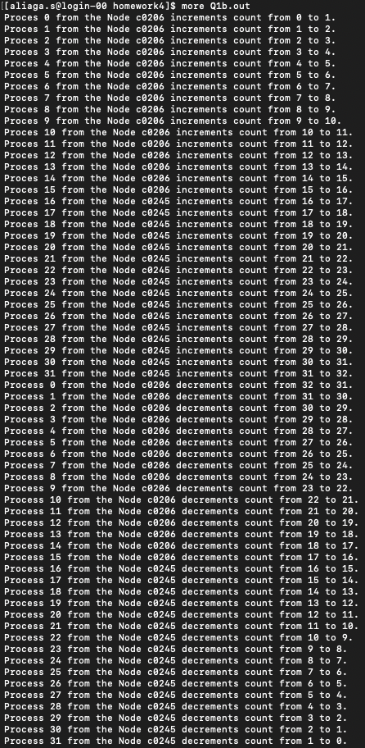

Figure 2: Results of the count to 32 and posterior decrement with OpenMPI