Homework 4

Question 3

*Performance analysis of MPI applications has been an active area of research. There have been many performance tools developed to support performance MPI applications. Please identify two of these frameworks and compare and contrast the capabilities of the toolsets you have selected. Make sure to cite all your resources. Please do not copy text out of user guides when you discuss the frameworks.*

The first identified testing tool for MPI is the MPI Testing Tool ([MTT](https://www.open-mpi.org/projects/mtt/)), provided by the Software in the Public Interest non-profit organization, which also holds Open MPI as an Associated Project. As the official testing tool for Open MPI, MTT is used to determine whether MPI can be successfully installed, compiled, and executed in the system under test.

The second identified framework is an open source project created by the Bristol, UK based company Stack HPC and can be found [here](https://github.com/stackhpc/hpc-tests). This framework offers different testing applications to evaluate the performance in multiple benchmarking options. The different benchamrks ar summarized in what they call a “test matrix”, included in Fig.1:

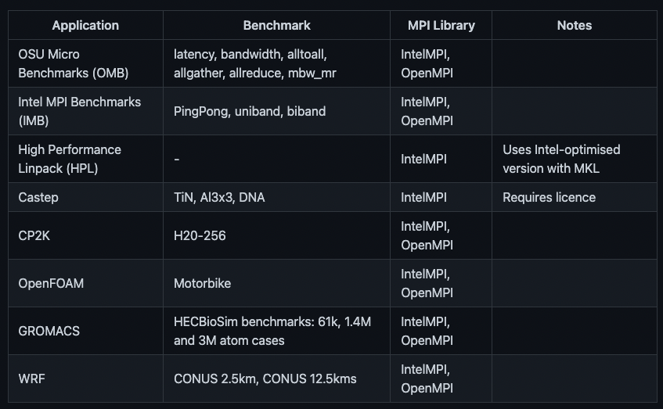

Figure 1: Test matrix of the Stack HPC testing framework for MPI