POV Big Data: Data-Driven City Management

Ali Gowani, Ksenia Luu, Anna Zink

**Summary:**

The city of Amsterdam can be thought of as having a scandalous reputation, often associated with drugs and the red-light district. However, Amsterdam is on a quest to become a smart city, which will hopefully elevate their reputation and improve the lives of their residents and visitors. The concept of a smart city isn’t very well defined, but it is broadly accepted as being the integration of information technology with city services. “Big Data” certainly would be considered as a key enabler to the success of a smart city, but it turns out this isn’t necessarily the case.

“Big Data” has gained a reputation for being a “buzzword,” with many organizations wishing to harness the proclaimed power, but few actually being able to deliver. In fact, the amount of data required to generate value is not as big as once assumed. Having the right data in an appropriate state to be analyzed is key. That’s exactly the first thing the CTO of Amsterdam, Ger Baron, decided to do, by wrangling the 12,000 datasets across 32 departments into a usable format, to be digested by the machine learning or deep learning algorithms. Baron says “analytics don’t have to be focused on big data to help cities be smarter. The analytics can use small data, as long as it points toward better ways to help citizens.”

The now 10-year-old initiative has launched well over 80 projects, many of which would not be possible without a solid foundation of structured data, and one that can keep up with the lightning speed at which data is generated today.

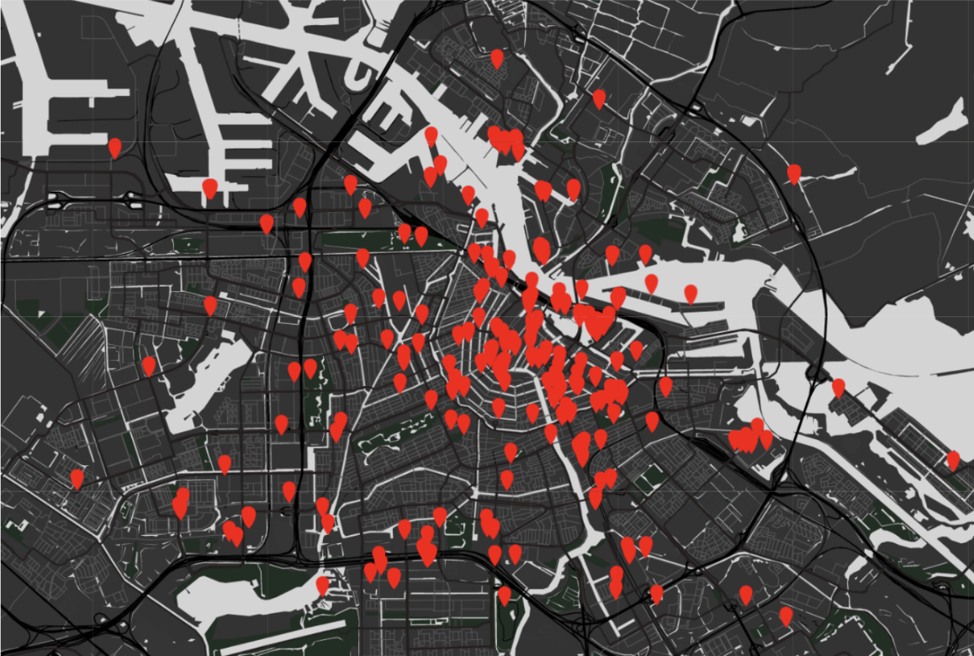

**Analysis:**

Today, the concept of “big data” is often viewed as a necessity for companies to grow, innovate, and even gain competitive advantage. Technology giants like Google and Amazon have shown the world their successes in utilizing big data. What most do not realize is that big data comes with big responsibility and that it is more important to have the right data rather than all of the data.

**Figure 1: Active Smart City Projects in Amsterdam.**

**Infrastructure:**

Big data requires a robust infrastructure that most organizations do not have. This infrastructure takes time, money, and often external resources to build and manage. Smart Lighting project mentioned in the case study describes how important it is to fully understand the infrastructure needed before taking steps forward. City officials thought that it would be easy to utilize traffic pattern data along with smart-light LED technology to reduce energy use across the city in low traffic areas and times. However, they did not account for the fact that it would take manpower to manually replace 150,000 bulbs across the city along with the cost of LED devices to enable wireless connection. Even though this project seems simple, the city did not have the infrastructure in place to execute. Big data can be useful in solving complex problems and improving operations, but it is usually just a small piece of the bigger picture. It is important to understand the full scope of what you are trying to accomplish and if it is feasible with the current infrastructure.

**Security:**

Big data can not only be used to improve our lives, but also cause us harm if it ends up in the wrong hands. Storing data comes with a big responsibility of protecting it. Big data is much harder and more costly to store and protect and it is imperative that only the right people have access. Amsterdam city officials quickly learned their lesson when they decided to launch a crowdsourcing project called Apps for Amsterdam that would challenge app developers to use publicly available data to create applications that would benefit the city. However, they did not realize that not all developers had the most pure intentions. The data was used to build a Burglar app to show which houses are the most favorable for burglaries. Big data is very powerful but comes with a great responsibility of having the resources to protect it.

**Ethics:**

Without clear laws and guidelines for the usage of big data, it can be easy to lose sight of when utilization of certain data can become an invasion of privacy. The line between ethical and unethical use of data is nebulous and it is usually up to the organization harvesting the data to make the right call. A project mentioned in the case study outlined a municipal campaign to encourage children to eat more vegetables. To evaluate the program's impact the city leveraged grocery store data to see whether people were buying more vegetables. The idea is that by accessing this data, it allows the city to measure impact much quicker than having to wait a few years to see the impact on childhood obesity. However, they did not take into account that they would be using citizen shopping behavior data to make decisions which could potentially affect the allocation of the city budget. Tax money from citizens are used to derive the city budget. Would the public always consent to how their data is used by the city? It is a fine line between using data to benefit the citizens versus overstepping the privacy boundary.

**Conclusion:**

Our research on the successes and lessons learned in the Smart City initiative by Amsterdam, clearly outlines areas for us to consider in our team-based project: analysis, infrastructure, security and ethics. However, one thing is for certain, we do not need to harvest large amounts of data to make a meaningful impact in the Dow Chemical Company. We should focus on leveraging existing data and use multiple proof-of-concept projects in order to learn from these projects and adjust to meet the needs of our stakeholders. Lastly, we should make it clear to our stakeholders that this is a journey and as Baron says, “...we’re very much as a starting point of the transformation.”

**References**

M. Fitzgerald, “Data-Driven City Management,” MIT Sloan Management Review, May 2016.

<http://marketing.mitsmr.com/PDF/57470-MITSMR-EY-Amsterdam-Case.pdf>

Wessel, Maxwell. “You Don't Need Big Data - You Need the Right Data.” *Harvard Business Review*, 21 Apr. 2017, <https://hbr.org/2016/11/you-dont-need-big-data-you-need-the-right-data>.

How Amsterdam Smart City aims to shape the city of the future. (n.d.). Retrieved October 26, 2019, from <https://crowded.co/blog/case-studies/amsterdam-smart-city>.