## Ali Ahdab

## Homework Week 2

## Step 1: Command Line

1. Research how to create a hidden file and how to display it using ls command.

To create a hidden file:

We use **touch .filename** then we have created a file in the location where we were.

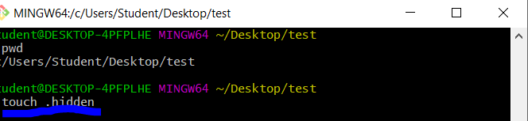

To display a hidden files.

We use the command ls -a

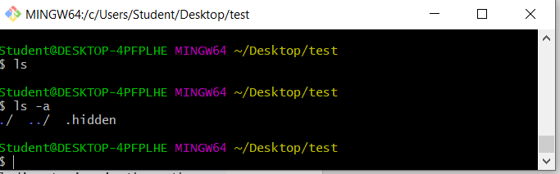

Note: ls command does not give us any result.

2. Research how to create multiple nested directories with one mkdir command.

We use mkdir -p directory name/ dir1/dir2/dir3

The -p flag tells the mkdir command to create the main directory first if it doesn’t already exist , and then write the subdirectories name followed by /.

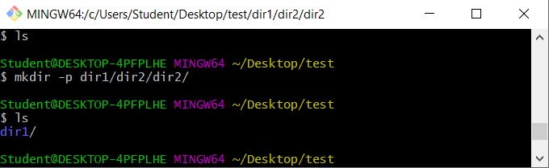

3. Execute following commands terminal:

echo "test" > fun

echo "another test" >> fun

wc -c fun

Verify number of characters in the file.

We see first > write a word test in the file fun, but second command >> has appended

Another test in a new line to the text we have in the file, and the characters are 18.

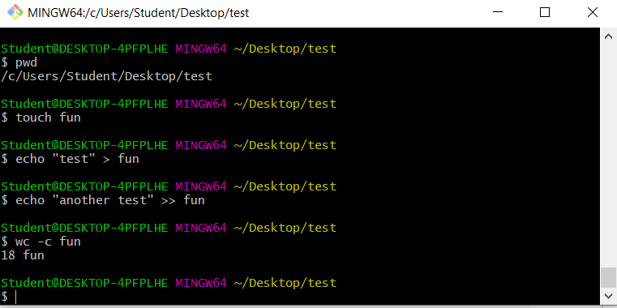

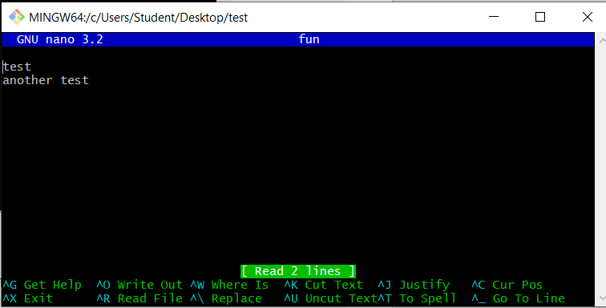

4. Research how to append something in the file *WITHOUT* a newline character.

E.g.

echo "test" > fun

echo "another test" >> fun

cat fun

Output of "cat fun" is

test

another test

How would you use echo command, so that output would be:

testanother test

