**Advanced techniques for using Redux with React JS, such as using Redux DevTools or Redux Toolkit**

Redux is a popular state management library used for managing the state of an application in a predictable way. It is widely used with React JS, but it can be used with any other JavaScript library or framework. In the first part of blog, we will explore some useful tips for working with Redux in React JS and then we will see some technical issues regarding Redux in React JS.

**1. Use Redux DevTools Extension**

Redux DevTools is a browser extension that provides a powerful debugging tool for Redux. It allows you to view the current state, track actions, and see how the state changes over time. You can also time travel through the state history to see how the application behaved at any point in time.

To use the Redux DevTools Extension, you need to install it in your browser and add the extension to your Redux store. Here’s an example of how to add the extension:

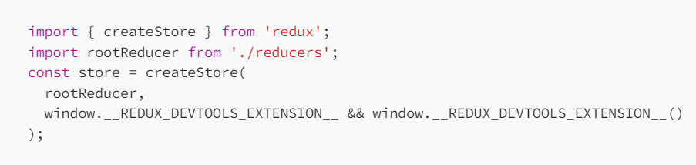

**2. Use Redux Toolkit**

Redux Toolkit is a set of utilities that simplifies the process of working with Redux. It provides a standardized way of writing Redux code and reduces boilerplate. With Redux Toolkit, you can create a store, create reducers, and dispatch actions without writing a lot of code.

To use Redux Toolkit, you need to install it in your project and create a slice. A slice is a collection of reducers, actions, and selectors that work together to manage a specific part of the state. Here’s an example of how to create a slice:

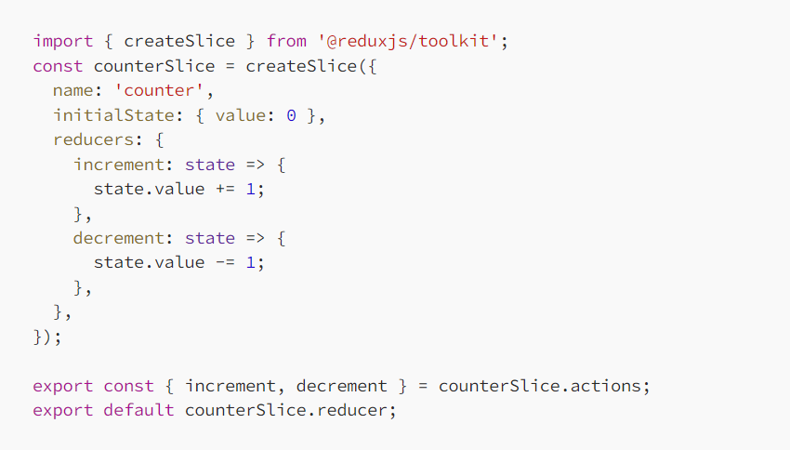

**3. Use Selectors to Access the State**

Selectors are functions that extract a specific part of the state from the Redux store. They provide an easy and efficient way to access the state in your components without having to worry about the structure of the state.

To use a selector, you need to define it in your Redux store and call it in your component. Here’s an example of how to define and use a selector:

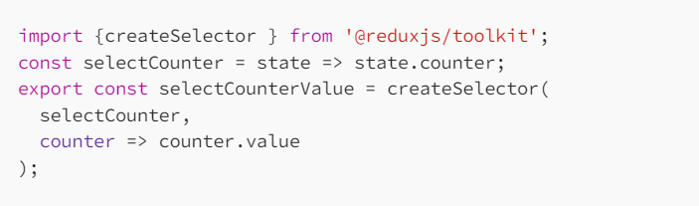

In your component, you can use the selector like this:

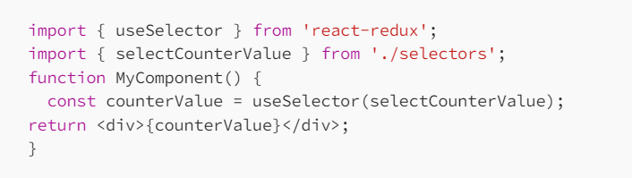

**4. Use Redux Thunk for Asynchronous Actions**

Redux Thunk is a middleware that allows you to write asynchronous actions in Redux. It provides a way to dispatch actions that return functions instead of objects. This is useful for making API calls or other asynchronous operations.

To use Redux Thunk, you need to install it in your project and add it to your middleware. Here’s an example of how to use Redux Thunk:

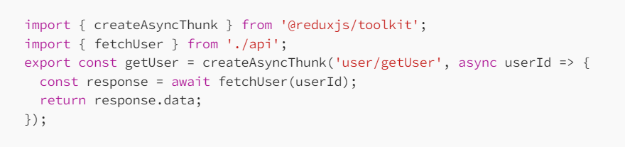

**5. Use Reselect to get optimization**

Reselect provides a memoization technique that optimizes selectors by caching their results. This means that if a selector is called with the same arguments, the cached result is returned instead of recomputing the value. This can significantly improve the performance of your application, especially when dealing with large or complex state trees and prevent unnecessary re-renders of components.

Here is an example of how to use Reselect with Redux in a simple counter application:

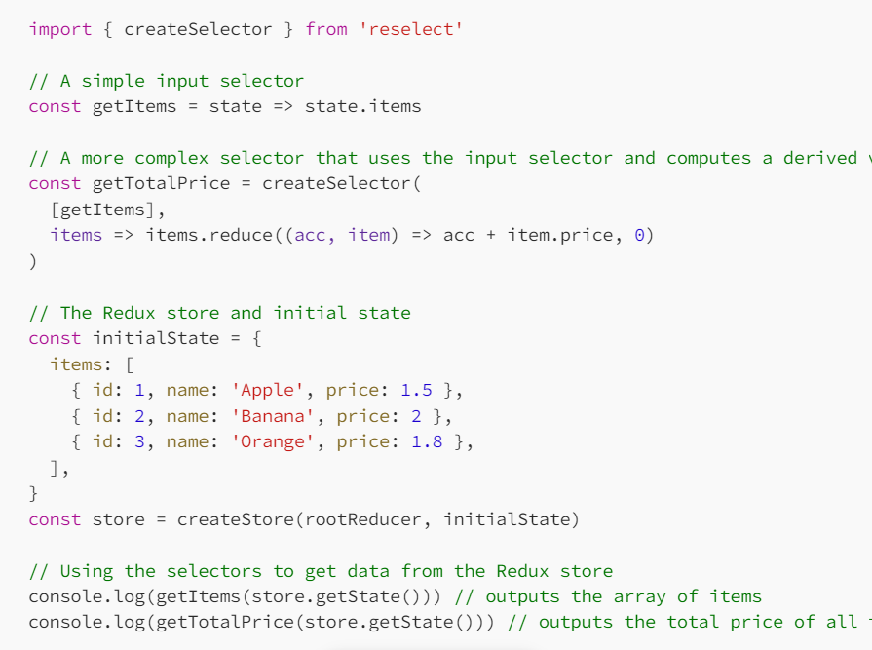

**6. Use Redux Saga for more efficiency**

Redux Saga is a middleware library for Redux that allows you to handle side effects such as asynchronous API requests and impure operations in your Redux application in a more efficient and manageable way. It uses generator functions to write asynchronous logic, which makes the code easier to read and test.

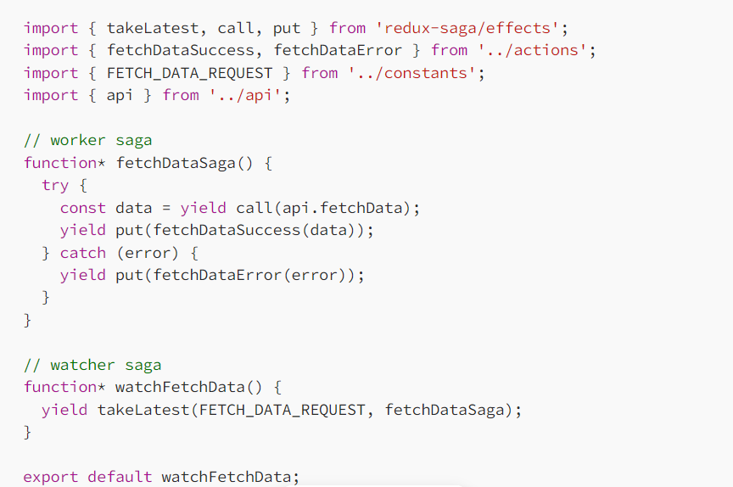

While Redux is a popular state management library for React and other JavaScript applications, there are several technical issues that can arise when working with it. Here are some of the common technical issues in Redux:

**1. Overly complex state structure**

One of the most common issues in Redux is having an overly complex state structure. When the state tree is too complex, it can make it difficult to manage the state and write efficient selectors.

To address this issue, you can simplify your state structure by breaking it down into smaller, more manageable pieces. This can be done by using multiple reducers, using nested objects to represent different parts of the state, and using selectors to extract only the data that you need.

**2. Boilerplate code**

Redux can require a lot of boilerplate code, especially when defining actions and reducers. This can make it difficult to write and maintain Redux code.

To address this issue, you can use a library like Redux Toolkit. Redux Toolkit provides a set of tools that simplify the process of writing Redux code, including creating reducers and defining actions.

**3. Performance issues**

When working with large or complex state trees, Redux can sometimes cause performance issues. This is because every time the state changes, all connected components are re-rendered.

To address this issue, you can use memoization techniques to optimize your selectors and prevent unnecessary re-renders. You can also use tools like Reselect to create memoized selectors that only recompute when their inputs have changed.

**4. Asynchronous actions**

Redux is primarily designed for synchronous actions, but many applications require asynchronous actions like making API calls. Handling asynchronous actions in Redux can be complex and require additional middleware.

To address this issue, you can use middleware like Redux Thunk or Redux Saga to handle asynchronous actions in Redux. These middleware libraries provide additional functionality for handling asynchronous actions, including handling loading states and error handling.

**5. Testing**

Testing Redux code can be challenging, especially when dealing with complex state trees and asynchronous actions.

To address this issue, you can use testing frameworks like Jest and Enzyme to write unit tests for your Redux code. You can also use tools like Redux Mock Store to mock your Redux store and simulate actions and state changes. Additionally, you can use the Redux DevTools Extension to debug and test your Redux code in the browser.

**Conclusion**

In conclusion, Redux is a powerful state management library that can greatly simplify the process of managing and sharing state in your React applications. By keeping your state in a single, centralized store, Redux can make it easier to debug and test your application, and also enable features like time-travel debugging and hot-reloading.

While Redux can have a bit of a learning curve, it is definitely worth taking the time to understand its key concepts and how it can be used in conjunction with React. Additionally, there are a number of useful tools and libraries that can help make working with Redux even easier, such as the Redux DevTools and Redux Saga.

Overall, if you’re building complex applications with React, Redux is definitely worth considering as a way to manage your application state in a more organized and efficient way.