

DIGITAL MARKETING

ASSIGNMENT 1



aLI AHMAD JAN

19I0572

# Digital Marketing:

Buying and selling of goods and services through internet is called digital marketing

# Digital Channels:

Digital channels refer to the various ways in which businesses can reach and interact with their customers through the use of digital technology. Some common digital channels include:

* Social Media
* Influencer Marketing
* Content Marketing
* Email Marketing
* Search Engine Optimization (SEO)
* Pay-per-click (PPC)
* Affiliate Marketing
* Mobile marketing
* Marketing Automation Platforms
* Marketing Analytics Platforms

# Selected Local Firm:

Exports Leftovers (elo)

# Motive:

Selling exported goods which are left overs in factory direct prices. They give free shipping on orders over Rs. 1499.

# Target Audience:

Elo’s audience is **70.61% male** and **29.39% female**. The largest age group of visitors are 25 - 34-year-olds. They have vast collection of products in Men’s fashion, Women’s fashion, Kid’s fashion, Home Textile, Food and Groceries, Home Decor, Kitchen and appliances and Electronics.

# Elo’s Digital Channels:

* Social Media
* Search Engine Optimization (SEO)
* Website
* Mobile Application
* Influencer Marketing

# Samples:

## Social Media

Elo’s main and major marketing has been done on social media where they have connected with their target audience to build their brand, increase sales and provide best services to customers. Social media apps such as Facebook and Instagram are widely popular and **elo** has used these platforms to promote their products.

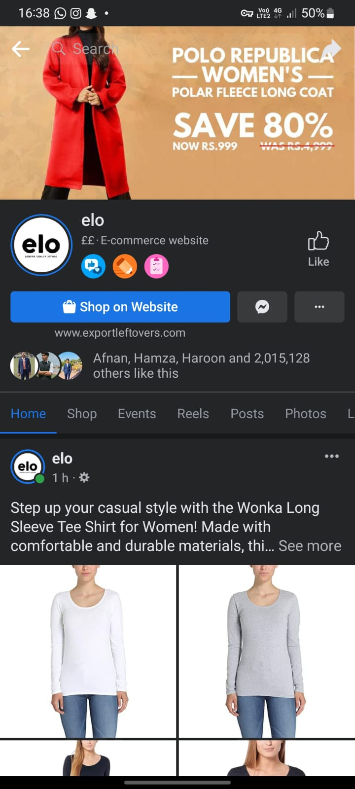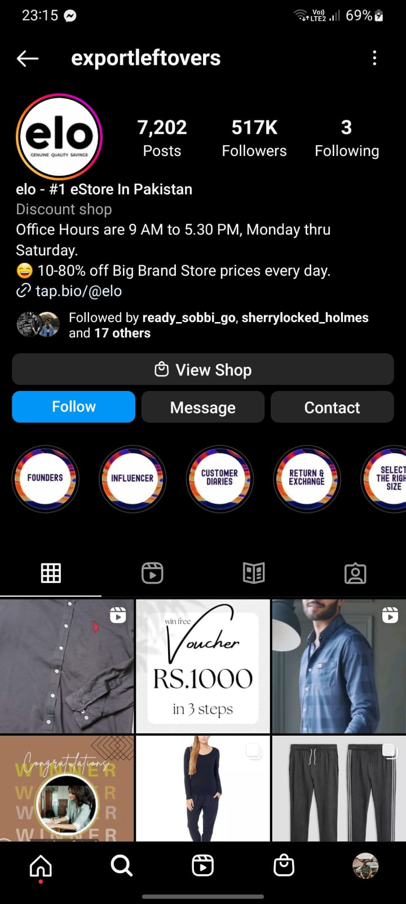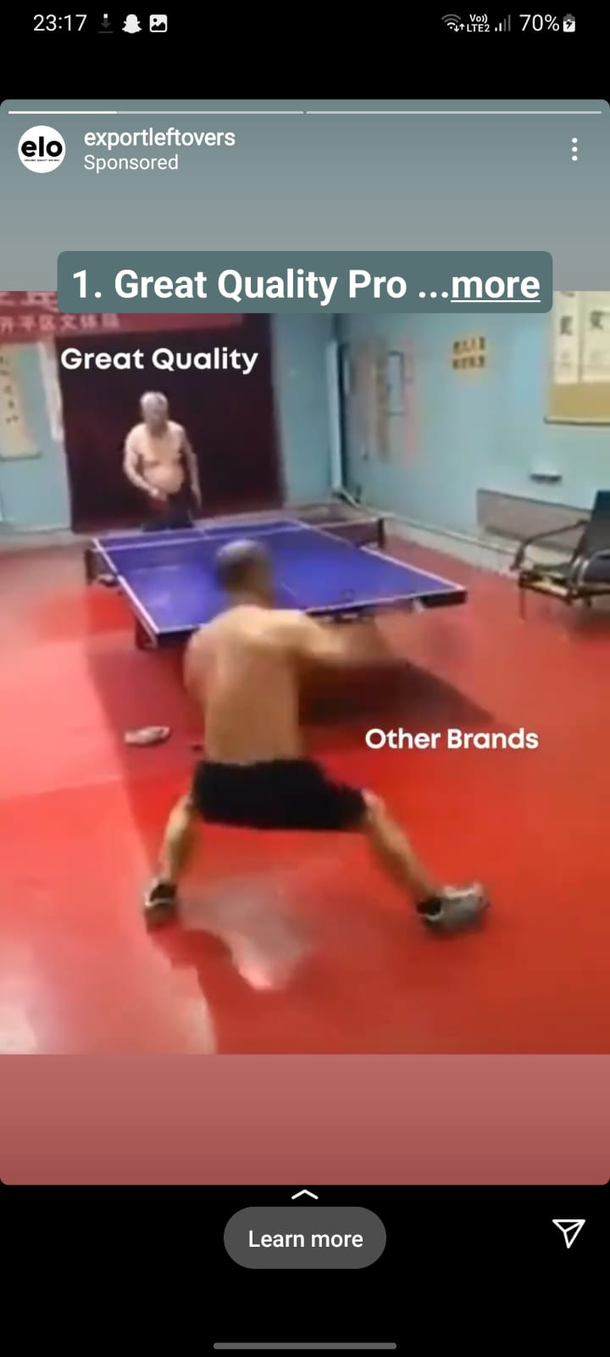

## Search Engine Optimization (SEO)

Elo has also practiced the use of orienting their website to rank higher on a search engine results page (SERP).

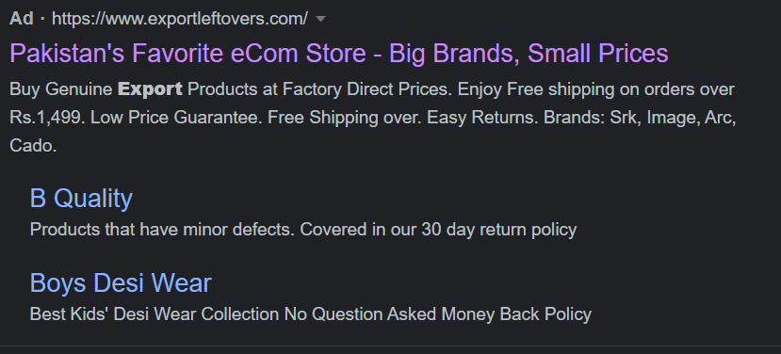

## Website

Elo has promoted their website and has attracted a large number of potential customers to buy. They have made their website top notch which can been seen by the quality and user experience of the website.

<https://www.exportleftovers.com/?tw_source=google&tw_adid=&tw_campaign=17364469084&gclid=CjwKCAiA3KefBhByEiwAi2LDHOVe6Ht5pGQ5yghaAVw1_OIITgoF7HMfeAUcFYQ1F5uZ5TZ19KTaLBoCH1MQAvD_BwE>

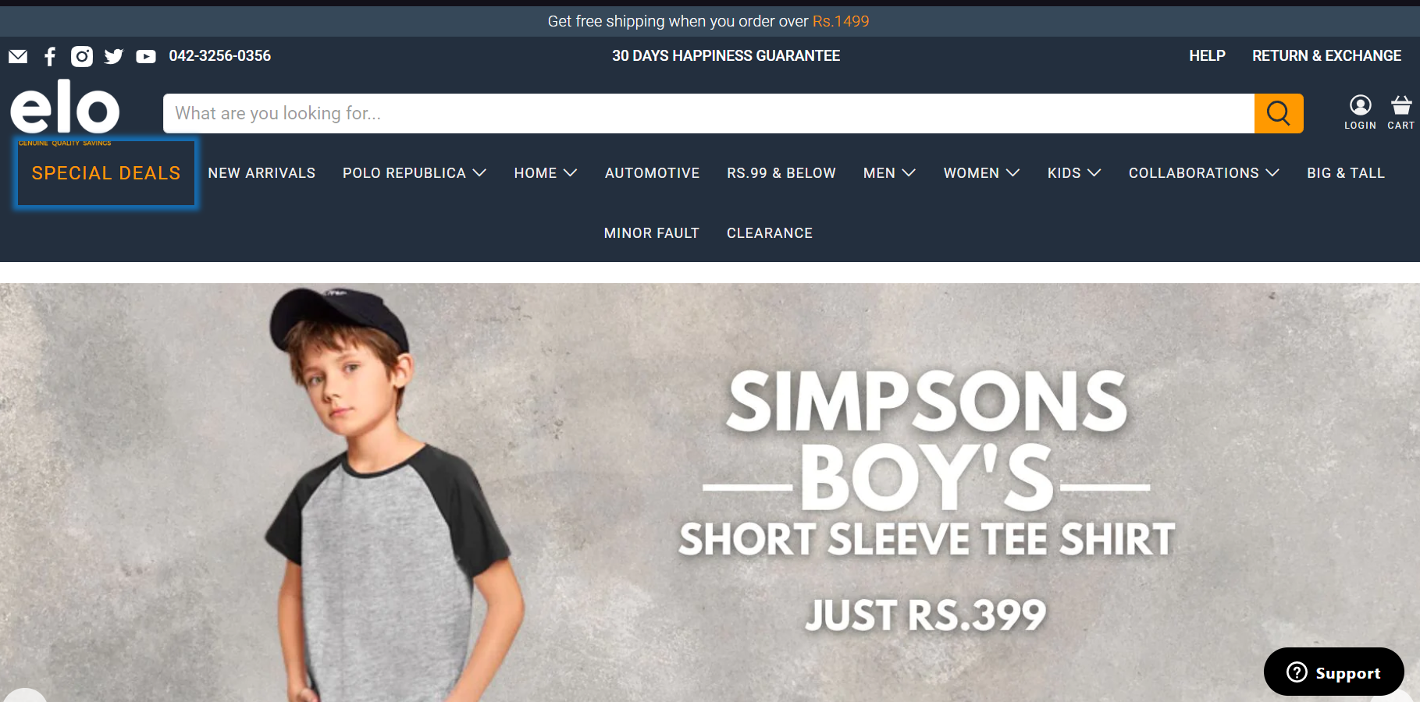

## Mobile Application

Elo has also made their mobile application and promotions and advertisements are also done through mobile application.

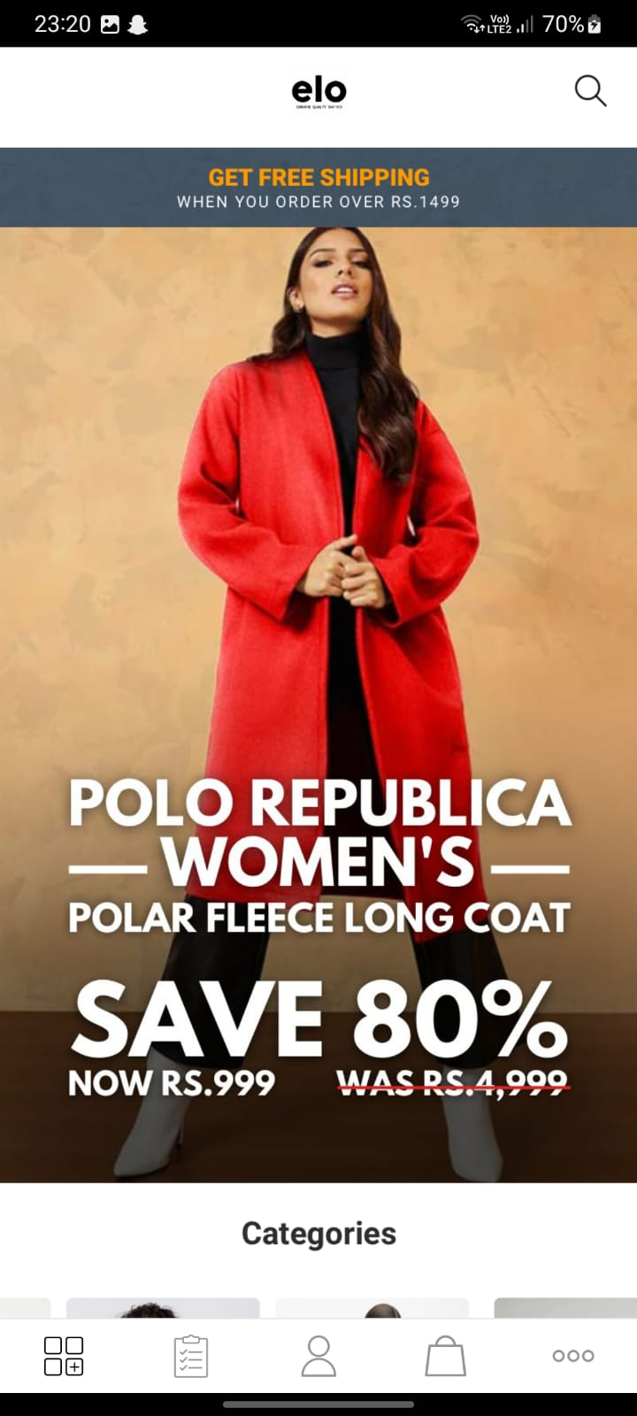

## Influencer Marketing

Elo collaborated with online influencers to market products or services. They collaborate with influencers to get brand recognition and promote their brand. They collaborated with **Arzu Fatima** who is a digital creator on social media (Instagram and facebook)

