<!--

Bootstrap 5 Containers

You learned from the previous chapter that Bootstrap requires a containing element to wrap

 site contents.

Containers are used to pad the content inside of them, and there are two container classes

 available:

The .container class provides a responsive fixed width container

The .container-fluid class provides a full width container, spanning the entire width of

 the viewport

 -->

## Fixed Container

Use the .container class to create a responsive, fixed-width container.

Note that its width (max-width) will change on different screen sizes:

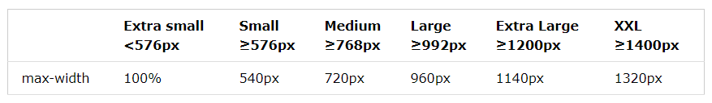Open the example below and resize the browser window to see that the container width will change at different breakpoints:

<div class="container">  
  <h1>My First Bootstrap Page</h1>  
  <p>This is some text.</p>  
</div>

The XXL breakpoint (≥1400px) is **new** in Bootstrap 5, while the largest breakpoint in Bootstrap 4 is Extra large (≥1200px).

## Fluid Container

Use the .container-fluid class to create a full width container, that will always span the entire width of the screen (width is always 100%):

<div class="container-fluid">  
  <h1>My First Bootstrap Page</h1>  
  <p>This is some text.</p>  
</div>

## Container Padding

By default, containers have left and right padding, with no top or bottom padding. Therefore, we often use **spacing utilities**, such as extra padding and margins to make them look even better. For example, .pt-5 means "add a large **top padding**":

<div class="container pt-5"></div>

## Container Border and Color

Other utilities, such as borders and colors, are also often used together with containers:

<div class="container p-5 my-5 border"></div>  
  
<div class="container p-5 my-5 bg-dark text-white"></div>  
  
<div class="container p-5 my-5 bg-primary text-white"></div>

## Responsive Containers

You can also use the .container-sm|md|lg|xl classes to determine when the container should be responsive.

The max-width of the container will change on different screen sizes/viewports:

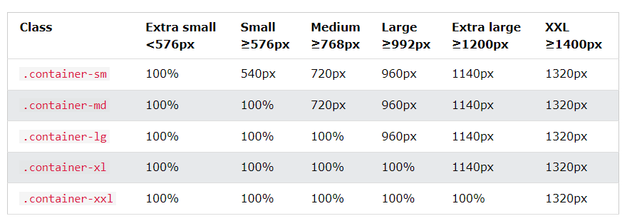<div class="container-sm">.container-sm</div>  
<div class="container-md">.container-md</div>  
<div class="container-lg">.container-lg</div>  
<div class="container-xl">.container-xl</div>  
<div class="container-xxl">.container-xxl</div>