Step1: Create your account on Heroku.
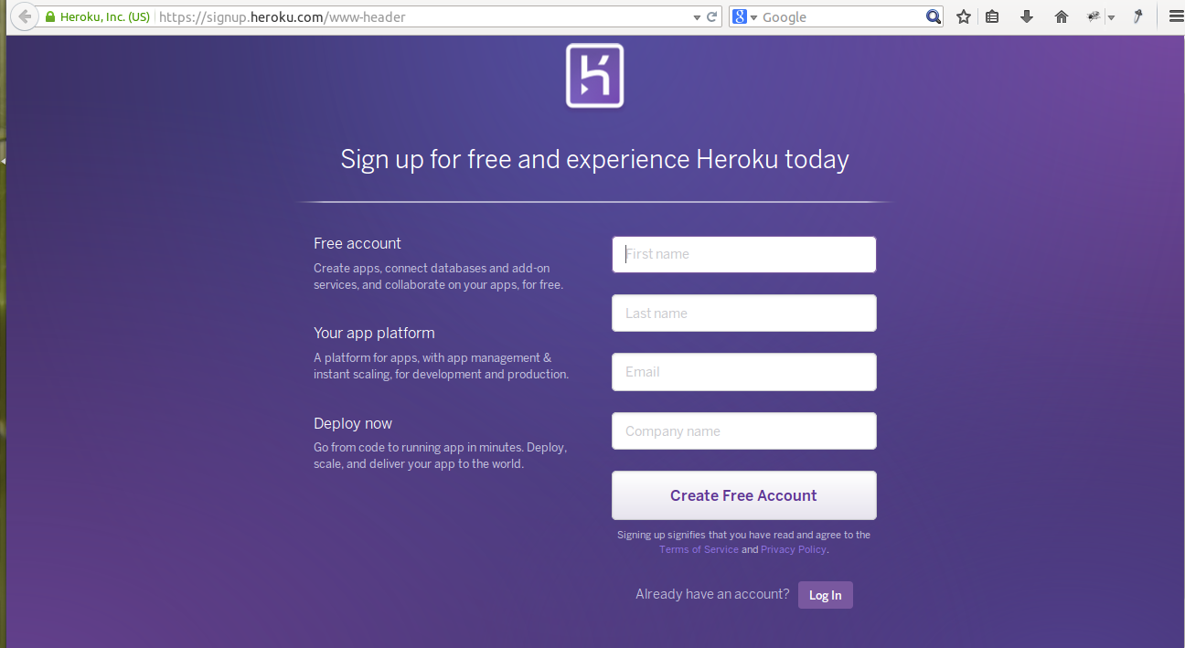

Step2: In this step you will install the Heroku Toolbelt. This provides you access to the Heroku Command Line utility, as well as git and Foreman, tools you’ll use in later steps.

# Run this from your terminal:
# Please ensure that you have Ruby installed.
wget -qO- https://toolbelt.heroku.com/install-ubuntu.sh | sh
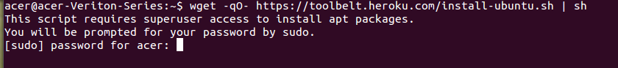

Step3: Once installed, you can use the heroku command from your command shell.
Log in using the email address and password you used when creating your Heroku account:
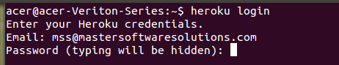

Step4: Create Application on Heroku.

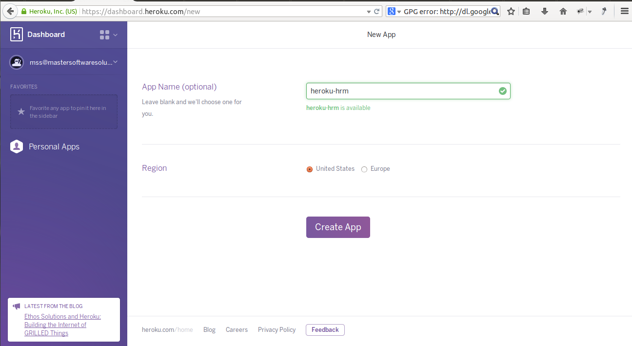

Step5: After App is created, Deploy your Application.

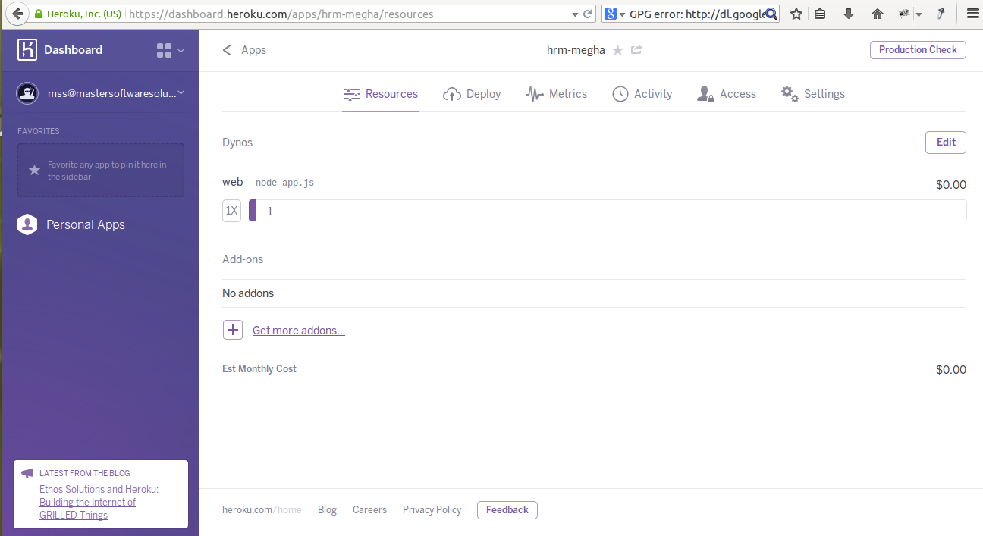

Step6: If you haven't already, log in to your Heroku account and follow the prompts to create a new SSH public key.

Step7: Clone the repository:-Use Git to clone hrm-megha's source code to your local machine.

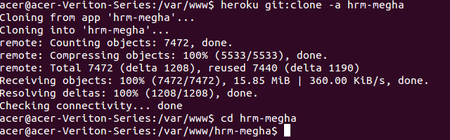

Step8: Deploy your changes:- Make some changes to the code you just cloned deploy them to Heroku using Git.
