Wearable Computers for Quantification for Lower Back Disorders

Ben Johnston

Kevin Burns

Benny Chan

Alex Dubois

**Functional System Requirements**

REVISION – Draft

30 March 2016

Functional System Requirements

for

Wearable Computers for Quantification of Lower Back Disorders

Prepared by:

_____________________________

Author Date

Approved by:

_____________________________

Project Leader Date

_____________________________

Dr. Sam Villareal Date

_____________________________

T/A Date

**Change Record**

|  |  |  |  |  |
| --- | --- | --- | --- | --- |
| **Rev.** | **Date** | **Originator** | **Approvals** | **Description** |
| **-** | [date here] | [person’s name] |  | Draft Release |

Table of Contents

Table of Figures 7

1. Introduction 8

1.1. Purpose and Scope 8

1.2. Responsibility and Change Authority 8

2. Applicable and Reference Documents 9

2.1. Applicable Documents 9

2.2. Reference Documents 9

2.3. Order of Precedence 11

3. Requirements 12

3.1. System Definition 12

3.1.1. Characteristics 12

3.1.1.1. Functional / Performance Requirements 13

3.1.1.2. Physical Characteristics 13

3.1.1.3. Electrical Characteristics 14

3.1.2. Environmental Requirements 15

3.1.3. Failure Propagation 16

3.2. Wearable Sensors 17

3.2.1. Characteristics 17

3.2.1.1. Functional / Performance Requirements 17

3.2.1.2. Physical Characteristics 18

3.2.1.3. Electrical Characteristics 19

3.2.2. Environmental Requirements 20

3.2.3. Failure Propagation 20

3.3. Motion Sensor Interface 21

3.3.1. Characteristics 21

3.3.1.1. Functional / Performance Requirements 21

3.3.1.2. Physical Characteristics 22

3.3.1.3. Electrical Characteristics 23

3.3.2. Environmental Requirements 23

3.3.3. Failure Propagation 24

3.4. Correction Unit 24

3.4.1. Characteristics 25

3.4.1.1. Functional / Performance Requirements 25

3.4.1.2. Physical Characteristics 25

3.4.1.3. Electrical Characteristics 26

3.4.2. Environmental Requirements 27

3.4.3. Failure Detection 27

3.5. Signal Processing Unit 28

3.5.1. Characteristics 28

3.5.1.1. Functional / Performance Requirements 28

3.5.1.2. Physical Characteristics 29

3.5.1.3. Electrical Characteristics 30

3.5.2. Environmental Requirements 31

3.5.3. Failure Propagation 31

3.6. Data Display 31

3.6.1. Characteristics 31

3.6.1.1. Functional / Performance Requirements 31

3.6.1.2. Physical Characteristics 32

3.6.1.3. Electrical Characteristics 33

3.6.2. Environmental Requirements 34

3.7. Display Feedback 34

3.7.1. Characteristics 34

3.7.1.1. Functional / Performance Requirements 34

3.7.1.2. Physical Characteristics 35

3.7.1.3. Electrical Characteristics 35

3.7.2. Environmental Requirements 36

4. Support Requirements 36

5. Appendix A Acronyms and Abbreviations 38

6. Appendix B Definition of Terms 39

7. Appendix C Interface Control Documents 39

7.1. Overview 39

7.2. References and Definitions 40

References 40

Definitions 40

7.3. System Interface 41

Physical Interface 41

Electrical/Communications Interface 42

7.4. Communications/Device Interface Protocols 42

Wireless Communications 42

7.5. Appendix: Subsystems Interfaces 43

Wearable Sensors Interface (Ben Johnston) 43

Motion Sensor Interface (Benny Chan) 44

Synchronization Unit Interface (Kevin Burns) 46

Signal Processing Unit Interface (Alex Dubois) 48

Data Display Interface (Alex Dubois) 50

# Table of Figures

Figure 1: System Concept Image 6

Figure 2: Block Diagram of System 10

Figure 3: Block Diagram of Wearable Sensors 15

Figure 4: Block Diagram of Motion Sensor 19

Figure 5: Block Diagram of Correction Unit 22

Figure 6: Correction Unit Flow Chart 24

Figure 7: Signal Processing Unit Flow Chart 26

Figure 8: Overall System Interface 40

Figure 9: Wearable Sensors Interface 42

Figure 10: Motion Sensor Interface 44

Figure 11: Synchronization Unit Interface 45

Figure 12: Signal Processing Unit Interface 47

Figure 13: Data Display Interface 49

# Introduction

## Purpose and Scope

This functional specification requirements document lays out the technical requirements of the overall project. Figure 1 shows a representative integration of the project in the proposed CONOPS. The verification requirements for the project are contained in a separate Verification and Validation Plan.

Figure : System Concept Image

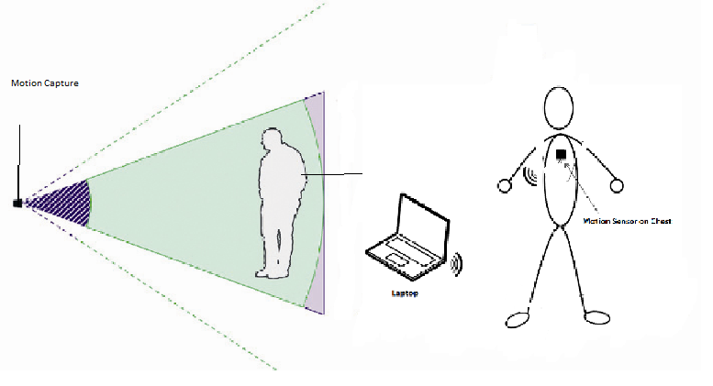

## Responsibility and Change Authority

Overall system responsibility lies with the project leader, Ben Johnston. All individuals are responsible for their respective subsystem(s). Overall system changes may be made by the clients, Dr. Marras or Dr. Jafari. Dr. Marras is the creator of the lower back disorder quantification system. Dr. Jafari is the team’s direct supervisor and mentor at Texas A&M. Subsystem changes may come from the team if approved by the project leader.

# Applicable and Reference Documents

## Applicable Documents

* **Materials Handling: Heavy Lifting**OSHA.gov
* **Thermal Comfort for Office Work**Modified: Mar 18, 2016  
  CCOHS.ca Canadian Occupational Health and Safety
* **Wi-Fi™ and Bluetooth™ - Interference Issues**Jan 2002  
  Hewlett Packard

## Reference Documents

The following documents are reference documents utilized in the development of this specification. These documents do not form a part of this specification, and are not controlled by their reference herein.

* **Systematic accuracy and precision analysis of video motion capturing systems--exemplified on the Vicon-460 system.**  
  Aug 28, 2008  
  Windolf M., Gotzen N., Morlock M.
* **Chronic low back pain patient groups in primary care – A cross sectional cluster analysis**Mar 4, 2013  
  Annika Viniol et al.
* **Some typical measurements of an average human adult figure. Harvard.**2001  
  J Michael Griggs
* **What You Should Know Before Buying a Sedan**Edmunds.com 2016 New Car buying guides
* **What is the ideal CPU temperature: how to check if your processor is too hot**  
  May 15, 2015  
  Jim Martin
* **Overview and Evaluation of Bluetooth Low Energy: An Emerging Low-Power Wireless Technology**Aug 29, 2012
* **USB 3.0 Electrical Compliance Methodology White Paper**Revision 0.5  
  2009  
  Hewlett-Packard Company et al.
* **Validation of the Microsoft Kinect as a Portable and Inexpensive Screening Tool for Identifying ACL Injury Risk**

2014

The Orthopaedic Journal of Sports Medicine

* **Evaluation of the Microsoft Kinect for Screening ACL Injury**2013

IEEE

* **Validity and reliability of Kinect skeleton for measuring shoulder joint angles: a feasibility study**

2015

Physiotherapy

* **A Feasibility Study of Using a Single Kinect Sensor for Rehabilitation Exercises Monitoring: A Rule Based Approach**

2014

Cleveland State University

## Order of Precedence

In the event of a conflict between the text of this specification and an applicable document cited herein, the text of this specification takes precedence without any exceptions.

All specifications, standards, exhibits, drawings or other documents that are invoked as “applicable” in this specification are incorporated as cited. All documents that are referred to within an applicable document are considered to be for guidance and information only, with the exception of ICDs that have their applicable documents considered to be incorporated as cited.

# Requirements

This section provides requirements for the system as a whole, as well as specific function, performance, design, and reliability requirements for the various subsystems. These requirements are the minimum to which the system should meet to maintain desired functionality.

## System Definition

The purpose of this system is to collect and process gathered data to provide quantifiable results concerning lower back disorders in patients. Motion detection and sensor networks collect movement information from specific tests, which is processed and forwarded to physicians for review and analysis.

Figure : Block Diagram of System

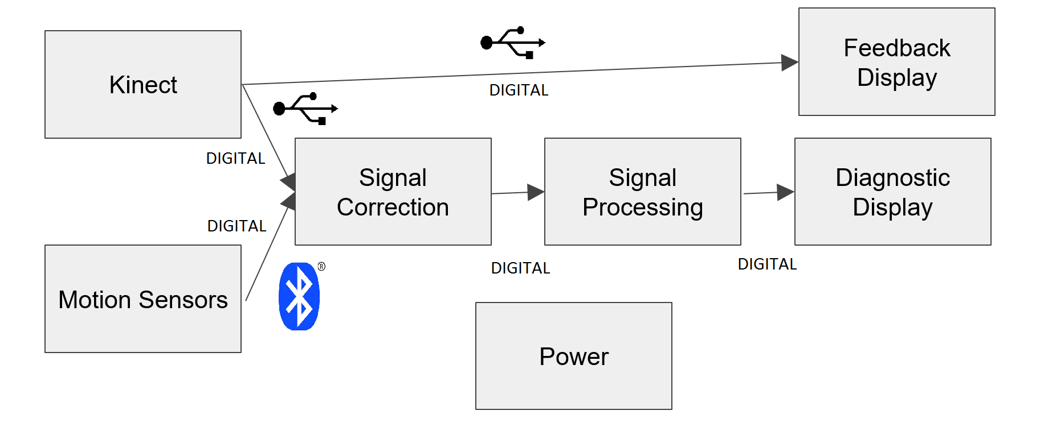

The stimulus to the entire system comes from two sources, the motion capture Kinect system and the wearable motion sensor network. These sources will feed digital signals via USB and Bluetooth into a personal computer for the duration of data processing. The signals will first be corrected for any sensor drift error, as well as synchronized to a relative time point. These corrected digital signals will then be passed into signal processing for calculation, before passing the diagnostic data to the output display. Error detection will also be accomplished via the Kinect system by providing an output to a feedback display.

## Characteristics

### Functional / Performance Requirements

#### Precision of Quantified Disorder Severity

The numerical value produced by the system to quantify the severity of the lower back disorder should be within 10% of an established control value throughout repeated experiments.

*Rationale: This value comes from the error factors in the hardware used, as well as variance from human error when repeating experiments, as perfectly repeated physical motion cannot be expected.*

#### Time Sensitivity

The system is required to collect, process, and output diagnostic data within a time window of no more than five minutes.

*Rationale: Time sensitivity is important in real world applications, so the system should produce results in a relatively short amount of time. The current system tested by the customer produces results in around this time period, so improving upon this is a primary objective of this project.*

### Physical Characteristics

The physical requirements are listed below, including mass, volume, and mounting locations.

#### Mass

The mass of this system revolves around the ability for the system to be portable. Each part of the system should weigh no more than 22.68 kg to keep this portability.

*Rationale: This requirement is specified in reference to OSHA guidelines concerning two man lifts. By staying below this value, this system will be moveable by a single person if needed.*

#### Volume Envelope

The system volume requirement is also determined with portability in mind. The total system components should not exceed .283 cubic meters in volume

*Rationale: A volume of .283 meters is on the low end of average trunk spaces in sub-compact sedans according to Edmunds.com. By maintaining a smaller volume than this standard, portability is ensured.*

#### Mounting

No part of the system should be mounted above two meters. Detailed information about system mounting can be found in each subsystem section, as well as the ICD in appendix C.

*Rationale: Mounting equipment above two meters could yield increased risk of injury due to falling objects, as well as decreased functionality to specific subsystems, detailed more below.*

### Electrical Characteristics

#### Inputs

The only electrical inputs to the overall system is the power input. This input varies depending on the device, but most devices are run or charged through devices that take input power of 120 V AC, 60 Hz standard NEMA wall socket.

##### Power Consumption

The maximum peak power for the system shall not exceed 300 watts.

*Rationale: This should be the maximum power draw by the laptop computer selected to operate as the PC in this system.*

##### Input Voltage Level

The input voltage level for this system varies largely depending on subsystem requirements. It may vary from 3.7 VDC to 120 VAC.

*Rationale: The wearable electronics draw smaller input voltage levels, while the PC being used may draw much larger.*

##### External Commands

The system should have external command to start the program.

*Rationale: The system should not need outside stimulus once it has been initiated to complete the required test.*

#### Outputs

##### Data Output

The system will give output data in format readable by trained medical personnel. System output data should also be in similar format to established databases to provide ability to cross reference.

*Rationale: Dr. Marras has developed a database through years of study in this field that would be useful to compare to.*

##### Diagnostic Output

There should be no diagnostic output of the system, as errors should be handled by subsystems.

*Rationale: Due to a variety of subsystems, integration of diagnostic tools may be dificult due to licenses, etc.*

##### Raw Video Output

This system will not support raw video to maintain appropriate frame rate and latency by the motion detection unit.

*Rationale: Processed video data will be used in display systems, but raw video would cause too much stress to the system and create delay and data loss errors.*

#### Connectors

The overall connections for this system revolve around how the inputs and outputs are attached to the physical stimulus and the process output respectively. This is detailed further in the ICD.

*Rationale: Physical stimulus inputs are through wearable sensors and Kinect, detailed in the ICD, as well as the digital output to a monitor.*

#### Wiring

The inputs to this system are not wired, as they are physical stimulus delivered to devices to transform into digital signals, though this governed by specific subsystems. The output wiring should be either HDMI, DVI, or VGA, depending on how the computers are connected to output monitors.

### Environmental Requirements

This system should operate exclusively indoors with conditions kept to standard temperature and pressure as much as possible. This is detailed further in the following sections.

*Rationale: Due to the system being used in clinical settings with valuable and sensitive technology, well regulated environmental procedures should be established. The comfort of the subject is also essential, as varying levels sweat or shivering could result in data that cannot be used in quantification.*

#### Pressure (Altitude)

Standard pressure of one atmosphere (760 torr) should be established. This would keep experimentation standard across multiple tests.

*Rationale: Values close to standard pressure should be maintained to keep consistent across tests. Different electrical properties may change slightly which could cause variation if this is not done.*

#### Thermal

Temperature ranges of 21-27 degrees Celsius should be established. This is within the operational confines of multiple subsystems, as well as the comfort of the patient.

*Rationale: Temperature is important both to electrical properties as well the patient. Excessive sweat or shivering could harm components and contaminate results*

#### External Contamination

Electrical signals that could interfere with bluetooth wireless should not be in the vicinity. This includes signals in the 2.4-5 GHz range.

*Rationale: Standard bluetooth and wireless signals run in the 2.4-5 GHz range according to HP.*

#### Humidity

Humidity levels should be no less than 40% no greater than 70%.

*Rationale: Less than 40% relative humidity could cause increased chance of static electricity build up, which could prove harmful to sensitive components. Greater than 70% increases chance for fungi buildup over time, and should therefore be a maximum for long term planning according to CCOHS.*

### Failure Propagation

Failure in a system input should result in near real-time error detection and correction from system input. Failure in the subsystems should be handled independently as detailed below in their respective sections

#### Failure Detection, Isolation, and Recovery (FDIR)

##### Built In Test (BIT)

This system has built in error detection via a subsystem. This will detect any errors made by the patient and notify them via the feedback display.

###### BIT False Alarms

The BIT shall have a false alarm rate of less than 5 percent.

*Rationale: This is a requirement given by our client.*

##### Isolation and Recovery

This system allows for each subsystem to establish an error has happened and dump that test’s results as tainted. The system would then restart that specific test in order to maintain continuity.

*Rationale: If an error has occurred, the tainted test results are not kept, but the overall experiment data is not destroyed. The test is then restarted so as not to eliminate the entire test time used. In addition, the data is permitted to be dumped without major consequence, as it is only 15-30 seconds of data and not a major time loss.*

## Wearable Sensors

The sensors to be worn on the patient are housed in two separate pieces of equipment placed on the thorax of the patient and the waist of the patient. These sensors will collect data to model the movement of the lower back and transmit that data wirelessly.

Figure : Block Diagram of Wearable Sensors

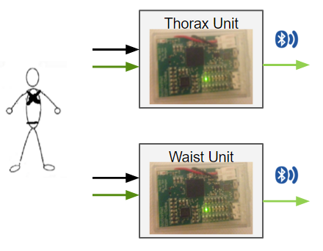

Both sensor units have inputs of the raw physical motion data they record and the power required for operation. They both output digital motion data via Bluetooth, as detailed in the following section.

## Characteristics

### Functional / Performance Requirements

#### Thorax Module and Waist Module

The sensors must be split into two separate pieces of equipment: the thorax module and the waist module.

*Rationale: Data needs to be collected from two points to model the movement of the back as one edge between two points.*

#### Sensor Data Acquisition

The sensors will track linear acceleration, angular velocity, and radial position. The sensors will do so with at absolute maximum 5% error. Error is defined relative to tests being run simultaneously with a Vicon motion capture system.

*Rationale: The 5% figure comes from the client, Dr. Marras. Dr. Marras has been developing systems similar to this for 20 years at Ohio State University, and has determined that 5% error is a sufficient guideline for still delivering accurate results.*

#### Sensor Housing Requirements

The pieces of equipment that will house the individual sensors must be lightweight, comfortable to wear, and easy to put on. Further numerical specifics listed later where relevant.

*Rationale: The average patient with musculoskeletal back disorders is 56 years old, per BioMed Central. In conjunction with the fact that the patient is experiencing lower back pain, this means that the equipment must be easy to use and not exacerbate any issues or cause the patient any additional pain, as this runs counter to the whole purpose of the system.*

* + - * 1. **Sensors Require Stability**

The sensors must fit snugly within the housing and close to the patient’s skin. The sensor must not slip more than 0.8 mm in any given direction in relation to the housing.

*Rationale: As previously stated, the error of the sensors must be no greater than 5%. An unintended movement of 0.8 mm or more may result in an angular shift of 5% and thus error of 5%.*

### Physical Characteristics

#### Weight

The weight of the thorax module will be less than 3 pounds. The weight of the waist module will be less than 1 pound. The weight of the individual sensors will be 1.5 ounces.

*Rationale: The patient must not be hindered by the wearable equipment while performing the necessary tests. More than 3 pounds on the back would appreciably alter the motion of the average adult.*

#### Volume Envelope

The thorax housing will measure approximately 14 inches in height by 18 inches in length by 10 inches in depth in total volume. The waist housing will be annular in shape, adjustable in a range of 32 inches in circumference to 40 inches in circumference. The unit will be 1.5 inches tall and, at its thickest point, 1 inch in thickness. Each 3D printed box, which houses the sensors, measures 0.71 inches in height by 1.13 inches in width by 1.60 inches in length, on the outside. The inside measures 0.61 inches in height by 1.05 inches in width by 1.57 inches in length.

*Rationale: The measurements need to fit a wide range of body shapes and are slightly larger than human size averages provided from the resources of Harvard University.*

#### Mounting

The thorax unit will be worn like a harness around the chest of the patient. The waist unit will be worn in the fashion of a belt. One sensor will be mounted on both of the physical housing modules. Both sensors will be mounted on the back of their respective modules, along the spine, in the center.

*Rationale: The sensors must be positioned in such a way that best capture the required information. Specific location has been provided by the client, Dr. Marras, based on decades of study.*

### Electrical Characteristics

#### Inputs

The only electrical input to the system is the power. Analog movement data is also recorded and discretized for digital compatibility.

*Rationale: The function of the sensors is to track physical motion data, thus the only electrical input required is the power which facilitates the operation of the device.*

##### Power Consumption

The maximum peak power for the system shall not exceed 50 milliwatts.

*Rationale: Current of the system should remain in the microamp range in order to extend battery life. The operational requirements of the sensors is not very high, therefore battery life should be a top concern when discussing power consumption.*

##### Input Voltage Level

The input voltage level for the sensors themselves will be 3.7 V DC. This will be supplied by a rechargeable Lithium-ion battery with a 400 mAh 1.48 Wh battery life.

*Rationale: 3.7 Volts will be required for all necessary sensor components. Individual tests will run for 15-30 seconds. 15-20 tests may be run per patient. Total visit length with patient may be up to 30 minutes, as specified by the client, Dr. Marras. The battery life must last for at least 4 consecutive patients, as specified by the client, Dr. Marras. This marks a bare minimum, superior battery life may be achieved.*

##### External Commands

The only external command delivered to the sensors will be on or off to the power switch.

*Rationale: The sensors will continually track information while on, and send information when connected via Bluetooth, so only an on/off switch is required to save battery life.*

#### Outputs

##### Data Output

The sensors will output a digital data signal via Bluetooth 4.0 as outlined in Appendix C: Interface Control Document.

*Rationale: The signal will be received by the signal correction unit, which is a functional block of a computer. Considering the signal is being sent to a computer it needs to be digital and not analog. The data is transmitted wirelessly because a wired system would be awkward for the patient and would appreciably alter the movement data if the patient found the wires to be uncomfortable. Bluetooth 4.0 provides a low loss, power efficient wireless data transmission system which is desirable for the project’s needs.*

#### Wiring

The only wiring within the system is to the battery and will be contained within a 3D printed capsule.

*Rationale: Exposed wires significantly decrease the wearability, a major requirement, of the sensors and will be avoided entirely.*

### Environmental Requirements

As mentioned in the system requirements, the wearable sensors will operate indoors and under the conditions laid out in that section.

#### No Loose Clothing

The patient must not wear overly loose clothing while wearing the wearable sensors.

*Rationale: Loose clothing will create unwanted additional movement between the patient’s back and the sensors. As previously mentioned that additional movement may not be greater than 0.8 mm in any direction.*

* + - 1. Unobstructed Pathway to Signal Correction Unit

The pathway to the signal correction unit must be unobstructed. This means no walls or other dividers between the two. Also, no source of appreciably large electromagnetic interference between the two.

*Rationale: Any additional interference with the signal brings the error ever close to 5%, which is when it reaches unacceptable levels. Interference should always be avoided.*

### Failure Propagation

Error of the sensors is known, as well as data loss rate of the Bluetooth transmission (outlined in the ICD). The sensors will not have any additional onboard error detection, rather known error will be dealt with in the signal correction unit.

## Motion Sensor Interface

For this sub-system, the purpose is to provide consistency in the overall system compared to the wearable sensors. This is going to capture the joint motion of the patient and provide a visual aid of the patient’s posture. As a result, we are planning to use the Kinect V2 by Microsoft since the device has an interface similar or possibly the same requirements for our purpose.

Figure : Block Diagram of Motion Sensor

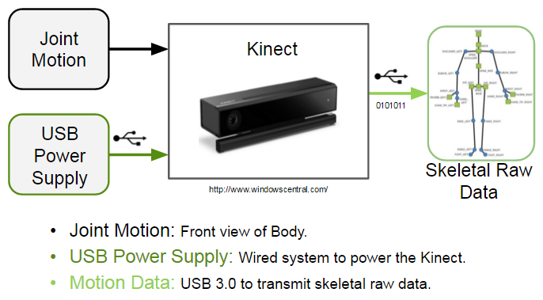

## Characteristics

### Functional / Performance Requirements

#### Requirement #1

The Kinect for the overall system should maintain a consistent tracking of the patient’s posture while performing the test.

*Rationale: We need a device that is capable of having a consistent error to provide aid for the drift correction.*

* + - * 1. **Requirement #2**

The Kinect should be positioned at a height of at least 2 or 3 feet above the ground as a maximum.

*Rationale: Standards from Microsoft*

* + - * 1. **Requirement #3**

The Kinect should be put near the edge of a flat stable surface to avoid the obstruction of the surface itself.

*Rationale: Standards from Microsoft*

* + - * 1. **Requirement #4**

The user should be positioned 4.5 to 5.5 feet away from the Kinect, depending on the body size.

*Rationale: Standards from Microsoft*

* + - * 1. **Requirement #5**

The room that the sub-system is going to be tested shall be more than 6x6 feet in area and less than 8 x 8 feet.

*Rationale: Standards from Microsoft*

* + - * 1. **Requirement #6**

The room that the sub-system is going to be tested shall have a good lighting to be able to clearly see the patient.

*Rationale: Standards from Microsoft*

#### Consistency

The Kinect shall meet a consistency of about 95% to be able to consider the hardware as a stable device for clinical use.

*Rationale: Without having a consistent device, there would not be a method to correct the drift.*

### Physical Characteristics

#### Mass

The weight of this subsystem shall be less than 5 pounds, depending on the accessories that will include for the proper function of the Kinect.

*Rationale:* The motion sensor interface (MSI) will be a Microsoft Kinect will be run in conjunction with a computer and has to be portable.

#### Volume

The dimensions shall be no more than 5.46 x 14.2 x 6.48 inches.

*Rationale: Since the Kinect is a pre-made device, it already comes with a fixed dimension and fits with our requirement for the overall system.*

#### Mounting

The Kinect shall require a tripod, or be mounted over a monitor for it to be sufficiently stable.

*Rationale: we will have to make sure that the front of the sensor is not obstructed by power cords, computer cables, or other solid objects, as well as, make sure the Kinect sensor is in a well-ventilated space for it to properly function.*

### Electrical Characteristics

#### Inputs

The Kinect will receive the movement of the patient as an input, which will be focused on the Joint movement.

*Rationale: Keep the Kinect’s bit data transfer as low as possible for the frames/second be consistent.*

##### Power Consumption

The maximum peak power and for the sub-system shall not exceed 16 watts.

*Rationale: This is a requirement specified by Microsoft.*

##### Input Voltage Level

The input voltage level for the Kinect shall be +12 VDC

*Rationale: This is a requirement specified by Microsoft.*

#### Outputs

##### Data Output

The Kinect shall output the skeletal raw data and analyze 26 joint points from the body.

*Rationale: This will be used to verify our data with the wearable sensors, which error overtime is greater and inconsistent.*

##### Raw Video Output

The Kinect unit shall include a raw video interface to support external recording.

*Rationale: Too much data to store internally. Would be used for diagnostics.*

#### Wiring

The Kinect shall following the guidelines set forth by Microsoft

*Rationale: Conform to Kinect standard.*

### Environmental Requirements

The Kinect shall withstand and operate in the environments and laboratory tests specified in the following section.

*Rationale: This is a requirements specified by Microsoft*

#### Rain

The Kinect shall not withstand areas that requires rainproof as it is going to be in a physician’s office.

#### Humidity

The Kinect shall withstand a non-humid environment for the proper functionality

### Failure Propagation

The Kinect shall not allow propagation of faults beyond the Kinect API interface.

#### Failure Detection, Isolation, and Recover (FDIR)

##### Built In Test (BIT)

The Kinect shall have a catch block that will generate an error signal whenever the patient is in a bad position.

## Correction Unit

The correction unit’s function is to take in two signals, one from the motion sensor network, and the other from the motion detection system, and ensuring the signals timestamps are lined up with one another. The correction unit also analyzes the motion sensor network signal and checks it against the motion detection system for sensor drift. If drift is detected, it is adjusted based on mathematical modeling.

Figure : Block Diagram of Correction Unit

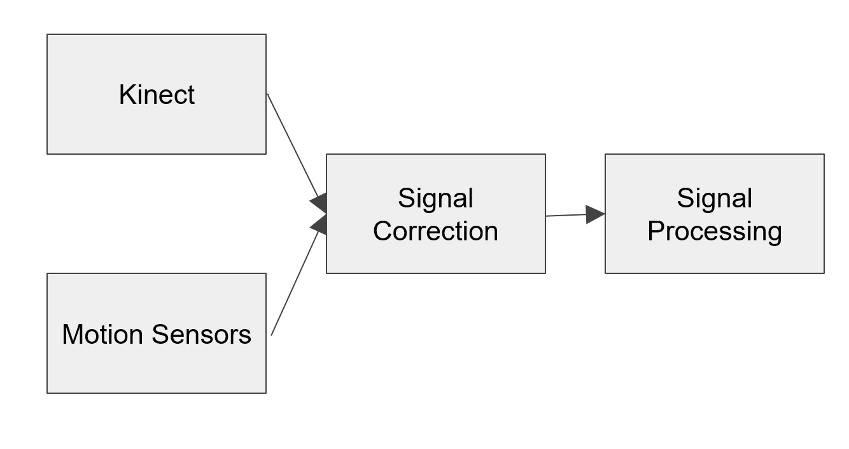

## Characteristics

### Functional / Performance Requirements

#### Global Reference Detection

The correction unit must recognize certain signal inputs from the Kinect as calibration references in order to obtain a global reference time for the overall sensor system. This is performed via the gesture control in Microsoft Kinect’s API.

*Rationale: This requirement is needed to ensure the time sync window is appropriately calibrated.*

* + - * 1. **Timing Sync Window**

The signals must be synced with one another to a degree of accuracy necessary to achieve appropriate quantification. Therefore, the signals must sync within 16 ms of each other before the correction unit can output said signals.

*Rationale: Detectable human latency is between 60-120 Hz, which translates to 8-16 ms. In order to ensure desired results, 8 ms is selected to ensure minimum latency can be seen.*

* + - * 1. **Drift Correction**

The drift correction portion of signal correction should provide a motion sensor signal that does not deviate from the expected axis by greater than 1%.

*Rationale: This assumes the sensor drift follows a linear model. Further testing must be accomplished to determine ranges for non linear drift.*

### Physical Characteristics

The Correction Unit will be contained within the personal computer being used to process data, and therefore its physical characteristics are difficult to quantify. Program compatibility and program flow are instead listed in this section.

#### Program Compatibility and Size

The program shall run on Windows operating systems spanning 7, 8, and 10, and should take up no more than 500 MB of space.

*Rationale: Recent Windows-based operating systems will be used in order to maintain compatibility without major issues. Program sizes greater than 500 MB should be considered excessive for the applications this system will be performing.*

#### Program Flow Chart

Figure : Correction Unit Flow Chart

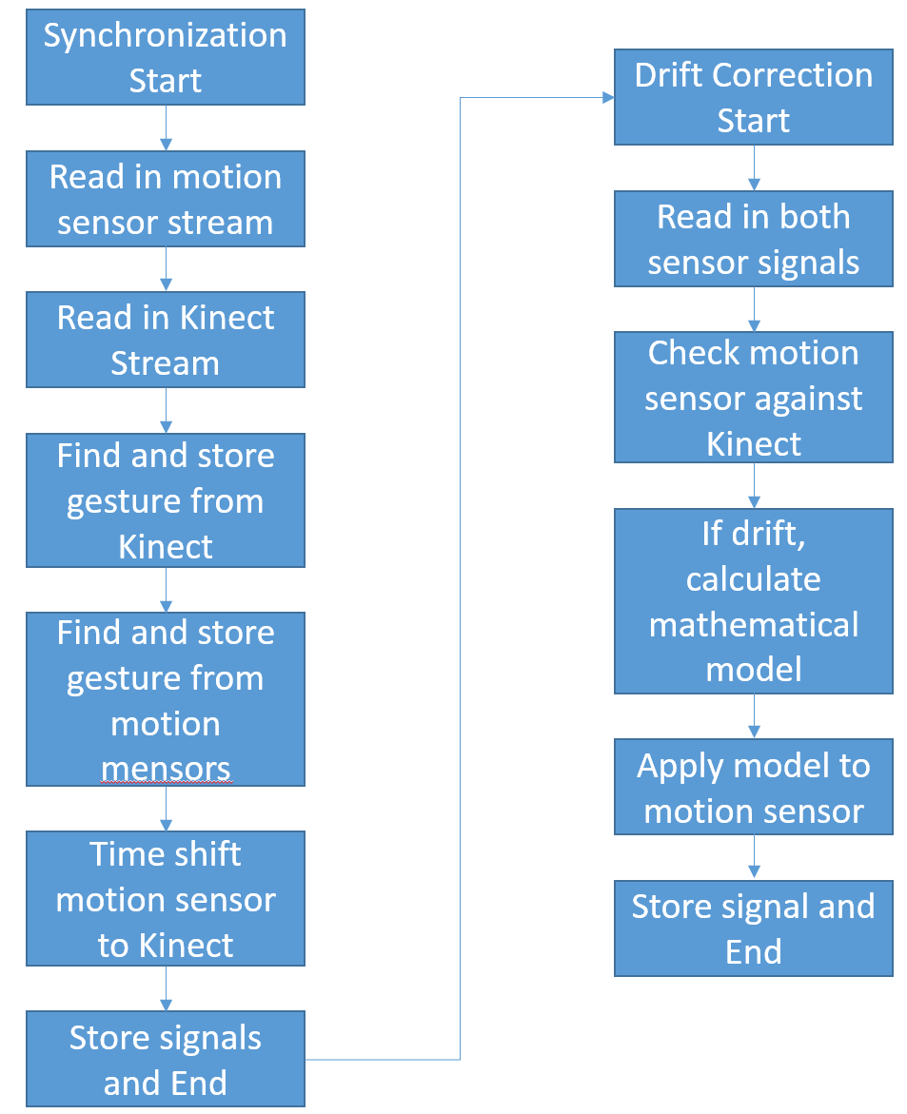

### Electrical Characteristics

#### Inputs

Input data stream from wearable devices should not have a bit error rate (BER) exceeding .001. The BER from the Kinect should not exceed 10-12. Further input characteristics can be found in the ICD.

*Rationale: Wearable devices requirement in accordance with Bluetooth 4.0 BLE standards. Kinect requirement in accordance with USB 3.0 standards.*

##### Input Range

Wearable device will have a range of 7.6 meters (25 feet), while the Kinect system range will vary between 1-3 meters (3-9 feet).

*Rationale: Wearable requirement within maximum theoretical in accordance with Bluetooth 4.0 BLE standards. Kinect requirement due to varying sizes of USB 3.0 cables, not exceeding 9 feet due to desired closeness of system components.*

#### Outputs

##### Data Output

Output of subsystem will be synchronized and drift correct digital data streams. Will sync and correct in accordance with function subsystem requirements.

*Rationale: Digital signals required for output to travel to signal processing module for further analysis and manipulation.*

##### Diagnostic Output

Data is not itself diagnostic but transferred to further subsystem blocks for use in determining overall diagnostic output of system.

#### Wiring

No wiring is required in this subsystem beyond the integrated PCB trace pathways designed in personal computer construction. These traces provide electrical paths for transfer of data from registers and memory blocks for allocated programs.

### Environmental Requirements

Internal components of computer systems should not exceed operating temperatures above 60 degrees Celsius for extended periods of time.

*Rationale: Guideline suggested by PC advisor.*

#### Moisture

Computer components used in this subsystem should not be exposed to excessive amounts of moisture. Potential causes of short-circuits and circuit degradation are consequences of exposure to moisture.

### Failure Detection

Subsystem will throw error to operator if no global reference can be established.

*Rationale: Gesture control may read gesture and pass without error, but may need to be reinitiated if subsystem cannot detect it.*

#### Failure Detection, Isolation, and Recovery (FDIR)

If failure is detected, reason for failure will be isolated and error thrown specifying issue. Subsystem will dump experimental data and wait for reinitialization.

*Rationale: Should error be detected, experimental data is no longer of use due to tarnished results.*

##### Built In Test

Should unit encounter an internal error with processing, will throw error and request restart within 500 ms of error.

*Rationale: Error should be seen and test stopped in a timely manner in order to restart test quickly and maintain efficiency.*

## Signal Processing Unit

Figure : Signal Processing Unit Flow Chart

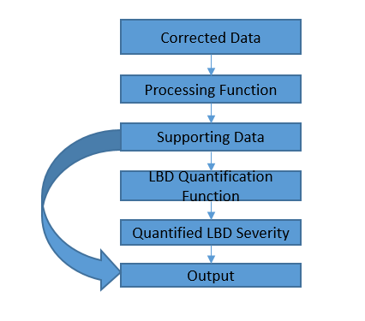

## Characteristics

### Functional / Performance Requirements

#### Requirement #1

The signal processing unit must quantify the severity of LBD within the patient and output it to the Data Display Interface.

*Rationale: The SPU is what will perform the calculation of the system’s desired output. As a result, it will also need to output this to the final level of our system which is the DDI in order to make it available to the physician.*

* + - * 1. **Requirement #2**

The signal processing unit must calculate the Angle, Angular Velocity, Angular Acceleration, and Angular Jerk within 90% accuracy when compared to a Motion Capture System..

*Rationale: These are necessary sets of data which must be calculated using the sensor data in order to quantify LBD according to a set of tests developed by Dr. Marras from Ohio State. The accuracy of 90% will need to be tested in order to verify this can give a sufficient level of consistency. The motion capture is used because it has been proven to be able to accurately measure this set of data. However, Motion Capture systems cost far too much for typical physician office usage.*

* + - * 1. **Requirement #3**

The signal processing unit should output the Angle, Angular Velocity, Angular Acceleration, and Angular Jerk to the data display interface using a data structure containing all of the data.

*Rationale: It is desired to make this information available to the physician. As a result, we will allow access to a structure containing all of this data so the data display has the ability to read and display it.*

* + - * 1. **Requirement #4**

The signal processing unit must finish quantifying LBD within 5 minutes of receiving the corrected data from the Correction Unit.

*Rationale: A similar system was investigated by Dr. Marras from Ohio State who was able to calculate their quantified level of LBD within 5 minutes and we wish to make a new and improved system.*

#### Consistency

The signal processing unit should be able to output a consistent quantified level of LBD within the patient if the same patient were to take the same set of tests multiple times,, there should only be about a 10% degree of difference between them.

*Rationale:* 10% should be good enough to keep the level of LBD consistent enough to give similar diagnosis from the physician. This number may vary upon later re-evaluation.

### Physical Characteristics

#### Mass

The Signal Processing Unit (SPU) will be a program that is run on a computer. As a result, the weight of this subsystem will be the weight of the computer which will be mounted in a physician’s office. As a result, the aim is to have this subsystem weigh less than approximately 25 lbs.

*Rationale: 25 lbs is the average weight of a typical desktop computer. As a result, we wish to aim to make this be our approximate weight, but anything below would be desirable to make the system more portable.*

#### Volume

As mentioned, this subsystem will be the desktop computer which means the dimensions desired will be less than 20” x 20” x 10”.

*Rationale: The dimensions specified is the average dimension of a desktop computer. Once we again, we aim to make this our approximate dimensions and anything smaller to make the system more portable is desirable.*

#### Mounting

The computer will be required to also implement the Data Display subsystem which will output required data to the physician. As a result, the SPU will also be mounted in the physician’s office.

*Rationale: Since our entire system will be used within a physician’s office, the SPU will be mounted in the same area.*

### Electrical Characteristics

#### Inputs

The signal processing unit must receive a collection of corrected sensor data from the Correction Unit which will be contained in a data structure and passed as a reference to the signal processing unit.

*Rationale: Make it as easy as possible to access large quantities of data.*

##### Power Consumption

Since the SPU is interfaced internally in the computer, the input power will simply be a standard PC Power Supply (power depends on PC’s power supply) connected to a standard wall socket (~120Vac, 15A).

*Rationale: This is simply a standard wall sockets power specification and the PC Power Supply will vary depending on the type of computer used by the physician.*

#### Outputs

##### Quantified Severity of LBD

The SPU must output the quantified level of LBD which should be a number from 1-10 with decimal values.

*Rationale: This will allow for accurate diagnosis of LBD by the physician.*

##### Supporting Data

The Kinect unit shall output a collection of measurements used to calculate the severity of LBD within the patient. These measurements include Angle, Angular Velocity, Angular Acceleration, and Angular Jerk.

*Rationale: Allow the physician to view and verify the data to have a better insight regarding the quantified level of LBD.*

### Environmental Requirements

The SPU shall withstand and operate in the environments and laboratory tests which were specified for the overall system.

### Failure Propagation

The SPU will only propagate an error message when a serious error occurs during signal processing or if it has received an error from the Correction Unit.

*Rationale: This is desirable because we wish to denote to the physician whenever a serious error has occurred during the processing of the tests at any point.*

#### Failure Detection, Isolation, and Recover (FDIR)

##### Built In Test (BIT)

The SPU shall have a catch block that will generate an error signal whenever the signal processing unit encounters an error such as floating point errors, any significant sources of error during processing, or errors from the Correction Unit.

###### BIT False Alarms

The BIT shall have a false alarm rate of less than 1 percent.

*Rationale: This will ensure the validity of these error messages.*

## Data Display

## Characteristics

### Functional / Performance Requirements

#### Requirement #1

The Data Display Interface (DDI) for the overall system should display to the physician the quantified severity of LBD within the patient and any supporting calculated data.

*Rationale: We wish to make this data available to the physician and we need an interface to display it.*

* + - * 1. **Requirement #2**

The DDI should be able to be clearly viewed by the physician from 1-2ft away from the monitor. This means they can easily view any text, buttons, or filters on the GUI display.

*Rationale: 1-2ft away from the monitor is reasonably close but not too far from the monitor such that any standard GUI can be viewed by an average person.*

* + - * 1. **Requirement #3**

The DDI should have a refresh rate of approximately 60 Hz which is that of a standard monitor to allow for clear viewing of the GUI.

*Rationale: A standard, relatively cheap monitor usually has a refresh rate of at least 60 Hz which is is sufficient for our system since we do not need an intensive GUI.*

* + - * 1. **Requirement #4**

The DDI should display text, buttons, and filters in order to allow the physician to view, save, and sift through the data that will be displayed.

*Rationale: Our GUI will be simplistic. As a result, only a simplistic set of widgets and text will be required for our purposes.*

* + - * 1. **Requirement #5**

The DDI should update the displayed data whenever output is received from the SPU since this will signal when a new test has been processed.

*Rationale: The GUI will only need to display new information when a new test has been finished being processed.*

#### Consistency

The Data Display should always display the data that it is prompted for.

*Rationale: Without the display, the output of the entire system is unavailable. As a result, we need the DDI to always display the data.*

### Physical Characteristics

#### Mass

The Data Display Interface (DDI) will be another computer program which creates a GUI on the computer monitor (LCD). As a result, the subsystem will be the weight of the computer as mentioned above plus the monitor itself (a typical monitor weighs approximately 10 lbs).

*Rationale: Since 10 lbs is the weight of a typical desktop computer monitor, we wish to make this our aim weight of the DDI, but anything less than 10 lbs is desirable from a portability aspect.*

#### Volume

Once again, the DDI will be the dimensions of the computer mentioned above as well as the monitor which will be less than 24in x 24in.

*Rationale: 24in x 24in is the average volume of a computer monitor. As a result, this is once again our target dimension.*

#### Mounting

Since the computer is mounted in the physician’s office, the monitor will be mounted as well in the physician’s office in order to allow for easy connection.

*Rationale: Since the entire system is mounted in the physician’s office, we wish to keep the DDI mounted there as well.*

### Electrical Characteristics

#### Inputs

The DDI will receive the quantified level of LBD and all of its supporting data as a reference to a data structure containing all of the data.

*Rationale: Make it easy and use up as little memory as possible to read and display the data.*

##### Power Consumption

The monitor will be powered by a standard wall socket connection.

*Rationale: Standard wall socket is used to power a computer monitor.*

##### Input Voltage Level

The computer will be powered by the power supply mentioned above, and the monitor itself will be powered via a normal wall socket connection (~120Vac, 15A).

*Rationale: Typical output of a wall socket.*

#### Outputs

##### Data Output

The Data Display will output all of the data to the user himself through a GUI.

*Rationale: The entire system’s output passes directly to the Data Display Interface.*

##### GUI Display

The DDI shall display all of the data as text and allow the user to view any of the data and filter and sift through the data using buttons.

*Rationale: For the scope of this project and for the information needed from this system, a simple GUI including the displays mentioned is sufficient..*

### Environmental Requirements

The DDI shall withstand and operate in the environments and laboratory tests which were specified for the overall system.

#### Failure Detection, Isolation, and Recovery (FDIR)

##### Built In Test (BIT)

The DDI shall output any of the error messages that occurred during correction or processing to the user so they may redo the entire procedure or fix the issues mentioned.

*Rationale: The error messages are required to know whenever an error occurred during correction or processing and will need to be accounted for accordingly.*

## Display Feedback

## Characteristics

### Functional / Performance Requirements

#### Requirement #1

The Display Feedback (DF) for the overall system should display to the patient any error signal that the patient is doing during the test.

*Rationale: We wish to make this data available to the patient and we need an interface to display it.*

* + - * 1. **Requirement #2**

The DF should be able to be clearly viewed by the patient from 1-2ft away from the monitor. This means they can easily view on the GUI display.

*Rationale: 1-2ft away from the monitor is reasonably close but not too far from the monitor such that any standard GUI can be viewed by an average person*

* + - * 1. **Requirement #3**

The DF should have a refresh rate of approximately 60 Hz which is that of a standard monitor to allow for clear viewing of the GUI.

*Rationale: A standard, relatively cheap monitor usually has a refresh rate of at least 60 Hz which is is sufficient for our system since we do not need an intensive GUI.*

* + - * 1. **Requirement #4**

The DF should update the displayed data whenever output is received from the SPU since this will signal when a new test has been processed.

*Rationale: The GUI will only need to display new information when a new test has been finished being processed.*

#### Consistency

The Display Feedback should always display the data that it is prompted for.

*Rationale: Without the display, the output of the entire system is unavailable. As a result, we need the DF to always display the data for the patient.*

### Physical Characteristics

#### Mass

The Display Feedback (DF) will be another computer program which creates a GUI on the computer monitor (LCD). As a result, the subsystem will be the weight of the computer as mentioned above plus the monitor itself (a typical monitor weighs approximately 10 lbs).

*Rationale: Since 10 lbs is the weight of a typical desktop computer monitor, we wish to make this our aim weight of the DF, but anything less than 10 lbs is desirable from a portability aspect.*

#### Volume

Once again, the DF will be the dimensions of the computer mentioned above as well as the monitor which will be less than 24in x 24in.

*Rationale: 24in x 24in is the average volume of a computer monitor. As a result, this is once again our target dimension.*

#### Mounting

Since the computer is mounted in the physician’s office, the monitor will be mounted as well in the physician’s office in order to allow for easy connection.

*Rationale: Since the entire system is mounted in the physician’s office, we wish to keep the DF mounted there as well.*

### Electrical Characteristics

#### Inputs

The DF will receive the patient’s posture and the degrees of which the patient is making.

*Rationale: Make it easy and use up as little memory as possible to read and display the data.*

##### Power Consumption

The monitor will be powered by a standard wall socket.

*Rationale: Standard wall socket is used to power a computer monitor.*

##### Input Voltage Level

The computer will be powered by the power supply mentioned above, and the monitor itself will be powered via a normal wall socket connection (~120Vac, 15A).

*Rationale: Typical output of a wall socket.*

#### Outputs

##### Data Output

The Display Feedback will output any error signal to the patient through a GUI.

*Rationale: The entire system’s output passes directly to the Display Feedback.*

##### GUI Display

The DF shall display all the patient’s movement.

*Rationale: This will be used to verify our data with the wearable sensors, which error overtime is greater and inconsistent.*

### Environmental Requirements

The DF shall withstand and operate in the environments and laboratory tests which were specified for the overall system.

#### Failure Detection, Isolation, and Recovery (FDIR)

##### Built In Test (BIT)

The DF shall output any of the error messages that occurred during correction or processing to the user so they may redo the entire procedure or fix the issues mentioned.

*Rationale: The error messages are required to know whenever an error occurred during correction or processing and will need to be accounted for accordingly.*

# Support Requirements

Provide details of provided support or requirements for the customer such as the fact that the system requires a laptop with listed requirements. What will you provide with the system? Any requirements for support such as tech support service or warranty? How will you resolve issues in the field? This section may be long or may not be needed at all depending upon the project and customer requirements.

# Appendix A Acronyms and Abbreviations

BIT Built-In Test

CCA Circuit Card Assembly

EMC Electromagnetic Compatibility

EMI Electromagnetic Interference

EO/IR Electro-optical Infrared

FOR Field of Regard

FOV Field of View

GPS Global Positioning System

GUI Graphical User Interface

Hz Hertz

ICD Interface Control Document

kg Kilogram

kHz Kilohertz (1,000 Hz)

LCD Liquid Crystal Display

LED Light-emitting Diode

mA Milliamp

MHz Megahertz (1,000,000 Hz)

MTBF Mean Time Between Failure

MTTR Mean Time To Repair

mW Milliwatt

PCB Printed Circuit Board

RMS Root Mean Square

TBD To Be Determined

TTL Transistor-Transistor Logic

USB Universal Serial Bus

VME VERSA-Module Europe

LBD Lower Back Disorder

SPU Signal Processing Unit

DDI Data Display Interface

MSI Motion Sensor Interface

DF Display Feedback

Hz Hertz

GUI Graphical User Interface

ICD Interface Control Document

LCD Liquid Crystal Display

USB Universal Serial Bus

mAh Milliampere hours

Wh Watt hours

BER Bit Error Rate

# Appendix B Definition of Terms

# Appendix C Interface Control Documents

## Overview

Low back disorders (LBD) are very common disorders where the muscles and the bones of the back are involved. It affects about 40% of people at some point in their lives, which results in a substantial cost to society in terms of healing the patients. Although society knows about this common problem, in general, there has been little to no progress in the control of LBDs. This is because many assessment tools of low back disorders are subjective. As a result, usage of a wearable device which will quantify the level of LBD within patients to allow physicians to make more accurate diagnosis of LBD is being investigated.

In this document, the subsystems and interfaces for our wearable electronic device will be defined. This will include the general purpose of each subsystem, as well as its inputs and outputs to allow for interconnection and communication between the entire system. While defining our inputs and outputs, we will denote the specific connection types, standards, and other specifications required to start defining how our entire system will operate.

## References and Definitions

### References

* **MPU-9150 Product Specification Sheet, Revision 4.0**14 May 2012
* **Blue Creation BC127 Datasheet**29 November 2013
* **Openkinect Protocol Documentation**

7 March 2012

### Definitions

mA Milliamp

mAh Milliampere-hours

mW Milliwatt

kHz Kilohertz (1,000 Hz)

MHz Megahertz (1,000,000 Hz)

TBD To Be Determined

bpp Bits Per Pixels

fps Frames Per Second

MSI Motion Sensor Interface

lbs Pounds

PCB Printed Circuit Board

V Volt

LBD Lower Back Disorders

SPU Signal Processing Unit

SU Synchronization Unit

GBPS Gigabytes per Second

ms Milliseconds

## System Interface

Figure 8: Overall System Interface

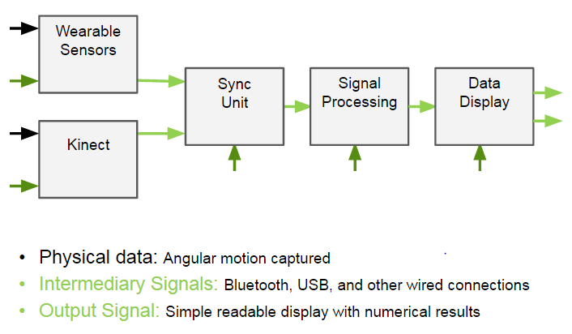

### Physical Interface

#### Weight

There are multiple components of the overall system, but all must follow some basic guidelines. Anything wearable must be able to be worn comfortably, meaning all wearable pieces should be lightweight (less than 3 pounds). This system should also be reasonably portable. Thus, all other components should be reasonably able to be carried around (all modules less than 30 pounds). Specific details concerning the weight of the various subsystems may be found in their respective appendices.

#### Dimension

The components of the system vary in size but overall will fit easily into a relatively small patient room in a doctor’s office. Each physical component will be relatively small in size, but the standing room required for the patient to use the Kinect will consume the most space by far. Specific details regarding the dimensions of individual subsystems is located in their respective appendices.

#### Mounting locations

The overall system will be placed in a patient room in a physician’s office, which consists of having a relatively open, but small room with the purpose of giving the patient the freedom to perform the test without any obstructions. Additionally, this will allow the Kinect to perform better without any hindrances. The system will be set up with a patient, wearing the wearable sensors, facing a television screen and Kinect, spaced around 6 feet away from the screen. There will be a laptop which will function as the synchronization unit, signal processing unit, and results data display unit in close proximity to the Kinect as that requires a wired USB connection. Further information about the location of subsystems relative to one another may be found in the appendices.

### Electrical/Communications Interface

#### Primary Input Power

The system will be powered via a standard 120V AC wall socket at 60 Hz. This power input will provide energy for the Kinect, technician monitor, patient monitor, and computer run sub systems. The wearable electronic devices are powered by 3.7V, 400 mAh batteries. These batteries can be charged via a USB to micro-USB cable.

#### Signal Interfaces

The input signals will come from three places in the system. The physical inputs of the patient will be converted to digital signals by the sensor modules and the visual representation of that data captured by the Kinect and digitized. The final signal input will be the key presses and mouse clicks of the technician operating the system. These will also be converted to their digital streams and interpreted by the technician control interface.

#### User Control Interface

##### Patient Interface

From the patient perspective, the patient will wear two pieces which will contain the wearable sensors in order to gather data. In addition, the patient will stand in front of the Kinect approximately 2 feet away. Afterwards, the patient will perform a series of test according to the software provided by the GUI, which will guide the patient in every step of the way to successfully complete it.

##### Technician Interface

The technician will utilize a standard computer interface in order to interact with the system. This includes a keyboard, mouse, and LCD screen monitor. Physical input will be provided to the mouse or keyboard concerning which test to be implemented and for what duration. Any errors during the testing process will also be displayed to the technician for rectification.

## Communications/Device Interface Protocols

### Wireless Communications

* IEEE 802.15.1: WPAN / Bluetooth
* IEEE 802.11a: OFDM Waveform

## Appendix: Subsystems Interfaces

### Wearable Sensors Interface (Ben Johnston)

Figure 9: Wearable Sensors Interface

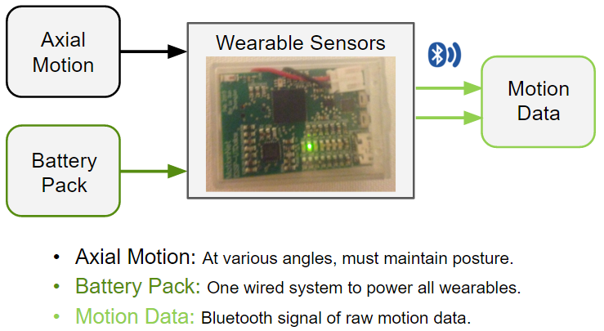

#### Physical Housing Interface

##### Weight

The sensors will be housed in two separate pieces: thorax housing and waist housing. The thorax housing needs to be made of lightweight, cushioned material for comfort of the user, but also have a rigid brace to keep the sensor steady. The unit should weigh around 2 pounds. The waist housing has similar requirements: lightweight, comfortable, but must maintain the integrity of the sensor. The waist unit should weigh around 5 ounces.

##### Dimensions

The thorax housing will measure approximately 12 inches in height by 16 inches in length by 8 inches in depth in total volume. The unit must fit a reasonably wide amount of body types with a reasonable amount of comfort. The waist housing will be annular in shape, adjustable in a range of 32 inches in circumference to 40 inches in circumference. The unit will be 1.5 inches tall and, at its thickest point, 1 inch in thickness.

##### Mounting Locations

The thorax unit will be worn like a harness around the chest of the patient. The waist unit will be worn in the fashion of a belt.

#### Physical Sensor Interface

##### Weight

There will be two MotionNet sensors in total. Each MotionNet sensor is comprised of an accelerometer, gyroscope, and magnetometer on a PCB with Bluetooth communications, connected to a battery, inside of a 3D printed box. Each unit weighs 1.5 ounces.

##### Dimensions

Each 3D printed box, which houses the sensors, measures 0.71 inches in height by 1.13 inches in width by 1.60 inches in length, on the outside. The inside measures 0.61 inches in height by 1.05 inches in width by 1.57 inches in length.

##### Mounting Locations

One sensor will be mounted on both of the physical housing modules. Both sensors will be mounted on the back of their respective modules, along the spine, in the center.

#### Electrical/Communications Interface

##### Primary Input Power

The power input will be a small rectangular battery that is capable of fitting the inside the 3D printed box. The battery will supply 3.7 V and have a span of 400 mAh.

##### Signal Interfaces

The inputs of the sensors will be the raw physical data captured by the accelerometers and gyroscopes. Most importantly, the angular displacement and acceleration as measured between the two sensor units. This information will also be used to derive the angular velocity and jerk between points. The raw data is captured in the x, y, and z planes relative to the sensor. Each data point captures 16 bits of data at a rate of 1.024 kHz. So in total, per MotionNet sensor, the output is 6 16 bit 1.024 kHz digital I2C signals.

##### User Control Interface

The MotionNet sensors require some way for the developer to access and change their logic. This is done through a mini-USB connection that is mounted on the PCB and is accessible by opening the 3D printed box. The code governing the logic of the MotionNet sensor is C#, a graphical higher level of C.

##### Wireless Communications

To communicate the raw data acquired to the signal processing unit, a Bluetooth 4.0 unit is attached to the PCB of the MotionNet sensor.

### Motion Sensor Interface (Benny Chan)

Figure 10: Motion Sensor Interface



#### Physical Interface

##### Weight

The motion sensor interface (MSI) will be a Microsoft Kinect that will be run in conjunction with a computer. Therefore, the weight of this subsystem is approximately 4.5 pounds, depending on the accessories that will include for the proper function of the Kinect.

##### Dimensions

As mentioned, this subsystem will be the Kinect, which means that the dimensions are 5.46 x 14.2 x 6.48 inches.

##### Mounting Locations

The motion sensor interface will be mounted in the physician's office. As a result, the Kinect will require a tripod, or be mounted over a monitor for it to be sufficiently stable. In addition, we will have to make sure that the front of the sensor is not obstructed by power cords, computer cables, or other solid objects, as well as, make sure the Kinect sensor is in a well-ventilated space for it to properly function.

#### Electrical/Communications Interface

##### Primary Input Power

The input power will a special adapter made by Microsoft, which takes a normal wall socket connection (~120V, 15A) and supply power to the Kinect via USB 3.0.

##### Signal Interfaces

The MSI will receive the movement of the patient as an input, which will be focused on the joint movement, and the depth of where the patient is. This will be handled internally in the Kinect and will be sent via USB 3.0 to the computer, which afterwards, it will be analyzed by a special software made for the Kinect that process the data by outputting the skeletal raw data and analyze 26 joint points from the body. Finally, it will go into the next subsystem for synchronization.

##### User Control Interface

The MSI will require a basic setup, which it consists of opening the main software for the Kinect to start gathering data and sending it over to the computer. This will run in real-time and does not require anything else, besides the movement of the patient to start the test.

##### Wired Communications

As mentioned before, the data transfer will be handled via USB 3.0, which will be expecting a data transfer of at least 2 GBPS. This will consist of three different bitstreams, which are color, depth and infrared. The color stream will be our main data, which takes 1920 x 1080 x 16 bpp at 30 fps, the depth stream will take 512 x 424 x 16 bpp with a 13-bit depth, and the infrared stream will take 512 x 424 bpp with an 11-bit dynamic range. In addition, this will send a control packet structure of 8-bytes, which consist of RequestType (1 byte), Request (1 byte), Value (2 bytes), Index (2 bytes) and Length (2 bytes). As a result, this will be used to read accelerometer values, set Motor/LED status and camera registers that is integrated in the Kinect. Thus, we will be expecting a latency of approximately 60-80 ms by tracking this information.

### Synchronization Unit Interface (Kevin Burns)

Figure 11: Synchronization Unit Interface

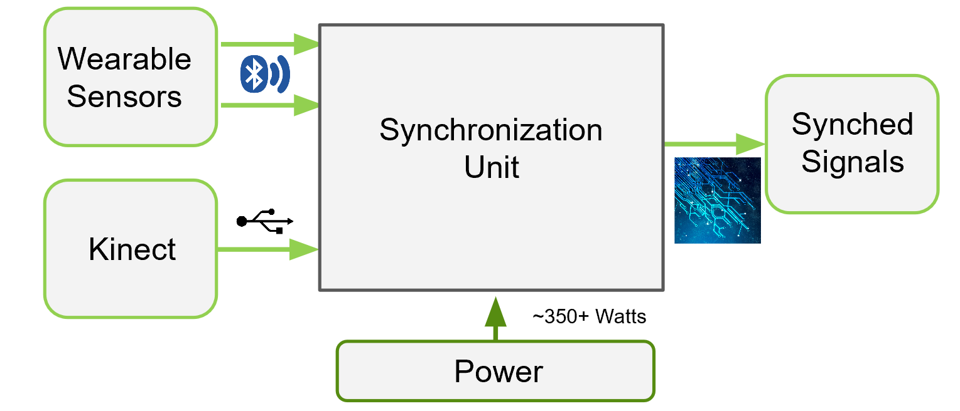

#### Physical Interface

##### Weight

The Synchronization Unit (SU) will interface via a computer, running as MATLAB code. This therefore will not factor into the physical weight aside from the necessity of a computer to run the MATLAB program and receive the input signals. Therefore the required weight for the SU will be wrapped into the computer weight at an aim of approximately 25 lbs.

##### Dimensions

The dimensions for the SU will follow those of the computer that will be running the MATLAB code. The physical dimensions will therefore be less than 20’’ x 20’’ x 10’’.

##### Mounting Locations

The mounting location for the SU will coincide with the location of the computer running the MATLAB program. This unit is an integral bridge between both sensor units and the signal processing unit, so the computer must be within Kinect cable range and Bluetooth 4.0 range.

#### Electrical/Communications Interface

##### Primary Input Power

Due to the SU being run from within a computer, the required input power for the unit to function is supplied via the computer power supply. This power requirement is approximated at 200W and with a current draw of no more than 15A.

##### Signal Interfaces

The SU must be capable of receiving multiple input streams from the sensor devices. Therefore it must read in data streams from the wearable sensors at 16 bps via Bluetooth 4.0 as described above in section 5.1.3.2. The expected latency for the Bluetooth module is approximately 3 milliseconds. The Kinect signal interface is through USB 3.0 cable as also described above in section 5.2.2.4, and will experience a latency of approximately 60-80 milliseconds. The Bluetooth interface signals will then be delayed in this module and two output signals will be produced. These signals will follow their previous standards as described, but will each timestamp will coincide with the same global instant.

##### User Control Interface

This unit will not contain any user control, as established latencies from the system should be universal across use. Should alternate technologies be used in the sensor systems, adjustment of raw MATLAB code should be performed by a qualified technician.

##### Wireless Communications

There will only be one wireless communications signal incoming to this module, which will follow Bluetooth 4.0 standards.

##### Wired Communications

There will be one wired communication signal coming into this module, which will follow USB 3.0 standards. The output of this module will be stored into memory, directed by the computer’s operating system. This memory will then be accessed by the Signal Processing Unit to provide real time signal analysis.

### Signal Processing Unit Interface (Alex Dubois)

Figure 12: Signal Processing Unit Interface

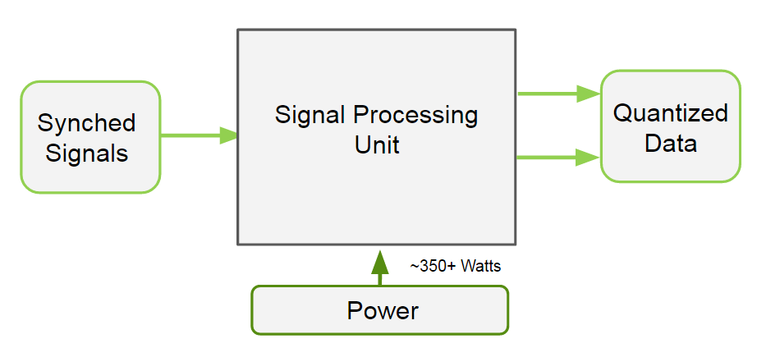

#### Physical Interface

##### Weight

The Signal Processing Unit (SPU) will be a program that is run on a computer. As a result, the weight of this subsystem will be the weight of the computer which will be mounted in a physician’s office. As a result, the aim is to have this subsystem weigh less than approximately 25 lbs.

##### Dimensions

As mentioned, this subsystem will be the desktop computer which means the dimensions desired will be less than 20” x 20” x 10”.

##### Mounting Locations

The computer will be required to also implement the Data Display subsystem which will output required data to the physician. As a result, the SPU will also be mounted in the physician’s office.

#### Electrical/Communications Interface

##### Primary Input Power

Since the SPU is interfaced internally in the computer, the input power will simply be a standard PC Power Supply (power depends on PC’s power supply) connected to a standard wall socket (~120Vac, 15A).

##### Signal Interfaces

The SPU will receive a set of synchronized signals from the synchronization unit which will contain a comprehensive set of sensor data. This will be handled internally in the computer and sent through a process which will return a stream of data in the form of the corresponding sensor data according to their specific APIs mentioned above with timestamps attached. The SPU will then collect this data into a data structure and begin to analyze and correct the data and output a quantified LBD level within the patient which we will aim to make a number on a scale of approximately 1-10 (decimal values will be allowed to give a more accurate analysis rather than an attempt at rounding). It will proceed to directly send the data it received and analyzed which supports its quantified result, the result itself, and any notifications of serious errors during analysis to the Data Display Interface.

##### User Control Interface

The SPU will not be user accessible and will run in the background processing the data received from the synchronization unit to quantify LBD so all of the user control will be done through the Data Display Interface.

### Data Display Interface (Alex Dubois)

Figure 13: Data Display Interface

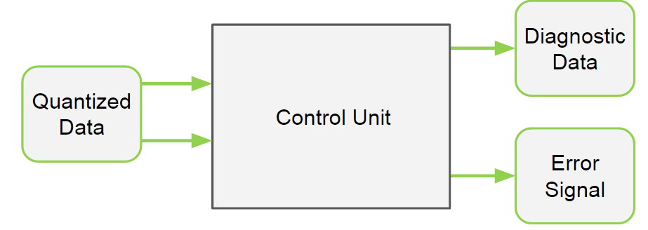

#### Physical Interface

##### Weight

The Data Display Interface (DDI) will be another computer program which creates a GUI on the computer monitor (LCD). As a result, the subsystem will be the weight of the computer as mentioned above plus the monitor itself (a typical monitor weighs approximately 10 lbs).

##### Dimensions

Once again, the DDI will be the dimensions of the computer mentioned above as well as the monitor which will be less than 24in x 24in.

##### Mounting Locations

Since the computer is mounted in the physician’s office, the monitor will be mounted as well in the physician’s office in order to allow for easy connection.

#### Electrical/Communications Interface

##### Primary Input Power

The computer will be powered by the power supply mentioned above, and the monitor itself will be powered via a normal wall socket connection (~120Vac, 15A).

##### Signal Interfaces

The DDI will receive the set of supporting data, error signals, and quantified level of LBD mentioned as input from the SPU. Once again, this will be done internally by the computer through software which will receive the set of supporting sensor data as a reference to the data structure containing a comprehensive list, an integer value for the quantified level of LBD, and some simple integer values which will be parsed to specify the error values and figure out what the value corresponds to. This data will be displayed to the monitor using a GUI built using a GUI builder such as Windows Forms available for C# and Windows C# API.

##### User Control Interface

The DDI will be required to receive user input from the mouse and keyboard in order to allow the physician to search and filter the supporting data received and hide or expand other features. As a result, we will be receiving inputs through standard I/O interfaces through the Windows API for C#.