CPP DSA
Data structure:

How application run:
Our program file remain on hard memory. When we play it, it goes to the ram(main memoy). Where it execute that file.
A programs and its data has to be take into the main memory to be executed.

Data mining algorithms: these algorihms are used to analyze the big data.
Memory:
memory is divided into smallest units called bytes. Every byte has its address.
Segment: the memory of ram divided into small manageable memory called segment.
.
Main memory is divide into three parts:
- Heap:
It is unorganized memory. Use as resource, when we need memory we create and delete manually. It cannot be accessed directly. We can access it by using pointer.
We use “new” to create heap memory. We use “delete []” to delete heap memory. Explicity assign and delete.
If we will not delete it will cause memory leak.
- Stack:
Memory allocation is done in stack frame. The size of memory is static which decided in compile time. When the function used it removed from the stack. It is organized memory process.
- Code section:
In main memory the program code will come in code section.usually It takes the main function in which all other code of different file will execute. When main func need other code then it also come into code section.

Physical Data Structure: (Array & linked list)
They decide how memory organized or allocated.
Array is Collection of contagious memory size. Contain fixed size. It can be created in heap or stack.
Linked list created in heap. Their head can be in stack
Logical Data Structure:(stack ,queue, tree, hash-table, graph)
Use to store the data or other operation. These are actually used in program by using physical data structure.

Datatype: representation of data with the operations applied to it.
ADT(Abstract data type):
the data type defined by user in the form of OOP in which we can hide internal operation and let the user to use public operations.

Time Complexity:
The amount of work required to complete a work/program/task.
If single loop is using then TC= O(n)
If one loop inside a loop then TC= O(n^2)
When we do binary search it divide the procedure into half (divide represent by log and the list divided into two parts which represent by 2) so TC= O(log2 n) → init during loop we use i=n/2

If we process all elements of matrix then TC=O(n^2)

Space Complexity:
Space complexity depends on the declarations.
Recursion:
A function calling itself with some base condition to stop the function running.
It have two phase, one is calling phase and the otehr one is returning phase.
If we first print then pass value in recursion by subtracting then we get descending order (known as tail recursion)
If we 1st pass the value by subtracting in recursion then print the value then it will be returning in descending (known as head recursion)
Assume a tree(recursion tree) to visualize it.
We can take an example in which there a three rooms which are connected via attached doors.
Then you have to go in first room and turn on the light then go to the next room via door and on the light and then go to the last room and on the light then turn back.
We can also take an example of rubber band, we can stretch it until it reaches its limit then we release it and it will come back.
in loop we have only ascending phase and but in recursion we have ascending and descending phase.
Time complexities for Loop:
Space complexity: O(1 )
Time Complexity: O(n)
Complexities for recursion:
Space complexity: O(n)
Time Complexity: O(n)

Recursion use stack, in stack data structure the value to enters first comes out and last and the last value comes out 1st. same thing happens in stack, if we give 5 as value and do operation (n-1) the 5 will come at the end and after meeting the condition the last value before condition meetup will comes out.
If we use static variable in recursion like int x and we do x++ then we will not have multiple copies of x, it will only have single copy. In which we perform action and all changes will happen ND REMAIN IN THAT copy.
Types of recursion:
- Tail recursion:
Recursive function 1st print value/perfor_action then recursively call it self. Print/perform action at calling phase.
- Head recursion:
Perform action/ prin value after recursion time.
- Tree recursion:
In tree recurion the function calls itself multiple times (not nested but at same level)
Like:
Fn(){ Fn()
Fn()}

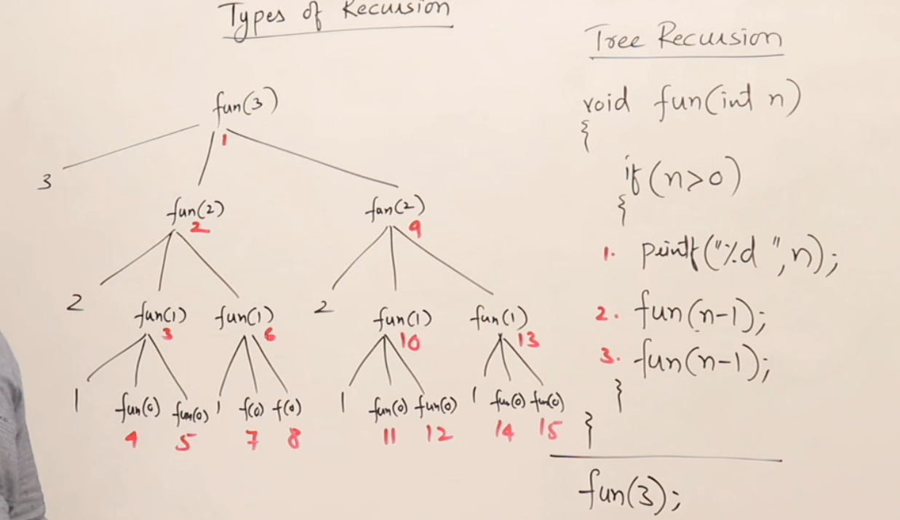
Formula to calulate the value of n is→ 2^(n+1) -1
Time complexity for tree recusion is O(2^n)
Space complexity for Tree recursion is O(n)
- Indirect recursion:
In indirect recurion there are two function, one function is called into the another function and vice versa due to which it makes a loop, and we use a condtion to break this loop.
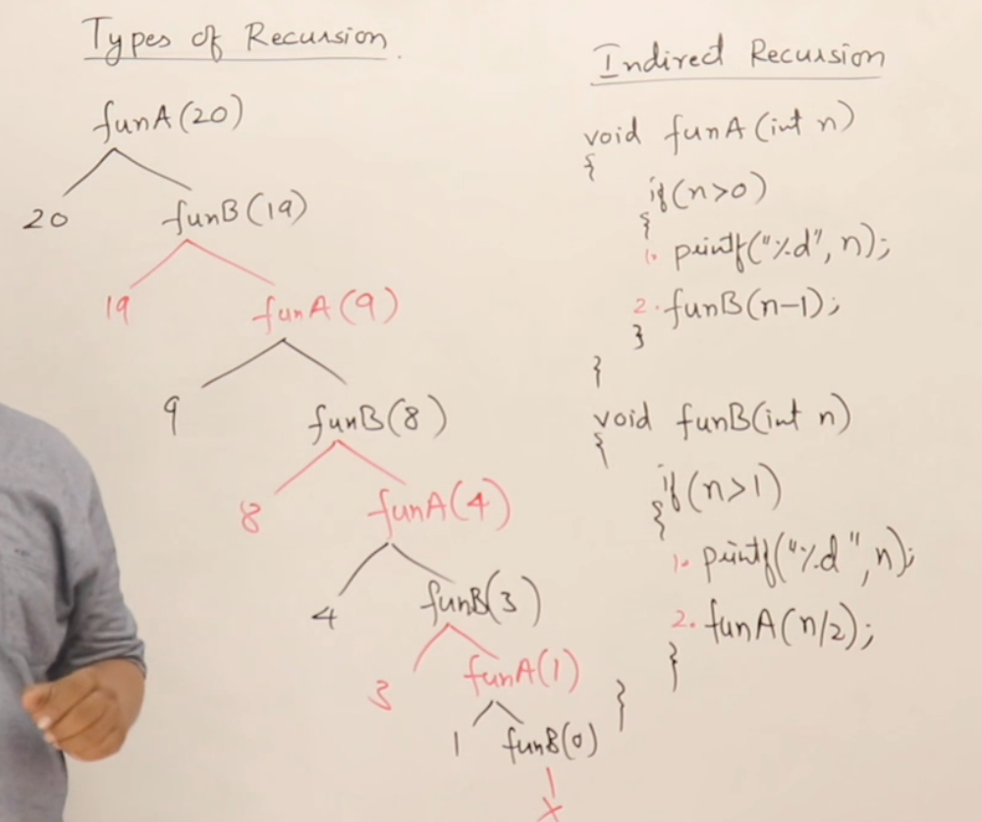
- Nested recursion:
The recurion in in we pass a function.
Like:
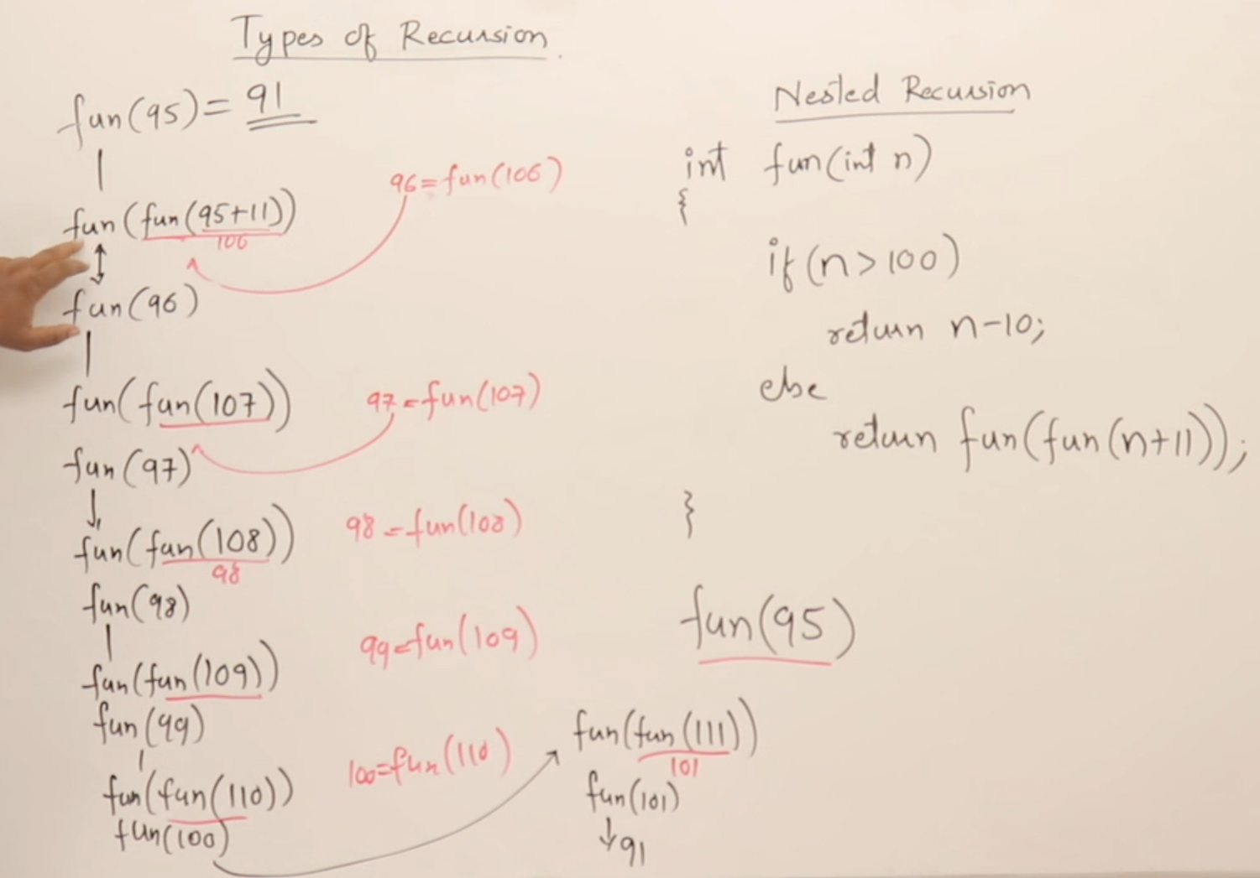

Tower of Hanoi:
This is classical problem. In which we have stach of disk, in which lower disk is larger than the upper disk.
We have to move it in other point with same arrangement and we have to take just one disk at a time a and put to other position.
To solve this problem we can take a temporary stack/position.
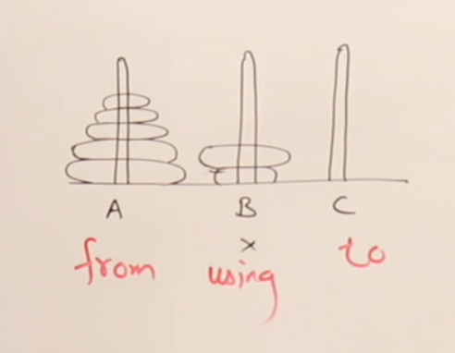

To solve this problem we can have three condition
- We have one disk in stack
- We have to disk
- We have three or more disks
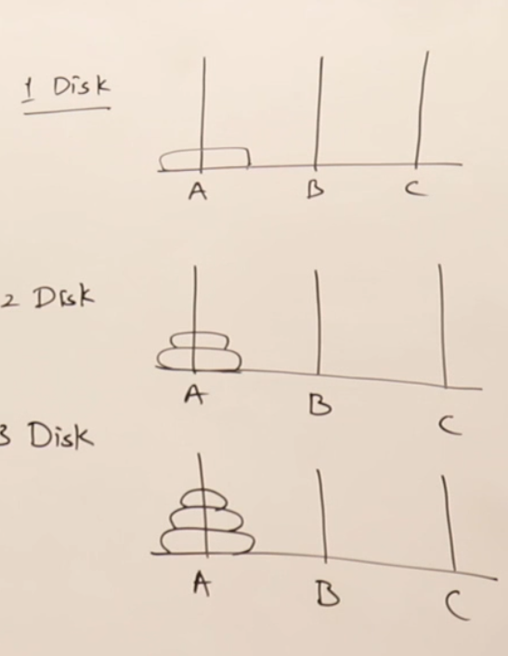
- When we have one disc we can simply move it to next position, no need of helping stack.
- If we have two disc then move upper disk temporary into helping stack, then lower to the destination, then move disc from helping stack to the destination
- If we have three discs then move 1st two discs into the helping stack by using solution of condition two, then move the loweset bigger disc into the destination and again move it to destination by using solution of second condition.
- When we do third step recursively it will solve n number of discs.
- E.g. if we have (n,A,B,C)/(3,1,2,3)→ n is number of discs, A is main tower, B is helper, c Is destination.
- Time Complexity→ O(2^n)
How recursion will work:
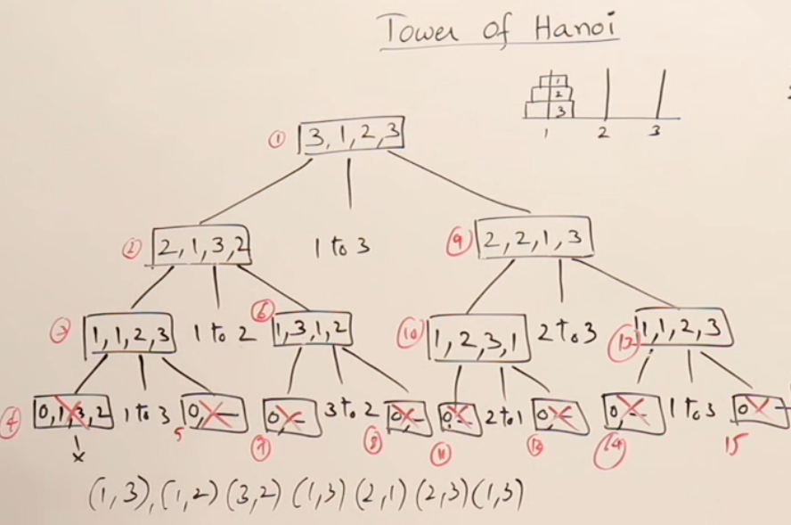

Steps involved:
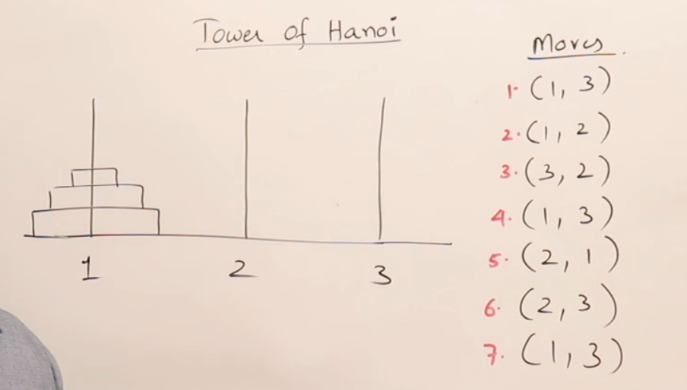

Code:
void TOH(int n, int A,int B, int C){
if(n>0){
TOH(n-1,A,C,B);
printf("(%d,%d)\n",A,C);
TOH(n-1,B,A,C); }}

Arrays:
Formula to check the memory address of any index:
L0 + i * BitSize;
L0 → Memory address of 1st index (should be given)
I → index number
BitSize → bit size that a data type is taking (2,4,8)

Like: L0 = 2002, I = 3 , bitsize=2 → 2002 + 3*2 = 2008
we use this during assembly language or system designing. It is done by compiler so we do not need to cram it.

Arrays:
It a a vector variable.
It is linear DS which contains contagious memory locations.

Static Array:
The size of array is not dynamic/ fixed size.
When we initialize it initialize in stack memory.
Size is decided at compilation time
Like a[5]
Dynamic Array:
Size is decided at run time
Size is dynamic
We use pointer
Array is created in heap.
Memory allocation wil be in stack but the array will be created In the heap. And the stack will pints to variables in the heap.
We access it indirectly.
To change size dynamically we have to create new array with bigger size in heap. By using loop we can shift all the value of old array. Then delete old array to avoid memory leakage. Then point old arrays reference to new array so now new array have two reference. Turn the original array reference to null, now new array have old arrays reference only.

