Objective: Build a Flask application with a JSON API route and a frontend form that stores submitted data in MongoDB Atlas, with proper success and error handling.

Task 1: JSON API Route
- Create a Flask application with an /api route. When this route is accessed, it should return a JSON list. The data should be stored in a backend file, read from it, and sent as a response.
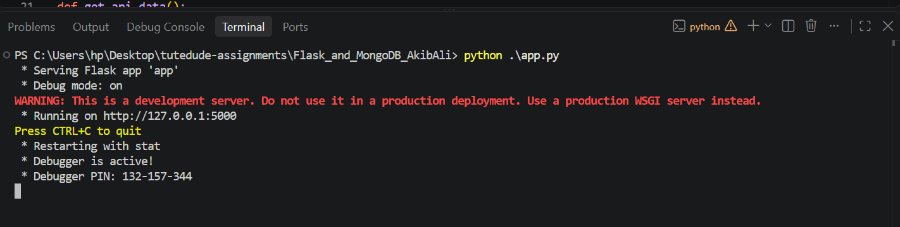
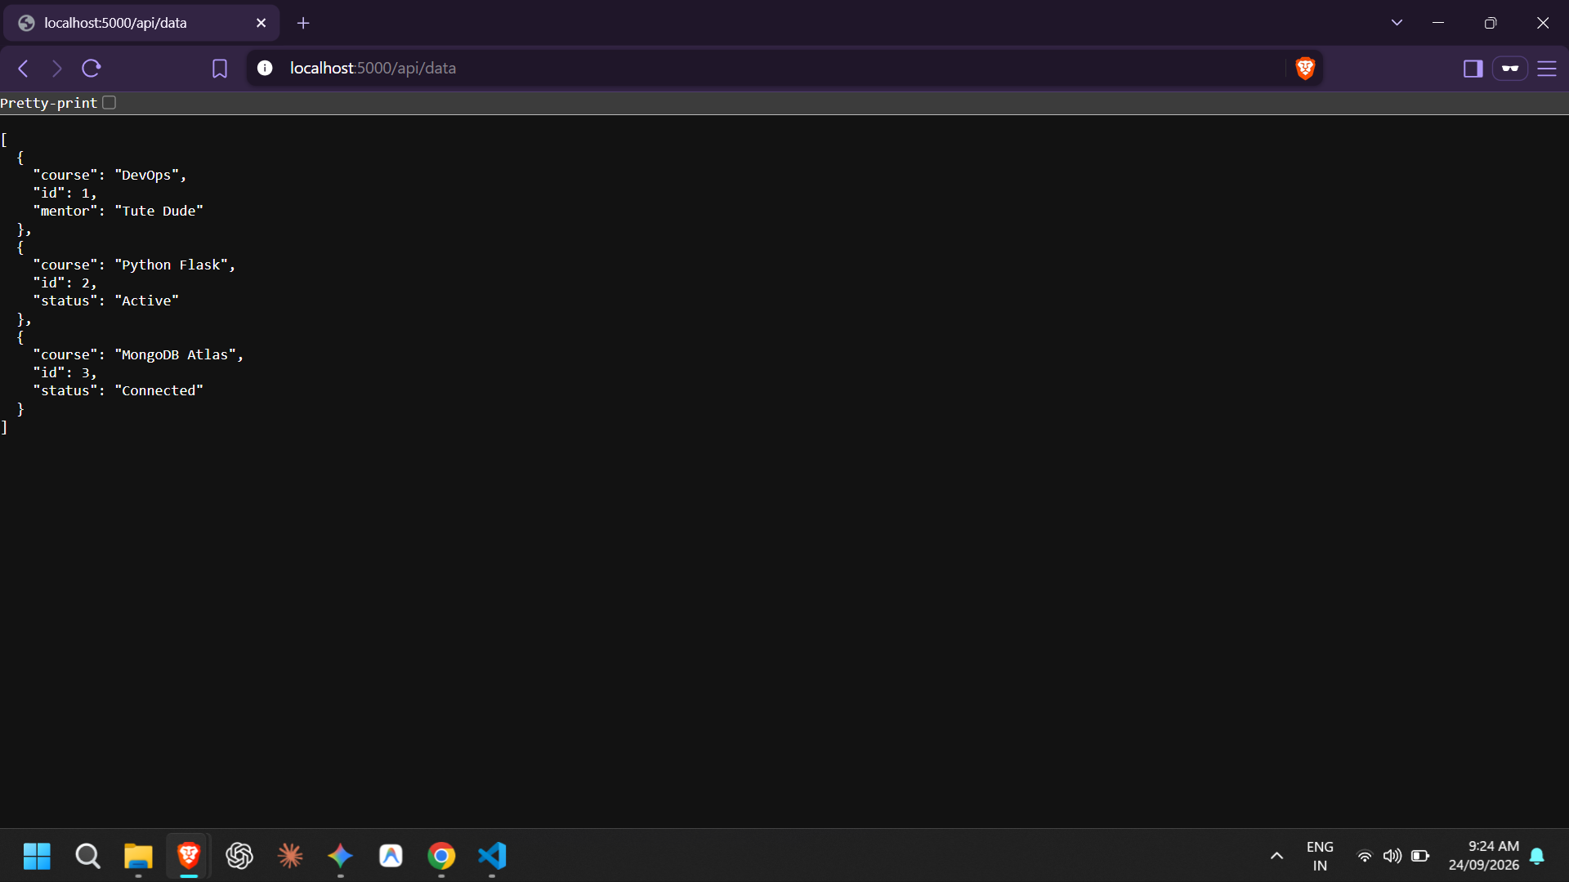
Task 2: Frontend Form with MongoDB Atlas
- Create a form on the frontend that, when submitted, inserts data into MongoDB Atlas.
- On success: the user should be redirected to another page displaying the message “Data submitted successfully”.
- On error: display the error on the same page without redirection.
