Real-Time Obstacle Detection and Distance Estimation Using Raspberry Pi, OpenCV, and Deep Learning

Project Overview
This project implements an object detection system with distance estimation using a 5MP infrared camera on a Raspberry Pi. It uses a deep learning model (SSD MobileNet v3) to identify objects and estimate their distance based on real-world width and focal length. The system sends warnings and stop alerts via D-Bus signals when obstacles are detected within predefined danger zones.

1. Library Imports and Setup
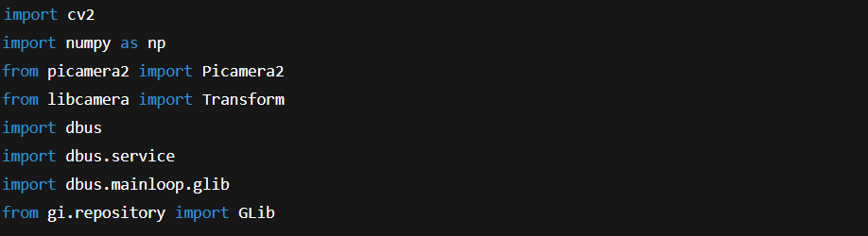

- cv2 / numpy: For image processing and math.
- picamera2: Interface for the Raspberry Pi camera.
- libcamera.Transform: Used for flipping camera feed if needed.
- dbus: Sends messages (signals) across system components.
- GLib: Processes events in D-Bus event loop.

2. Parameters and Constants
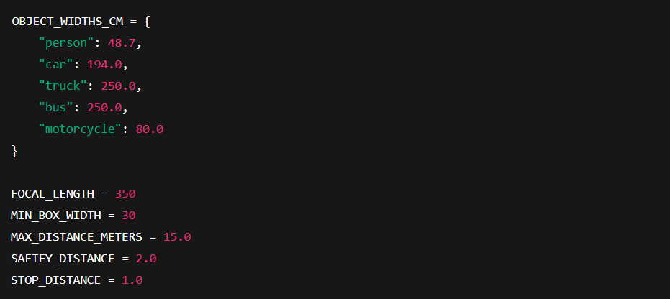

- OBJECT_WIDTHS_CM: Known average real-world object widths.
- FOCAL_LENGTH: Estimated/calibrated focal length in pixels.
- SAFTEY_DISTANCE: Threshold to trigger a warning.
- STOP_DISTANCE: Immediate stop signal threshold.

3. D-Bus Signal Class for Alerts

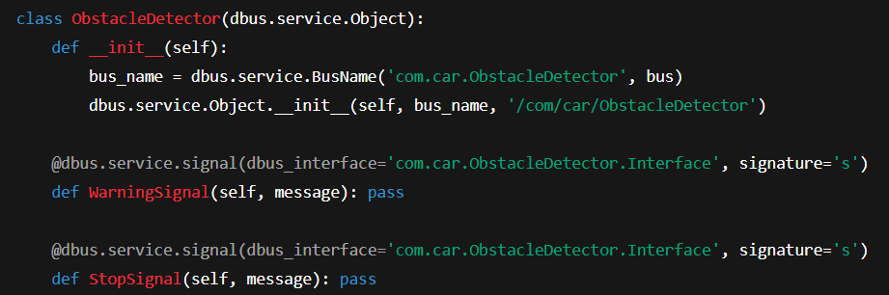
Purpose of ObstacleDetector Class
This class defines a custom D-Bus service that:
- Sends real-time alerts to any other D-Bus-aware program
- Helps decouple detection logic from the action (e.g., stopping motors, triggering sounds, etc.)

Class Breakdown:-

- Inherits from dbus.service.Object, making it capable of being registered as a D-Bus object.

-__init__() Constructor
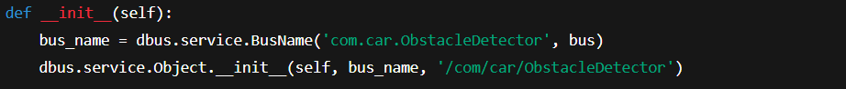
- bus_name: Registers a unique name (com.car.ObstacleDetector) on the D-Bus session bus.
  - Think of it like reserving a “channel” or namespace that other apps can subscribe to.
- Object path: '/com/car/ObstacleDetector'
  - Acts like a URL path to find this object on the bus.
This setup tells the system:
"Hey, I’m a service named com.car.ObstacleDetector, and I live at /com/car/ObstacleDetector."
-Signal: WarningSignal

- Defines a signal named WarningSignal.
- Other programs can listen for this signal on the D-Bus.
- signature='s' means it sends a string message (e.g., "WARNING: person at 1.5m").

- Signal: StopSignal
- Same as above, but this one indicates a critical stop event.
- Could trigger a braking system, emergency light.

How Signals Work (Analogy)
- Imagine D-Bus like a public announcement system.
  - ObstacleDetector is a speaker.
  - WarningSignal() is a loud “CAUTION!” shout.
  - StopSignal() is a “STOP IMMEDIATELY!” shout.
- Other components — like a motor controller or dashboard display — are like people listening for these announcements.

4. Distance Estimation Function
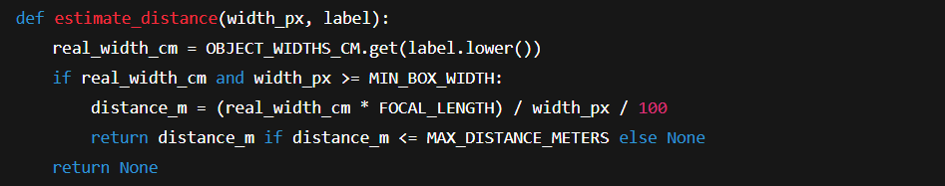

Focal Length Theory
This uses the pinhole camera model:
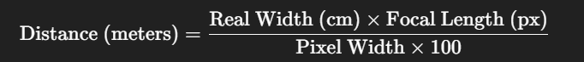
- FOCAL_LENGTH should be calibrated with known object and distance.
- MIN_BOX_WIDTH helps avoid noisy or small detections.

5. Load Object Detection Model
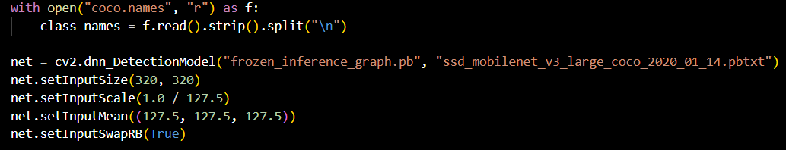
- SSD MobileNet v3 (COCO): Fast, lightweight object detection.
- Used here via OpenCV's DNN API.

1. net.setInputSize(320, 320)
This sets the input size of the neural network to 320×320 pixels.
- Deep learning models expect images of a fixed size.
- Even if your camera captures larger frames (e.g., 640×480), they’re resized to 320×320 before feeding into the model.
- This resolution is a good balance between speed and accuracy — ideal for real-time applications on Raspberry Pi.

2. net.setInputScale(1.0 / 127.5)
This scales pixel values from the 0–255 range down to 0–2:
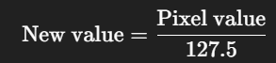

- Most deep learning models (especially TensorFlow models like SSD MobileNet) expect input values in a certain range.
- In this case, it normalizes pixel values to the range [0, 2].

3. net.setInputMean((127.5, 127.5, 127.5))
This subtracts the mean value of 127.5 from each color channel (R, G, B):
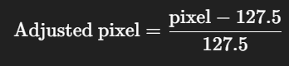

- This line, combined with the setInputScale, normalizes the input to the range [-1, 1], which is what the model expects.

4. net.setInputSwapRB(True)
This swaps the red and blue color channels.
- OpenCV reads images in BGR format.
- TensorFlow and most deep learning models expect RGB.
- This flag automatically swaps channels to match the model’s expectations.

Why Do All These Steps Matter?
Neural networks are very sensitive to input format. If you don’t normalize or prepare the image in the way the model expects:
- It can fail to detect anything
- Or give incorrect classifications

6. Initialize and Start Camera
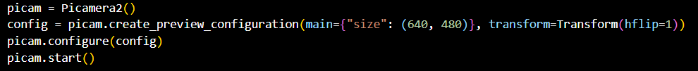
- Starts the PiCamera at 640×480 resolution with a horizontal flip.

7. Main Loop and Detection Logic

- Capture and Prepare Frame
- Captures a frame from the PiCamera2 (picam).
- Converts it from BGRA (Blue, Green, Red, Alpha) to BGR (used by OpenCV for processing).

Gets the height (h) and width (w) of the captured frame

- Define Detection Zone - ROI (Region Of Interest)
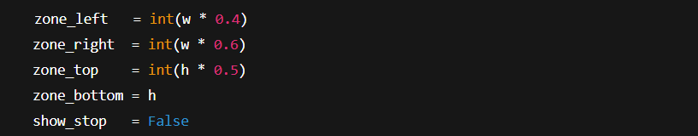
- These define a rectangle at the center-bottom part of the frame.
- Objects inside this zone are considered directly in front of the vehicle.
- show_stop is a flag for displaying "STOP!" text if a critical object is detected.

As we see the red arrow points at the virtual rectangular (The detection zone) to detect the
close and in front objects of the car.
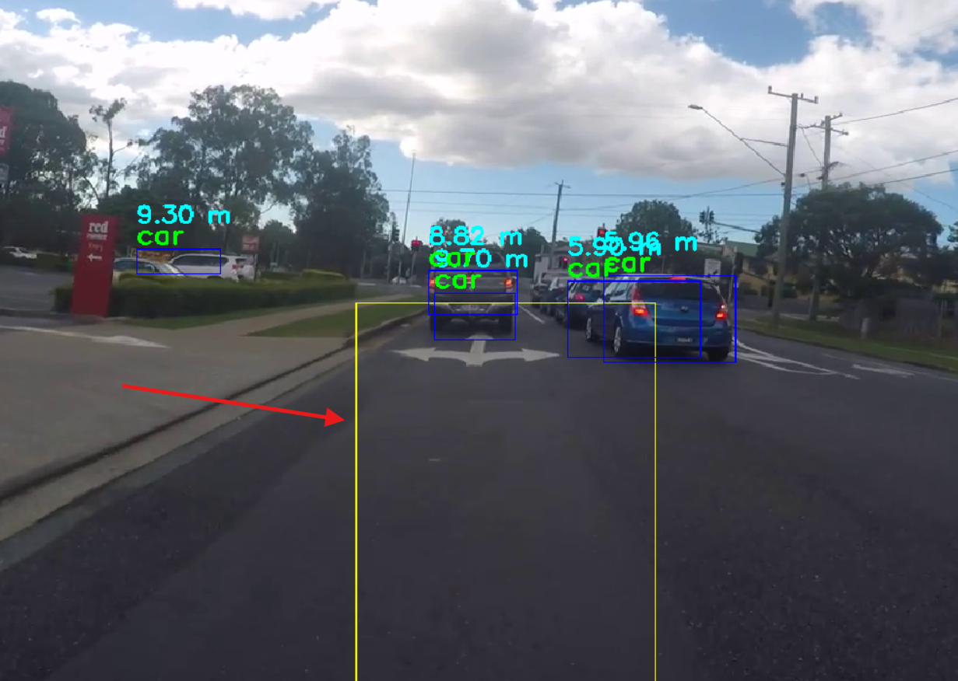

In the figure below once the box of the detected object interfaces with our virtual rectangular it emits a red WARNING sign .
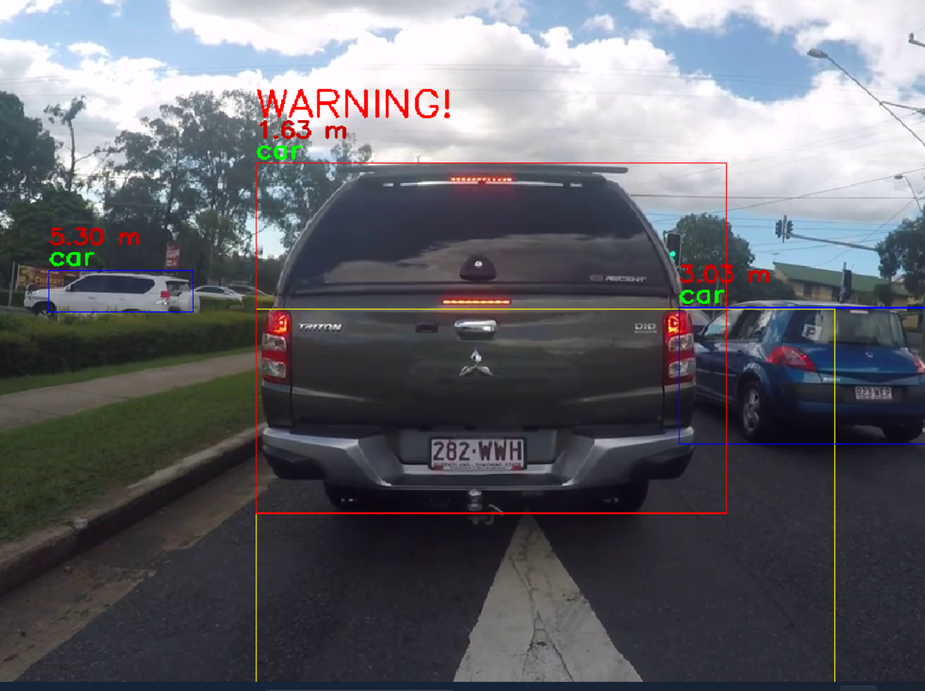

- Run Object Detection
- Runs detection using the loaded neural network (net), with 50% confidence threshold.
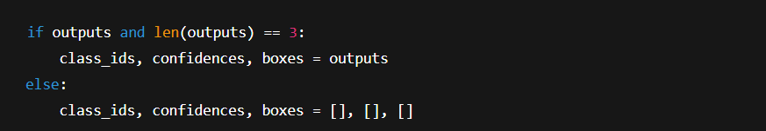
- If the network returns valid detections, unpack them.
- If not, fall back to empty lists to prevent crashes.

- Process Each Detected Object

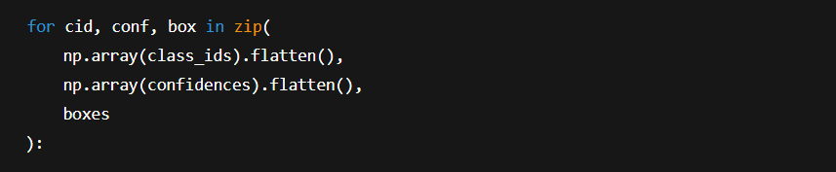
- Loops through each detection result: cid = class ID, conf = confidence, box = bounding box.
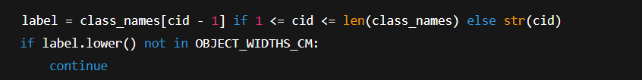

- Converts class ID to human-readable label (like "person", "car", etc.).
- Skips unknown labels not in your defined real-world widths dictionary.

- Filter Small Boxes & Check Zone

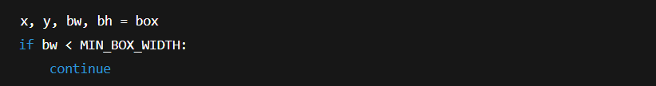
- Unpacks bounding box values (x, y, width, height).
- Filters out objects that are too narrow — likely noise or background.

- Calculates center of the bounding box.
- Checks if it falls inside the defined front-facing zone.

- Estimate Object Distance
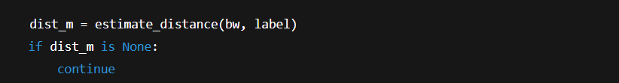
- Uses known real-world width and bounding box width to estimate distance using the pin-hole camera model:
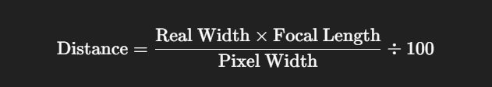

- Check If Object Is Too Close

- If object is closer than your safety threshold, flag the WARNING sign.
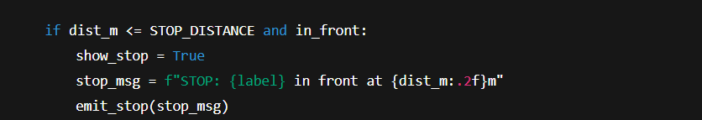

- If object is very close (within STOP_DISTANCE) and directly in front:
  - Set show_stop to draw alert
  - Send DBus StopSignal for system response
- As we see in the figure below when the distance is less than 1meter
it displays a STOP! Sign in the mid of the screen to alert the driver to stop the car immediately, also it emits a massage via Dbus to the main system so it stops the motors automatically

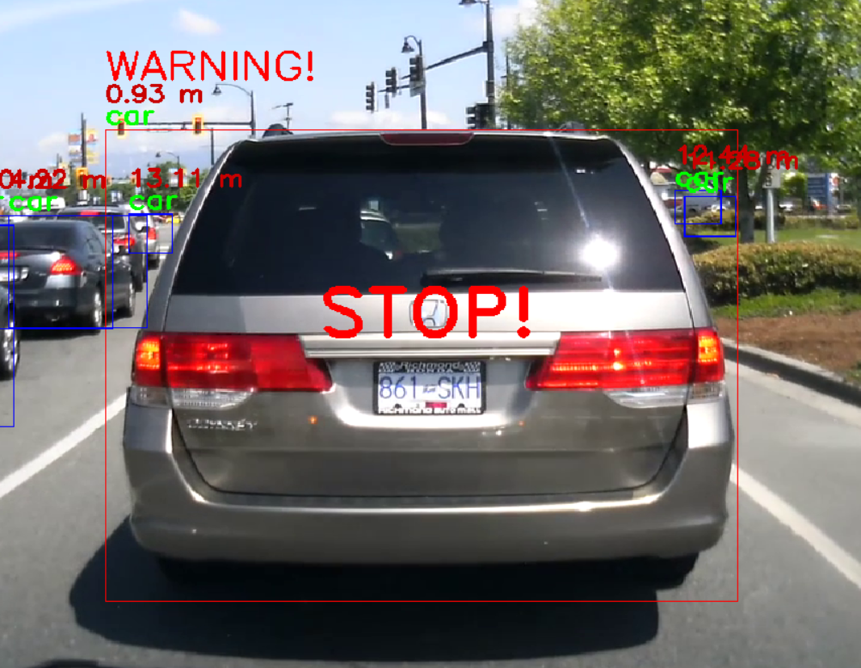

- Draw Bounding Boxes and Labels
- Red box if it’s dangerously close and in front.
- Blue otherwise.
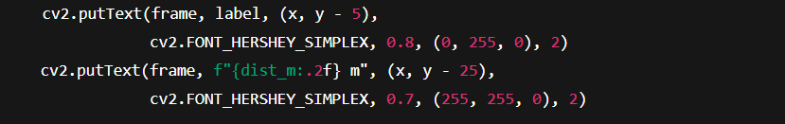
- Shows the object name and distance just above the bounding box.

- Emit Warning and Display Message
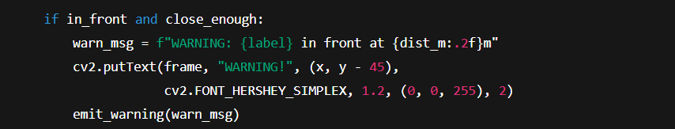
- If object is in the front zone and within safety distance:
  - Displays "WARNING!" on screen
  - Sends a DBus WarningSignal

- Draw Stop Message

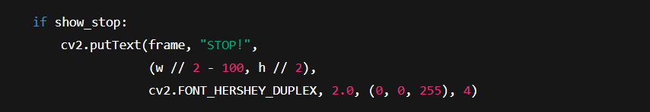
- If a STOP condition was detected, draws a big red "STOP!" at the center of the screen.

- Show Frame & Break on 'q'
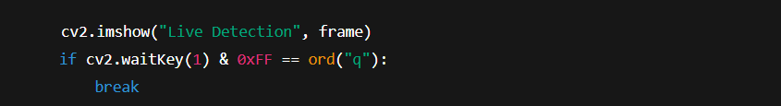
- Shows the processed frame in a window.
- Pressing the q key stops the loop.

- Handle DBus Events
- Keeps the DBus message loop active, processing any pending inter-process events or listeners.

